Task A Steps 1-6

Task A steps 2-8

Task B steps 1-2

Task B Steps 2-11

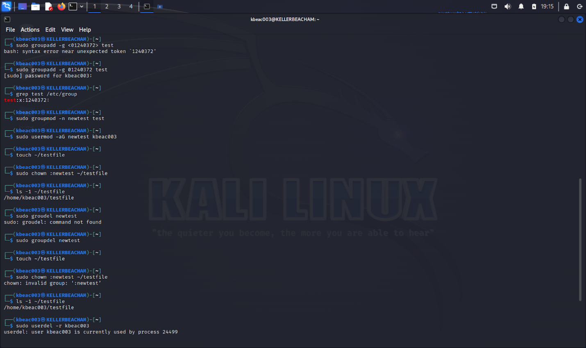

Task B steps 11-12