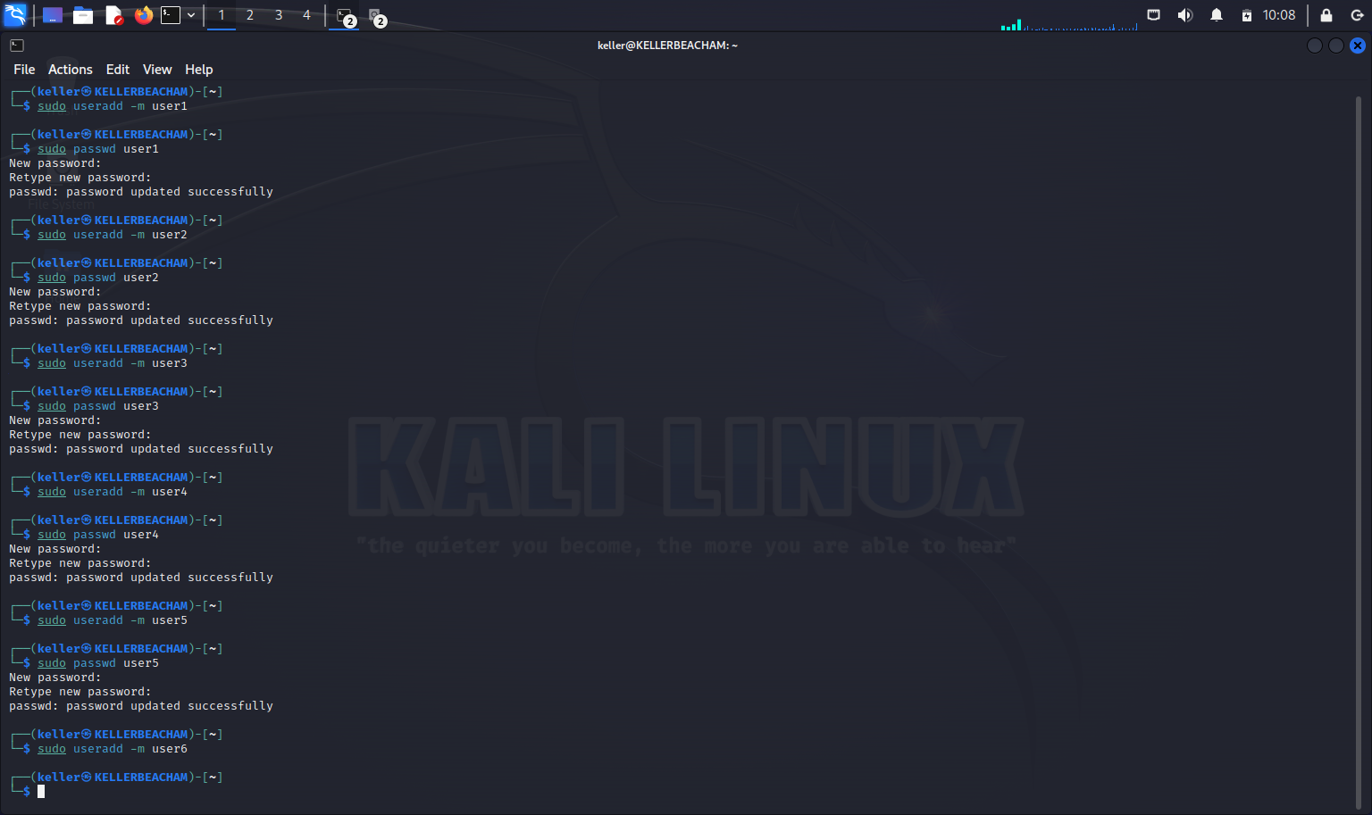
Task A: I created the six users and gave them all passwords that meet the requirements.
User1: book
User2: 1111
User3: wave33
User4: money24!
User5: mississippi456
User6: HUmaN29!@

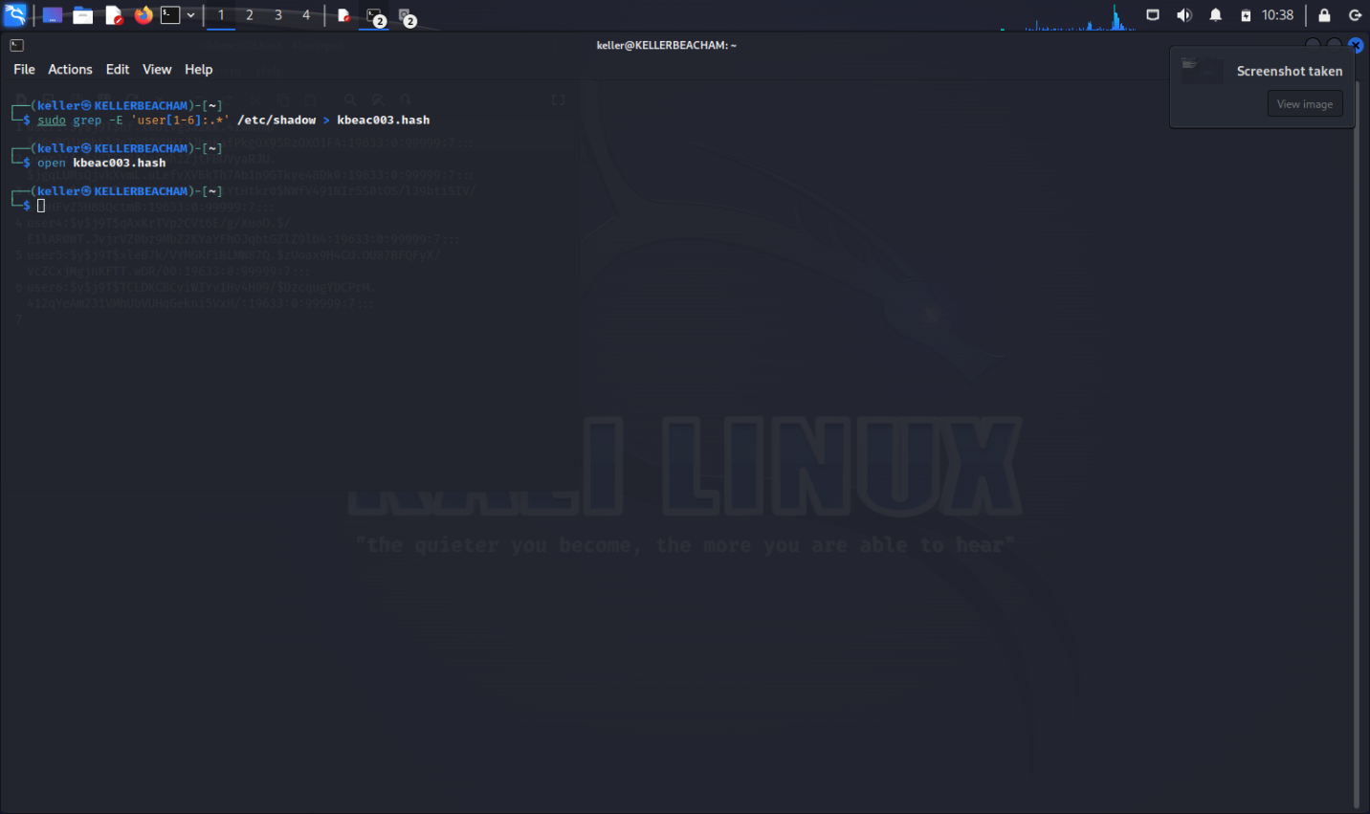
I added all of the users into a file, and opened it to make sure that my code worked properly (below).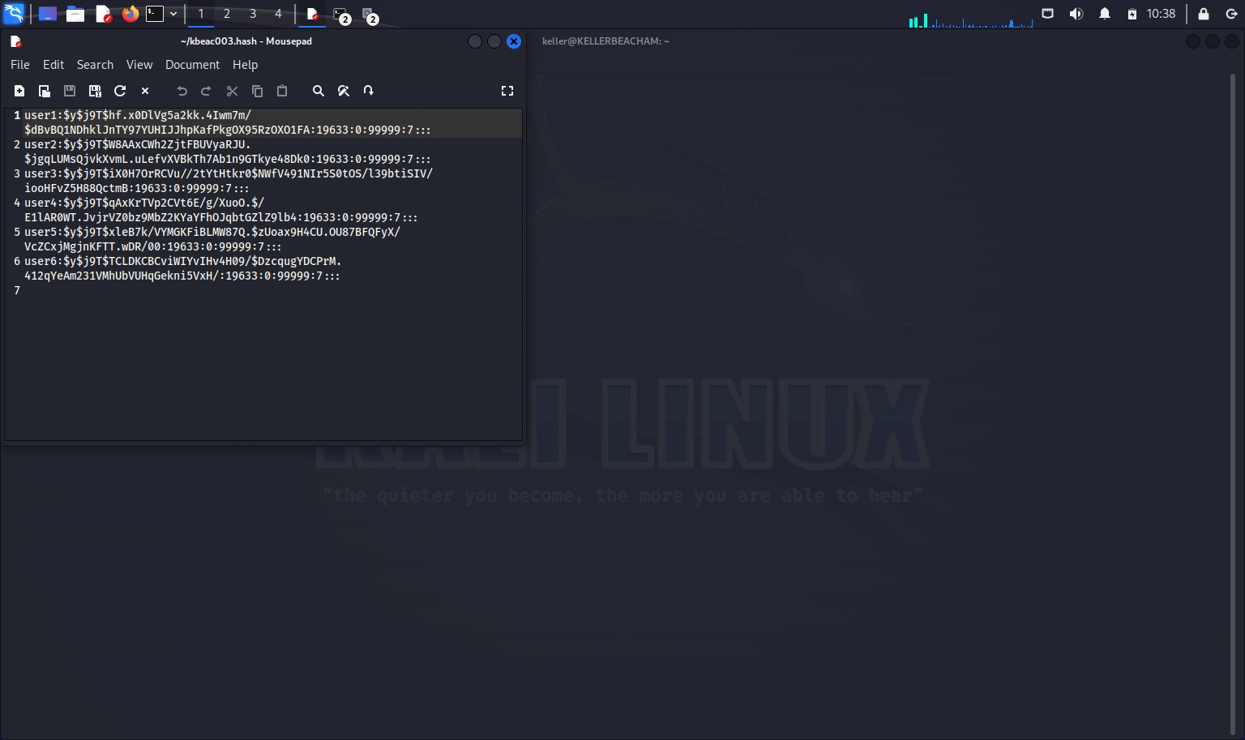

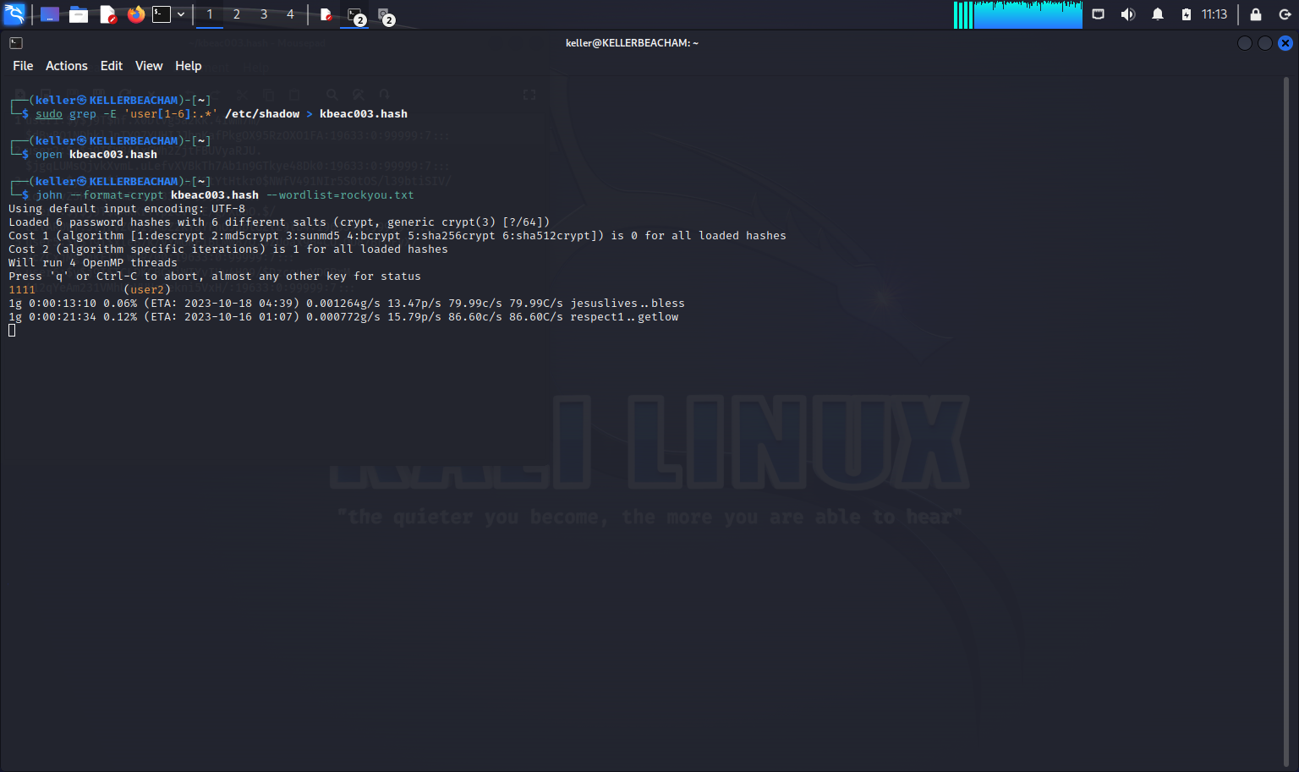
I ran john the ripper for 10+ minutes because I expected it to crack more of my passwords than that when I pressed the keyboard or tried to scroll it gave me weird ETA’s. I am surprised that more of my passwords weren’t cracked faster.

