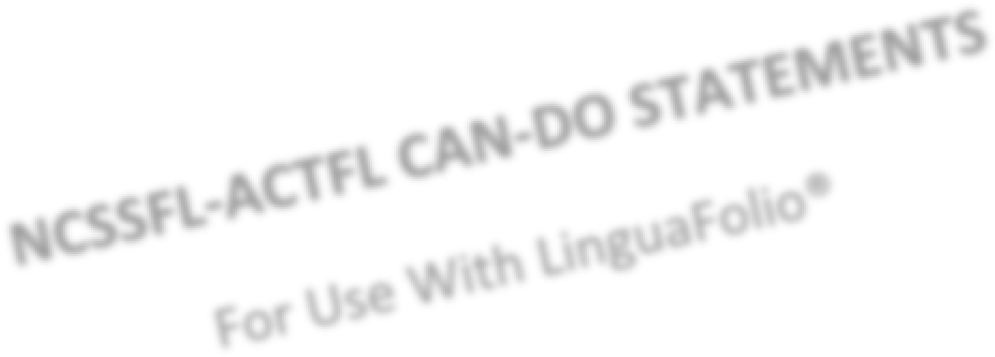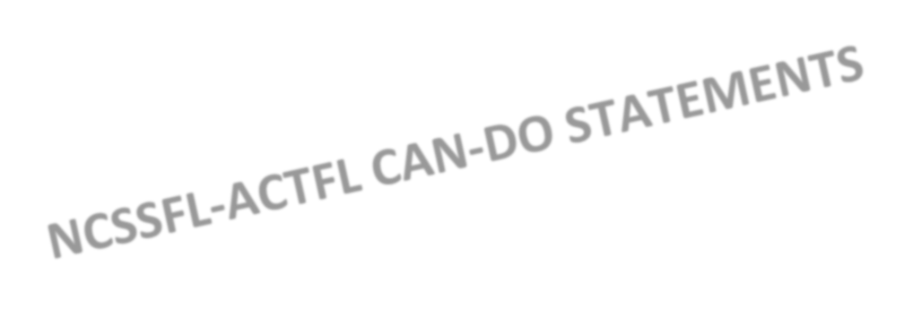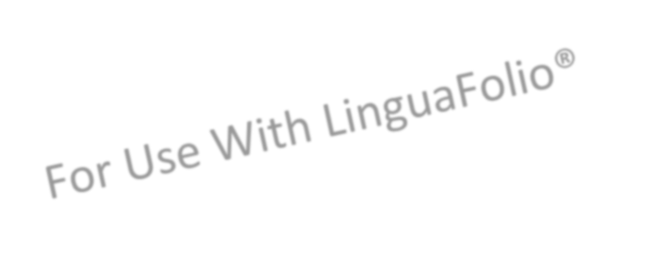

**Novice**

**High**

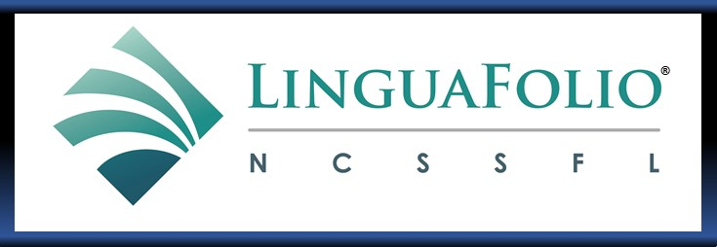

**NOVICE HIGH**



# INSTRUCTIONS

The NCSSFL-ACTFL Can-Do **Benchmark*s*** are***italicized*** and are followed by specific Can-Do **Indicators** in **bold**. The indicators break down the benchmarks into smaller steps. Directly below the can-do learning indicators is a bulleted list of**Examples** that illustrate and make transparent what such expectations might look like. Benchmarks and indicators are aligned to ACTFL proficiency levels and sublevels and as such should **NOT** be modified. The blank can-do statement is designed for that purpose – to personalize learning targets that illustrate your language skills and performance.

Each statement should be assessed separately to identify a level of proficiency.

|  |  |
| --- | --- |
| **Self-Assessment Statement** | **Explanation** |
| This is my goal. | This is something that I want to be able to do. |
| I can do this with help. | I am able to do this when prompted, when someone provides a word or hint, or after multiple tries. |
| I can do this consistently. | I have done this numerous times, comfortably and independently, without hesitation. |
| I have provided evidence to demonstrate this | Since I can do this without much effort, I have provided proof by sharing samples of my work that demonstrate this goal. |

These self-assessment statements are provided to help you understand and document what you can do with the language that you are learning in each of the three modes of communication: interpretive, interpersonal and presentational.

* The **interpretive mode\*** describes how you interpret meaning from hearing, reading or viewing the language in a variety of ways (e.g. voice mail, podcasts, lyrics, television, stories, books, public announcements, etc.).

* The **interpersonal mode** describes how you engage in direct oral, written or signed communication with others (e.g. face-to-face conversations, online discussions or video conferences, emails, text messaging, etc.).

* The **presentational mode** describes how you speak, write or sign to a variety of audiences (e.g. leaving a voice message, making a presentation, giving directions to a group, delivering a speech, etc.).



*\* What elements of literacy lead to higher levels of understanding in the Interpretive Mode?*

*Learners move along the proficiency continuum at different speeds in listening, reading or viewing. Learners bring prior skills and experience in L1 and L2 to the Interpretive mode. Factors that impact how well learners understand texts include: a) text complexity or length*

1. *familiarity with topic and background*
2. *knowledgeability to use literacy strategies such as recognizing key words, detecting the main idea, identifying supporting details, noting organizational features, guessing meaning from context, identifying logical inferences, identifying the author’s perspective and cultural perspectives/norms.*



**NOVICE HIGH**

|  |  |  |  |  |
| --- | --- | --- | --- | --- |
| **Novice Benchmark**  **Interpretive Listening or Viewing**    *I can identify the general topic and some basic information in both very familiar and everyday contexts by recognizing practiced or memorized words, phrases and simple sentences in texts that are spoken, written or signed.* | **This is my goal.** | **I can do this with help.** | **I can do this consistently.** | **I have provided evidence**    **to demonstrate this.** |
|  |  |  |
| *What can I understand or interpret in authentic informational texts that I hear or view?* | | | | |
| **I can identify the topic and some isolated facts from simple sentences in informational texts.**    **Examples**   * I can_________________ * I can understand the name of a product, the cost and where to buy it from a radio ad. * I can understand who to pick up and where to take them from a friends’ voicemail. * I can follow a YouTube video on how to play a simple game. * I can understand an emergency alert during a TV show. * I can understand when a sports announcer introduces the team players. |  |  |  |  |
|  |  |  |  |  |
| *What can I understand or interpret in authentic fictional texts that I hear or view?* | | | | |
| **I can identify the topic and some isolated elements from simple sentences in short fictional texts.**    **Examples**   * I can_________________ * I can identify where and when a read-aloud story takes place. * I can identify how to get to the next level when playing a video game. * I can identify some of the events in a videostreamed show. * I can identify some of the traits of a superhero described in video comic books. * I can identify some actions described in a movie scene. |  |  |  |  |
|  |  |  |  |  |
| *What can I understand or interpret in conversations or discussions that I hear or view, in which I am not a participant?* | | | | |
| **I can understand familiar questions and simple sentences in conversations.**    **Examples**   * I can_________________ * I can sometimes understand to whom people are directing their conversation.  * I can understand someone’s simple descriptions of a photo.  * I can understand questions about someone’s social schedule.  * I can understand simple compliments given to a hostess. * I can understand simple questions a guest asks about family. |  |  |  |  |

**NOVICE HIGH**

|  |  |  |  |  |
| --- | --- | --- | --- | --- |
| **Novice Benchmark**  **Interpretive Reading**    *I can identify the general topic and some basic information in both very familiar and everyday contexts by recognizing practiced or memorized words, phrases and simple sentences in texts that are spoken, written or signed.* | **This is my goal.** | **I can do this with help.** | **I can do this consistently.** | **I**  **have provided evidence**    **to demonstrate this.** |
|  |  | | |  |
| *What can I understand or interpret in authentic informational texts that I read?* |
| **I can identify the topic and some isolated facts from simple sentences in informational texts.**    **Examples**   * I can_________________  * I can follow directions in a Scavenger Hunt game. * I can understand a variety of simple messages on greeting cards.  * I can understand someone’s profile on a social media site. * I can select a movie based on a short description.  * I can understand some facts about the weather, especially when weather symbols are used. |  |  |  |  |
|  |  |  |  |  |
| *What can I understand or interpret in authentic fictional texts that I read?* | | | |  |
| **I can identify the topic and some isolated elements from simple sentences in short fictional texts.**    **Examples**   * I can_________________ * I can identify the topic of a short story.  * I can identify the topic of a poem.  * I can identify some of the events in a fairy tale. * I can identify some of the traits of a superhero as described in a comic book. * I can identify some actions described in a scene from a play. |  |  |  |  |
|  |  |  |  |  |
| *What can I understand or interpret in conversations or discussions that I read, in which I am not a participant?* | | | |  |
| **I can understand familiar questions and simple sentences in conversations.**    **Examples**   * I can_________________ * I can understand someone’s simple description of a photo on Instagram.  * I can understand questions about class schedules in a group text message.  * I can understand simple feedback on a homework assignment.  * I can understand simple questions about family in correspondence among ePals.  * I can understand simple questions in a forum discussion. |  |  |  |  |

