Research Methods in Public Health: MPH 616
Data Analysis Project

Krista Plogger

For this assessment exercise, you are asked to analyze data comprise of 641 records on mothers who had births. The data is called MPH 616_Data_Analysis_Project.sav. You are asked to analyze the data with the aim to find out whether birth weight as an outcome variable is significantly higher in the intervention group compared to no-intervention group. You need also to investigate whether birth weight is significantly related to each maternal age, hypertension, sex of the infant, and gestational age. You may like to categorize a certain variable during this analysis.

Comment on whether birth weight is higher in intervention group. (Max. 2 point)
Based on the histogram developed (Figure 1) the data is determined to be normally distributed, therefor, a t-test was conducted. A mean of 3113.09 and standard deviation of 684.341 were determined for the intervention group. The placebo group had a mean of 3145.23 and standard deviation of 620.171. According to the data the birth weight was not significantly higher in the intervention group based on comparison of mean and median. The t-test determined a p-value of .534 concluding no statistical significance present.

Analyze the association between the birth weight and sex of the infant (Max. 2 point)
Based on the histogram (Figure 2) the data appeared to be normally distributed and a t-test was conducted. The t-test resulted in means of 3211.28 and 3044.13. Additionally, standard deviations of 665.980 and 628.660. This information lead me to believe there was a difference in this correlation as these numbers were not exactly close to each other. With a P-value of 167.152 birth weight and sex of the infant were determined to be statistically significant.

Analyze the association between the birth weight and hypertension (Max. 2 points)
A histogram was produced (Figure 3) to determine if the data was normally distributed. It was determined that it was and a t-test was conducted. There appeared to be a significant difference in means and standard deviations amongst the comparison. The means were 3191.53 and 2742.16 with standard deviations of 601.096 and 812.947. With a p-value of 0.001 it was determined that birth weight and hypertension are in fact statistically significant though I would have stated otherwise. The way the histogram reflects the data it would appear as though they would not correlate.

Analyze the association between the birth weight and gestational age (Max. 2 points)
A scatter plot was used due to two quantitative measurements. After analyzing the relationship between birthweight and gestational age in the scatter plot (Figure 4) it was determined that the relationship appears to be linear. There is a correlation between birth weight and gestational age. A bivariant correlation was run to determine whether there was a positive or negative relationship between the two variables. It was determined that there is a positive relationship between birth weight and gestational age as the correlation coefficients are above zero (1, .738). A regression was performed to predict the birth weight based on gestational age. It was concluded that with every week gain in gestational age there was a 206.6 gram increase in weight.

Analyze the association between the birth weight and maternal age (Max. 2 points)
A scatter plot was used to determine if there was likely a relationship between birthweight and maternal age. There does not appear to be a relationship between birth weight and maternal age (Figure 5).

Check if the impact of the intervention is affected by the confounding by sex of the child (Max. 2 points)
Sex of the child is suspected to distort the relationship between the intervention and birth weight. A crude analysis was conducted to determine if sex of the child impedes as a confounding factor. No significant difference between intervention groups during the crude analysis (p-value equals .534, .533). Stratified by sex of the child by male (P-value .704) Stratified by female (P-value .813). The same conclusion was determined from the stratified analysis of the relationship.

Check if the impact of the intervention is affected by hypertension (Max. 2 points)
Hypertension is suspected to have possibly distorted the relationship between the intervention and birth weight. To determine if the intervention is affected by hypertension, we will analyze hypertensive women and men. It was determined that hypertension is a confounding factor because p-values differed between the crude and stratified analysis. This was concluded through a stratified analysis and the results of stratified by hypertension in mothers: .P-Value .057 and .054 statistically significant defers from the crude analysis P-Value .534. and .533.

Summary of the findings from all analysis (Max. 2 points)
In summary, it was determined that there was no statistical significance present for whether birth rate was higher in the intervention group or a correlation between birth weight and maternal age. Birthweight had a statistical significance with sex of the infant, hypertension, and gestational age. There was no relationship determined between and maternal age. Overall, it appeared as though majority of comparisons were normally distributed and the overall impact of the intervention did not seem to be outwardly significant as expected.

Figures (Max. 2 point)

Figure 1 – Effects of Intervention on Birthweight
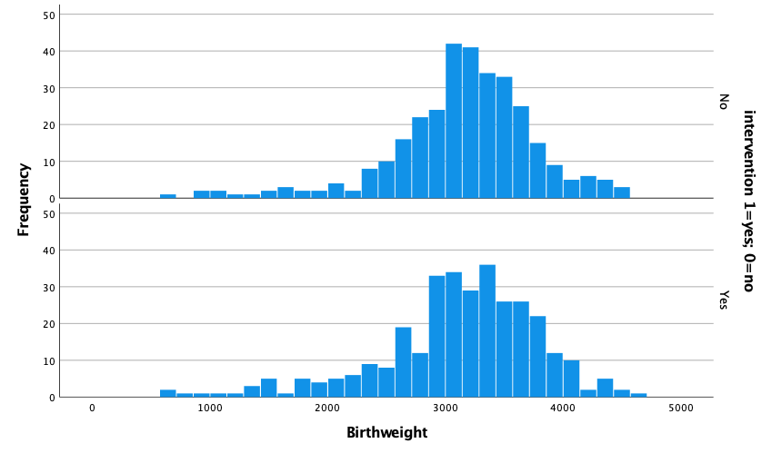

Figure 2 – Association of Birthweight and Sex

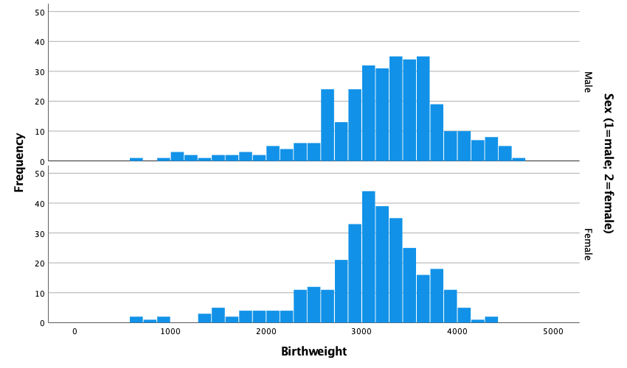

Figure 3 – Relationship between Birthweight and Hypertension
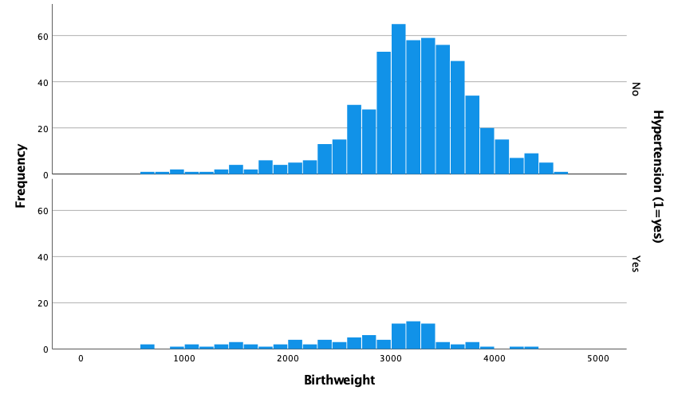

Figure 4 – Relationship between Birthweight and Gestational Age

Figure 5 – Relationship between Birthweight and Maternal Age

