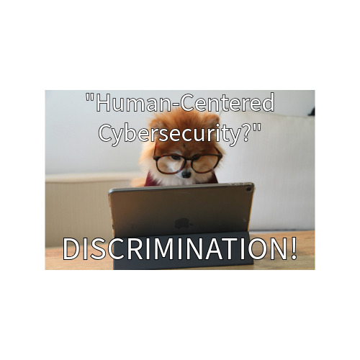

1. Highlights the “human” portion of “human-centered cybersecurity” and touches upon the subject of discrimination in that field of work.



1. Highlights a common mistake made by people in the workplace, leaving their private work information vulnerable.

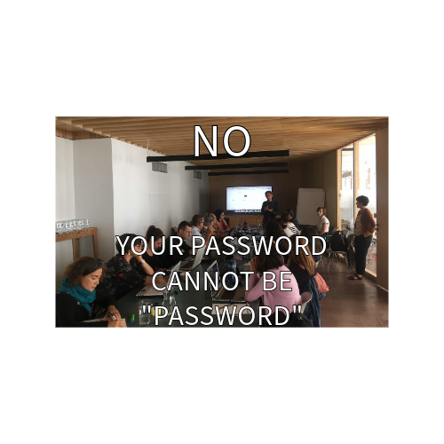

1. Displays good habits for safekeeping information, setting a good example of what not to use as your passcode and emphasizes the importance of a strong password.