CYSE 301: Cybersecurity Technique and Operations

Assignment M6: Digital Steganography

(Total 100 Points)

Task-A: [10 points]
Explain what steganography is and how it differs from cryptography?
They are very similar, but steganography hides the existence of a message why cryptography scrambles the contexts of a message. This is the best way of putting it in short terms and that makes sense to me.

Task B : Lab Preparation:
- Access Windows7 VM in CCIA to open steghide command prompt (available in windows 7 Desktop)
You need to use steghide, not s-tool to complete this assignment.
You may refer to the lecture for Module-6 to learn about using steghide tool. Please submit the screenshot as a proof for all the steps/commands
- [10 Points] Create a text file containing the answers to the following questions:
  - What are your name and current date and timestamp?
  - What is your expected grade in this course?
NAMED – “SECRET”
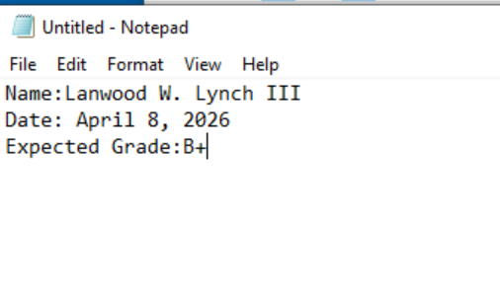

- [40 Points] Completeteh following tasks using steghide command:

- Use steghide to hide this text file in the cover image, " Monarch.bmp.", which you can find in Windows7 under VMShare folder--> Lab-Resources--> Module 6.
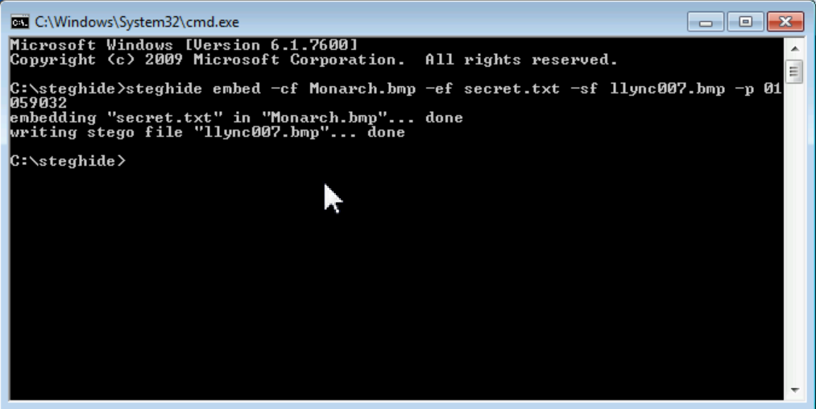

- Use your Midas ID (all lowercase) as “YourName.bmp” for example
"svatsa.bmp" as the name of the STEGO file.

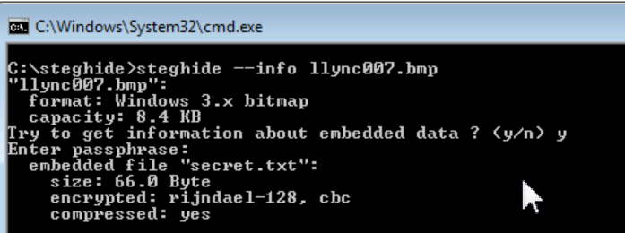

- Use your own UIN (for example, 01000123) as the password.

- 01059032

- List the contents of the current directory/folder to verify if the stego file is created or not.

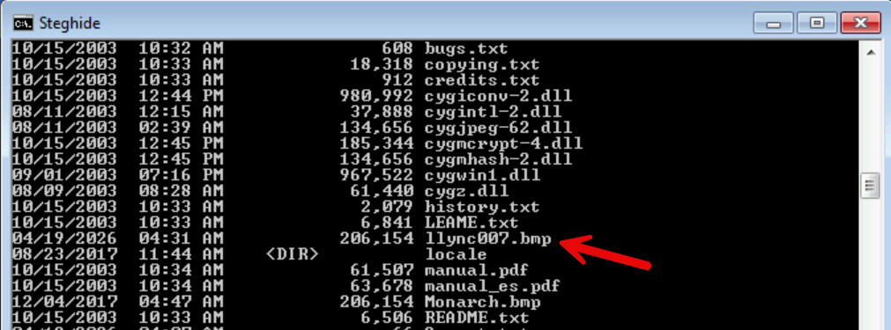

- [20 Points] Extract the secret message by executing steghide command and save in a file named “extracted_YourName.txt”.

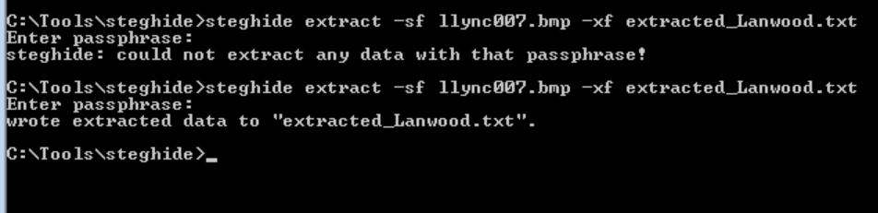
- [10 Points] Execute the command to list the contents of the current directory in CMD to verify whether the extracted textfile with secret message has been extracted or not.

You should see textfile there because it was hidden in the image file and appeared after extracting the image file in the previous step.

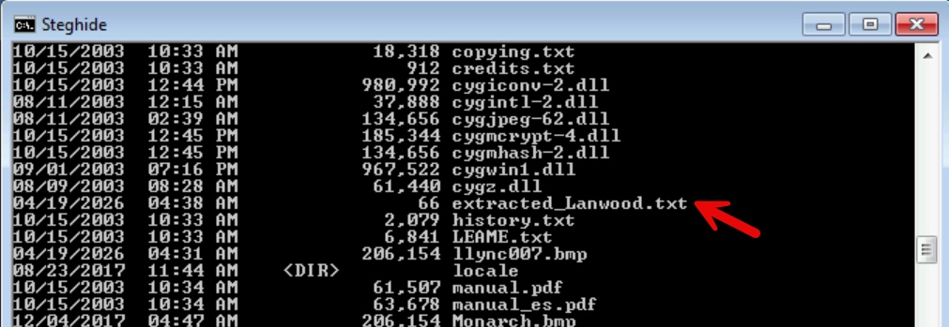

- [10 Points] Execute the command to display the contents of the extracted file you revealed.


