CYSE 270: Linux System for Cybersecurity Assignment: Lab 5 – Password cracking

Lanwood Lynch III

CYSE 270: Linux System for Cybersecurity

The goal of this lab is to test the strength of different passwords.

Task A – Password Cracking
- Create 6 users in your Linux Terminal, then set the password for each user that meets the following
complexity requirement respectively. You should list the passwords created for each user. [6 * 5 = 30 points]
  - For user1, the password should be a simple dictionary word (all lowercase)
    - User: Nike | Password: swoosh
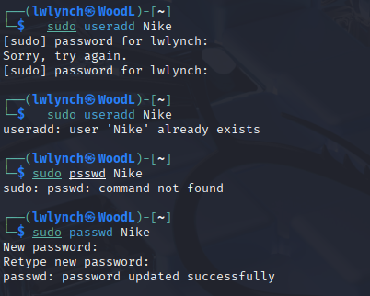
  - For user2, the password should consist of 4 digits
    - User: Adidas | Password: 1234
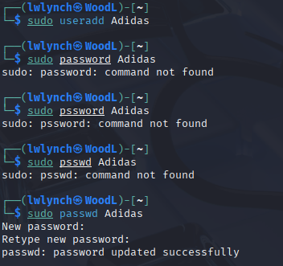
  - For user3, the password should consist of a simple dictionary word of any length characters (all lowercase) + digits
    - User: Jordan | Password: jumpman23
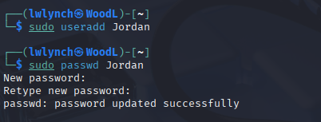
  - For user4, the password should consist of a simple dictionary word character (all lowercase)
+ digits +symbols
- User: Asics | Password: kayano14!
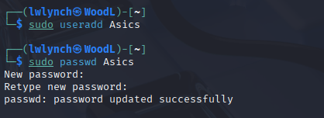
  - For user5, the password should consist of a simple dictionary word (all lowercase) + digits
    - User: Goyard | Password: wallet1010
    - 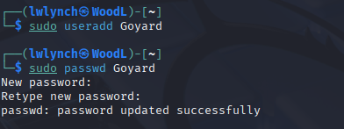
  - For user6, the password should consist of a simple dictionary word (with a combination of lower and upper case) + digits +symbols
    - User: God | Password: iSgood7!
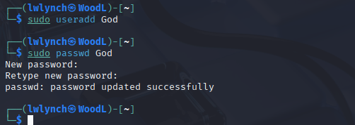

Remember, do not use the passwords for your real-world accounts.

- Export above users’ hashes into a file named xxx.hash (replace xxx with your MIDAS name) and use
John the Ripper tool to crack their passwords in wordlist mode (use rockyou.txt). [ 40 points]
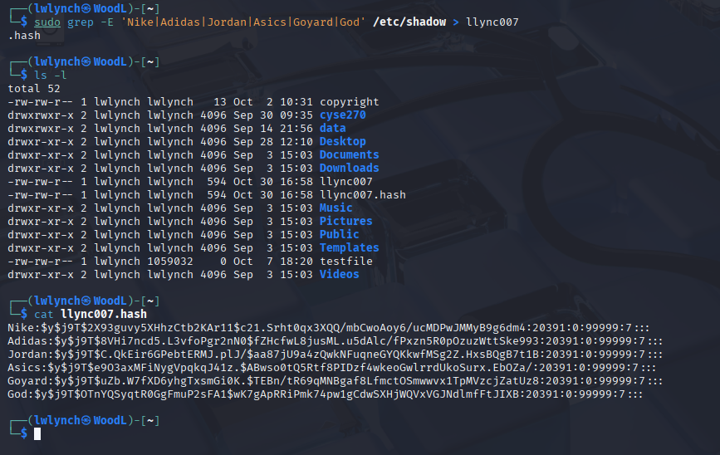
- Keep your john the ripper cracking for 10 minutes. How many passwords have been
successfully cracked? [30 points]
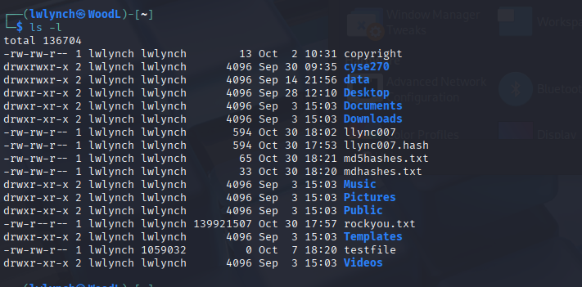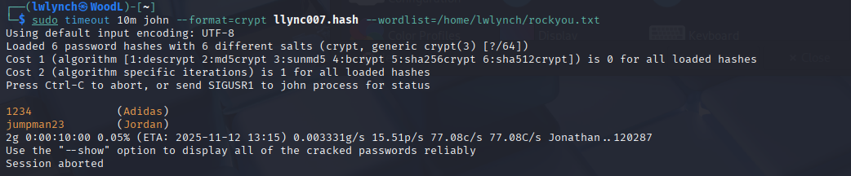

Extra credit (10 points):
- Find and use the proper format in John the ripper to crack the following MD5 hash. Show your steps and results.
  - 5f4dcc3b5aa765d61d8327deb882cf99



