CYSE 270: Linux System for Cybersecurity

Lab 6 – File Permission

Lanwood Lynch III

CYSE 270: Linux System for Cybersecurity
You need to configure the system to allow three users to perform the shared folder actions. Please submit the screenshot for all the steps in a word or pdf file

Task A: Get accounts and groups ready (70 points)
Step 1. Create three groups- employee, payroll, and admin. (You may refer to the slides for week-4 –
Group Management)
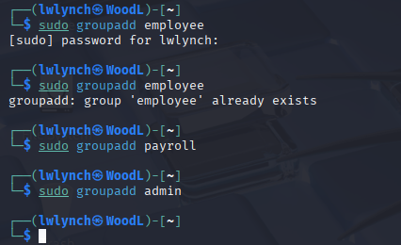

Step 2. Create three user accounts with a specified home directory for Sophia, Olivia, and Emma. Set the primary group for Sophia, Olivia, and Emma to "employee", "payroll", and "admin", respectively. And change their login shell to /bin/bash. Don't forget to set their passwords.
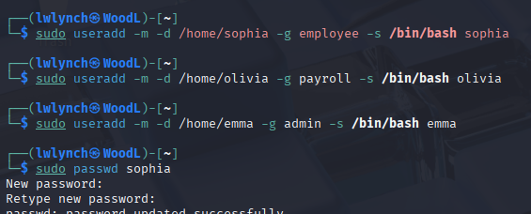
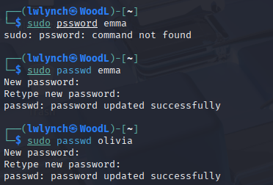

Step 3. Create a shared group called "your_midas" (replace it with your MIDAS name) and set this shared group as the above accounts' secondary group. After this step, remember to check each user's group profile.

Step 4. Create a directory named /home/cyse_project, which is to be owned by the “your_midas” group
which is a shared group). After this step, remember to check the permission of this shared directory.
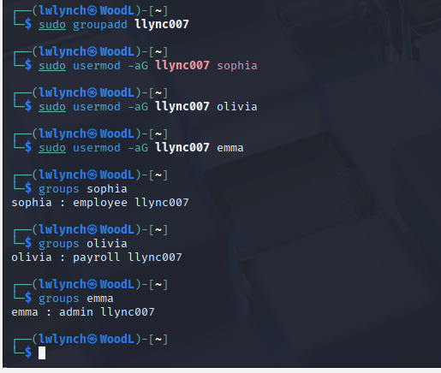

Step 5. Change the permissions of the /home/cyse_project directory to "rwxrwx---" using the octal method so that only the project group members have access to this directory. After this step, remember to check the permission of this shared directory.

Step 6. Switch to Sophia's account. Change the default permissions using octal method with umask command, to "rw-r " for Sophia when she creates a file or directory. Check the value of umask, and

permission of a new file after this step.
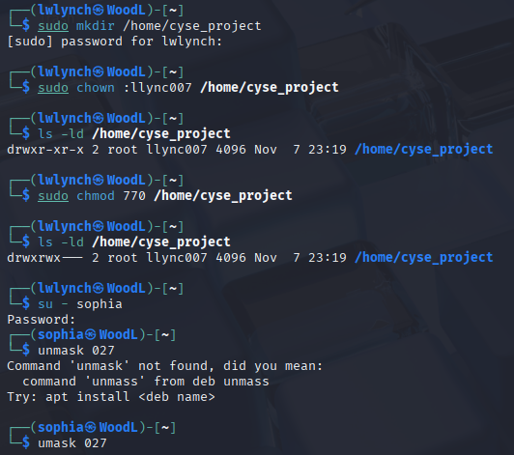

Step 7. Create a new file called "Sophia_homework" in the home directory of Sophia and put your name in the file as content. After this step, remember to check the content and the permission of the new file. (ls -l Sophia_homework)

Step 8. Copy "Sophia_homework" to the /home/cyse_project directory. After this step, remember to check the permission of the file in the shared directory.

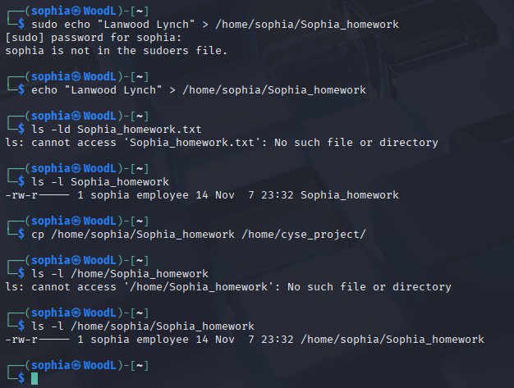

Step 9. Switch to Emma's account. Try to read "Sophia_homework" in the /home/cyse_project Directory.

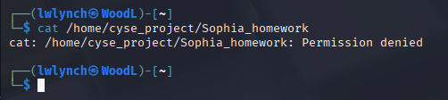

Step 10. Exit out of Emma’s account and Sophia’s account.

Task B: Set SGID permission (15 points)
Step 1. Switch to root or the regular user’s account. To allow group members to access the files shared in the shared directory, you need to fix the sharing issue by setting the correct SGID group values to
/home/cyse_project directory.
Step 2. Switch to Sophia's account. Copy "Sophia_homework" to the /home/cyse_project directory as "Sophia_homework2".
Step 3. Switch to Emma's account. Try to read "Sophia_ homework2" in the /home/cyse_project directory.
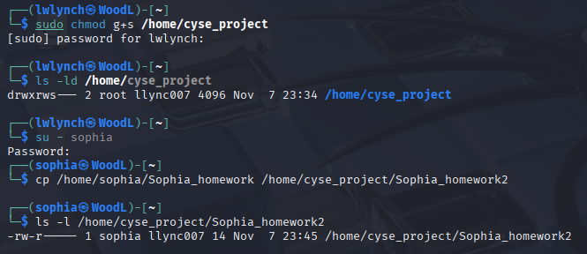
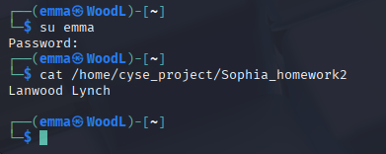

Task C: Unset SGID permissions (15 points)
Step 1. Switch to root the regular user’s account. To disallow group members to access the files in the shared folder, you need to fix the sharing issue by setting the correct SGID group values to
/home/cyse_project directory to remove the group user read permission.
Step 2. Switch to Sophia's account. Copy "Sophia_homework" to the /home/cyse_project directory as "Sophia_homework3".
Step 3. Switch to Olivia's account. Try to read "Sophia_home3" in the /home/cyse_project directory.

SCREENSHOT BELOW!

CYSE 270: Linux System for Cybersecurity
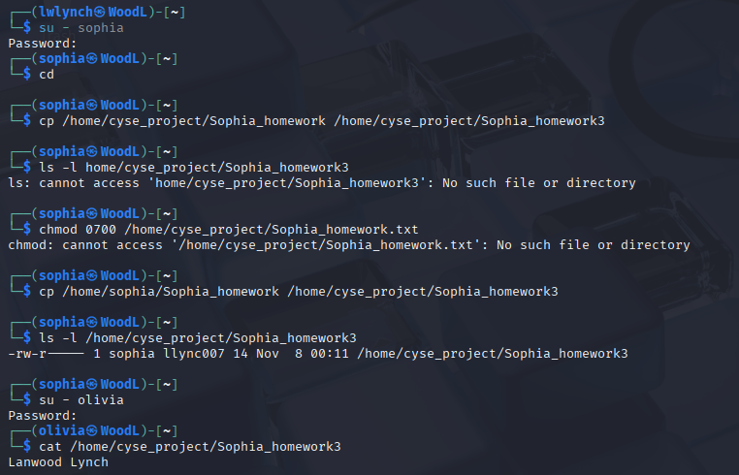

Extra credit: Sticky Bit (10 points)
Step 1. Switch to Olivia’ account. Delete “Sophia_ homework" in the /home/cyse_project directory. Step 2. Switch to root account. Set the sticky bit permission, to make files can only be removed by the owner of the file.
Step 3. Switch to Olivia’ account. Try to delete “Sophia_ homework3" in the /home/cyse_project
directory. Can you delete it this time? Why?



