Task 4: Mindmap
LaShanda Broussard
Old Dominion University
HMSV 440W
Professor Silverberg
July 10, 2022
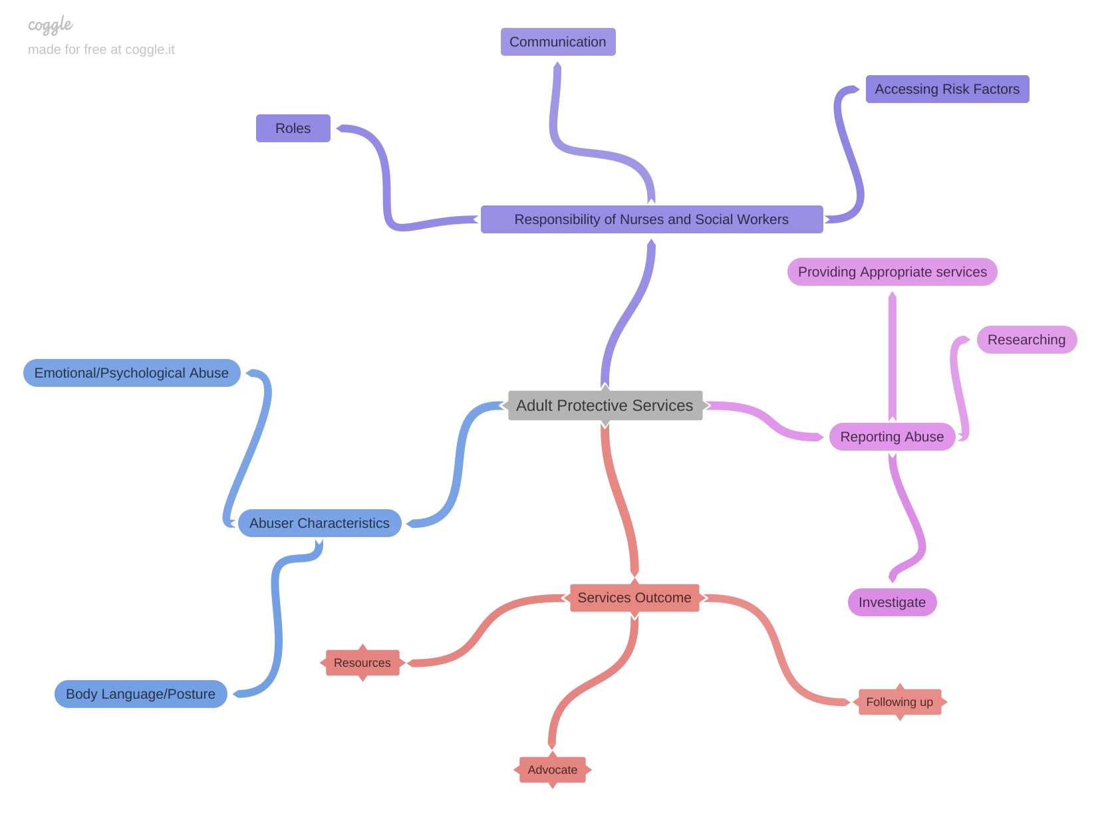
References
Conrad, K., & Conrad, K. (2019). Abuser Risk Measure: Reports by Alleged Victims to Adult
Protective Services. The Gerontologist, 59(5), E403-E414.
Liu, P., & Chilatra, J. (2020). Nurses Working in and With Adult Protective Services: Agency
Characteristics and Job Responsibilities. Innovation in Aging, 4(Suppl 1), 695-696.
Liu, P., Conrad, K., Beach, S., Iris, M., & Schiamberg, L. (2019). The Importance of
Investigating Abuser Characteristics in Elder Emotional/Psychological Abuse: Results
from Adult Protective Services Data. The Journals of Gerontology. Series B,
Psychological Sciences and Social Sciences, 74(5), 897-907.
Liu, P., Hass, Z., Stratton, S., Conrad, K., & Conrad, K. (2022). Examining Adult Protective
Services Outcomes: Services Associated with the Decrease of Mistreatment Differed by
Elder Mistreatment Type. The Gerontologist, The Gerontologist, 2022.

