**CYSE 270: Linux System for Cybersecurity Assignment: Lab 5 – Password cracking**

Due: Sunday, October 10, 2021

# CYSE 270: Linux System for Cybersecurity

The goal of this lab is to test strength of different passwords.

**Task A – Password Cracking**

1. Create 6 users in your Linux system, then assign each user a password that meets the following complexity requirement respectively. You should list the passwords created for each user.
   1. A simple dictionary word (all lowercase) bob cat
   2. 4-character digits tom 1234
   3. A simple dictionary word (all lowercase) + digits guy dog1256
   4. A simple dictionary word (all lowercase) + digits +symbols tiger hack048@
   5. A simple dictionary word (all lowercase) + digits sam myuncle789
   6. A simple dictionary word (w. a mix of lower and upper case) + digits +symbols dave WafflE@*654

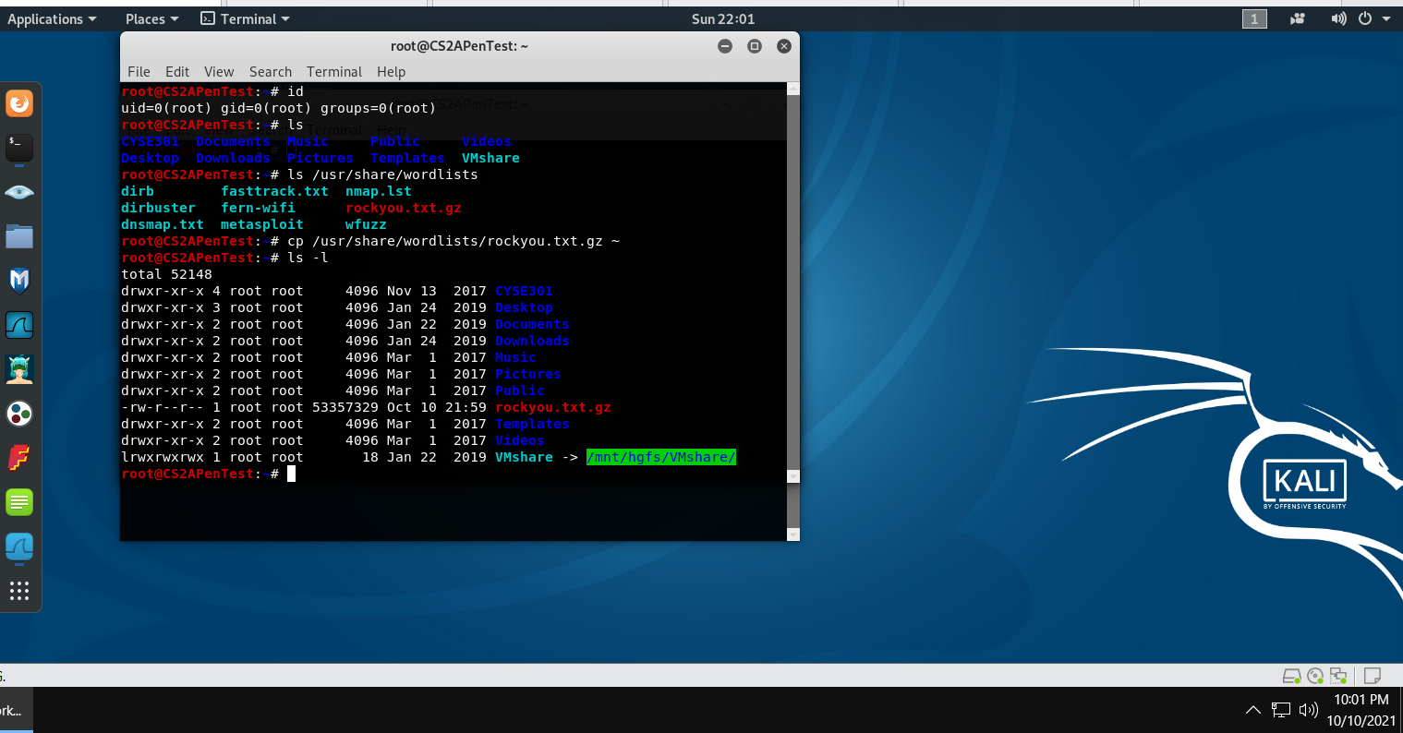



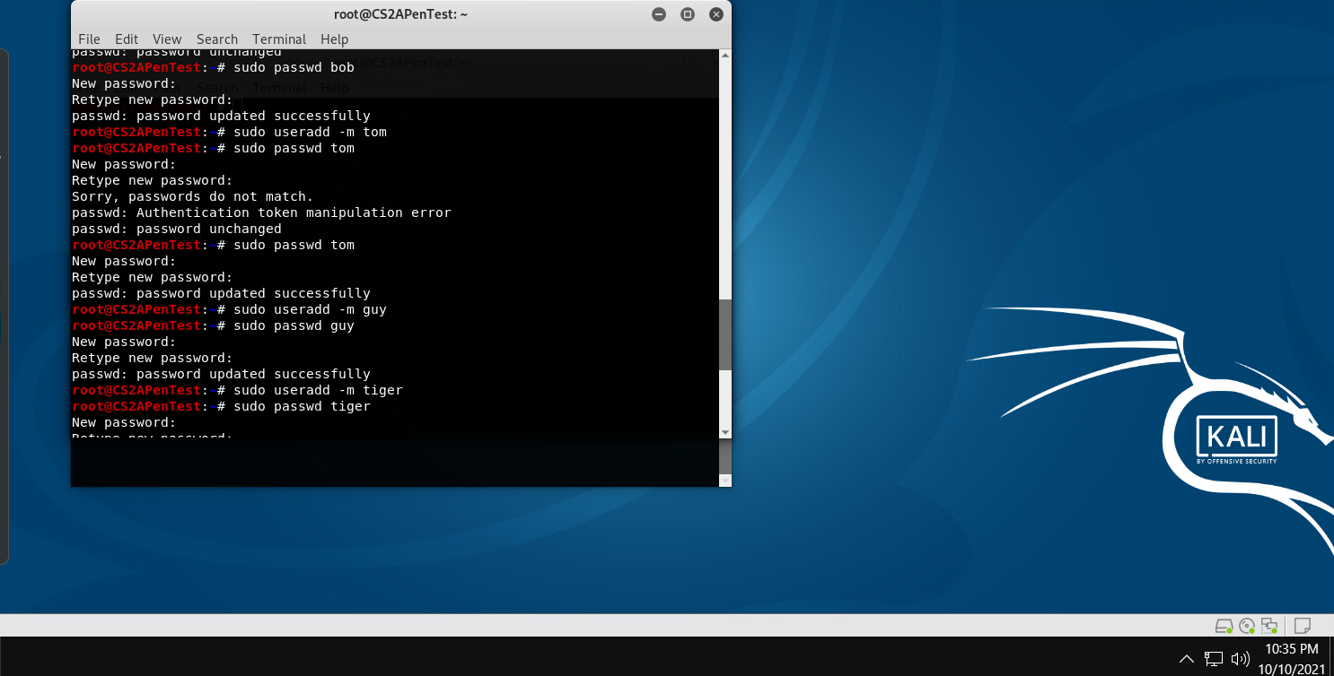

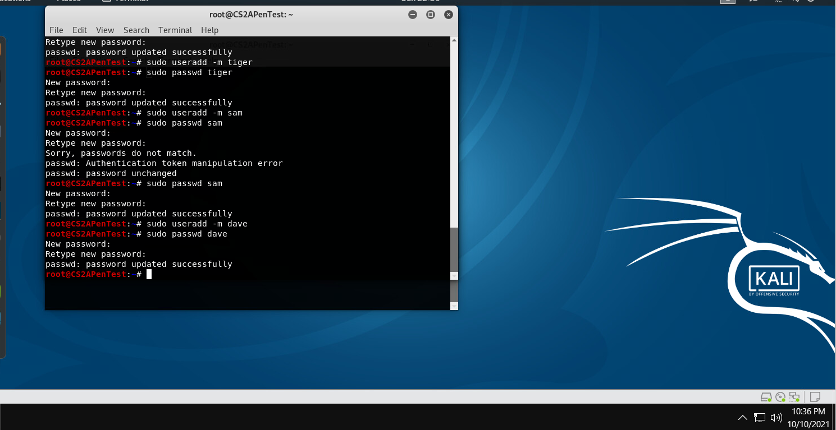 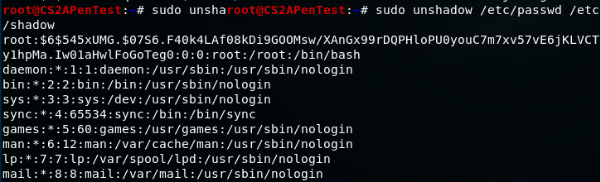Remember, do not use the passwords for your real-world accounts.

1. Export above users’ hash into a file named xxx.hash (replace xxx with your MIDAS ID) and use John the Ripper to crack their passwords in wordlist mode (use rockyou.txt).

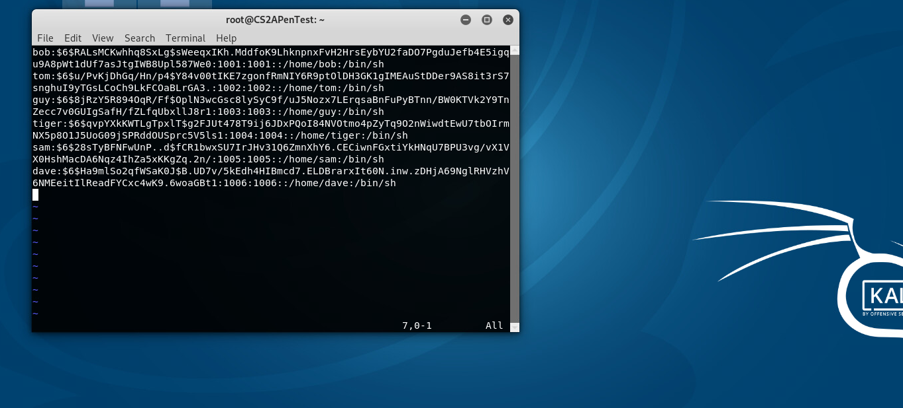

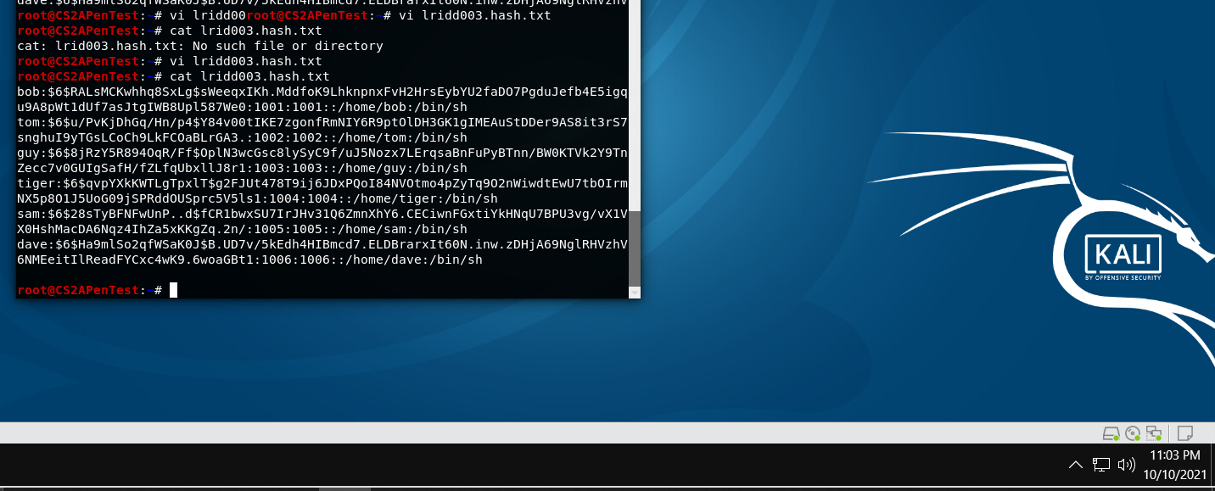

1. Keep your john the ripper cracking for at least 10 minutes. How many passwords has been successfully cracked?

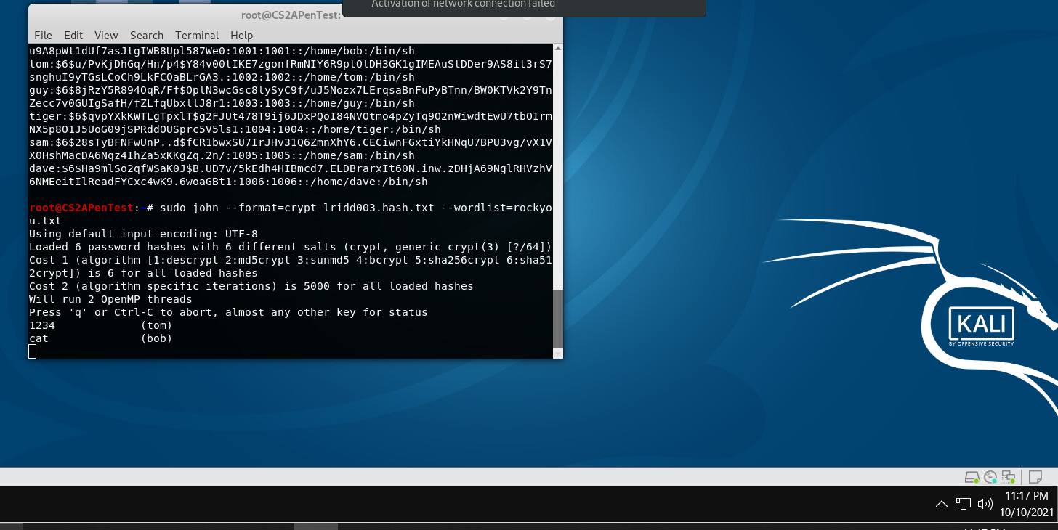

**Extra credit (10 points):**

1. Find and use the proper format in John the ripper to crack the following MD5 hash. Show your steps and results.

* 5f4dcc3b5aa765d61d8327deb882cf99
* 63a9f0ea7bb98050796b649e85481845