MET 440 Heat Exchanger Design Project

Charboneau – Martin
12/12/2019

Abstract:

We have been hired to engineer a heat exchanger to meet the demands laid forth by the custom. The customer requirements are to cool 320,000 lb/hr of liquid Ammonia from 122ᵒF to 86ᵒF. To accomplish this cooling the heat exchanger will using liquid water at an initial temperature of 50ᵒF. The owner has also listed some limits for the heat exchanger which we have to design around.
For our final design, we have a single-pass-in-shell, two-pass-in-tube, BEN Type Heat exchanger encompassing 574 tubes, 12 baffles, and meets all heat transfer and dimensional requirements.

Table of Contents
Abstract: 2
List of Figures and Tables: 6
Report Body: 7
Job Site location: 7
Specifications and Design Philosophy: 7
Sources: 7
Materials and Specifications: 12
Establish the HX materials to use: 12
Fluid Characteristics: 12
Preliminary Drawings and Sketches: 13
Plot Plan: 13
Elevation: 13
Methodology: 14
Design Calculations: 18
Final Drawings: 19
Plot Plant: 19
Elevations View: 19
Isometrics: 19
Heat Exchanger Data Sheet: 20
Discussion: 21
Final Remarks: 22
Appendix: 23

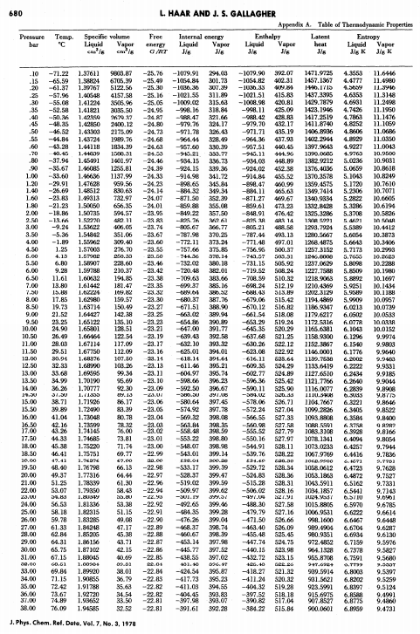
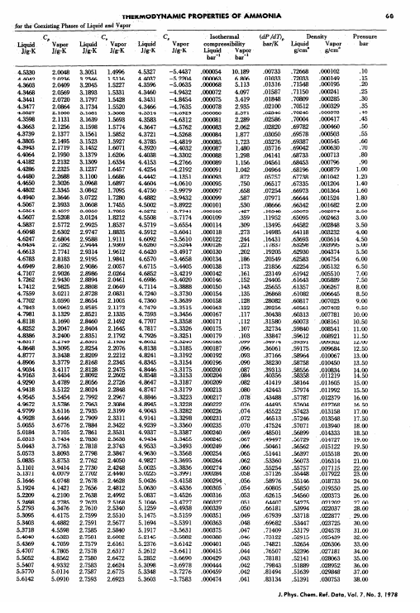

List of Figures and Tables:
Figure 1. Table 8.1 Dimensional Data for Commercial Tubing. 8
Figure 2. Table 8.1 (Continued). 8
Figure 3. Table 8.3 Tube-Shell Layouts. 9
Figure 4. Table 8.3 (Continued_1). 10
Figure 5. Table 8.3 (Continued_2). 11
Figure 6. Table 8.3 (Continued_3). 11
Figure 7.One Pass Shell Preliminary Elevation Drawing. 14
Figure 8. Final Elevations View. 20
Figure 9. Final Isometrics View. 20
Figure 10. Heat Exchanger Data Sheet. 21
Figure 11. Heat Exchanger Effectiveness Graph. 22

Table 1. Fluid Characteristics. 12

Report Body:

Job Site location:
Local shipyard.

Specifications and Design Philosophy:
This heat exchanger is based on criteria prescribed by the test prompt. It is designed to efficiently use water to cool down liquid ammonia from its heated state of 122°F to 86°F. The tube material is of aluminum, the layout angle is 90°, and the pitch is square.

Sources:
Bayazitoglu,Y., Ozisik, N., “A Textbook for Heat Transfer Fundamentals”, Begell House Inc (2012)
Kakaç, S., Liu, H., “Heat Exchangers Selection, Rating, and Thermal Design”, CRC Press
Haar, L., Gallagher, J. S., “Thermodynamic Properties of Ammonia”, National Measurement Laboratory

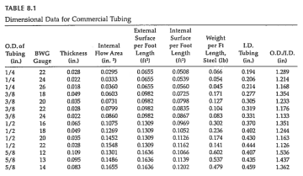
Figure 1. Table 8.1 Dimensional Data for Commercial Tubing.
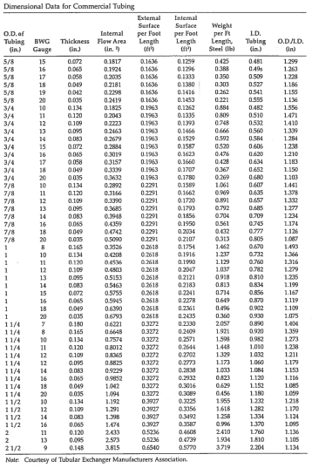
Figure 2. Table 8.1 (Continued).

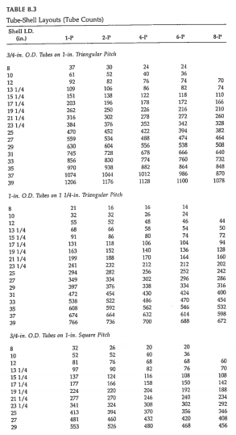
Figure 3. Table 8.3 Tube-Shell Layouts.

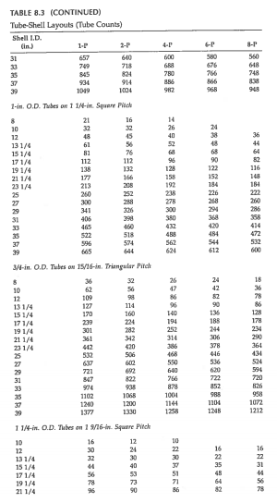
Figure 4. Table 8.3 (Continued_1).

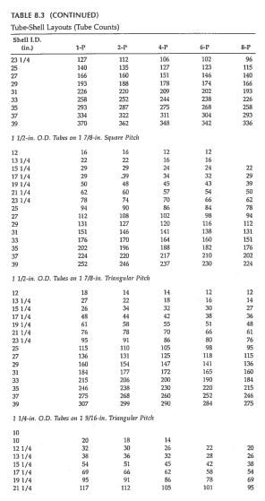
Figure 5. Table 8.3 (Continued_2).

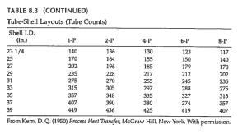
Figure 6. Table 8.3 (Continued_3).

Materials and Specifications:

Establish the HX materials to use:
The tubes are made out of aluminum tubing to ensure that the ammonia and water do not mix. Using aluminum tubes instead of copper will also ensure that the tubes will last longer.

Fluid Characteristics:
Property | Unit | WATER | AMMONIA
Temperature (In) | °C | 10 | 50
Temperature (Out) | °C | 26.67 | 30
Bulk Temperature | °C | 18.33 | 40
Density, ρ | Kg/m^3 | 580.99 | 999
Specific Heat, Cp | J/kg/K | 4184.8 | 4999
Thermal Conductivity | W/m/K | 0.493 | 0.593
Mass Flow Rate, ṁ | kg/s | 57.8 | 40.32
Dynamic Viscosity | Pa*s | 3.40E-7 | 1.07E-3
Film Dynamic Viscosity | Pa*s | ----- | 1.012E-3
Table 1. Fluid Characteristics.

Preliminary Drawings and Sketches:

Plot Plan:
Nothing is known of the location other than that it is a shipyard. The layout schematics were not given, so we did not create a plot plan.

Elevation:
Below is a preliminary drawing of the heat exchanger.
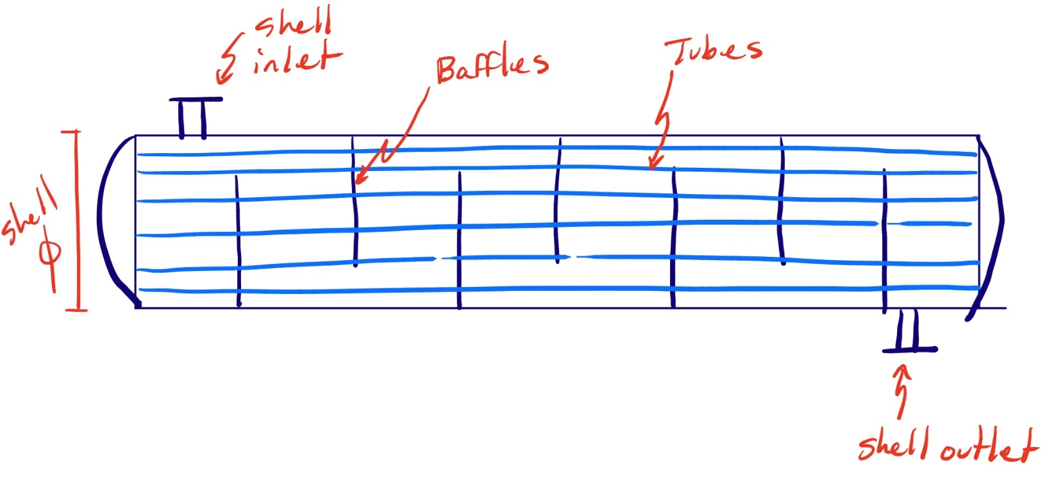
Figure 7.One Pass Shell Preliminary Elevation Drawing.

Methodology:
Start with the following equation:
$$Q=ṁC_{p}∆T$$
The Q value solved for in the above equation is then put into the following equation:
$$Q=U_{o}A_{o}MLDT*F$$
Where:
$$U_{o}=assumed value from Table 8.5 of Heat Exchanger Tables$$
$$(Ammonia to water is 1000 to 2500)$$
$$A_{o}=Outer surface area of the tubes that we need to solve for$$
$$MLDT=\frac{∆T_{1}-∆T_{2}}{\ln\left(\frac{∆T_{1}}{∆T_{2}}\right)}=computed based on counter flow HX$$
$$F=Correction factor$$
The correction factor above was located in Supplemental Materials Bergman HEAT TRANSFER: Figure 11S.3
Once $A_{o}$ is solved for, use it to solve for the number of tubes required in the heat exchanger by using the following equation:
$$A_{o}=πD_{o}L*N_{t}$$
Where:
$$L=Selected length of the tubes$$
$$D_{o}=Selected outer diameter of the tubes from Table 8.1$$
$$N_{t}=Calculated number of tubes$$

From the number of tubes calculated (which is not a permanent number), we were directed to Table 8.3 where we selected a shell diameter and number of passes. The option we selected was 1-in. O.D. Tubes on 1 ¼-in. Square Pitch. We selected this size because it is the most common tube diameter in the industry. We then selected 23.25 inches for our shell I.D. and 208 as our number of tubes for a single pass of tubes in shell (these values were subject to change with the iterations to come). We initially designed the heat exchanger with a shell ID as close to 24 inches as possible because that is the maximum size in the industry before fabrication is required.
The baffle spacing was the next step in the design process. Using the equation below, we found a range for the distance between each baffle and from that range of numbers we selected a suitable value.
$$0.4D_{s}<B<0.6D_{s}$$
Where:
$$D_{s}=Diameter of the shell selected in the above process (23.25 in=0.5906m)$$
The required number of baffles was also calculated from the range calculated above. We divided the overall length of the tubes by the selected baffle spacing of 0.343m and rounded up to the nearest whole number of baffles, which was 16 baffles (this was subject to change).

With the new number of tubes from Table 8.3, we recalculated $A_{o}$ and $A_{i}$ using the previous equations used:
$$A_{o}=πD_{o}L*N_{t}$$
$$A_{i}=πD_{i}L*N_{t}$$
Where:
$$A_{i}= Inner surface area of the tubes that we need to solve for$$
$$D_{i}=Inner tube diameter$$

The next step was to start calculating resistances, beginning with $h_{i}$. To do this, we needed the velocity of the ammonia inside of the tubes by using the following equations:

$$ṁ_{ammonia}=ρ_{ammonia}*V_{ammonia}*A_{internal flow}$$
$$A_{internal flow}=\frac{π}{4}D_{i}^{2}*\left(\frac{N_{tubes}}{N_{passes}}\right)$$
Where:
$d_{i}=0.0221m$, $A_{internal flow}=0.055m^{2}$, $ρ_{ammonia}=580.99\frac{kg}{m^{3}}$
With the above values, we computed the ammonia velocity inside the tubes to be $1.25 m^{2}$. With this value, we are now able to calculate Reynold, Prandtl, and Nusselt numbers using the following equations:
$$Reynold^{'}s=\frac{{Velocity}_{ammonia}*D_{i}}{Viscosity_{ammonia}}=81666$$
$$Nusselt^{'}s=0.023Re^{0.8}{Pr}^{0.3}=240.8$$
Where:
$$Pr=2.00=Value obtained in the back of the textbook$$
Now that we have the above values, we can pair Nusselt’s with the thermal conductivity (k) of ammonia to compute the heat transfer coefficient inside the tubes ($h_{i}$), using the following:
$$h_{i}=\frac{Nu*k_{ammonia}}{D_{i}}=5372.4\frac{W}{m^{2}*K}$$
With the discovery of $h_{i}$, the last piece we needed to solve for the resistances was $h_{o}$ (the heat transfer coefficient outside the tubes).

To find $h_{o}$, we needed the following equation from the heat exchanger tables (equation 8.11):
$$\frac{h_{o}D_{e}}{k}=0.36{\left(\frac{D_{e}G_{s}}{μ}\right)}^{0.55}{\left(\frac{C_{p}μ}{k}\right)}^{\frac{1}{3}}{\left(\frac{μ_{b}}{μ_{w}}\right)}^{0.14}$$
Where:
$$D_{e}=\frac{4\left(P_{T}^{2}-\frac{πD_{o}^{2}}{4}\right)}{πD_{o}}=0.036m$$
$$G_{s}=\frac{ṁ}{A_{s}}=1228.95\frac{kg}{m^{2}*s}$$
$$A_{s}=\frac{D_{s}CB}{P_{T}}=0.047m^{2}$$
$$C=Clearance between tubes in the heat exchanger=Pitch size-Tube O.D.$$
$$D_{s}=Shell diameter$$
$$B=Baffle spacing$$
$$P_{T}=Pitch size$$
$$ṁ=Mass flow rate$$
$$C_{p}=Specific heat of water$$
$$μ=Dynamic viscosity of water$$
$$k=Thermal conductivity of water$$
$$μ_{b}=Bulk temperature viscosity$$
$$μ_{w}=film temperature viscosity$$

Using the above equations and values, our initial value for $h_o$is:
$$h_{o}=4025\frac{W}{m^{2}*K}$$

After finding $h_{o}$, we needed to find the wall resistance $R_{w}$.
$$R_{w}=\frac{\ln\left(\frac{D_{o}}{D_{i}}\right)}{2πkL}*\left(\frac{1}{N_{tubes}}\right)=6.876*{10}^{-8} K/W$$
With our given fouling factors for water and ammonia () coupled with our computed values for $h_{o}$, $h_{i}$, $A_{o}$, $A_{i}$, and $R_{w}$, we can finally calculate a new value for $U_{o}$, which we will then use to compute a new value of Q, and compare that new Q value to the original Q calculated from the ammonia to the water at the beginning and reiterate the entire process above. We will do this till the Q percentage difference is less than 10%.

To compute ${U_{o}}_{new}$, use the following:
$$\frac{1}{U_{o_{new}}}=\frac{A_{o}}{A_{i}}\left(\frac{1}{h_{i}}+R_{f_{i}}\right)+A_{o}R_{w}+R_{f_{o}}+\frac{1}{h_{o}}$$
Where:
$$A_{o}=Tube outer surface area$$
$$A_{i}=Tube inner surface area$$
$$h_{i}=heat coefficient inside the tubes$$
$$R_{f_{i}}=Fouling factor inside tubes (ammonia)$$
$$R_{w}=Wall resistance$$
$$R_{f_{o}}=Fouling factor outside tubes (water)$$
$$h_{o}=heat coefficient outside the tubes$$

With this newly calculated value, $U_{o_{new}}=974.9\frac{W}{m^{2}*K}$, we were able to compute a new Q value using the equation stated at the beginning of this section:
$$Q_{new}=U_{o_{new}}A_{o}MLDT*F=2245826 W$$
With this new Q, we did a percent difference calculation between this Q and the Q that needs to be transferred from the ammonia to the water.
$$\% Diff=\frac{Q-Q_{new}}{Q}*100\%=44.3\%$$
With this percent difference, we knew that we needed to reiterate the process in order to get the percent difference as close to zero as we can.

Per requirements we had to calculate the pressure drop on the shell side and on the tube side. The equations used to determine these pressure drops are the following, respectively:
$$∆p_{s}=\frac{fG_{s}^{2}\left(N_{b}+1\right)∙D_{s}}{2ρD_{e}φ_{s}}$$
$$∆p_{t}=4f\frac{LN_{p}}{D_{i}}ρ\frac{U_{m}^{2}}{2}$$
Where:
$$f=\exp\left(0.576-0.19ln*Re_{s}\right)$$
$$400<Re_{s}=\frac{G_{s}D_{e}}{μ}≤1*{10}^{6}$$
$$φ_{s}={\left(\frac{μ_{b}}{μ_{w}}\right)}^{0.14}$$
$$N_{b}=Number of baffles$$
$$L=Length of the heat exchanger$$
$$N_{p}=Number of tube passes$$

Design Calculations:
See the attached MS Excel Spreadsheet for the calculations done for this project.

Final Drawings:

Plot Plant:
Nothing is known of the location other than that it is a shipyard. The layout schematics were not given, so we did not create a plot plan.

Elevations View:
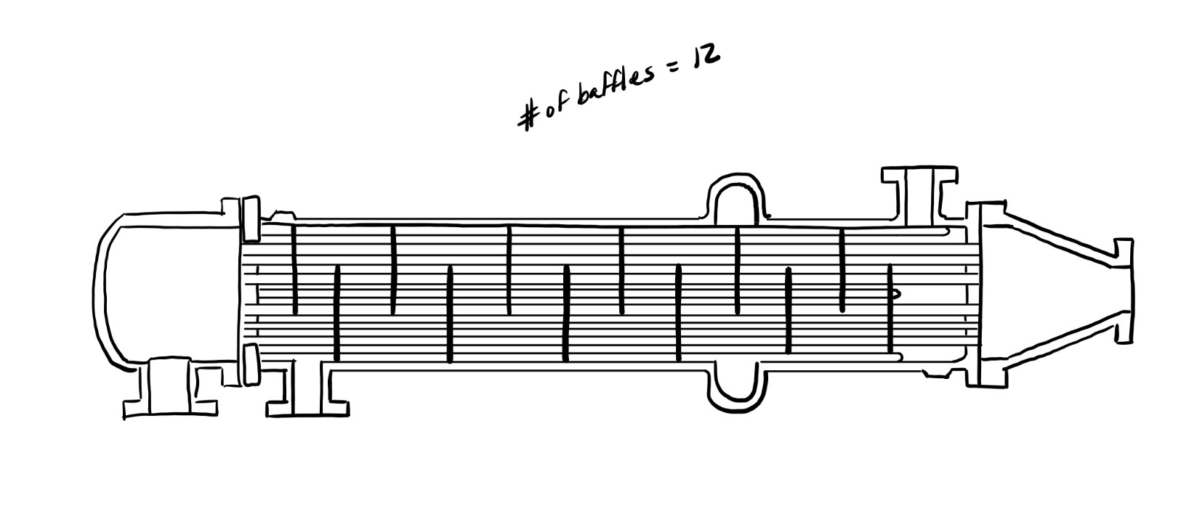
Figure 8. Final Elevations View.

Isometrics:
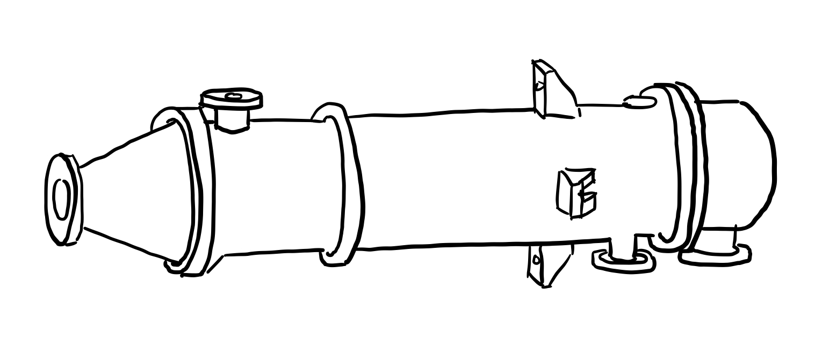
Figure 9. Final Isometrics View.

Heat Exchanger Data Sheet:
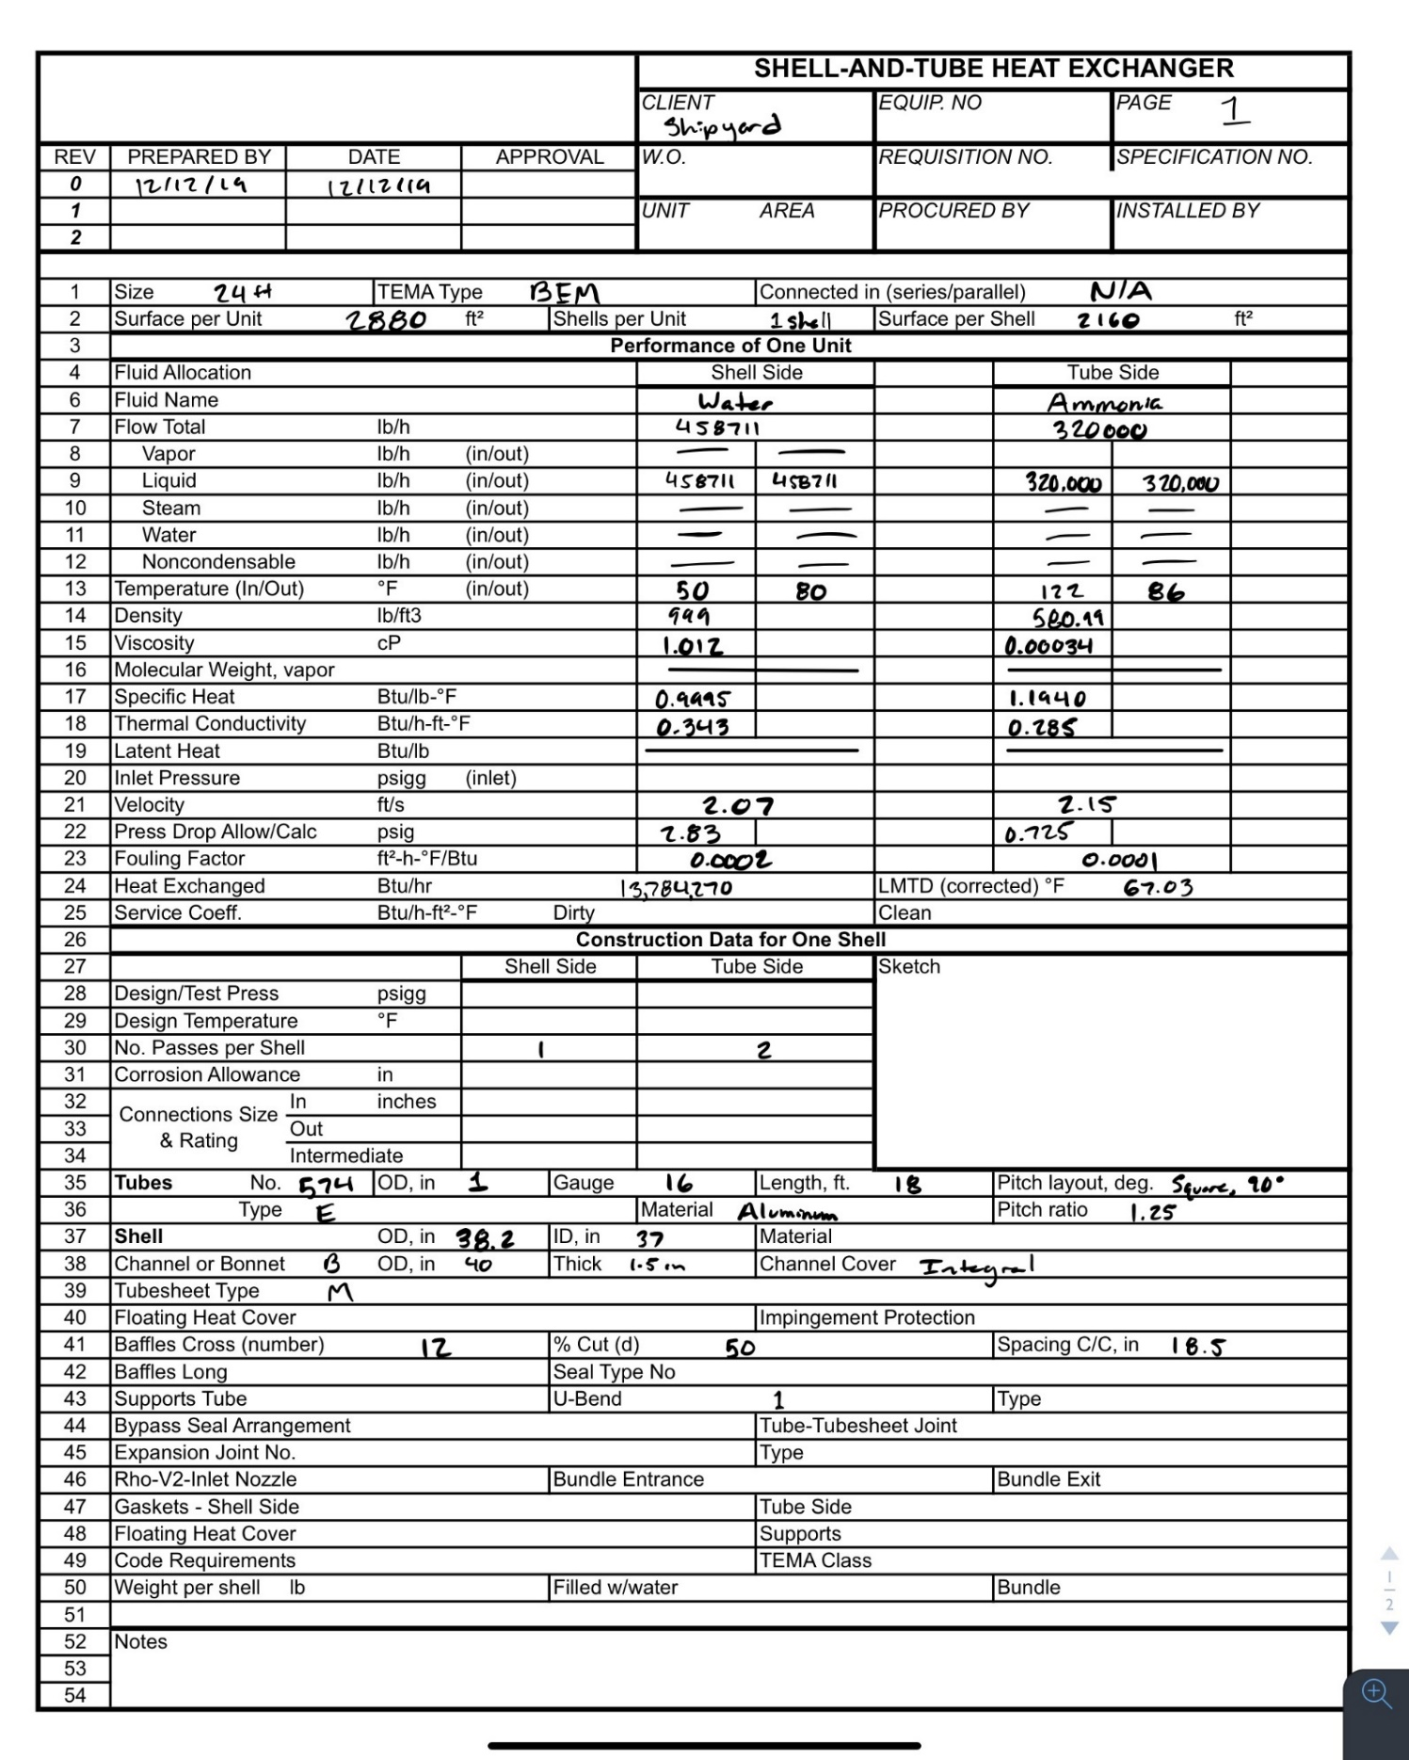
Figure 10. Heat Exchanger Data Sheet.

Discussion:
We went through four different iterations of this heat exchanger. Our resulting percentage difference was well below the minimum threshold of 10%. Our pressure drop from the shell inlet to the shell outlet was 2.83 psi. The pressure drop from the tube inlet to the tube outlet was 0.725 psi.
Our effectiveness was computed once we were completely finished with the iterative process and we were satisfied with our results. We used the below chart to calculate our effectiveness:
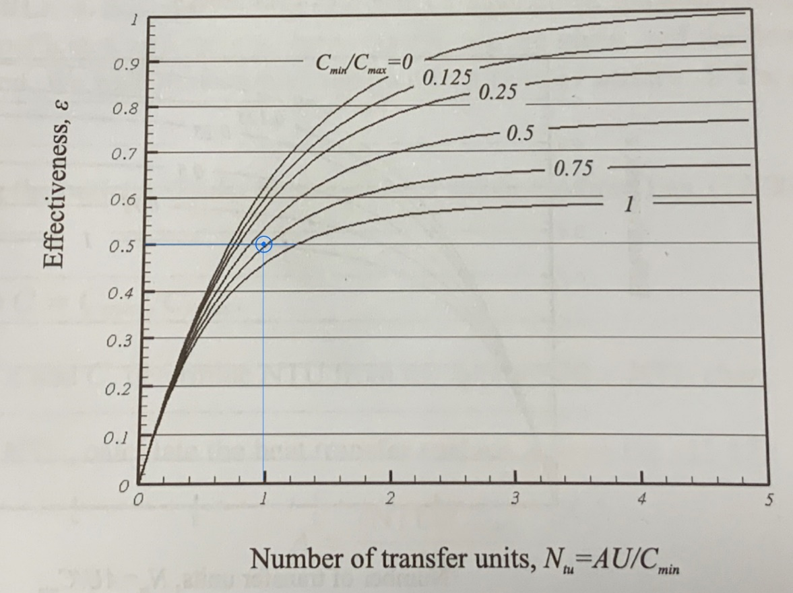
Figure 11. Heat Exchanger Effectiveness Graph.

Final Remarks:
The results told us that the effectiveness was average, which means we did it right. The overall heat transfer coefficient value went down, which caused the Q (heat transfer value) to increase and then level off with the target Q value.

Appendix:
- Do you think what you learn is important for your professional career?
  - Noah: Absolutely. It does not even have to be heat transfer material for it to be important for my professional career. Everything from sitting and listening in class, to networking with the professor and classmates is important for my professional career.
- Where do you think you will be using everything you learned?
  - Graham: In terms of heat transfer, I do not think that I will use all of the principles that I’ve learned in my life as soon as I leave college. I will certainly use the methods of critical thinking and perseverance that I learned in this class every day in my professional life.
- How would you explain the project and your contribution to the project in a job interview?
  - Noah: I would explain the project as a culmination of the principles learned in this course. I contributed by taking good notes and by pulling the report together in a clear and cohesive format.
- How would you explain how your strengths helped you contribute to the project in a job interview?
  - Graham: I don’t have many strengths when it comes to this subject material. I know how to ask questions and am competent enough to understand this material, but it the understanding comes to me after lots of work and perseverance. It does not come to me naturally; I have to work very hard on it in order to make any headway.
- How would you explain in a job interview how your weaknesses affected your ability to work on this project and how did you address them (or what part of the class helped you address them)?
  - Noah:
- Explain the technical strengths and weaknesses in your project.
  - Graham: My technical strength was the report and overall formatting. I did contribute to the calculations, but I made a few mathematical mistakes when I was directly involved with the equations.
- If you were starting the class over again, what advice would you give yourself to ensure that you had a successful semester and a successful final project?
  - Noah: Take very detailed notes, go to every single class, and don’t be afraid to ask questions of the professor or the other students. Make friends in the class and work on the homework assignments together, as this will help you complete them on time and helps build good working relations for the future.

