Adriana Mercedes

Scientific Lit. Essay

Bio 293

9/17/2022

Scientific Literacy Essay pt. 1

Mitosis is one of the multiple steps in the cell cycle; the step allows the copied DNA to separate forming two new cells; humans as well as most organisms are multicellular but life begins with one cell that is formed from two gametes.

The zygote has all the necessary DNA to give rise to a fully functioning organism but there is still not a large number of cells.

Mitosis allows our cells to double up and, after some time, there are finally enough cells to carry out different tasks within the body.

Mitosis is needed for development; it is also necessary to replace damaged tissues.

Mitosis is the process of cell duplication and chromosome duplication. While this four-step process occurs; one cell is duplicated into two new cells called daughter cells that are genetically identical.

This process has 4 stages- Interphase which also consists of the G1, S, and G2 phases; prophase, metaphase, anaphase, and telophase. This entire process takes 24 hours. During interphase, microtubules extend from these centrosomes. The DNA in the cell is duplicated for the preparation of the cell cycle, this results in two full sets of chromosomes. During prophase, each chromosome is made of the two sister chromatids, that have identical genetic information. During this phase, the mitotic spindles that consist of the microtubules and other proteins extend across the cell; between the centrioles as they move to opposite sides of the cell.

During metaphase, the mitotic spindle fibers connect to each of the sister chromatids. During anaphase, the sister chromatids are pulled apart by the mitotic spindle causing them to pull the chromatids to opposite sides of the cell. Finally; during telophase, a membrane is formed around the sets of chromosomes to make two new nuclei. The cell cleaves in the middle to form two new cells that are completely identical; this process is known as cytokinesis *(Raven, Johnson and Mason ., et al).*

There are multiple steps a cell must go through in order to become its own independent cell. Before a cell is ready for mitosis it must go through Interphase; during which the cell grows and creates its necessary proteins. During interphase in the S -phase is where the cell copies its chromosomes and where DNA replication occurs.

DNA replication is regulated so that it is only replicated once before cell division begins. DNA replication takes about 60 minutes or less depending on the speed of DNA replication, the amount of DNA within the cell, and the number of replication origins on each DNA molecule *(Eric.,2019).*

Cell division is the copying of a parent cell into two daughter cells which results in 2 genomic copies or 2 diploids of that replicated DNA. To make sure there are no errors in the newly copied DNA. One of these checkpoints in the cell cycle is the DNA replication fork *(Bobby and Russell,2001)* or the G1/S and G2/M checkpoints *(Willis and Rhind,2009)* occur to ensure that the DNA had been replicated correctly before it goes into mitosis. These checkpoints have several processes to control how DNA is replicated and delay the onset of mitosis while DNA synthesis is occurring.

We looked at 4 figures regarding cell division in Zebrafish all of them including different information on what was occurring during cell dividion in these fish.

The first figure shows us that H2B was used to highlight genes to see which ones were expressed. They did this to understand what kind of cell division their skin cells were going through. Using a computer the scientist were able to have clear images of each individual cell and what color it was; a few of the cells came back unregistered resulting in some black spots showing up .

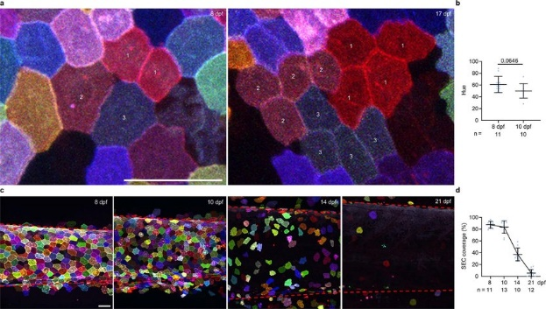

In the next figure they showed us a few different aspects of the fish; size(length, width, height) and they also looked at how many surface epithelial cell were present for 2 days; within these two days the scientist realized that the fish were rapidly growing as well. In chart F we see that the cells go from 1>2>3>4 cells.

But what was strange was a grouping of three cells when normal mitosis multiplies by two. To determine how many cells were being produced; the scientist looked at image E-D.P.f and were able to see how many cells were grouped which is when they noticed the strange cell groupings. Diagrama

In figure three we looked at what else could have be causing all this to happen. We see that their DAPI is normal. When live palmskin +H2B-BEFP was measured, all the cell signals looked normal as well and with each division the die that was used would come back lighter each time hinting that with each division, the cell would lose dye in the nucleus. 

The scientist also discovered that there were anaphase bridges, lagging chromosomes, micronuclei and tripolar separation; these are not normal process for mitosis.

An anaphase bridge is a DNA strand that is stretching between 2 DNA masses as the cells attempt to separate them *(Visintin and Finardi, 2020).* Lagging chromosomes or anaphase lag is where sister chromatids do not correctly separate from each other due to tangles spindle fibers(SITE)

Micronuclei are extra nuclear bodies that have damaged chromosome fragments or entire chromosomes that were not put into the nucleus after division *(Luzhna,Lidiya et al, 2013)*

Tripolar segregation is when specific cells divide into 3 cells instead of the normal 2. In the video it seems as if the cell goes from one cell directly into two other cells; since there is not DNA copying, they seem to be going through mitosis individually every time. Imagen que contiene Interfaz de usuario gráfica

In the final figure the scientist put the fish arranged in high- and low-density population groups. The fish in lower density grew faster than those in high density populations which we can see in chart F and E. This mean that since the fish are rapidly growing they also need to grow new skin cells at the same rate.

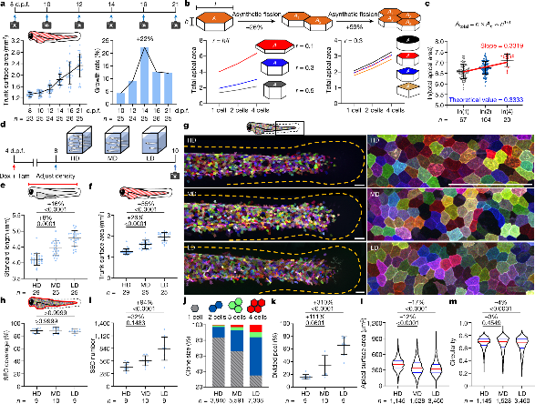

These zebrafish cells divide without replicating their DNA, while normal mitosis requires that. Normally before a cell divides it needs to make couples of all its DNA so the new cells can get a full replica.

The zebrafish cells split their DNA so the new cells do not have a full set which is not normal. Not only did the cells not need a full set of DNA; they were also going through this process with many mistakes occurring. This type of cell division is also different from meiosis because there are no sex cells being produced and because the skin cells of the zebrafish are only dividing into three cells instead of 4 sex cells.

Normal cell division Synthetic division.

Works Cited

Bank, Eric. “How Much Time Does It Take for a DNA Molecule to Replicate?” *Sciencing*, Sciencing, 30 July 2019, https://sciencing.com/much-time-dna-molecule-replicate-21660.html.

Boddy, Michael, and Paul Russell. “DNA Replication Checkpoint - Current Biology.” *Current Biology*, Current Biology, 27 Nov. 2001, https://www.cell.com/current-biology/fulltext/S0960-9822(01)00572-3.

Bozeman. “Cell Division & DNA Replication.” *University of New Hampshire*, University of New Hampshire, 27 June 2019, https://www.unh.edu/cfar/cell-division-dna-replication.

Liao, Eric C., and Leonard I. Zon. “Chapter 10 Simple Sequence-Length Polymorphism Analysis.” *Methods in Cell Biology*, Academic Press, 10 Apr. 2008, https://www.sciencedirect.com/science/article/abs/pii/S0091679X08619007.

Loata, Gloria. “Mitosis.” *Encyclopædia Britannica*, Encyclopædia Britannica, Inc., <https://www.britannica.com/science/mitosis>.

OpenStax College, Biology. (2016, May 27). The cell cycle. In *OpenStax CNX*. Retrieved from <http://cnx.org/contents/GFy_h8cu@10.53:1tJ55Ot6@7/The-Cell-Cycle>.

Raven, P. H., Johnson, G. B., Mason, K. A., Losos, J. B., and Singer, S. R. (2014). How cells divide. In *Biology* (10th ed., AP ed., pp. 187-206). New York, NY: McGraw-Hill.

Willis, Nicholas, and Nicholas Rhind. “Regulation of DNA Replication by the S-Phase DNA Damage Checkpoint - Cell Division.” *BioMed Central*, BioMed Central, 3 July 2009, https://celldiv.biomedcentral.com/articles/10.1186/1747-1028-4-13.