Analyzing the Biology Behind Body Dysmorphic Disorder

Old Dominion University, Department of Biology

BIOL 405W: Biology Seminar

Mackenzie Kastner

29 April 2022

Sponsor: Dr. Osgood

**Abstract**

Body Dysmorphic Disorder, more commonly known as Body Dysmorphia is a disorder that affects the brain's way of seeing one's physical being. With this being the central issue of the disorder it commonly (or typically) leads to various symptoms like compulsive behaviors, eating disorders, depression, and anxiety. Body Dysmorphia, which can sometimes be referred to as its acronym BDD, is a debilitating mental disorder in which many patients do not see themselves the way they truly look. The illness itself has a major lack of research behind it, up until a few years ago it had only been touched on concerning different mental disorders like Obsessive Compulsive Disorder or Bipolar Disorder. Recently, the research has been taken from just a glance to looking in-depth at BDD itself and the different effects it has on different groups of people. The research on the difference between body dysmorphia in men and women is prevalent, the discussion of how BDD correlates with other disorders, and how medication use could aid in the future of the illness. As a way to wrap the conclusion made in the paper, another topic to look into was the future treatment and diagnosis of body dysmorphia. To further the research on this illness, those thoughts need to be reworded into why exactly this illness occurs and what treatments/exercises can be done to aid in the quality of life for those diagnosed with Body Dysmorphic Disorder.

**Introduction*:***

Body Dysmorphic Disorder is an often-overlooked mental disorder. It falls under the various disorders that encapsulate the aspect of overeating or constriction when eating. It is also a major disorder that coincides as a symptom of premenstrual syndrome. In many cases, those who have this disorder are often seen as just not being aware of what they look like. When in reality it is much more detrimental than just simply not seeing yourself the way others do. The science behind this disorder shows the extent of this condition and helps see just how important awareness is. Another pivotal turning point in this disorder is the lack of research regularly done on it. Up to only 2% of the population is affected by this illness and it usually begins to manifest in children or young adulthood. Even with all of those points in mind, body dysmorphia is still seen as insignificant in the clinical environment (Feusner et al. 2010) For my paper, I would like to show the biology behind the disorder but also create a general understanding of BDD as a whole. This comes with understanding the symptoms, the disorders connecting with BDD, and the research behind it. I hope the class becomes more considerate of those who suffer from this disorder and considers themselves more informed; the same goes for me as I am writing this research paper.

**Classification of BDD**

Body dysmorphic disorder is classified as a DSM*-*IVdisorder. DSM*-*IVis a method of classifying certain disorders into various groups through the Diagnostic and Statistical Manual of Mental Disorders. Per this manual BDD is defined as *“Preoccupation with an imagined defect in appearance. If a slight physical anomaly is present, the person's concern is markedly excessive.” (*Bjorssen 2010)*.* The “preoccupations” termed in this definition commonly include skin mars, hair, and nose shape/size. These numerous preoccupations then can cause affliction in a patient's everyday life - whether that be socially, professionally, or academically. Finally, the focus of the preoccupation is taken into consideration when classifying BDD. If a patient is solely focused on an appearance like their weight, then the patient would be placed into another category with diagnoses like anorexia nervosa or bulimia nervosa.

**Comorbidity: BDD**

A diagnosis of Body dysmorphic disorder alone was not always common. We see now more patients who are only categorized under the classification of BDD, but without the proper research, BDD was always conjoined with other disorders. In the majority of cases, there is a collection of well-known mental illnesses that coincide with BDD. There are a few images and figures that give an overview of those disorders in the pages following. The most common two include Major Depressive Disorder and Generalized Anxiety Disorder. These are the ones that come along with the symptoms and are not necessarily labeled as a disorder linked with Body dysmorphia. Instead, they are just simply listed as symptoms of anxiety and depression.

Below, a figure is linked to look into a widely researched link between Obsessive-Compulsive Disorder and Body dysmorphia. Noticeably that there are more similarities between the two rather than differences but there is also a good amount of inconclusive evidence/findings. To summarize a few of these similarities, the age of onset for the disorders is a key likeness. The severity of the symptoms and the course of action when it comes to diagnosing the illnesses. The final similarity that is important to point out is the defeatist attitude in patients with BDD and OCD. there is a fear of being seen in a negative light, this adds to why patients with those disorders tend to overwork themselves. Another key finding is the linkage between the hereditary BDD and OCD; both are very similar genetically (Feusner et al. 2010).

Figure. 1 – A visual of similarities and differences between body dysmorphic disorder and obsessive-compulsive disorder (Malcolm 2018). 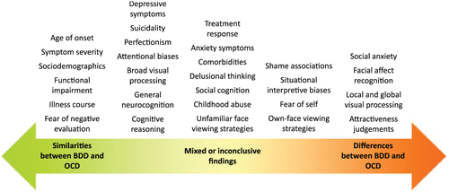

The figure depicted below is taken from a research article on the cognitive biases in body dysmorphia. Along with their research on the topic, Summers et all went into detail on how their case study elucidated the multiple disorders that were comorbid with BDD. As introduced at the beginning of this paper as well as in the figure before this, Major depressive disorder is a largely present disorder in discussing comorbidity. Another case study depicted in a research paper by Snorrason et. al glanced into how suicidal thoughts coincided with BDD and a few other common disorders. A sample of 498 patients admitted into a behavioral health program were interviewed to assess their psychiatric needs and past diagnosis with other disorders. Once the correct region of patients were selected, the researchers continued with their observations through group sessions and continuous interviews, until collecting the data they needed.

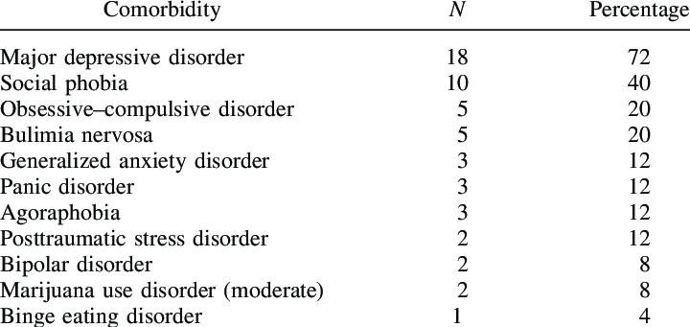

Figure 2 – Clinical trial representation of comorbidity in BDD (Summers 2020).

Accompanying major depressive disorder, substance use disorders are also significant (Bjornsson 2010).

**Treatment & Symptoms**

Symptoms of Body dysmorphic disorder occur in different severity for different patients. A case study performed by Andri S. Bjornsson et al. (2010) observed a female who was encouraged to go to a BDD specialist by her dermatologist. In this situation, the patient spent 7+ hours focusing on their skin-centered appearance. Because the case patient was so focused on their blemishes their productivity slipped and soon landed themselves in unfortunate situations due to their lack of focus. Another symptom in the case patient was consistent skin picking, which dermatologists first passed off as a habit (Bjornsson et al. 2010). Symptoms like these, in many cases, tend to come and go in waves. Patients indicate that some days they feel like their appearance is “fine” while other days they are hyper aware of everything they assume is wrong with them.

Treatment for Body dysmorphic disorder is widely researched. The main course of action to treat BDD in severe cases is either CBT (cognitive behavioral therapy) or SRI (Serotonin reuptake inhibitor) medications (Singh et al. 2019). SRIs are also more commonly known to treat mental disorders like depression and anxiety. The specific three SRI medications found to be most effective in treating BDD include fluvoxamine, citalopram, and escitalopram. In many of these medications, the dosage is higher when treating Body dysmorphic disorder compared to use when treating depression (Singh et al. 2019). Cognitive-behavioral therapy is the exercise of talk therapy in a sense. It helps patients learn to deflect their harmful thoughts into different patterns that will help them with their quality of life in the future (Cologne 2006). CBT aimed directly toward BDD focused on their thoughts and tried to re-focus them. It also aids in developing strategies of coping for patients, and a good comprehension of why they are thinking the thoughts they are.

Another lesser known, or less common, treatment for BDD is the use of cosmetic treatment. Treatment like this is when a patient seeks out reconstruction to the part of their body that they obsess over. This can manifest in smaller things like hair or facial marks; in other cases it is more severe. Plastic surgery has become an option for those who believe it would improve their quality of life. This is quite a sensitive topic in many cases due to the notion in society that those with insecurities should try and love themselves before going and changing their physical appearance. It has been proven that those who receive cosmetic treatment on the areas they obsess over tend to be happy in the first few moments but as the years go on it begins to negatively affect their mental wellness. This treatment is not common because of this fact as well as the lack of knowledge around BDD and its symptoms.

**Evidence and Research on BDD.**

In any environment, experimenting/researching a disease requires key points on the physiology of the illness in question. Body dysmorphic disorder is no different, especially with the lack of research on the disorder by itself. A small portion is known about the physiology and etiology of BDD but research has been conducted on how it correlates with genetics. There is key evidence in genetics because of patterns of inheritance. There is a severe lack of data to back this fact up but it again correlated with the heredity of Obsessive-Compulsive Disorder. It is known that up to 7% of patients with BDD have a history of a family member being diagnosed with OCD (Feusner et al. 2010). A good way to further elaborate on the genetic theory would be to look more into molecular genetic data and perform studies that correlate with that experimental method.

Another method used to study BDD is brain imaging. Again, there is a lack of published studies that go along with Body dysmorphic disorder. The one study that is the most recently published showed a key difference in structures closer to the temporal and occipital regions of the brain (Feusner et al. 2010). This study, however, had a lack of control group which makes it difficult to fully trust the findings. Within another study, it was found that there was an activation of the amygdala, which was abnormal in comparison to the control group study.

Finally, neuropsychological studies provide evidence for information processing of those with Body dysmorphic disorder and Obsessive-compulsive disorder. In both brain studies, there was poor performance in the memory portion as well as the motor function. This performance was compared to a control group of those without any previously diagnosed neurological disorders. An additional source of research on the disorder comes directly from case studies and medical cases reported in the past (Feusner et al. 2010).

**Varying Severity Between Females and Males.**

In a research study by Taqui et al., a population of medical students of the same age were instructed to fill out a questionnaire that had criteria for diagnosing BDD. Out of the total population, a little over half were female while the remainder were males. In the conclusion of this study, it was found that males were more likely to suffer from body dysmorphic disorder. That being said, it was also concluded that in each gender different symptoms come along with the disorder. For example, the men were mainly concerned with being too thin, while the women were the opposite (Taqui et al. 2008). Below there is a visual representation of the survey taken from these medical students. Statistically, females focus more on the weight aspect of appearance checking while males focus more on the hair on their heads. In the minor appearance-based obsessions like nose or height males and females tend to be more equal in frequency. As stated in previous sections, it is difficult to completely confirm the entirety of the differences between males and females. With further research and a broader scope of research, there could soon be a trend in results. 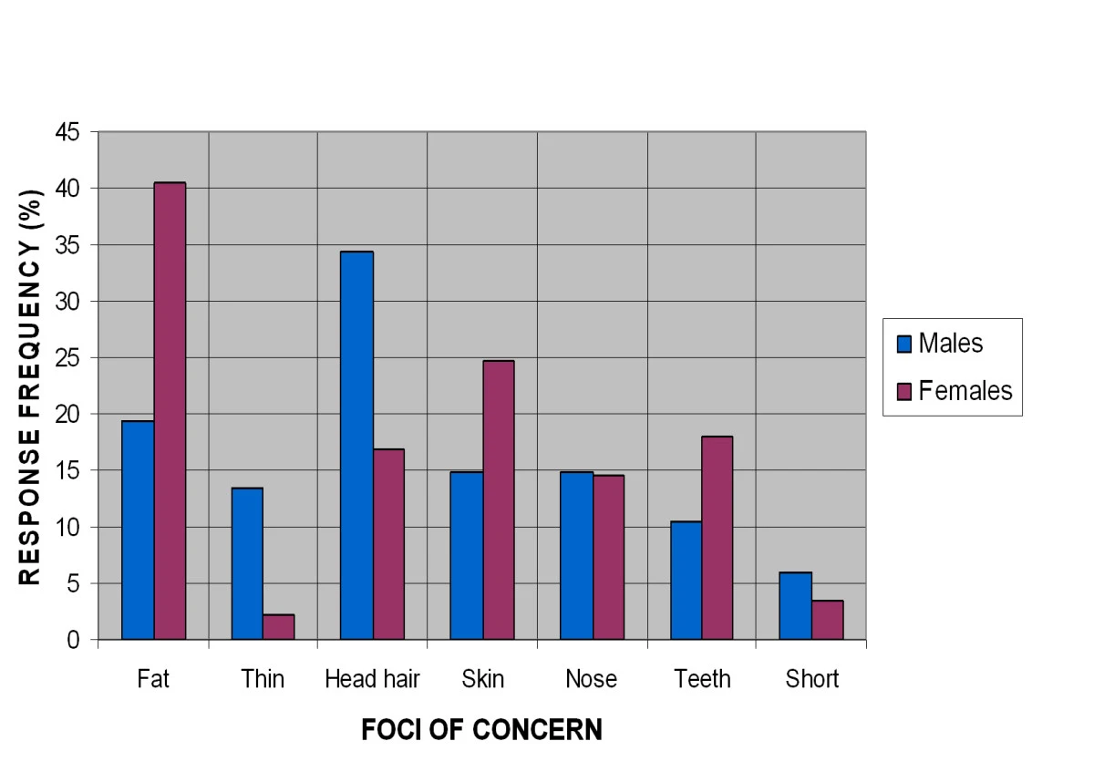

Figure 3 – Chart representing data collected from a case study of medical students with Body dysmorphic disorder (Taqui et al. 2008).

**Future of Disorder**

Body dysmorphic disorder is extremely underdiagnosed in the grand scheme of things. As mentioned previously, the disorder affects up to 2% of the population and is a common disorder alongside anxiety, depression, and OCD. As of today, BDD is treated with cognitive behavioral therapy and pharmacotherapy (Hong et al. 2018). SRIs are, again, a drug used to treat BDD and in many patients, they are prescribed higher doses than the recommended amount. This can be detrimental to those prescribed in the future due to the side effects that come with the drugs. These side effects are minute in those who take the regular dosage, it cannot be determined the long-term effects of higher dosing until further along in the future.

Cosmetic treatment is a controversial topic in discussing Body dysmorphia. It is believed that in some cases, those who have gotten cosmetic treatment on areas they have obsessed over, are happier afterward. In other cases, there have been mixed feelings after receiving cosmetic rehabilitation in certain areas. The overall conclusion is that there is a limited positive impact on patients who correct their problem areas with cosmetic treatment. Long term, there can be remission into the same thoughts those patients were having before as well as worsened preoccupation (Siegfried et al. 2018). A final strategy to further the development of BDD is to bring awareness to it. This can be seen in being able to detect the disorder earlier rather than later. Healthcare officials need to have the correct tools to help identify BDD in patients as well as use these tools to educate their patients on the disorder (Siegfried et al. 2018).

**Conclusion:**

**Lack of Research into BDD**

Body Dysmorphic Disorder is a mental disorder that has not reached the limelight in terms of research. This can be seen just by simply looking at the disorder on a general site like Google. A considerable amount of articles show up, however, they state the same things within them. The generalized symptoms with a few percentages and different facts. When looking more into research journals and articles, it is implied that the lack of research on BDD could negatively affect the future of research. When continuing forwards with research, it is important to begin collecting new data at all times. To further the exploration of the biology behind BDD, there needs to be consistent studies and evaluations of topics that haven't been explored yet. In many of the research articles cited in this paper, there have been multiple case studies that cannot come to a direct conclusion because they do not have another controlled study to refer to.

A way to combat this underdiagnosis of BDD is to normalize feeling the way patients with BDD feel. In recent years the idea of mental illness has been brought to the forefront and that has made people feel seen in their feelings as well as become aware of what exactly they are feeling. With being comfortable to speak up and get the help they need, there could be an influx of patients who receive the diagnosis of BDD. This influx could then lead to case rates spike, which in many disorders, calls for research into the case that is being dealt with. Overall, the biology behind BDD is constantly having new information added to it. In a few years, this research analysis could be doubled in length with the latest knowledge on Body dysmorphic disorder.

**References**

Bjornsson, A. S., Didie, E. R., & Phillips, K. A. (2010). Body dysmorphic disorder. Dialogues in clinical neuroscience, 12(2), 221–232. https://doi.org/10.31887/DCNS.2010.12.2/abjornsson

Feusner, J.D., Neziroglu, F., Wilhelm, S., Mancusi, L., and Bohon, C. (2010). What Causes BDD: Research Findings and a Proposed Model. Psychiatr Ann. 349-355. 10.3928/00485713-20100701-08.

Feusner, J.D., Townsend, J., Bystritsky, A., McKinley, M., Moller, H., and Bookheimer, S. (2009). Regional brain volumes and symptom severity in body dysmorphic disorder. Psychiatry Res *172*, 161-167. 10.1016/j.pscychresns.2008.12.003.

Hardardottir, H., Hauksdottir, A., and Bjornsson, A.S. (2019). [Body dysmorphic disorder: Symptoms, prevalence, assessment and treatment]. Laeknabladid *105*, 125-131. 10.17992/lbl.2019.03.222.

Hong, K., Nezgovorova, V., & Hollander, E. (2018). New perspectives in the treatment of body dysmorphic disorder. F1000Research, 7, 361. https://doi.org/10.12688/f1000research.13700.1

Malcolm, A., Labuschagne, I., Castle, D., Terrett, G., Rendell, P. G., & Rossell, S. L. (2018). The relationship between body dysmorphic disorder and obsessive-compulsive disorder: A systematic review of direct comparative studies. The Australian and New Zealand journal of psychiatry, 52(11), 1030–1049. https://doi.org/10.1177/0004867418799925

Snorrason, I., Beard, C., Christensen, K., Bjornsson, A.S., and Björgvinsson, T. (2019). Body dysmorphic disorder and major depressive episode have comorbidity-independent associations with suicidality in an acute psychiatric setting. J Affect Disord *259*, 266-270. 10.1016/j.jad.2019.08.059.

Siegfried, E., Ayrolles, A., & Rahioui, H. (2018). L’obsession de dysmorphie corporelle : perspectives d’évolution de la prise en charge [Body dysmorphic disorder: Future prospects of medical care]. L'Encephale, 44(3), 288–290. https://doi.org/10.1016/j.encep.2017.08.001

Singh, A. R., & Veale, D. (2019). Understanding and treating body dysmorphic disorder. Indian journal of psychiatry, 61(Suppl 1), S131–S135. https://doi.org/10.4103/psychiatry.IndianJPsychiatry_528_18

Summers, B. J., Schwartzberg, A. C., &amp; Wilhelm, S. (2021). A virtual reality study of cognitive biases in body dysmorphic disorder. Journal of Abnormal Psychology, 130(1), 26–33. https://doi.org/10.1037/abn0000563

Taqui, A. M., Shaikh, M., Gowani, S. A., Shahid, F., Khan, A., Tayyeb, S. M., Satti, M., Vaqar, T., Shahid, S., Shamsi, A., Ganatra, H. A., & Naqvi, H. A. (2008). Body Dysmorphic Disorder: gender differences and prevalence in a Pakistani medical student population. BMC psychiatry, 8, 20. <https://doi.org/10.1186/1471-244X-8-20>

InformedHealth.org [Internet]. Cologne, Germany: Institute for Quality and Efficiency in Health Care (IQWiG); 2006-. Cognitive-behavioral therapy. 2013 Aug 7 [Updated 2016 Sep 8]. Available from: https://www.ncbi.nlm.nih.gov/books/NBK279297/