|  |
| --- |
| **Library Media Center**  **Collaboration Planning & Teaching Log** |

|  |  |
| --- | --- |
| Teacher(s): Jessica Drinks and Heather Drinkwater  Grade Level: ______7th grade Planning Date: _February 2016_ Project Date:_February 2016________ | |
| **Standards for 21st Century Learner**  ***Skills:***  1.1.9 Collaborate with others to broaden and deepen understanding  3.1.3 Use writing and speaking skills to communicate new understandings effectively  ***Dispositions***  1.2.1 Display initiative and engagement by posing questions and investigating the answers beyond the collection of superficial facts.  ***Responsibilities***  1.3.4 Contribute to the exchange of ideas within the learning community. | **Project Description**  Students will be introduced to a cooperative learning strategy called “jigsaw”. The LMS will be using online resources to explain and demonstrate how the jigsaw process will be used (resources listed below). According to the website [www.jigsaw.com](http://www.jigsaw.com) , the process occurs as follows:   * Students will be assigned to groups of 4. The LMS will assign each student to learn one type of nonfiction (segment): narrative nonfiction, expository nonfiction, persuasive nonfiction, or description nonfiction. * Students will be given time to read over their segment and become familiar with it (handouts will be provided by the LMS as well as access to internet research resources). * The LMS will form temporary “expert groups” by having 1 student from each jigsaw group join other students who were assigned to that particular segment. These groups will discuss their research and work collaboratively to combine their information. * The LMS will bring students back to their jigsaw group. * Ask each student to present his or her segment to the group. Allow time for questions and answers for each segment. |
| **Academic Standards**  **Language Arts—7th grade**  7.6 The student will read and demonstrate comprehension of a variety of nonfiction texts.  b) Use text structures to aid comprehension.  c) Identify an author’s organizational pattern using textual clues, such as transitional words and phrases.  d) Draw conclusions and make inferences on explicit and implied information.  e) Differentiate between fact and opinion.  f) Identify the source, viewpoint, and purpose of texts.  g) Describe how word choice and language structure convey an author’s viewpoint.  h) Identify the main idea.  i) Summarize text identifying supporting details.  j) Identify cause and effect relationships.  k) Organize and synthesize information for use in written formats | **Classroom Teacher will:**  The classroom teacher will assist in compiling written information on different types of nonfiction for students’ use as well as assisting students in their jigsaw groups with any questions. The classroom teacher will also form the jigsaw groups before the lesson begins so that groups are formed with diversity in mind (combinations of gender, race, ethnicity, and ability levels).  **Library Media Specialist will:**  The LMS will be responsible for assisting the students by presenting the information on how jigsaw learning works, as well as assisting students with accessing information during their research phase of the assignment.  The LMS may also assist students in using online resources to find information about their assigned form of nonfiction either through precise keyword searches or the use of the school’s databases. |
| **School Improvement**  The school is currently under a state improvement plan to bring Language Arts SOL scores to an overall pass rate of 75% as required by the state. This lesson was created with the school’s literacy coach and reading specialist to solidify the students’ understanding of nonfiction text and what information it presents to the reader. |
| **Resources**   * The classroom teacher has printed copies of information about types of nonfiction (specific sections from the textbook and workbook). * There is a handout of internet resources for the students to access (included with the lesson plan) * A [handout](http://www.mightylittlelibrarian.com/?p=1328) for students to review some books in the library to use as examples for their assigned nonfiction category |
| **Pre Lesson Activities**   1. Before the lesson in the library, the classroom teacher will assign the students into 4-student teams. Each student in the team will be assigned to a particular form of nonfiction. Students will be given information from their textbooks and workbooks to read in order to familiarize themselves with the type of nonfiction they will cover in the jigsaw activity. 2. Depending on time, the LMS may choose to present a lesson on how jigsaw activities are conducted prior to the lesson on nonfiction texts.   **Assessment for current lesson:**   1. Students will complete a peer review of how well their group members presented information to the group. 2. Students will complete a nonfiction text evaluation response worksheet in reference to a book they use as an example of their type of nonfiction. 3. Students will complete an exit ticket at the end of the lesson to show understanding.   **Assessments for future lessons/end of project.**   1. Students will be using the information on nonfiction texts along with other lessons on fictional texts to complete a cumulative project on nonfiction vs. fiction.   **Supplemental Activities:**  -Students may choose to write reviews of nonfiction books to share with the class during book talks  -Students may complete compare and contrast assignments on the different types of nonfiction texts.  **Adaptations for Special Learners AND Differentiated Instruction:**  The classroom teacher will dividing the jigsaw groups according to varied levels of abilities with a focus on inclusion and support. Tiered partnering will be considered so that each member of the group will be successful. | |

|  |
| --- |
| **Lesson Author: Jessica Drinks and Heather Drinkwater** |
| **Grade Level: 7th** |
| **Subject Area: Language Arts** |
| **Short Description:** |
| This lesson will be an opportunity for students to use the cooperative learning method of jigsaw in order to learn information on different forms of nonfictional text. The students will be divided into groups of four and each student will be assigned a particular form of nonfiction. The student will then become an “expert” on the single form of nonfiction and upon returning to the group, will teach the other members of the group about their form of nonfiction. The student will include hands on examples from library books of their particular type of nonfiction. |
| **Standards** |
| **VA SOL:**  **Language Arts—7th grade**  7.6 The student will read and demonstrate comprehension of a variety of nonfiction texts.  b) Use text structures to aid comprehension.  c) Identify an author’s organizational pattern using textual clues, such as transitional words and phrases.  d) Draw conclusions and make inferences on explicit and implied information.  e) Differentiate between fact and opinion.  f) Identify the source, viewpoint, and purpose of texts.  g) Describe how word choice and language structure convey an author’s viewpoint.  h) Identify the main idea.  i) Summarize text identifying supporting details.  j) Identify cause and effect relationships.  k) Organize and synthesize information for use in written formats  **AASL Standards:**  ***Skills:***  1.1.9 Collaborate with others to broaden and deepen understanding  3.1.3 Use writing and speaking skills to communicate new understandings effectively  ***Dispositions***  1.2.1 Display initiative and engagement by posing questions and investigating the answers beyond the collection of superficial facts.  ***Responsibilities***  1.3.4 Contribute to the exchange of ideas within the learning community. |
| **Instructional Outcomes:** |
| * Students will use the jigsaw technique to learn information about different forms of nonfiction. * Students will demonstrate an understanding of various forms of nonfictional texts. * Students will identify examples of nonfictional texts within the library collection. |
| **Enduring Understandings/Essential Knowledge:** |
| All students should:   * use the reading process to activate prior knowledge, predict, question, clarify, infer, organize, compare, summarize, and synthesize. * choose graphic organizers based on the internal text structure most prevalent in the text in order to track key points and summarize the text. * recognize an author’s purpose: * to entertain; * to inform; and * to persuade. * notice use of connotations and persuasive language to convey viewpoint. * make inferences, which imply meaning, and draw conclusions based on both explicit and implied information.   distinguish between a fact, which can be verified, and an opinion, which cannot. |
| **Essential Questions:** |
| To be successful with this standard, students are expected to   * activate prior knowledge before reading by use of, but not limited to: * small-group or whole-class discussion; * anticipation guides; and * preview of key vocabulary. * use textual features to make predictions and enhance comprehension, including: * boldface and/or italics type; * type set in color; * underlining; * indentation; * sidebars; * illustrations, graphics, and photographs; * headings and subheadings; and * footnotes and annotations. * recognize organizational pattern to enhance comprehension, including: * cause and effect; * comparison/contrast; * enumeration or listing; * sequential or chronological; * concept/definition; * generalization; and * process. * recognize transitional words and phrases authors use to signal organizational patterns, including, but not limited to: * *as a result of, consequently* for cause and effect; * *similarly, on the other hand* for comparison/contrast; * *first, three* for enumeration or listing; * *today, meanwhile* for sequential or chronological; * *refers to, thus* for concept/definition; * *always, in fact* for generalization; and * *begins with, in order to* for process. * determine two or more central ideas in a text and analyze their development over the course of the text. * provide an objective summary of the text by recording the development of the central ideas. |
| **Procedures** |
| **Lesson Set:** |
| * Students will be assigned to groups of 4. The LMS will assign each student to learn one type of nonfiction (segment): narrative nonfiction, expository nonfiction, persuasive nonfiction, or description nonfiction. * Students will be given time to read over their segment and become familiar with it (handouts will be provided by the LMS as well as access to internet research resources). * The LMS will form temporary “expert groups” by having 1 student from each jigsaw group join other students who were assigned to that particular segment. These groups will discuss their research and work collaboratively to combine their information. * The LMS will bring students back to their jigsaw group. * Ask each student to present his or her segment to the group. Allow time for questions and answers for each segment. |
| **Rationale:** |
| According the website [www.jigsaw.org](http://www.jigsaw.org) :   * “The jigsaw classroom has a four-decade track record of successfully reducing racial conflict and increasing positive educational outcomes such as improved test performance, reduced absenteeism, and greater liking for school.” * “Just as in a jigsaw puzzle, each piece — each student's part — is essential for the completion and full understanding of the final product” * “If each student's part is essential, then each student is essential; and that is precisely what makes this strategy so effective” |
| **Techniques and Activities:** |
| 1. The LMS will be responsible for describing and demonstrating the jigsaw technique to the students. 2. The classroom teacher will be responsible for choosing thoughtful and appropriate groups for the students. 3. The classroom teacher will create informational handouts for the students’ research as well as handouts for assessment. 4. The LMS will assist in the use of databases and search engines to enhance the students’ research. |
| **Lesson Closure:** |
| 1. The students will reconvene into their jigsaw groups for their presentation of information. A round-robin style of discussion will ensure that each student has ample opportunity to present their research to the group. 2. The teacher and LMS will float from group to group, observing and assisting as needed. 3. The students will be assessed on their knowledge through an exit ticket. |
| ***Supplemental Activities/Future Lessons*** |
| * Students will complete peer review worksheets to provide feedback on the group members’ participation and depth of knowledge. * Students will use their example books to further extend the lesson through book talks. * Students will use their information on nonfiction to assist in their comparison to fictional texts. |
| ***Adaptations for Special Learners:*** |
| * The classroom teacher will provide tiered partnering when creating the jigsaw groups. * The classroom teacher will provide small group support as needed. |
| ***Differentiated Instruction:***   * The handouts will be available at different levels of intensity and depth of knowledge. |

**Resources:**

<https://www.jigsaw.org/>

<http://www.edutopia.org/stw-collaborative-learning-research>

<http://ascd.org/ASCD/pdf/journals/ed_lead/el_199102_slavin.pdf>

<http://www.nea.org/tools/16870.htm>

<http://www.mfschools.org/user/woodhala/students/6typesofnonfiction.pdf>

<https://www.eliteediting.com/blog/post.aspx?id=38>

<http://genresofliterature.com/>

**References:**

Whitehead, Tiffany (2015, October). *Interacting with Nonfiction text* . Retrieved on February 10, 2016 from <http://www.mightylittlelibrarian.com/?p=1328>.

Kissner, E. (2011, July). *Fiction, nonfiction, expository, narrative*. Retrieved on February 11, 2016 from <http://emilykissner.blogspot.com/2011/07/fiction-nonfiction-expository-narrative.html>

Rainbow Resource Center. Retrieved on February 11, 2016 from <https://www.rainbowresource.com/viewpict.php?pid=017785>

### 

### 

### 

### 

### 

### 

### 

### 

### 

### Handouts/Worksheets

Nonfiction Evaluation (T. Whitehead, [http://www.mightylittlelibrarian.com/?p=1328)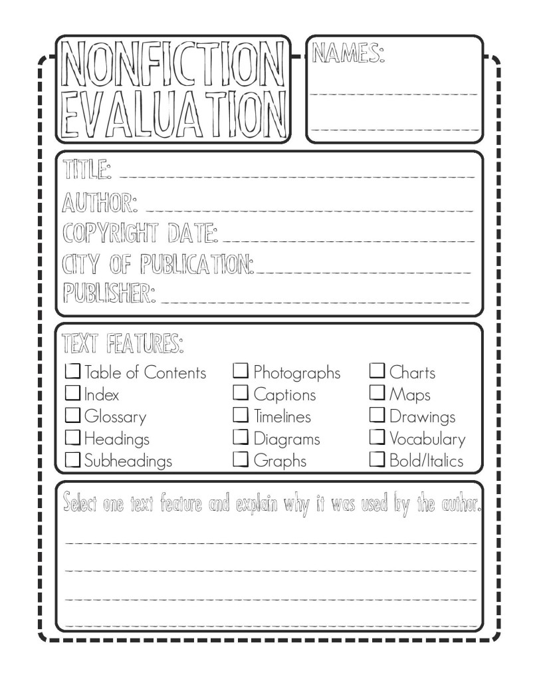](http://www.mightylittlelibrarian.com/?p=1328))

Kissner, E. (http://emilykissner.blogspot.com/2011/07/fiction-nonfiction-expository-narrative.html)

### http://3.bp.blogspot.com/-KbsPkkhsdiQ/TjSzeZmPGLI/AAAAAAAAARI/FyOqYvcUTRo/s320/Kinds+of+Text_1.jpg

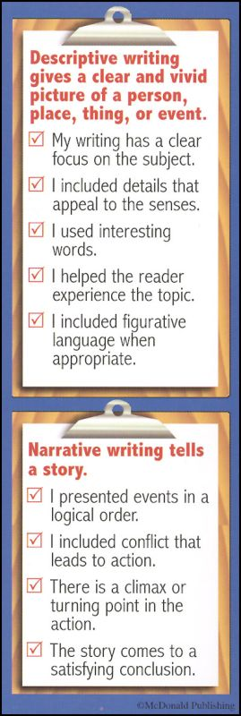Images: Rainbow Resource Center (https://www.rainbowresource.com/viewpict.php?pid=017785)

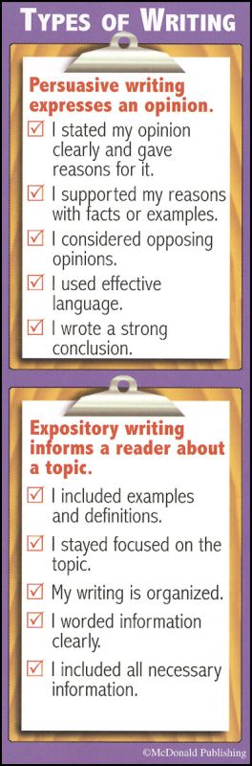

Peer Review: nonfiction jigsaw

|  |  |  |
| --- | --- | --- |
| Name (including you) | What was this student responsible for knowing? | How well did this student deliver the required information? |
|  |  |  |
|  |  |  |
|  |  |  |
|  |  |  |

What grade should your group receive? Why? _____________________________________________________________________________________________________________________

Is there anything I should know when considering your group’s grade? ______________________________________________________________________________

nonfiction exit ticket

Name: _____________________

Class Period: _______ Date: ________

Name 3 things you learned today about nonfiction:

1. ______________________________
2. ______________________________
3. ______________________________

Name 2 things you already knew about nonfiction:

1. ________________________________
2. ________________________________

Name 1 thing you will share with a friend about this lesson:

1. ________________________________