The Investigation of Coal Dust in the Lafayette River
Shelby S. Coleman
Mentor: Dr. Rodger Harvey
Abstract
To determine if the Lafayette River in Norfolk, VA is being impacted by coal dust from Norfolk Southern’s Lamberts Point coal terminal, this study examined the concentrations of polycyclic aromatic hydrocarbons (PAHs) and aliphatic n-alkanes in surface sediments (1-2 cm) among several sites in the Elizabeth River near the coal pier as well as particles collected in an atmospheric sampler on Old Dominion University’s campus. The samples were extracted using a MARS microwave accelerated extraction system and split; PAH fractions were analyzed by GC-MS and n-alkane fractions were cleaned up through solid phase extraction and then analyzed by GC-MS/FC-FID. A total of 54 PAHs (27 parent, 27 alkyl-substituted) and 21 n-alkanes (10 short chain, 11 long chain) were identified. Surface sediments yielded concentrations of individual PAHs ranging from 0.09 ng/g dry weight (naphthalene) to 4072 ng/g dry weight (dimethylnaphthalene) and of n-alkanes from 51 μg/g (C₁₆) to 19406 μg/g (C₂₉). Deposition samples yielded abundances of individual PAHs ranging from 0.01 ng (perylene) to 620 ng (trimethylnaphthalene) and of n-alkanes from 211 ng (C₂₄) to 20342 ng (C₂₉). These values were compared to two coal samples collected from the terminal, which yielded PAH concentrations from 0.67 ng/g dry weight (indo[1,2,3-cd]pyrene) to 4072 ng/g dry weight (dimethylnaphthalene) and n-alkane concentrations from 196 μg/g dry weight (C₃₁) to 3155 μg/g dry weight (C₁₅). Further inspection of these values provided evidence that organic contaminants associated with coal are being transported throughout Norfolk and have the potential to affect the Lafayette River.

- Introduction
Norfolk Southern’s Lamberts Point Coal Terminal is stationed within the Elizabeth River in Norfolk, VA. The terminal’s Pier 6 has an annual capacity of 48 million tons, which is comparable to the dumping of about 8000 tons of coal per hour (Lamberts Point Coal Terminal, Norfolk, VA). Because of its high coal capacity and 24/7 operation, the coal terminal is one of the largest in the United States.
The Lafayette River Watershed is contained completely within the urban city of Norfolk, Virginia. This watershed covers 13.87 square miles and includes over 40% of the city’s residents (Lafayette River). This coal terminal and its carts which dump coal at all hours of the day are located in the heart of Hampton Roads, which is included in this watershed. Eyewitness accounts have reported noticeable amounts of coal dust being generated when coal is dumped between carts. Eyewitnesses have also reported coal dust accumulation on their cars when parked in the area for a few hours at a time. When standing down by the coal terminal, it is possible to see the coal dust being thrown into the air as it is being transferred (Gregory, 2015). The observed pollution by this coal dust is a cause for concern and the motivation for this study.
By examining the polycyclic aromatic hydrocarbon (PAH) and n-alkane content of samples, it is possible to associate specific components with those of coal. Hallmarks of coal include excessive parent PAH concentrations, especially phenanthrene, anthracene, fluoranthene, pyrene, chrysene, and their derivatives (McRae et al., 2012). PAHs with lower molecular weights are representative of a coal structure, but these structures with lower amounts of rings are capable of evaporating at room temperature (Zhao et al., 2000).
PAHs have been identified as an environmental carcinogen that derives from combustion processes including vehicle exhaust, which is a concern in urban areas (Perrone et al., 2014). The EPA has identified 16 PAHs that have been widely examined in the literature; these PAHs are divided into two categories. The non-carcinogenic PAHs include: naphthalene, acenaphthylene, acenaphthene, fluorene, phenanthrene, anthracene, fluoranthene, and pyrene (Lee et al., 1999). The carcinogenic PAHs include benzo(a)anthracene, chrysene, benzo(b)fluoranthene, benzo(k)flouranthene, benzo(a)fluoranthene, indeno(1,2,3-cd)pyrene, dibenzo(a,h)anthracene, and benzo(g,h,i)perylene (Lee et al., 1999).
Ratios of fluoranthene (FLA) to pyrene (PYR) were calculated to determine if the PAHs were of pyrolytic or petrogenic origin. Ratios of FLA to (PYR + FLA) and indeno[1,2,3-cd]pyrene (IcdP) to (IcdP + benzo[g,h,i]perylene) (BghiP) were calculated to determine if the PAHs originated from petroleum or diesel, petroleum combustion, or combustion of coal, grass, or wood.
n-Alkanes are also a plentiful source of organic contaminants from combustion processes and vehicle exhaust emissions (Perrone et al., 2014). Long and odd chain n-alkanes are often representative of organic plant materials found in coals. Short and even chain n-alkanes are associated with petroleum sources (Harvey et al., 2014). Short chain alkanes are defined as saturated carbon chains with lengths of C₁₃ to C₂₂, and long chain alkanes are saturated carbon chains with lengths of C₂₃ to C₃₃.
The goal of this study is to determine if coal dust from Norfolk Southern’s Lamberts Point coal terminal is reaching the Lafayette River. This was achieved through the collection of surface sediment, wet and dry deposition, and coal samples which were extracted and analyzed for organic contaminants, specifically PAHs and n-alkanes.
- Materials and methods
2.1 Sample collection
A graphical representation of the sampling sites can be found in Figure 1. Approximate GPS coordinates can be found in Table 1.
2.1.1 Sediment
Surface sediment samples were collected from Golf Course Inlet (GCI) and Lamberts Point Inlet (LPI) on June 15, 2015 and from Storm Overflow (SO) on June 17, 2015. All three sediment samples were collected using a hand-held coring device. GCI and LPI were reached using a kayak. For all sediments, the top 1-2 cm of the core were scraped off and transferred to a pre-cleaned plastic I-chem jar with a teflon-lined lid. After transfer, the sediments were immediately frozen in a -70°C chest freezer.
2.1.2 Wet and dry deposition samples
An Aerochem Model 301 atmospheric sampler was located on the rooftop of Spong Hall. Wet deposition samples were collected from June 18, 2015 to July 20, 2015 after each major rain event. The wet deposition samples were filtered for particles immediately after collection using a combusted 0.7 µm GF/F. These filters were folded in half, transferred to combusted aluminum foil, and stored in a -70°C chest freezer.
A dry deposition sample was collected once over the four-week sampling period to allow more time for particles to accumulate. The inside of the dry deposition bucket was wiped down with a combusted 0.7 µm GF/F damp with 1:1 methanol:dH₂O to collect the particles. These filters were folded in half and transferred to combusted aluminum foil to await extraction.
2.2 Analysis of hydrocarbons
2.2.1 Extraction of sediments and filters
Sediments and filters were analyzed for aromatic and aliphatic hydrocarbons. Sediment samples were freeze dried for at least 48 hours prior to the extraction. The sediment and coal samples were ground into a fine powder before the extraction began. About 5 g of the freeze dried sediment and about 1 g of the coal was added to a Green Chem glass vessel. A stir bar and 30 mL of 1:1 hexane:acetone were added to the glass vessel.
A perdeuterated internal standard containing five PAHs (acenaphthalene, phenanthrene, benz(a)anthracene, benzo(a)pyrene, and benzo[g,h,i]perylene) was added to each sample.
The n-alkane (n-Octadecane-d38) was used as the internal standard and included prior to extraction.
Sediments and coal were extracted using a MARS microwave accelerated extraction system at 80°C for 30 minutes with 30 minutes of cool-down time, based on methods from Harvey and Taylor (Harvey et al, 2014). Once cool, extracts were filtered into solvent-rinsed (1:1 hexane:acetone) round bottom flasks using pre-cleaned and combusted glass wool. Two additional rinses of the extraction vessel were added to the total extracts, which were then concentrated using rotary evaporation. The concentrated extracts were transferred to solvent-rinsed 8 mL amber vials and split for PAH and n-alkane analyzation.
2.2.2 GC-MS analysis of PAHs
PAH samples were analyzed by capillary gas chromatography (GC) with an Agilent 7890A system coupled to an Agilent 5975C Network Mass Selective Detector (MS) in electron ionization mode. The GC-MS was fitted with a J&W Scientific DB-5MS fused silica column (60 m, 0.320 mm id, 0.25 film thickness) and operated in selected ion monitoring (SIM) mode. All samples were injected in splitless mode at 50°C with helium as the carrier gas. The oven temperature was ramped at 15 ̊C min ^{‾1} to 120 ̊C and then 3.5 ̊C min ^{‾1} to 300 ̊ C before holding at 300 ̊C for 25 minutes. To quantify the PAH concentrations, the base peak area for individual compounds was adjusted relative to the amount of internal standard added. Acidified samples (GCI, LPI, SO, Coal, Coal #2) were also analyzed for organic carbon using standard combustion methods through analytical services off site (CBL/UMCES).
2.2.3 Purification and GC-MS/GC-FID analysis of n-alkanes
Solid phase extraction (SPE) of total lipid extracts (TLE) for sediments was performed with Strata SI-1 Silica (55um, 70A) Teflon-coated SPE columns (500 mg 3 mL ^{‾1}, Phenomenex) to purify the sample for n-alkane analysis. After the SPE, the n-alkane fraction was concentrated by drying down the sample with nitrogen gas. The concentrated fraction was then transferred to a 4 mL amber vial using hexane. Nitrogen gas was again used to concentrate the alkane fraction, which was then diluted with 200 µL of hexane and transferred to pre-labeled autosampler vials. n-Alkanes were quantified by capillary GC using an Agilent 7890A Network GC system with flame ionization detection (GC-FID). This column is similar to that described in the PAH analysis. The base peak area of n-alkanes was adjusted relative to the known concentration of perdeuterated internal standard (n-Octadecane-d38) added. Alkanes were identified in full-scan mode by GC-MS.
2.2.4 Quality assurance and quality control
Procedural and freeze dryer blanks were prepared and analyzed for each set of sediment samples. These blanks followed an identical protocol to that of the sediment samples.
3. Results
3.1 Concentrations and distribution of PAHs in samples
All samples were analyzed for 27 parent and 27 alkyl-substituted PAHs, for a total of 54. No 5 or 6 ringed alkyl-substituted PAHs were examined. Masses of individual PAHs were determined by multiplying the peak area by the mass of added perdeuterated internal standard and dividing the product by the internal standard’s peak area. The mass was then divided by the sample mass or volume (for sediments and deposition samples, respectively) to find the PAH concentration. A detailed list of these compounds can be found in Appendix III.
3.1.1 Concentrations and distribution of PAHs in sediment
Total PAH concentration across the four sites ranged from 2434 ng/g dry weight (SO) to 68543 ng/g dry weight (LPI). Concentrations of detected PAHs ranged from a low of 0.09 ng/g dry weight (naphthalene) to 4072 ng/g dry weight (dimethylnaphthalene). Parent PAHs were the dominant structures across all three sediment sites with total concentrations ranging from 1435 ng/g dry weight (SO) to 60003 ng/g dry weight (LPI). The sediment samples were rich in higher molecular weight PAHs (4 to 6 rings). Relatively high concentrations of methylphenanthrene, fluoranthene, pyrene, chrysene, benzo[k]fluoranthene, benzo[a]fluoranthene, benzo[a]pyrene, perylene, benzo(g,h,i)perylene, and benzo(b)chrysene were observed in at least 3 out of 4 of the sediment samples. Figure 2 contains a graphical representation of this data. See Tables 4 and 5 for specific data summary values.
3.1.2 Concentrations and distribution of PAHs in particles
Total PAH concentration across the seven deposition samples (6 wet, 1 dry) ranged from 105 ng (June 24) to 2898 ng (July 8). Concentrations of detected PAHs ranged from a low of 0.01 ng (perylene) to a high of 620 ng (trimethylnaphthalene). Parent PAHs were dominant in a majority of the deposition samples with concentrations ranging from 89 ng to 1510 ng. Alkyl-substituted dominated in the samples from June 29 and July 8 with concentrations for 301 ng and 2762 ng, respectively. Dominance between lower and higher molecular weight PAHs varied throughout all samples. Relatively high values of trimethylnaphthalene, several methyl-substituted fluoranthenes, benzo[k]pyrene, and perylene were observed in most deposition samples. Figure 3 contains a graphical representation of this data; Tables 6 and 7 contain specific data summary values for the deposition samples.
3.1.3 Concentrations and distribution of PAHs in coals
Both coal samples were rich in PAH content. The first coal sample, which was already a powder during collection, was dominated by alkyl-substituted PAHs. The second coal sample, which was a lump collected from a different location and ground up in the lab, was dominated by parent PAHs. Total PAH concentrations in both samples exceeded 29000 ng/g dry weight. Concentrations of detected PAHs ranged from 0.67 ng/g dry weight (indo[1,2,3-cd]pyrene) to 4072 ng/g dry weight (dimethylnaphthalene). The lower molecular weight PAHs were dominated by alkyl-substituted structures. The two coals samples contained significant concentrations of most analyzed PAHs, especially: biphenyl, dimethylnaphthalene, trimethylnaphthalene, fluorine, phenanthrene, anthracene, methylphenanthrene, di-methyl substituted phenanthrenes, fluroanthene, pyrene, chrysene, triphenylene, benzo[k]fluoranthene, and benzo[a]fluoranthene. Figure 4 contains a graphical representation of this data. Tables 8 and 9 contain specific data summary values for coal samples.
3.2 Aliphatic n-alkanes in samples
A total of 21 n-alkanes were identified in all sediment, wet and dry deposition, and coal samples. Short chain alkanes are defined as C₁₃-C₂₂ and long chain alkanes are defined as C₂₃-C₃₃. Identified alkenes are included in the data totals. Masses of individual alkanes were determined by multiplying the peak area by the mass of added perdeuterated internal standard (n-Octadecane-d38) and dividing the product by the internal standard’s peak area. The mass was then divided by the sample mass or volume (for sediments and deposition samples, respectively) to find the alkane concentration. A detailed list of the examined n-alkanes can be found in Appendix IV.
3.2.1 Aliphatic n-alkanes in sediments
Total alkane abundances ranged from 3 µg (LPI) to 46 µg (GCI). Total alkene abundances ranged from 0 µg/g dry weight (Coal) to 638 µg/g dry weight (LPI). Abundances of detected n-alkanes ranged from 51 µg/g dry weight (C₁₆ in SO) to 19406 µg/g dry weight (C₂₉ in GCI). Short chain n-alkanes were dominant in LPI with an abundance of 27 µg/g dry weight. Odd-numbered chain alkanes were dominant in all sediment samples with abundances of 43 µg/g dry weight (GCI), 2 µg/g dry weight (LPI), and 7 µg/g dry weight (SO). Distributions of concentrations amount the sediment samples were fairly uniform, but there was a significantly higher concentration of C₂₉ and C₃₁ in all samples. Figures 5 and 6 provide a graphical representation of these distributions and Table 10 provides specific data summary values for the n-alkanes included in the sediment samples.
3.2.2 Aliphatic n-alkanes in particles
Total alkane abundances ranged from 26 μg (June 24) to 151 μg (June 29). Total alkene abundances ranged from 0 μg (June 24) to 11871 μg (June 29). Abundances of detected n-alkanes ranged from 211 ng (C₂₄ in July 20) to 20342 ng (C₂₉ in June 29). Long chain alkanes were dominant in a majority of the deposition samples with abundances ranging from 14 ng (July 20 dry) to 97 ng (June 29). Odd chain alkanes were also dominant in a majority of the deposition samples with abundances ranging from 18 μg (July 20 dry) to 20 μg (July 26). Distributions of abundances among the deposition samples were fairly standard, but a heightened abundance was noted with C₂₉ and C₃₁. Figures 8 and 9 provide a graphical representation of these distributions and Table 11 provides specific data summary values for the n-alkanes included in the sediment samples.
3.2.3 Aliphatic n-alkanes in coals
Total alkane concentrations ranged were 9 μg/g dry weight and 17 μg/g dry weight in the first and second coal samples, respectively. Alkenes were not detected in the first coal sample but totaled 1041 μg/g dry weight in the second coal sample. Abundances of detected alkanes ranged from 196 μg/g dry weight (C₃₁ in Coal) to 3155 μg/g dry weight (C₁₅ in Coal). Short, odd chain alkanes were dominant in both coal samples. The distribution of concentrations among all samples was fairly standard with less emphasis on the higher molecular weight alkanes, but a heightened concentration of C₁₅, C₁₇, C₁₈, and C₂₁ was noted. Figures 9 and 10 provide a graphical representation of these distributions and Table 11 provides specific data summary values for the n-alkanes included in the coal samples.
3.2.4 Percent particulate organic carbon in sediments and coals
Values for percent particulate organic carbon are listed in Table 13. Total organic carbon was highly variable ranging from a low of 0.71% in SO to a high of 45% in multiple coal samples.
3.2.5 Carbon Preference Index for samples
Values for the Carbon Preference Index (CPI) of all samples are listed in Table 14. All samples produced a value greater than 1 with a range from 1.12 (Coal) to 6.67 (June 24). CPI values for June 29, July 16, LPI, Coal, and Coal 2 were similar, all falling within the 1-2 range.
3.2.6 Comparison to historic data
A comparison of a run of 2014’s Station 13 surface sediment sample can be found in Figures 11, 12, and 13 and Tables 15 and 16. The values found when analyzing the sample for the second time a year later were consistently higher for both PAH and n-alkane concentrations, but the relative percent difference was very low, with the exception of 5 PAHs (fluoranthene, pyrene, benzo[k]fluoranthene, benzo[a]fluoranthene, benzo[b]chrysene). Parent PAHs and long chain alkanes dominated in both runs; the only relative difference in addition to the higher values was that odd chain alkanes dominated in 2014 but even chain alkanes dominated in 2015. Relatively higher concentrations of dimethylnaphthalene, methyl-substituted phenanthrenes, fluoranthene, pyrene, and chrysene were observed in both trials of the sample.
3.2.7 PAH source calculations
To determine the origin of detected PAHs, additional calculations were done based on work published by Amodio et al. Data for these calculations can be found in Table 17 (Amodio et al., 2014). Based on the calculated ratios, a majority of the samples were found to be of pyrolytic origin, resulting from the combustion of coal, grass, wood, or petroleum.
4. Discussion
4.1 PAHs in surface sediments and coals
A wide range of concentrations of various PAHs was observed. Parent PAHs were found to be in higher concentrations in the surface sediment samples than in the coal sample. As the literature discusses, parent PAHs are often found as byproducts of unnatural combustion processes (McRae et al., 1999). Alkyl-substituted PAHs were found in higher concentrations in the coal sample. This could be explained by the initial high organic content of coal. Since coal is initially formed by plant material, the alkyl-substituted PAHs are formed as a result of microbial degradation within the coal. Elevated levels of coal’s major components (naphthalenes, fluoranthenes, pyrenes) in the sediments indicate that there the footprint of coal is present.
LPI was found to have about two times the total concentration of PAHs of the pure coal sample. Since the sampling site was located in a water system directly adjacent to the railroad tracks and coal pier, it can be hypothesized that the sediments are being influenced by combustion byproducts in the area. When collecting the core at LPI, it was noted that the sediment contained a large amount of black particles. This observation supports the higher percent particulate organic carbon measurement as well as the larger amount of parent PAHs found in the sediment.
All sediment samples produced a FLA/PYR value that indicated a pyrolytic origin. Both the FLA/(PYR + FLA) and IcdP/(IcdP + BghiP) ratios indicated that the PAHs originated from the combustion of coal, grass, or wood. The only exception was the IcdP/(IcdP + BghiP) ratio for Station 13, which indicated that the PAHs may have been from petroleum or diesel. This data implies that the PAHs in collected sediments contain decomposed organic material, possibly from coal.
Studies have indicated that various coal values produced PAH concentrations ranging from 1200 ng/g to 28300 ng/g from various coal types (Zhao et al., 2014). Values obtained in this study are comparable to the literature values.
4.2 PAHs in particles and coals
All wet and dry deposition samples were collected over a 4-week period from June 18, 2015 to July 20, 2015. Throughout this time, a wide range of particulate abundances were observed. Samples collected earlier in the sampling period (up to the July 8 sample) were dominated by lower molecular weight PAHs. A study reported that PAHs of a higher molecular weight (4 to 7 rings) occur in environmental samples due to the incomplete combustion of fossil fuels (Bonfanti et al., 1997).
Filters from June 24, 26, 29 and July 8 were dominated by alkyl-substituted PAHs, while filters from July 16 and July 20 were dominated by parent PAHs. There is no obvious trend in the wind data that supports this sudden switch in the major PAH composition. Relatively high levels of several major PAHs found in coal, such as the naphthalenes, methyl-substituted fluoranthenes, and pyrenes, indicate that it is possible that coal is travelling through the air in either rain or wind to the atmospheric sampler.
Literature values suggest that the collection of particles can be quite variable, as was observed in this study. Collected amounts of PAHs were found to range from 0.6 ng to 6 ng for individual PAHs (Jaward et al., 2012). Another source observed individual dissolved PAH levels ranging from 5 ng to 9 ng (Chang et al., 2014). These values are fairly consistent with what was observed in this study. The size of the sampler, the length of collection, and the wind speeds were all variables that may have impacted the study and the amount of particles collected.
A majority of deposition samples expressed a FLA/PYR ratio that indicated a pyrolytic origin. June 29 and July 8’s samples indicated a petrogenic origin, which can be associated with coal combustion or petroleum; wind speeds were stronger on the dates of the two samples’ rain events, which could explain why direct products of coal combustion were reaching the deposition sampler on Spong Hall. The FLA/(PYR + FLA) and IcdP/(IcdP + BghiP) ratios indicate that a majority of the PAHs were produced by combustion of coal, grass, or wood, once again with the exception of June 29 and July 8. The two outliers implied a petroleum or diesel origin. Since the building is adjacent to a road and near a construction site for the summer, it can be assumed that the stronger winds carried more PAHs from petroleum or diesel during these two sampling periods.
4.3 n-alkanes in surface sediments and coals
According to the literature, long and odd chain alkanes are most concentrated in materials that were rich in plant matter (Vonk et al., 2008). Consequently, a relatively high amount of long and odd chain n-alkanes should be observed in the coal sample. In reality, the coal samples were rich in short, even-chain alkanes and the sediment samples, with the exception of LPI, consisted mainly of long, odd-chain alkanes. Since plant material is generally associated with long, odd-chain alkanes, this suggests that the surface sediment samples, with the exception of LPI, have similar compositions to that of pure coal.
The total concentrations of n-alkanes in coal samples collected in a previous study produced a range of 0.2 μg/g to 3350 μg/g (Barrick et al., 1984). Concentrations determined by this study are near the lower end of that range, which could be attributed to the uncertainty of the composition and age of the coal samples. Percent particulate organic carbon measurements obtained in this study are lower than the average 70% PC, but that can be attributed to the fact that the coal samples used may not have been truly representative of what is being transported on the basis of age (Brooks & Smith, 1969).
The Carbon Preference Index (CPI) of most sediment samples was relatively higher than that of the coal samples; based on this, it can be assumed that the organic alkane content of GCI, SO, and Station 13 is dissimilar to that of coal. LPI, however, produced a CPI value at the mean of the two coal samples. This correlation suggests that LPI contains alkanes similar to those contained in the coal samples. The literature indicates that a CPI range between 1.1 and 1.3 is characteristic of coal, which was supported with the data found in this study (Faure et al., 2006).
4.4 n-alkanes in particles and coals
Samples collected earlier in the period (June 24, 26, 29) as well as the dry deposition sample collected on July 20 were dominated by long chain alkanes. Samples from June 24 and 26, July 8, and July 20 (dry) were dominated by odd chain alkanes. These samples which were dominated by long and odd chain alkanes can be associated with materials rich in plant matter. All others dominated by short and even chain alkanes are more similar in composition to coal.
The CPI of most deposition samples was much higher than the values obtained for the coal samples. Because of this, with the exception of samples from June 29 and July 16, it can be assumed that the organic alkane content of the deposition samples is not extremely similar to the coal samples. Wind and rain patterns do not offer any obvious explanation as to why these two dates produced values more similar to coal than the with the other rain events.
Guo and Fang reported that individual n-alkanes in deposition samples can range from 45 ng to 281 ng (Guo and Fang, 2012). Observed values are consistently higher than these reported values. Many observed abundances were found to be in the thousands of ng, which is inconsistent with the published data.
4.5 PAHs and n-alkanes in Station 13 over time
Even though the total concentrations of PAHs and n-alkanes did increase over the past year, the relative percent differences remained fairly low. It can be stated with confidence that the changing values did not affect the overall quality of the data. PAHs with relatively higher concentrations over both trials of the sample were consistent with those in other collected samples, including the coal samples. n-Alkane samples were consistent with the coal samples as they were dominated by odd chains, but were inconsistent because they were dominated by long chains. This indicates that the alkanes’ origin is more characteristic of combustion products than the plant material found in coal.
5. Summary
When dealing with organic contaminants, it is difficult to differentiate between the different varieties of combustion byproducts. Petroleum, diesel, coal, and vehicle emissions have similar organic footprints. Based on the data collected in this study, it is possible to conclude that there is a trace of some sort of organic contamination being transported throughout Norfolk. Further data would need to be collected to differentiate between the specific types of organic contamination and say with certainty that the coal is reaching the Lafayette River.
To improve the study, more samples rich in coal could be collected and compared to the Lafayette River. In this study, the previously collected Station 13 sample had been sitting on a benchtop at room temperature for a year; this may have contributed to the heightened levels of organic contaminants observed in the sediment. More care could be taken when storing the collected baseline for future reference. Collecting more deposition samples, especially dry deposition, could be beneficial to widen the data set. Extra care should be taken with the PAH samples because the lower molecular weight structures are so volatile that they can be easily lost during the extraction process.
Acknowledgements
This project was funded by the National Science Foundation through the Research Experience for Undergraduates program and Old Dominion University. Many thanks to the MOGEL group.

References
Amodio, M., S. Catino, P. R. Dambruoso, et al., “Atmospheric Deposition: Sampling Procedures, Analytical Methods, and Main Recent Findings from the Scientific Literature,” Advances in Meteorology, vol. 2014, Article ID 161730, 27 pages,\ 2014. doi:10.1155/2014/161730.

Barrick, R. B., et al. “Hydrocarbon and azaarene markers of coal transport to aquatic sediments.” Environ Sci Technol (1984) 18, 846-854.

Bonfanti, L., et al. "Production of n-alkanes and polycyclic aromatic hydrocarbons in coal pyrolysis." Journal of analytical and applied pyrolysis 44.1 (1997): 89-99.

Brooks, J. D. and J. W. Smith. “The diagenesis of plant lipids during the formation of coal, petroleum, and natural gas – II. Coalificatino and the formation of oil and gas in the Gippsland Basin.” Geochimica et Cosmochimica Acts 33 (1969): 1183 1194.

Bush, Rosemary T., and Francesca A. McInerney. "Leaf wax n-alkane distributions in and across modern plants: implications for paleoecology and chemotaxonomy." Geochimica et Cosmochimica Acta 117 (2013): 161-179.

Chang, Wan-Ting, et al. "Measuring bioavailable PAHs in estuarine water using semipermeable membrane devices with performance reference compounds." Marine pollution bulletin 89.1 (2014): 376-383.

Faure, P et al. “Alkanes and hopanes for pollution source appointment in coking plant soils.” Environ Chem Lett (2007) 5:41-46.

Gregory, R. (2015, May 26). DEQ: Virginia’s Watchdog or Norfolk Southern’s
Lapdog? Retrieved from http://altdaily.com/features/news/121-opinion36/
7856-virginia-department-of-environmental-quality-watchdog-or-lapdog.

Guo, Ji-xiang, and Jia Fang. "The Distribution of n-alkanes and polycyclic aromatic hydrocarbons in water of Taihu Lake." Procedia Environmental Sciences 12 (2012): 258-264.
Harvey, H. Rodger, et al. "Polycyclic aromatic and aliphatic hydrocarbons in Chukchi Sea biota and sediments and their toxicological response in the Arctic cod, Boreogadus saida." Deep Sea Research Part II: Topical Studies in Oceanography 102 (2014): 32-55.

Jaward, F. M., et al. “Levels of PAHs in the Waters, Sediments, and Shrimps of Estero de Urias, an Estuary in Mexico, and Their Toxicological Effects.” The Scientific World Journal (2012). doi: 10.1100/2012/687034.

Lamberts Point Coal Terminal, Norfolk, VA. (n.d.). Retrieved from
http://www.nscorp.com/content/nscorp/en/shipping-options/coal/
transload-facilities/lamberts-point-coal-terminal-norfolk-va.html.

Lee, P. K. et al. “Extraction Method for Analysis of PAHs in Coal-Tar-Contaminated Soils.” Practice Periodical of Hazardous, Toxic, and Radioactive Waste Management. (1999): 155-162.

McRae, C. et al. “δ¹³C values of coal-derived PAHs from different processes and their application to source apportionment.” Organic geochemistry 30 (1999): 881 889.

Perrone, M.G. et al. “Exhaust emissions of polycyclic aromatic hydrocarbons, n alkanes and phenols from vehicles coming within different European classes.” Atmospheric Environment 82 (2014): 391-400.

Vonk, J.E. et al. “Lipid biomarker investigation of the origin and diagenetic state of sub-arctic terrestrial organic matter presently exported into the northern Bothnian Bay.” Marine chemistry 112 (2008): 1-10.

Winds at 8638511: Dominion Terminal Associates, VA. (n.d.). Retrieved from NOAA
Tides and Currents website: http://tidesandcurrents.noaa.gov/
met.html?id=8638511.

Zhao, Z. B. et al. “Soluble polycylic aromatic hydrocarbons in raw coals.” Journal of Hazardous Materials. B73 (2000): 77-85.

Appendix I
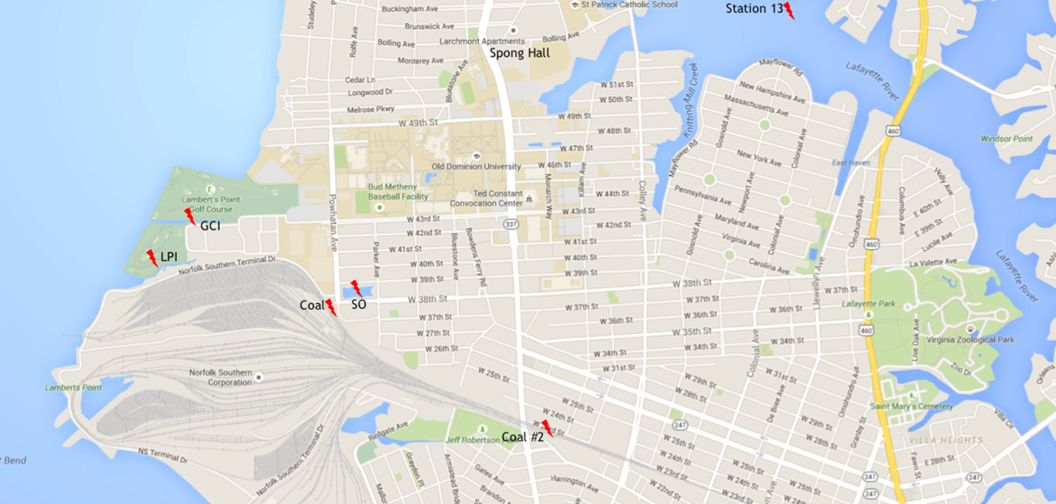
Figure 1. Sediment, wet and dry deposition, and coal sampling sites.

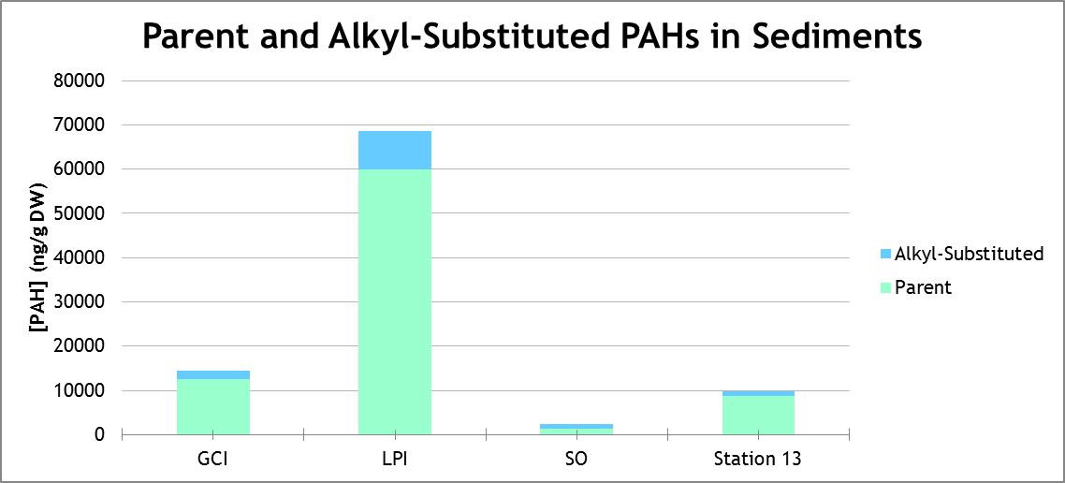
Figure 2. Parent and alkyl-substituted PAHs in sediments.

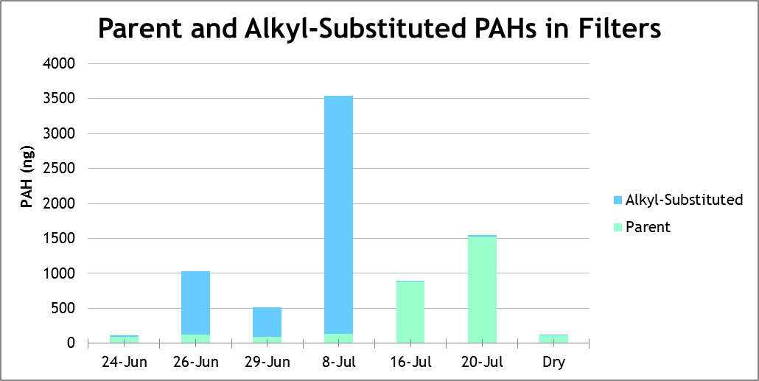
Figure 3. Parent and alkyl-substituted PAHs in filters.
Note: “Dry” is the dry deposition sample. All other samples are wet deposition.

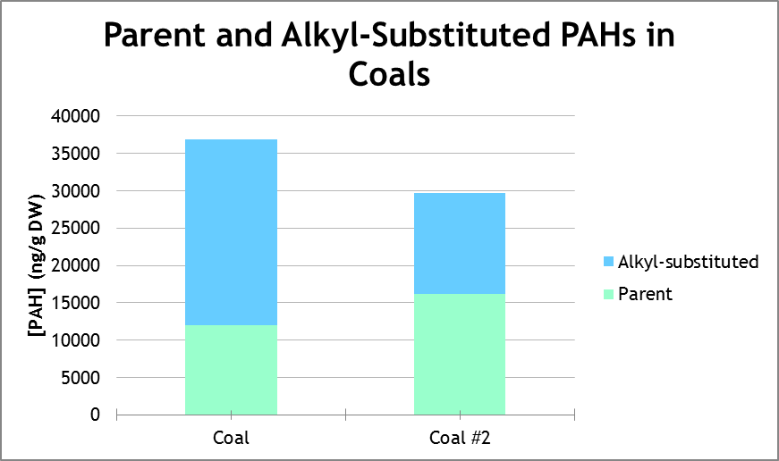
Figure 4. Parent and alkyl-substituted PAHs in coals.

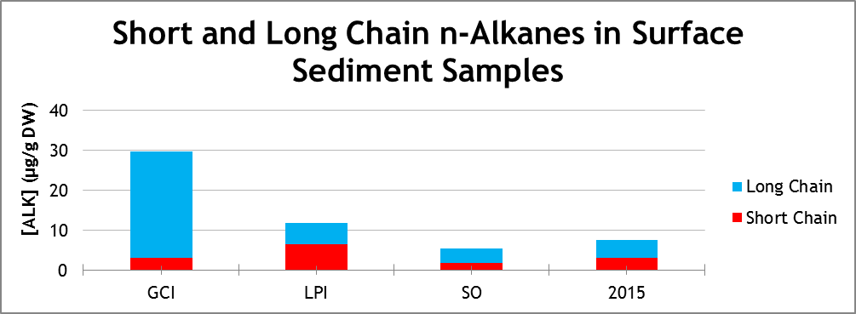 Figure 5. Short and long chain n-alkanes in surface sediment samples.

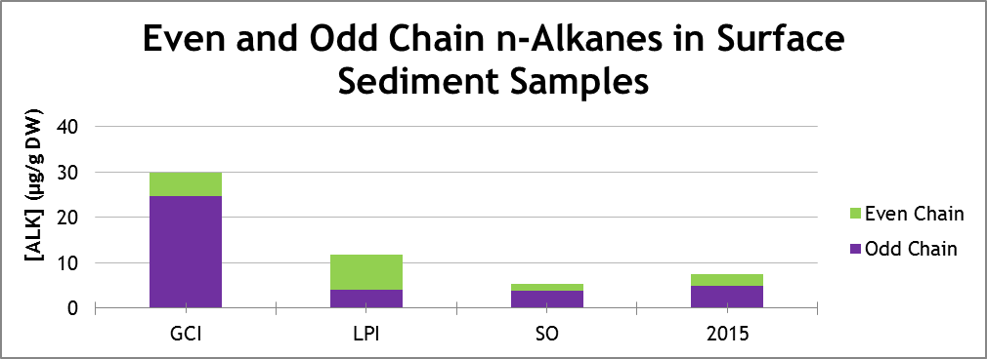
Figure 6. Even and odd chain n-alkanes in surface sediment samples.

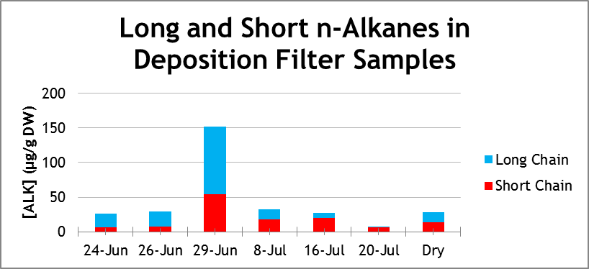
Figure 7. Long and short chain n-alkanes in deposition filter samples.
Note: “Dry” is the dry deposition sample. All other samples are wet deposition.

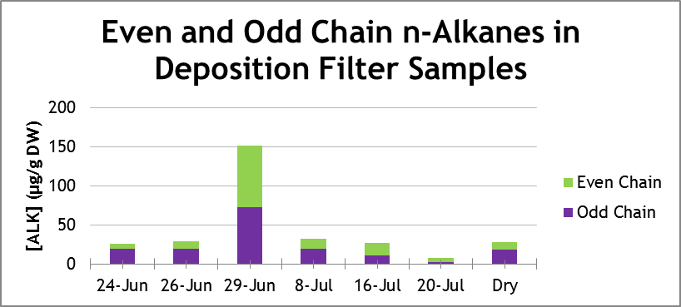
Figure 8. Even and odd chain n-alkanes in deposition filter samples.
Note: “Dry” is the dry deposition sample. All other samples are wet deposition.

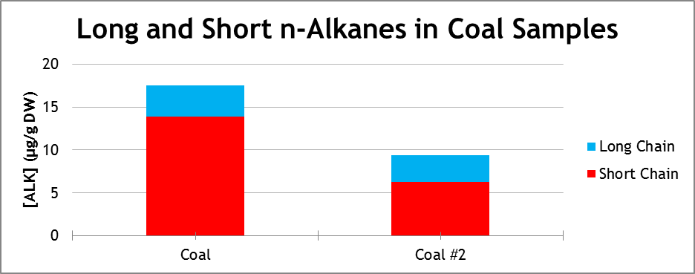
Figure 9. Long and short chain n-alkanes in coal samples.

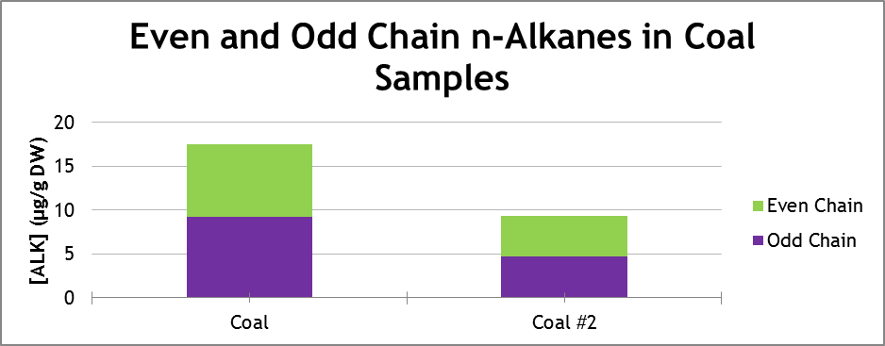
Figure 10. Even and odd chain n-alkanes in coal samples.

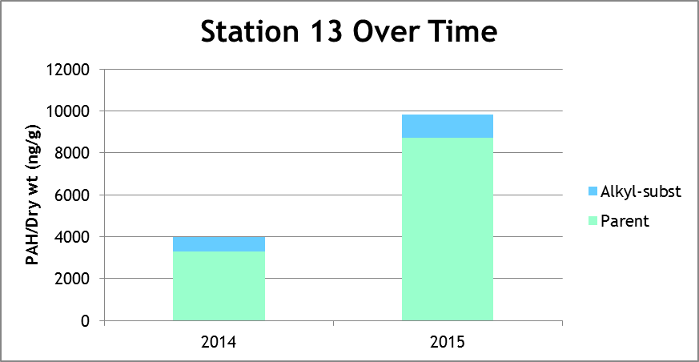
Figure 11. Station 13 PAHs over time.

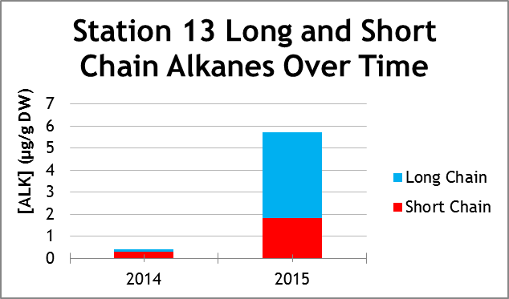
Figure 12. Station 13 long and short chain n-alkanes over time.

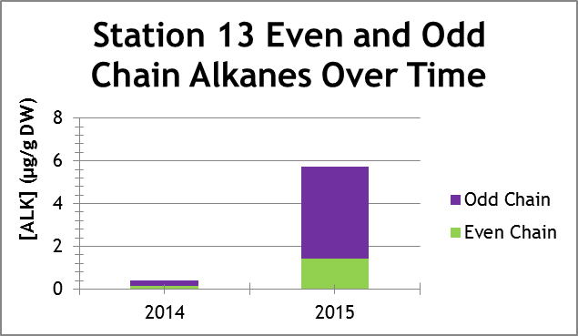
Figure 13. Station 13 even and odd chain n-alkanes over time.
Appendix II
Sampling Site | Latitude (°) | Longitude (°)
Golf Course Inlet (GCI) | 36.883051 | 76.320748
Lamberts Point Inlet (LPI) | 36.881043 | 76.321432
SO (Storm Overflow) | 36.879534 | 76.310977
Station 13 - 2014 | 36.899836 | 76.291058
Spong Hall | 36.890805 | 76.304399
Coal | 36.878659 | 76.312434
Coal #2 | 36.873215 | 76.299367
Table 1. Sampling site locations.
Rain Event | Type | Filtered Date | # of Filters | Rain Volume (L)
20 & 23 June | wet | 24 June | 4 | 4.25
25 & 26 June | wet | 26 June | 2 | 2.25
27 June | wet | 29 June | 2 | 1.95
4 & 5 July | wet | 8 July | 2 | 2.30
11 & 13 July | wet | 16 July | 2 | 1.75
28 July | wet | 20 July | 1 | 0.30
 | dry | 20 July | 4
Table 2. Wet and dry deposition collection details.
Rain Event Date | Wind Coming From | Wind Moving Toward | Wind Speed (kn)
20 June | WNW | ESE | 8.94
23 June | SW | NE | 6.92
25 June | S | N | 1.36
26 June | WSW | ENE | 7.97
27 June | E | W | 14.00
4 July | W | E | 14.97
5 July | ENE | WSW | 13.69
11 July | WSW | ENE | 0.97
13 July | S | N | 5.83
18 July | SW | NE | 9.14
Table 3. Wind directions near on dates of rain events (Winds at 8638511).
in ng/g DW | GCI | LPI | SO | Station 13
Parent | 12571.87 | 60003.76 | 1435.80 | 9944.95
Percent Parent | 87.26 | 87.54 | 58.97 | 86.79
Alkyl-Substituted | 1836.28 | 8539.31 | 998.95 | 1514.18
Percent Alkyl-Substituted | 12.74 | 12.46 | 41.03 | 13.21
Total PAH | 14408.16 | 68543.07 | 2434.75 | 11459.13
Table 4. PAH content of surface sediment samples.
in ng/g DW | GCI | LPI | SO | Station 13
2-Ring Parent | 125.15 | 427.59 | 23.62 | 12.35
2-Ring Alkyl-substituted | 545.55 | 967.51 | 331.96 | 69.25
2-Ring PAH Totals | 670.70 | 1395.10 | 355.58 | 81.61
3-Ring Parent | 269.70 | 4819.31 | 140.61 | 161.60
3-Ring Alkyl-substituted | 301.32 | 2429.61 | 341.89 | 679.73
3-Ring PAH Totals | 571.02 | 7248.92 | 482.50 | 841.33
4-RingParent | 4203.14 | 24116.02 | 644.56 | 5256.24
4-Ring Alkyl-substituted | 568.36 | 3508.61 | 62.13 | 765.20
4-Ring PAH Totals | 4771.50 | 27624.63 | 706.69 | 6021.44
5-Ring PAH Totals | 6840.11 | 27982.29 | 545.75 | 4514.74
6-Ring PAH Totals | 1221.46 | 2658.54 | 2658.54 | 0.01
Table 5. PAH ring breakdown of surface sediment samples.
in ng | 24 Jun | 26 Jun | 29 Jun | 8 Jul | 16 Jul | 20 Jul | Dry
Parent | 89.80 | 129.88 | 89.80 | 135.88 | 901.60 | 1510.32 | 899.06
Percent Parent | 85.23 | 14.71 | 22.92 | 4.69 | 99.04 | 98.65 | 86.59
Alkyl-Substituted | 15.56 | 752.87 | 301.95 | 2762.37 | 8.73 | 20.71 | 139.23
Percent Alkyl-Substituted | 14.77 | 85.29 | 77.08 | 95.31 | 0.96 | 1.35 | 13.41
Total PAH | 105.36 | 882.75 | 391.74 | 2898.25 | 910.33 | 1531.03 | 1038.30
Table 6. PAH content of wet and dry deposition samples.
in ng | 24 Jun | 26 Jun | 29 Jun | 8 Jul | 16 Jul | 20 Jul | Dry
2-Ring Parent | 0.75 | 0.03 | 2.10 | 2.16 | 17.36 | 87.98 | 0.66
2-Ring Alkyl-substituted | 9.43 | 32.10 | 29.56 | 620.82 | 3.32 | 11.39 | 1.97
2-Ring PAH Totals | 10.18 | 32.13 | 31.65 | 622.97 | 20.69 | 99.37 | 2.63
3-Ring Parent | 22.47 | 77.22 | 65.90 | 110.67 | 4.75 | 34.96 | 13.23
3-Ring Alkyl-substituted | 3.49 | 419.07 | 205.17 | 1657.56 | 1.44 | 7.08 | 4.11
3-Ring PAH Totals | 25.95 | 496.28 | 271.07 | 1768.23 | 6.19 | 42.05 | 17.34
4-RingParent | 24.91 | 34.87 | 16.92 | 15.67 | 56.79 | 42.30 | 823.26
4-Ring Alkyl-substituted | 2.64 | 301.71 | 67.22 | 483.99 | 3.96 | 2.23 | 133.16
4-Ring PAH Totals | 27.55 | 336.59 | 84.14 | 499.66 | 60.75 | 44.53 | 956.42
5-Ring PAH Totals | 41.19 | 17.72 | 4.51 | 7.33 | 763.56 | 1115.08 | 59.43
6-Ring PAH Totals | 0.48 | 0.03 | 0.37 | 0.05 | 59.14 | 230.00 | 2.47
Table 7. PAH ring-breakdown of wet and dry deposition samples.
in ng/g DW | Coal | Coal #2
Parent | 11988.77 | 16121.09
Percent Parent | 32.48 | 54.30
Alkyl-Substituted | 24925.70 | 13568.73
Percent Alkyl-Substituted | 67.52 | 45.70
Total | 36914.47 | 29689.82
Table 8. PAH content of coal samples.
in ng/g DW | Coal | Coal #2
2-Ring Parent | 2122.99 | 2945.05
2-Ring Alkyl-substituted | 8493.05 | 8196.32
2-Ring PAH Totals | 10616.04 | 11141.37
3-Ring Parent | 5247.61 | 4901.51
3-Ring Alkyl-substituted | 6611.28 | 4155.20
3-Ring PAH Totals | 11858.88 | 9056.71
4-RingParent | 2902.27 | 0.00
4-Ring Alkyl-substituted | 1827.19 | 15.19
4-Ring PAH Totals | 4729.46 | 15.19
5-Ring PAH Totals | 1587.37 | 2481.10
6-Ring PAH Totals | 128.53 | 0.67
Table 9. PAH ring-breakdown of coal samples.
in μg/g DW | GCI | LPI | SO | Station 13
Short Chain (C₁₃-C₂₂) | 27.27 | 5.53 | 3.88 | 4.92
Percent Short | 10.20 | 54.35 | 32.98 | 42.05
Long Chain (C₂₃-C₃₃) | 29.99 | 11.88 | 5.36 | 7.61
Percent Long | 89.80 | 45.65 | 67.02 | 57.95
Total | 57.25 | 17.41 | 9.23 | 12.53
Odd Chain Alkanes | 3.78 | 1.69 | 1.07 | 1.29
Percent Odd | 82.72 | 35.08 | 73.84 | 65.08
Even Chain Alkanes | 52.47 | 15.20 | 8.34 | 11.28
Percent Even | 17.28 | 64.92 | 26.16 | 34.92
Table 10. n-alkane content of surface sediment samples.
in μg/g DW | 24 Jun | 26 Jun | 29 Jun | 8 Jul | 16 Jul | 20 Jul | Dry
Short Chain (C₁₃-C2₂) | 6.20 | 7.23 | 54.02 | 17.78 | 9.92 | 6.49 | 13.50
Percent Short | 23.70 | 24.79 | 35.56 | 55.32 | 70.75 | 84.59 | 48.55
Long Chain (C₂₃-C₃₃) | 19.97 | 21.94 | 97.88 | 14.36 | 27.76 | 1.18 | 14.30
Percent Long | 76.30 | 75.21 | 64.44 | 44.68 | 29.25 | 15.41 | 51.45
Total | 26.17 | 29.18 | 151.90 | 32.14 | 37.68 | 7.67 | 27.80
Odd Chain Alkanes | 19.15 | 20.13 | 72.85 | 19.16 | 32.83 | 2.85 | 18.22
Percent Odd | 73.16 | 69.00 | 47.96 | 59.62 | 38.99 | 37.15 | 65.54
Even Chain Alkanes | 7.03 | 9.05 | 79.05 | 12.98 | 2.66 | 4.82 | 9.58
Percent Even | 26.84 | 31.00 | 52.04 | 40.38 | 61.01 | 62.85 | 34.46
Table 11. n-alkane content of wet and dry deposition samples.
in μg/g DW | Coal | Coal #2
Short Chain (C₁₃-C₂₂) | 13.84 | 6.30
Percent Short | 79.20 | 67.12
Long Chain (C₂₃-C₃₃) | 3.64 | 3.09
Percent Long | 20.80 | 32.88
Total | 17.48 | 9.39
Odd Chain Alkanes | 9.18 | 4.72
Percent Odd | 52.50 | 50.30
Even Chain Alkanes | 8.30 | 4.66
Percent Even | 47.50 | 49.70
Table 12. n-alkane content of coal samples.
Sediment Sample | % PN | % PC
GCI | 0.34 | 3.96
LPI | 0.25 | 9.32
SO | 0.07 | 0.71
Coal | 0.57 | 21.60
Coal #2 * | 0.89 | 45.45
Table 13. Percent particulate nitrogen and carbon for sediment and coal samples.
* average of four trials

Sample | CPI
24 June | 6.76
26 June | 5.12
29 June | 1.66
8 July | 2.27
16 July | 1.62
20 July | 2.28
Dry | 3.49
GCI | 5.90
LPI | 1.52
SO | 4.56
Station 13 | 4.07
Coal | 1.12
Coal 2 | 1.82
Table 14. Carbon Preference Index of sediment, wet and dry deposition, and coal samples.

in ng/g dry weight | 2014 | 2015
Parent | 3308.9 | 8733.4
Percent Parent | 82.76 | 88.67
Alkyl-Substituted | 689.2 | 1115.4
Percent Alkyl-Substituted | 17.24 | 11.32
Total | 3998.2 | 9849.6
Table 15. Station 13 PAH data over time.

in μg/g DW | 2014 | 2015
Short Chain (C₁₃-C₂₂) | 129.49 | 24.93
Percent Short | 31.34 | 42.05
Long Chain (C₂₃-C₃₃) | 283.74 | 30.22
Percent Long | 68.66 | 57.95
Total | 413.23 | 55.16
Odd Chain Alkanes | 306.29 | 22.35
Percent Odd | 74.12 | 65.08
Even Chain Alkanes | 106.94 | 32.76
Percent Even | 25.88 | 34.92
Table 16. Station 13 n-alkane data over time.

Sample | FLA/PYR | FLA/(PYR + FLA) | IcdP/(IcdP + BghiP)
24 June | 1.31 | 0.57 | 0.50
26 June | 1.11 | 0.53 | 0.31
29 June | 0.55 | 0.35 | 0.60
8 July | 0.35 | 0.26 | 0.11
16 July | 252.86 | 1.00 | 0.62
20 July | 118.24 | 0.99 | 0.63
Dry | 1.37 | 0.58 | 0.01
GCI | 1.18 | 0.54 | 0.87
LPI | 1.30 | 0.56 | 0.73
SO | 1.17 | 0.54 | 0.51
Station 13 | 1.13 | 0.53 | 0.00
Coal | 1.21 | 0.55 | 1.00
Coal #2 | 1.46 | 0.59 | 1.00
Table 17. Additional PAH calculations.

Appendix III
List of Tested PAHs | Parent/Alkyl-Sub | Molecular Weight (g/mol) | Number of Rings
Naphthalene | Parent | 128 | 2
1-Methylnaphthalene | Alkyl-Sub | 142 | 2
2-Methylnaphthalene | Alkyl-Sub | 142 | 2
Biphenyl | Parent | 154 | 2
Acenapthene | Parent | 154 | 3
Acenaphthylene | Parent | 152 | 3
1-Ethylnaphthalene | Alkyl-Sub | 156 | 2
Dimethylnaphthalene | Alkyl-Sub | 156 | 2
Trimethylnaphthalene | Alkyl-Sub | 170 | 2
Fluorene | Parent | 166 | 3
Dibenzothiophene | Parent | 184 | 3
Methylfluorene | Alkyl-Sub | 180 | 3
Phenanthrene | Parent | 178 | 3
Anthracene | Parent | 178 | 3
Methyldibenzothiophene | Alkyl-Sub | 198 | 3
Methylphenanthrene | Alkyl-Sub | 192 | 3
Methylanthracene | Alkyl-Sub | 192 | 3
3,5-Dimethylphenanthrene | Alkyl-Sub | 206 | 3
2,6-Dimethylphenanthrene | Alkyl-Sub | 206 | 3
2,7-Dimethylphenanthrene | Alkyl-Sub | 206 | 3
3,9-Dimethylphenanthrene | Alkyl-Sub | 206 | 3
1,6-Dimethylphenanthrene | Alkyl-Sub | 206 | 3
1,7-Dimethylphenanthrene | Alkyl-Sub | 206 | 3
4,9 & 1,9-Dimethylphenanthrene | Alkyl-Sub | 206 | 3
1,8-Dimethylphenanthrene | Alkyl-Sub | 206 | 3
1,2-Dimethylphenanthrene | Alkyl-Sub | 206 | 3
Fluoranthene | Parent | 202 | 4
Pyrene | Parent | 202 | 4
8-Methylfluoranthene | Alkyl-Sub | 216 | 4
7-Methylfluoranthene | Alkyl-Sub | 216 | 4
1-Methylfluoranthene | Alkyl-Sub | 216 | 4
3-Methylfluoranthene | Alkyl-Sub | 216 | 4
2-Methylpyrene | Alkyl-Sub | 216 | 4
4-Methylpyrene | Alkyl-Sub | 216 | 4
1-Methylpyrene | Alkyl-Sub | 216 | 4
Benzo[c]phenanthrene | Parent | 228 | 4
Benz[a]anthracene | Parent | 228 | 4
Chrysene | Parent | 228 | 4
Triphenylene | Parent | 228 | 4
Methyl-benz[a]anthracene | Alkyl-Sub | 242 | 4
Methylchrysene | Alkyl-Sub | 242 | 4
Benzo[b]fluoranthene | Parent | 252 | 5
Benzo[k]fluoranthene | Parent | 252 | 5
Benzo[a]fluoranthene | Parent | 252 | 5
Benzo[e]pyrene | Parent | 252 | 5
Benzo[a]pyrene | Parent | 252 | 5
Perylene | Parent | 252 | 5
Anthanthrene | Parent | 276 | 6
Benzo(g,h,i)perylene | Parent | 276 | 6
Indo(1,2,3,cd)pyrene | Parent | 276 | 6
Dibenzo(a,j)anthracene | Parent | 278 | 5
Dibenzo(a,h)anthracene | Parent | 278 | 5
Benzo(b)chrysene | Parent | 278 | 5
Picene | Parent | 278 | 5
Total Parent | 27
Total Alkyl-Sub | 27
Total Examined PAHs | 54

Appendix IV
List of Tested n-Alkanes | Alkane/Alkene
C13 | Alkane
C13:1 | Alkene
C14 | Alkane
C14:1 | Alkene
C15 | Alkane
C15:1 | Alkene
C16 | Alkane
C16:1 | Alkene
C17 | Alkane
C17:1 | Alkene
C18 | Alkane
C18:1 | Alkene
C19 | Alkane
C19:1 | Alkene
C20 | Alkane
C20:1 | Alkene
C21 | Alkane
C21:1 | Alkene
C22 | Alkane
C22:1 | Alkene
C23 | Alkane
C23:1 | Alkene
C24 | Alkane
C24:1 | Alkene
C25 | Alkane
C25:1 | Alkene
C26 | Alkane
C26:1 | Alkene
C27 | Alkane
C27:1 | Alkene
C28 | Alkane
C28:12 | Alkene
C29 | Alkane
C29:1 | Alkene
C30 | Alkane
C30:1 | Alkene
C31 | Alkane
C31:1 | Alkene
C32 | Alkane
C32:1 | Alkene
C33 | Alkane
C33:1 | Alkene
Total Alkanes | 21
Total Alkenes | 21
Total Examined n-Alkanes | 42

