Polycyclic aromatic and aliphatic hydrocarbons in Lafayette River sediment and Chesapeake blue crabs, Callinectes sapidus
Carrie O. Pfleiger
Abstract
To further knowledge of the Lafayette River, this study determined the concentrations and distributions of polycyclic aromatic hydrocarbons (PAHs) and aliphatic n-alkanes in surface sediments (0-2 cm) among 18 sites in the Lafayette River and in muscle and hepatopancreas tissues of the benthic blue crab (Callinectes sapidus) from two stations in the river. The total concentrations of PAHs in surface sediments in the Lafayette River included parent and alkyl-substituted compounds, and were in the range of 0.8 µg g¯¹ – 39.0 μg g¯¹ dry wt. Parent PAHs were dominant in all surface sediments (72 -91%). Total concentrations of aliphatic n-alkanes included long and short-chain alkanes (C₁₆ – C₃₁), and were in the range of 4.94 μg g¯¹ – 40.83 μg g¯¹ dry wt. Long-chain alkanes dominated in surface sediments except for three stations. Also, odd, long-chain alkanes dominated over even, long-chain alkanes at every sediment station (77 – 87%). Surface sediment samples were normalized using percent organic carbon, but the results only showed minute changes after normalization. In blue crab tissue, low concentrations of PAHs and n-alkanes were observed (1.1 μg g¯¹ – 6.25 μg g¯¹ dry wt.) with the exception of hepatopancreas tissue from the KC site which had concentrations of 28.74 μg g¯¹ and 36.50 μg g¯¹ dry wt. Data was compared to historical studies and found mixed results.
- Introduction
The Lafayette River watershead is unique in that it is contained within the urban area of Norfolk, Virginia which is home to more than 245,000 residents. On the river itself, are 1134 residential homes and other places such as schools, parks, community centers, churches, the Virginia Zoo, and the Norfolk Yacht and Country Club (Vogelbein et al. 2008 and cbf.org). The Lafayette River is directly connected to the highly industrialized Elizabeth River that houses the Port of Virginia and the Norfolk Naval Base (cbf.org). The Hampton Roads Sanitation District has a municipal wastewater treatment facility that empties in the Elizabeth River above the mouth of the Lafayette River (Vogelbein et al. 2008). The wastewater treatment plant has a capacity of 43,000 gallons per day (hrsd.com). Swimming and fishing in the Lafayette River are currently prohibited because of high enteric bacteria counts, and the Chesapeake Bay Foundation and Elizabeth River Project are hoping to make the Lafayette River swimmable and fishable by late 2014. They also hope to allow shellfish harvesting by 2020 (Vogelbein et al. 2008). Measures have been taken towards reaching their goals. This includes: Multiple living shorelines have been planted along the Lafayette River to restore the wetland habitat, oyster reef balls are being implanted into the river, rain gardens are being planted in the watershed, and trees are being planted (cbf.org). There is currently a monitoring program in the Elizabeth River, but no data in the Lafayette River concerning organic contaminants. With this knowledge in mind, the quality of the river’s sediment and benthic creatures is worth examining.
Organic contaminants are ubiquitous in the environment, with levels dependent on, anthropogenic and natural pollution. Specifically n-alkanes and polycyclic aromatic hydrocarbons (PAHs) were examined from the Lafayette River. Normal-alkanes are hydrocarbons that come from emissions of vegetation and combustion of fossil fuels (Wang et al. 2006). Natural sources of alkanes include terrestrial plant waxes, marine phytoplankton, volcanic eruptions, biomass combustion, and natural oil seeps (Tolosa et al. 2004). No previous studies were found on n-alkanes in the Lafayette River. In addition to n-alkanes, PAHs are also a concern in the Lafayette River.
PAHs can occur naturally through oil seeps or terrestrial debris or can be anthropogenic contaminants from the combustion of fossil fuels (Harvey et al. 2014). There are two types of anthropogenic sources of PAHs. Petrogenic PAHs are from crude and refined petroleum and can reach rivers due to oil spills, tanker discharge, and urban runoff. Pyrogenic PAHs are from fossil fuel combustion and end up in rivers through vehicle exhaust and solid residues (Zakaria et al. 2002). PAHs do not break down easily and stay in the environment for hundreds of years, which allows them to stay in the sediment of the Lafayette River (US EPA 2008). Aside from their deposition in the environment, PAHs are byproducts in the making of dyes, plastics, and pesticides which all have their own effects on the environment (US EPA 2008). Humans can be exposed to PAHs through aerosols from vehicle exhaust, coal, asphalt, eating food grown in contaminated soil, or touching contaminated soil (US EPA 2008). Previous studies have been done concerning PAHs in river sediments in the Elizabeth River, but none have been done as far as the Lafayette River. Since PAHs accumulate in the soil of rivers, people should also be concerned with PAHs in benthic creatures.
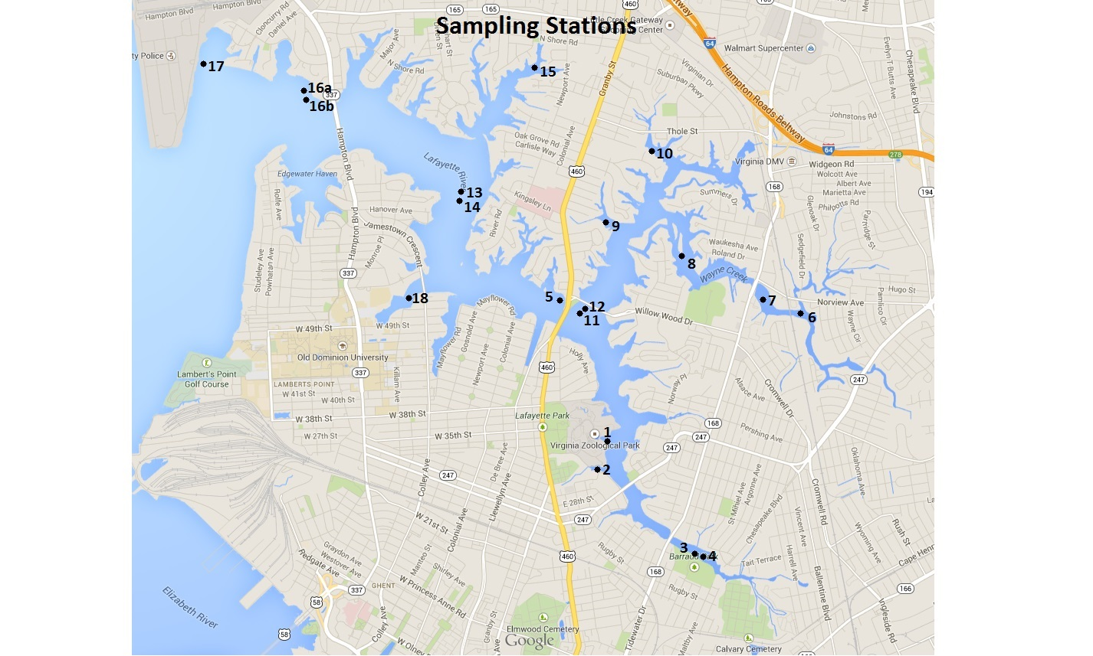
In addition to exposure by aerosols and plant material, both PAHs and alkanes can be present in animals living in the environment. The blue crab (Callinectes sapidus) is an epibenthic omnivore that is exposed to organic contaminants from sediments, the water column, and their food (Mothershead II et al 1991). They are found from Nova Scotia to Argentina and live 2-3 years (NOAA and Helz and Huggett 1987). During their larval stages, blue crabs live in high salinity environments off-shore, and then they move in to the estuary as they grow (NOAA). Blue crabs are heavily fished in the Chesapeake Bay region, and in Virginia in 2011, 28.4 million pounds of blue crabs were commercially harvested. They must be five inches in carapace length in order to keep (NOAA). Blue crabs are a popular delicacy, yet there is limited information on the levels of organic contaminants in these creatures (Mothershead II et al. 1991). PAHs and n-alkanes are toxic to aquatic life and carcinogenic to humans (Kimbrough and Dickhut 2006). Previous studies involving blue crabs and PAHs in the Elizabeth River, but none have been done in the Lafayette River or involving n-alkanes. There is a lack of quantitative information in the Lafayette River, hence the importance of this study.
- Material and methods
  - Sample collection
Fig. 1. A map of station locations sampled during the summer of 2014 for aromatic and aliphatic hydrocarbons.
2.1.1 Sediment
A total of 19 surface sediment samples were collected from the Lafayette River during the summer of 2014. Surface sediment samples were collected in the Lafayette River using a hand-held coring device, and the deepest stations (Station 16a and 16b) were collected using a sediment grab. The top two centimeters of sediment were removed from the top of the tube and placed in pre-cleaned plastic I-Chem jars with Teflon-lined screw caps. The sediments were immediately frozen in a ‾ 70 ̊ C chest freezer.

Table 1
Sampling locations and descriptions of sediment collected in the Lafayette River
Station Name | Sampling Date | Latitude (N) | Longitude (W) | Water Depth (m) | % Organic Carbon | % Water
1 | 6/11/2014 | 36.877097 | 76.274525 | 1 | 3.11 | 63.70
2 | 6/11/2014 | 36.875071 | 76.275126 | <1 | 5.77 | 73.46
3 | 6/11/2014 | 36.867295 | 76.264837 | <1 | 4.84 | 76.95
4 | 6/11/2014 | 36.866814 | 76.263721 | <1 | 5.42 | 77.20
5 | 6/11/2014 | 36.890260 | 76.280329 | <1 | 2.12 | 61.28
6 | 6/24/2014 | 36.888990 | 76.253207 | <1 | 7.16 | 74.98
7 | 6/24/2014 | 36.890535 | 76.257284 | <1 | 5.51 | 78.55
8 | 6/24/2014 | 36.894104 | 76.266382 | <1 | 3.95 | 71.75
9 | 6/24/2014 | 36.896987 | 76.274922 | <1 | 3.70 | 67.09
10 | 6/24/2014 | 36.903714 | 76.269858 | <1 | 3.80 | 69.62
11 | 7/2/2014 | 36.889025 | 76.278527 | 3 | 2.56 | 62.97
12 | 7/2/2014 | 36.889368 | 76.277668 | 3 | 2.50 | 66.02
13 | 7/2/2014 | 36.899836 | 76.291058 | 4 | 2.54 | 60.60
14 | 7/2/2014 | 36.899321 | 76.291444 | 4 | 0.96 | 33.51
15 | 7/2/2014 | 36.911126 | 76.282947 | 1 | 3.51 | 65.03
16a | 7/2/2014 | 36.909239 | 76.308353 | 6 | 0.88 | 43.47
16b | 7/2/2014 | 36.907454 | 76.305907 | 6 | 1.63 | 58.79
17 | 7/2/2014 | 36.911538 | 76.320198 | 2 | 1.49 | 48.89
18 | 7/2/2014 | 36.89002 | 76.297152 | <1 | 4.53 | 67.56

2.1.2 Crabs
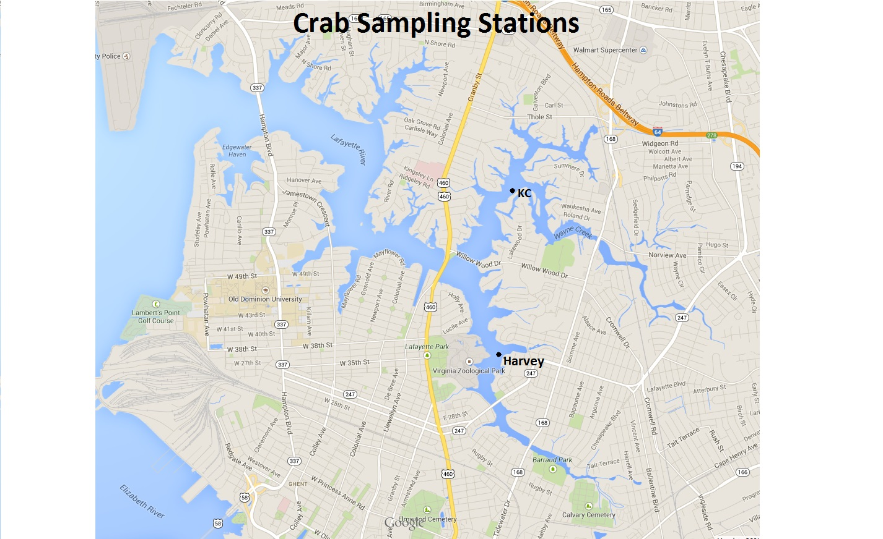
Crabs were collected during the week of July 7th 2014 using crab traps at two locations in Lafayette River. The crabs were placed directly into a freezer ( ‾ 18 - ‾ 20 ̊ C) until they were dissected. The crabs were taken out of the freezer and placed in a refrigerator two hours prior to dissection. They were dissected using scissors, a scalpel, and forceps. Muscle tissue from the claws and back fin was collected and placed in pre-cleaned plastic I-Chem jars with Teflon-lined screw caps. Muscle tissue from the Harvey site was composited and placed in one jar. The same was done for the muscle tissue from the KC site. The Hepatopancreas was dissected and placed in pre-cleaned plastic I-Chem jars with Teflon-lined screw caps. Hepatopancreas tissue was composited for each site and placed in jars for each site. All tissue was immediately frozen after dissection.
Fig. 2. A map of crab station locations sampled for aromatic and aliphatic hydrocarbons. See Table 1 for details on locations and sediment.

  - Analysis of hydrocarbons in sediments and crabs
    - Extraction of hydrocarbons
Analysis of PAHs and alkane hydrocarbons followed the approach of Harvey et al., (2014) with modifications. Samples were freeze dried for at least 48 hours in I-Chem jars. Each sample was homogenized and made into a fine powder before any chemical work was done. About 5 g of freeze dried sediment were placed in Green Chem glass vessels with a stir bar and a mixture of hexane:acetone (1:1, 30 mL) (refinement of EPA Method 3546). Six perdeuterated reference compounds were added to the vessels (acenapthene-d₁₀, phenathrene-d₁₀, benz(a)anthraecene-d₁₂, benzo(a)pyrene-d₁₂, and benzo(g,h,i)perylene-d₁₂) as internal standards for quantification of PAHs and n-alkanes (refinement of EPA Method 8270). Sediment and crab samples were extracted (80 ̊ C for 30 min) using a MARS microwave accelerated extraction system (CEM Corp., Matthews, NC). Cooled extracts were filtered into solvent rinsed round-bottom flasks using pre-cleaned and combusted glass wool. Two additional rinses of extraction vessel using hexane:acetone (1:1) were added to the extracts. Extracts were then concentrated using rotary evaporation and transferred three times to solvent rinsed 8 mL amber vials. The solvent volume was reduced using nitrogen gas. Total extracts were then split for analysis of PAHs and n-alkanes.
    - Gas chromatography – mass spectrometry analysis of PAHs
PAHs were analyzed by capillary gas chromatography (GC) with an Agilent 7890A system coupled to an Agilent 5975C Network Mass Selective Detector (MS) in electron ionization mode. The GC-MS has a J&W Scientific DB-5MS fused silica column (60 m, 0,320 mm id, 0.25 film thickness) and operated in selected ion monitoring (SIM) mode. Samples were injected in splitless mode at an initial oven temperature of 50 ̊ C and an injector temperature of 250 ̊ C with helium as the carrier gas. The oven temperature was ramped at 15 ̊ C min ‾¹ to 120 ̊ C and then 3.5 ̊ C min ‾¹ to 300 ̊ C before holding at 300 ̊ C for 25 min. For quantification, the base peak area for individual PAH compounds was adjusted relative to the amount of internal standard added (refinement of EPA Method 8270D). Acidified sediments were sent to another lab where each station was analyzed for the percent organic carbon in each sample. The data was normalized to the percent organic carbon in the samples.
    - Purification and GC-FID/GC-MS analysis of n-alkanes
Solid phase extraction (SPE) was performed on the total lipid extracts for sediments and crab tissue using Strata SI-1 Silica (55um, 70A) Teflon-coated SPE columns (500 mg 3 mL ‾¹, Phenomenex) to purify the sample for n-alkanes. The alkane fraction was then concentrated using nitrogen gas and transferred three times to a 4 mL amber vial using hexane. Nitrogen gas was used again to concentrate the alkane fraction followed by a dilution to 200 µL using hexane which was transferred to auto-sampler vials. N-alkanes were quantified by capillary GC using an Agilent 7890A Network GC system with flame ionization detection (GC-FID). The GC column and temperature program was similar to that described above for the PAH analysis. Base peak area of n-alkanes was adjusted relative to the known concentration of perdeuterated internal standard added (n-Octadecane-d₃₈). Alkanes were identified in full-scan mode by GC-MS.
    - Quality assurance and quality control
Procedural blanks were processed alongside the experimental samples for each of the 3 sets of sediment samples and 1 set of crab tissue samples, which followed identical protocol. Procedural blanks were used to monitor potential contamination from laboratory procedures. Sediment reference material (NIST SRM #1944) with certified PAH values was also analyzed to evaluate the accuracy of the analysis.
- Results
  - Concentrations and distribution of PAHs in samples
    - Concentrations and distribution of PAHs in sediment
In this study, a total of 65 PAHs were detected in surface sediments. Concentrations of PAHs ranged from 0.8 µg g‾¹ dry wt. at station 14 to 39.0 µg g‾¹ dry wt. at station 2. Parent PAHs dominated at every station and accounted for 72 – 91% of total PAHs. There was no pattern based on location for the percentage of parent PAHs. There is a pattern that deep stations (1-6 m) have less total PAHs than shallow stations (<1m) (Fig. 3A). After normalizing sediment from each station using the %OC, the concentration of PAHs ranged from 166.7 µg g¯¹ OC at station 14 to 1687.1 µg g ¯¹ OC at station 16a (Fig. 3B). There was no pattern based on location or depth for the concentration of PAHs in the normalized sediments.
Fig. 3. The contribution and distribution of PAHs in surface sediments shown as the sum and relative contribution of both parent and alkyl-substituted compounds observed in each station. A. shows total PAH concentrations in μg/g dry wt. B. shows total PAH concentrations in μg/g OC. Individual concentrations are described in Appendix A.

    - Concentrations and distributions of PAHs in blue crabs
In total, 65 PAH compounds present in sediments were targeted for in crab muscle and hepatopancreas tissue, although some compounds were below the detection limit. Crab muscle from the Harvey site showed a total concentration of PAHs of 1.8 µg g¯¹ dry wt. tissue, and muscle from the KC site had a total concentration of PAHs of 1.2 µg g¯¹ dry wt. tissue. Samples from the hepatopancreas showed similar concentrations. Hepatopancreas tissue from the Harvey site showed a PAH concentration of 1.1 µg g¯¹ dry wt. tissue, while hepatopancreas from the KC site had a PAH concentration of 1.8 µg g¯¹ dry wt. tissue. Each sample except for the muscle tissue from the KC site showed parent PAHs as the dominant species. Where parent PAHs are the majority, parent PAHs accounted for 60 – 86 % of total PAHs (Fig. 4). Blue crab tissue was not normalized for % Organic carbon.
Fig. 4. The concentration and distribution of PAHs in crab tissue shown as the sum and relative contribution of both parent and alkyl-substituted compounds observed in each crab sample. Concentrations are included for sediment samples closest to crab sampling stations. Individual concentrations are described in Appendix A.
  - Aliphatic n-alkanes in samples
    - Aliphatic n-alkanes in sediments
Aliphatic normal-alkanes with 16-31 carbon atoms were detected in all sediment samples. Concentrations of n-alkanes ranged from 4.94 µg g¯¹ dry wt. at station 11 to 40.83 µg g¯¹ dry wt. at station 2. The distribution of short (C₁₆ – C₂₂) vs. long chain alkanes (C₂₃ – C₃₁) favored long chain alkanes with the exception of sites 5, 14, and 16a. Of the sites that have a majority of long chain alkanes, the percentages of long chain alkanes range from 51 – 85% (Fig. 6). There is an odd/even predominance in C₂₃ – C₃₁ alkanes. Percentages of odd, long chain alkanes over total long chain alkanes range from 77 – 87% (Fig. 5A). Sediment samples were normalized to the percent organic carbon in each sample. Using the normalized data, total concentrations of n-alkanes ranged from 192.92 µg g¯¹ OC at station 11 to 902.84 µg g¯¹ OC at station 16a (Fig. 5B). The percentages of long chain alkanes and the odd/even predominance in C₂₃ – C₃₁ alkanes did not change after the normalization of the data (Fig 6). No patterns in location or water depth were observed for the normalized data.
Fig. 5. The concentration and distribution of n-alkanes in surface sediments shown as the sum and relative contributions of both short and long chain alkanes observed in each station. A. shows total alkane concentrations in μg/g dry wt. B. shows total alkane concentrations in μg/g OC. Individual concentrations are described in Appendix B.
Fig. 6. The concentration and distribution of n-alkanes in surface sediments shown as the sum and relative contribution of both short and long chain alkanes observed in each station. Individual concentrations are described in Appendix B.

Fig. 6. The concentration and distribution of n-alkanes in surface sediments shown as the relative contributions of both long, even and long, odd chain alkanes observed in each station. A. shows total long-chain alkane concentrations in μg/g dry wt. B. shows total long-chain alkane concentrations in μg/g OC. Individual concentrations are described in Appendix B.
    - Aliphatic n-alkanes in blue crabs
Aliphatic normal-alkanes with 16-31 carbons were detected in each crab tissue sample. The concentration of total alkanes in muscle tissue from the Harvey site was 4.57 µg g¯¹ dry wt. tissue, and the muscle tissue from the KC site was 6.25 µg g¯¹ dry wt. tissue. The hepatopancreas tissue showed higher concentrations of total alkanes. The hepatopancreas from the Harvey site had a total alkane concentration of 28.74 µg g¯¹ dry wt. tissue, while the KC site showed a concentration of 36.50 µg g¯¹ dry wt. tissue (Fig. 7). Long chain alkanes were the dominant species in three of the four crab samples. The hepatopancreas from the KC site did not have a majority of long chain alkanes. There was a long odd/even chain predominance for C₂₃ – C₃₁ alkanes except for muscle tissue from the KC site (Fig. 8). Crab samples were not normalized using percent organic carbon.
Fig. 7. The concentration and distribution of n-alkanes in crab tissue shown as the sum and relative contribution of both short and long chain alkanes observed in each crab tissue sample. Concentrations are included for sediment samples closest to crab sampling stations. Individual concentrations are described in Appendix B.
Fig. 8. The concentration and distribution of n-alkanes in crab tissue shown as the relative contribution of both long, even and long, odd chain alkanes observed in each crab tissue sample. Individual concentrations are described in Appendix B.

- Discussion
  - PAHs in Lafayette River surface sediments
Previous studies have been done mainly on the highly urbanized Elizabeth River, but few have sampled in the Lafayette River (Vogelbein et al. 2008). Six stations in this study were compared to historic data from the same locations. Station 5 was found to have a higher concentration of total PAHs than a previous study in 1998 (Winfield 1998). To allow a realistic comparison of the different dates, a subset of the present results were matched with the same suite of structures from earlier studies. Compared to a study done in 2000, station 8 and 15 both have higher total PAH concentrations (NOAA). Stations 16a and 16b have higher total PAH concentrations than a study done in 1989 (NOAA). Station 17 was compared to a previous study from 2008, but showed lower total concentrations of PAHs now (Vogelbein et al. 2008). The study had a replicate for the station, and the two values from 2006 were very different (Fig. 9). The study from 2008 also normalized their sediment to percent organic carbon, so station 17 was compared to their normalized data. Station 17 now has a lower normalized PAH concentration than in 2006 (Fig. 10).
Fig. 9. The concentration of PAHs in surface sediments from this study and previous studies done at the same sampling sites.

Fig. 10. The concentrations of total PAHs at station 17 from a previous study in 2006 and present results.

In this study, parent PAHs were the major group found (Fig. 3). Parent PAHs are from pyrogenic sources including automobile emissions and combustion of fossil fuels (Zakaria et al. 2002). Phenanthrene, fluoranthene, pyrene, and high molecular weight PAHs (252, 276, and 278 g mol¯¹) were major contributors to the total PAH concentrations (Appendix A.) Fluoranthene and pyrene are both combustion PAHs (Van Metre et al. 2000). On the other hand, phenanthrene does not have one specific source, but it is possibly pyrolytic or a fossil fuel source depending on the temperature of formation (Notar et al. 2001). High molecular weight PAHs have been found to have pyrolytic sources (Soclo et al. 2000). The main contributors to the total PAH concentrations suggest a possible anthropogenic source, which is important because the impact on the environment can be controlled by humans.
Concentrations of PAHs in the Lafayette River were affected by water depth. The three highest concentrations of PAHs were in shallow areas (<1m) at stations 2, 6, and 18. The three lowest concentrations of PAHs were in deep areas of the river (1-6 m) at stations 13, 14, and 17 (Fig. 3A). This suggests that contaminants enter the river from non-point sources. Non-point pollution is when runoff from rainfall or irrigation flows over the land and through the ground, picking up pollutants and deposits them in the river (Pramhukumar and Pagilla 2010). The contaminants are deposited in areas close to the land, not in the middle of the river where it is deepest. There was no obvious pattern in PAH concentrations associated with living shorelines. Sediment from stations 1 and 18 was taken near living shorelines in the river. The living shoreline at station 1 has been in place since 2009, and it does not seem to be making a difference concerning organic contaminants because the total concentration of PAHs is not lower than other stations. Station 18 has had a living shoreline there since 2013, and does not make a difference in total PAH concentrations (elizabethriver.org).
A study done in 2006 gives insight to possible sources of PAHs in the Norfolk area. The study examined Elizabeth River sediments, which is the closest study to the Lafayette River. They found the main sources of PAHs in Elizabeth River sediments are creosote and coal, although automotive sources are dominant sources of PAHs in southern Chesapeake Bay region surface waters and air (Kimbrough and Dickhut 2006). Results of this study support the idea that coal and creosote are dominant sources of PAHs in the Elizabeth River area because there are high concentrations of fluoranthene and pyrene with lower levels of other high molecular weight PAHs (Kimbrough and Dickhut 2006). A study conducted in 2000 also found that sediments from the Southern Chesapeake Bay contained PAHs that were 86% coal derived and 14% auto derived (Dickhut et al. 2000). Past studies show that this study is consistent with past results.
  - PAHs in blue crabs
A mixture of PAHs were detected in both muscle and hepatopancreas tissue of blue crabs collected from the Lafayette River. Many of the PAHs seen in the sediments were below the detection limit in animal tissues. There was no obvious pattern in the specific PAHs that were detected. Also, there was no difference in total PAH concentrations between the muscle tissue and the hepatopancreas (Fig. 4). This similarity could be because the crabs were frozen for a few days and then dissected, as opposed to dissecting the crabs immediately after being collected. This practice may have allowed for some tissue to be indistinguishable.
A study done in 1991 found that crab tissues from eight out of their nine stations consisted predominantly of alkyl-substituted PAHs (Mothershead II et al. 1991). In the current study, that was not the case. Parent PAHs make up a majority of total PAHs. The station that had predominantly parent PAHs also had predominantly parent PAHs in the sediment from that station in the 1991 study. Parent PAHs made up a majority of total PAH concentrations across all sediment samples from the Lafayette River. Muscle tissue from the KC site was made up of mainly alkyl-substituted PAHs, and as suggested by Mothershead II in 1991, there is probably contamination from fuel oils. Aside from the sources of PAHs, the storage of PAHs in blue crabs is worth evaluating.
Samples were taken from blue crab muscle and hepatopancreas tissue. PAHs are lipophilic in nature and therefore accumulate more readily in the lipid-rich hepatopancreas, which is the decapod crustacean equivalent of the liver in a mammal, than in the lipid-poor muscle tissue (Mothershead II et al. 1991). The hepatopancreas is an active site of PAH metabolism. One would expect to find more PAHs in the hepatopancreas than the muscle tissue, and they did in the study from 1991. As mentioned before, this was not the outcome of this study.
  - N-alkanes in surface sediments
Aliphatic n-alkanes with 16 – 31 carbon atoms were detected in Lafayette River sediments. There have been no previous studies in the Lafayette or Elizabeth Rivers. In this study, long-chain alkanes were predominantly found except for stations 5, 14, and 16a (Fig. 5). According to a previous study, long-chain alkanes are a sign of vascular plant sources. The stations that had predominantly short-chain alkanes could have algae/bacteria and petrogenic sources. Specifically C₁₇ and C₁₉ have algal and photosynthetic bacterial activity sources, while even, short-chain alkanes suggest petroleum sources (Harvey et al. 2014). There is also a distinct pattern of more odd than even long-chain alkanes in the data (Fig. 6). This pattern suggests a terrestrial source (Harvey et. al. 2014). Lastly, the three highest concentrations of total n-alkanes were found at stations 2, 3, and 4, which were all in shallow areas (<1m water depth). The lowest concentrations of n-alkanes were found at stations 11, 14, and 17, which were all deep stations (1-6 m) (Fig. 5). These results support the evidence of terrestrial sources.
The results from this study are similar to another study performed on an urban river in China. In that study from 2011, long-chain alkanes predominated in surface sediments. Also, they found higher total concentrations of n-alkanes, but were including a larger suite of compounds (Guo et al. 2011). A comparison to a study done in the Arctic by Harvey et al. in 2014, the total concentrations of n-alkanes were much higher. There is little data concerning n-alkanes in surface sediments, but this study shows what one would expect for an urban river.
  - N-alkanes in blue crabs
Aliphatic n-alkanes with 16 – 31 carbon atoms were detected in blue crab muscle and hepatopancreas tissue. There were higher total concentrations of n-alkanes in the hepatopancreas than in the muscle tissue of crabs. Each station except hepatopancreas from the KC site consisted of predominantly long-chain alkanes (Fig. 7). There was an odd/even predominance for long-chain alkanes except for muscle tissue from the KC site (Fig. 8). As stated above, long-chain alkanes are a sign of vascular plant sources, and odd, long-chain alkanes suggest other terrestrial sources (Harvey et al. 2014).
- Summary
Lafayette River surface sediments contain PAHs from a mixture of anthropogenic and natural sources. PAHs likely reach the river through multiple pathways, and their concentrations are heavily influenced by the presence of many industries along the highly polluted Elizabeth River into which the Lafayette River feeds. Aliphatic n-alkane concentrations in Lafayette River surface sediments are similar to concentrations of PAHs. The presence of the industrialized Elizabeth River influences the sources of n-alkanes as well as many other terrestrial and plant-based sources. Blue crabs (Callinectus sapidus) from the Lafayette River contain a mixture of PAHs in lesser concentrations than the sediment, while the n-alkane concentrations are similar to that in the sediment.

Acknowledgements
This study was funded by the National Science Foundation and Old Dominion University. Special thanks to the MOGEL group.
Appendix A
See Table A1
Appendix B
See Table B1
References
Chesapeake Bay Foundation website. cbf.org.
Dickhut R, Canuel E, Gustafson K, Liu K, Arzayus K, Walker S, Edgecombe G, Gaylor M, MacDonald E. 2000. Automotive sources of carcinogenic polycyclic aromatic hydrocarbons associated with particulate matter in the Chesapeake bay region. Environ Sci Technol 34(21):4635-40.
Elizabeth River Project. April 27, 2011. http://media.wix.com/ugd/8de0fd_151722a794fc49b7baae15aa142dc396.pdf.
Guo W, He M, Yang Z, Lin C, Quan X. 2011. Aliphatic and polycyclic aromatic hydrocarbons in the xihe river, an urban river in china's shenyang city: Distribution and risk assessment. J Hazard Mater 186(2–3):1193-9.
Hampton Roads Sanitation District website. http://www.hrsd.com/treatmentplants.shtml.
Harvey HR, Taylor KA, Pie HV, Mitchelmore CL. 2014. Polycyclic aromatic and aliphatic hydrocarbons in chukchi sea biota and sediments and their toxicological response in the arctic cod, boreogadus saida. Deep Sea Research Part II: Topical Studies in Oceanography 102(0):32-55.
Helz GR and Huggett RJ. 1987. Contaminants in chesapeake bay: The regional perspective. .
Kimbrough KL and Dickhut RM. 2006. Assessment of polycyclic aromatic hydrocarbon input to urban wetlands in relation to adjacent land use. Mar Pollut Bull 52(11):1355-63.
Mothershead RF, Hale RC, Greaves J. 1991. Xenobiotic compounds in blue crabs from a highly contaminated urban subestuary. Environmental Toxicology and Chemistry 10(10):1341-9.
National Oceanic and Atmospheric Administration. August 2012. http://chesapeakebay.noaa.gov/fish-facts/blue-crab.
National Oceanic and Atmospheric Administration Office of Response and Restoration. Elizabeth River, Virginia. Database updated 24 March 2012. http://response.restoration.noaa.gov/environmental-restoration/environmental-assessment-tools/query-manager-marplot-data-maps.html.
Notar M, Leskovšek H, Faganeli J. 2001. Composition, distribution and sources of polycyclic aromatic hydrocarbons in sediments of the gulf of trieste, northern adriatic sea. Mar Pollut Bull 42(1):36-44.
Ololade I and Amoo I. 2008. Occurrence and toxicity of hydrocarbon residues in crab (callinectes sapidus) from contaminated site. Journal of Applied Sciences and Environmental Management 12(4).
Prabhukumar G and Pagilla K. 2010. Polycyclic aromatic hydrocarbons in urban Runoff–Sources, sinks and treatment: A review. Dep.of Civ., Archit.and Environ.Eng., Inst.of Tech: Chicago, IL .
Soclo HH, Garrigues P, Ewald M. 2000. Origin of polycyclic aromatic hydrocarbons (PAHs) in coastal marine sediments: Case studies in cotonou (benin) and aquitaine (france) areas. Mar Pollut Bull 40(5):387-96.
Tolosa I, de Mora S, Sheikholeslami MR, Villeneuve J, Bartocci J, Cattini C. 2004. Aliphatic and aromatic hydrocarbons in coastal caspian sea sediments. Mar Pollut Bull 48(1–2):44-60.
United States Environmental Protection Agency. January 2008. http://www.epa.gov/osw/hazard/wastemin/minimize/factshts/pahs.pdf.
Van Metre PC, Mahler BJ, Furlong ET. 2000. Urban sprawl leaves its PAH signature. Environ Sci Technol 34(19):4064-70.
Vogelbein W, Unger M, Gauthier D. 2008. The Elizabeth River monitoring program 2006–2007: Association between mummichog liver histopathology and sediment chemical contamination. Richmond, VA: Virginia Department of Environmental Quality .
Wang G, Huang L, Xin Zhao, Niu H, Dai Z. 2006. Aliphatic and polycyclic aromatic hydrocarbons of atmospheric aerosols in five locations of nanjing urban area, china. Atmos Res 81(1):54-66.
Winfield J. 1998. The Elizabeth River monitoring program, a baseline environmental study for an assessment of trends in contaminant concentrations and effects. Norfolk, VA: Old Dominion University.
Zakaria MP, Takada H, Tsutsumi S, Ohno K, Yamada J, Kouno E, Kumata H. 2002. Distribution of polycyclic aromatic hydrocarbons (PAHs) in rivers and estuaries in malaysia: A widespread input of petrogenic PAHs. Environ Sci Technol 36(9):1907-18.

