**Cyberthreats and how they influence our opinions on Cyber Policies**

Article 2 Review

Najee Shelton

Old Dominion University

CYSE 201S Cybersecurity and The Social Sciences

Pr. Diwakar Yalpi

April 12, 2025

It’s of no surprise that in technology today, there are a lot of online cyber policies in place to help maintain the integrity of a user’s computer system, some of the policies may seem unnecessary and long winded at times but they are put in place to help prevent the user from potentially falling victim to a data breech or any other type of cybercriminal activity. Due to the somewhat ambiguous nature that some cyber policies may contain, it can seem somewhat alienating causing a user to become confused, uninterested, or intrusive the user then proceeds to carry on their process without the proper protection needed. Due to the aforementioned issues mentioned earlier, users’ systems end up being compromised potentially causing massive amounts of damage, does this sort of cybercriminal activity entice a user to comply with cyber policies? that’s what “Cyber threats, Cyber-attacks, and Attitudes towards Cybersecurity policies” a Cyber security research article tries to answer.

The article helps prove that users become more compliant with policies by referencing certain studies that were conducted by the authors, one of which was a controlled randomized survey experiment. In the experiment there were 1022 israeli citizens who participated, about half of which were shown video news reports of cyberattacks that were lethal, while the other participants were shown videos of cyber-attacks that weren’t lethal, this study was conducted with the intent to understand the relationship that public media announcement of cyber-attacks has on Israeli citizens and how it can possibly influence their opinion on cybersecurity policy. Of the 1022 participants 387 participants were shown lethal videos, 374 were shown non-lethal, and the control group had 361 participants. Roughly 49.9% of the participants were male and 50.04% were female, on the political spectrum 44.35% were right wing, 38.28% were central winged, and about 17.37% were left winged. Due to the very diverse nature of the participants that were used to gather important information, it’s safe to assume that the data that was collected for this experiment was very accurate, while it’s true that data isn’t always accurate, and it can’t speak for everyone; having a large amount of participants, from different sides of the political spectrum, and having the gender ratio roughly even benefits the research as it allows for more diverse opinion and in turn results in more detailed and accurate data.

What Chart’s were used and how does this relate to principle of social sciences?

The article uses a chart known as a path analysis model, the intention of which is to show the relationship in which certain participants where expose to lethal control groups and non-lethal control groups, the image should be displayed down below. Having a physical representation, for readers to better understand a concept is always a benefit, with the image of the chart analysis shown below I now have a better understanding of how the control substances were treated, and their correlation to the people that viewed them. The social science concept I think this article represents the most similarly to the first article is Relativism. The reason I believe this concept to be the most predominant social concept is because, proceeding news events played a major role in the decisions users made when using resources online; users witness a user being a victim of a crime, the same user proceeds to be more compliant with policies online.

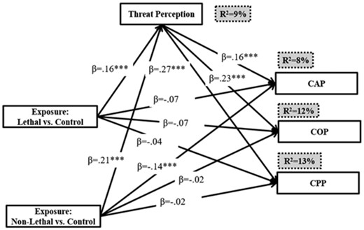

**Conclusion**

The article had the responsibility, of talking about a very common phenomena shared amongst most users online, that being certain policies may seem to be invasive, but when there seems to be a public announcement of a threat whether it be serious or minor, more users appear to be compliant. This topic is important because as mentioned earlier this is a very common trait that’s shared with people online they either don’t adhere to particular standards because the practices appear to be an invasion of privacy, or because they lose interest and don’t want to read all the guidelines, if websites could make the consequences of not following particular policies more easy to interpret, and explain why they have to use so many security measures to benefit them it could potentially result in an increase of obedience. A user should always be aware of potential dangers and consequences before they use resources online, but it should be told in a manor that will benefit them the most.

**Sources**

Canetti, Daphna. Shandler, Ryan. Snider, L G Karen. Zandani Shay . (October, 7th 2021) Cyberattacks, cyber threats, and attitudes toward cybersecurity policies

[**https://academic.oup.com/cybersecurity/article/7/1/tyab019/6382745?searchresult=1**](https://academic.oup.com/cybersecurity/article/7/1/tyab019/6382745?searchresult=1)