The dangers cyberbullying has on students, and the consequences of being bullied online

Article 1 Review

Najee Shelton
Old Dominion University
CYSE 201S Cybersecurity and The Social Sciences
Pr. Diwakar Yalpi
February 20, 2025

What Essay was Chosen?
The article I decided to write my review on is “Cyberbullying and cybullicide ideation among Jordanian college students”, a research article created in hopes of educating the reader about the impact cyberbullying has on students in Jordan, and the unfair consequences faced by such students who fall victim to cyberbullying. The reason I chose to review this article is because currently technology is very prominent, it’s very common to find children of this generation using electronic devices that can connect to the internet, and unfortunately there is a very real possibility that some of these children will fall victim to cyberbullying. The articles’ main purpose is to spread awareness to some of the characteristics some students may show when being bullied online, the emotion displayed by the victims vary but can provide a serious risk to their mental and physical health.

How was research conducted, what were the methods used to gather information?
Within the abstract of the article, a statistic was given of how many students across several universities within the country of Jordan were included in the study. The total amount being 1000 participants, 454 males and 546 females all receding from different schools and different ages. This is a very good ratio as it allows for more variety when pending the results from the study and can lead to more accurate analytics when it comes time to publish the article. The method used to obtain this data was by providing surveys to different students, all while explaining why the study was done and allowing participants of the survey to withdraw whenever they want. Providing the reason why the study is done, can be a great way to entice people to finish, or partake in the survey, considering this survey was conducted to help spread awareness to children and adults about the dangers cyberbullying may bring, according to the article a staggering 64% of students attending schools in Jordan have been victims of cyberbullying helping reduce this number and potentially saving lives may be all it takes to get another participant. Maintaining the participants integrity was another method used during these surveys; by doing this it allows participants to feel less pressured and can result in more accurate answers, as learned in class one of the biggest flaws with conducting surveys are dishonest answers that don’t accurately represent the participants thoughts and feelings.

What sociological trait does this closely relate to and why?
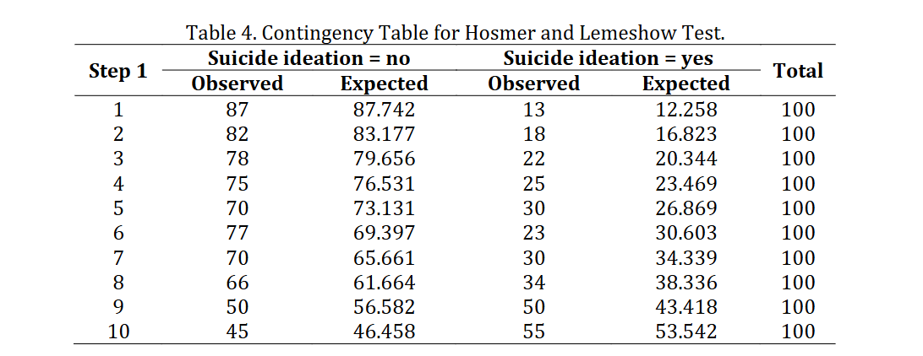

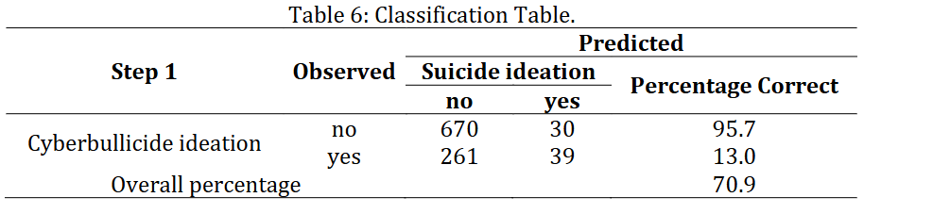
The concept of determinism plays a huge role in the narrative of cybellicide, Students may experience different emotions, after being victims of cyberbullying, the article mentions how some of their moods ranged from anger, anxiety, or even depression which can lead to different actions, which was determined by their moods after being bullied. The actions in the student might take varies one example includes self-isolation, the process of a student separating themselves from others in fear of being bullied. The most severe action that was mentioned was suicide the concept of taking one’s own life, the table charts above show how many people out of 100 thoughts about committing suicide, and the amount they expected to say yes or no.

Conclusion

In conclusion the article talks about a very serious, yet important concept that should be taught to both adolescence and adults about the ways in which being bullied online can affect mental and in a more unfortunate circumstance physical health. Spreading awareness about such a concept could potentially allow fellow students or parents who see a student getting bullied to step in and provide assistance to get them the help they may need. A world where there are less victims of suicide is the main goal of this article and should be praised as such.

Article used

Al-Badayney, D. Ben Brik, A. Khelifa, M. (2024, June) Cyberbullying and cybullicide ideation among Jordanian college students Vol 18. (1) 58 -82
https://academic.oup.com/cybersecurity/article/11/1/tyae032/7959399

