3D PRINTER USE BASICS

Labels:
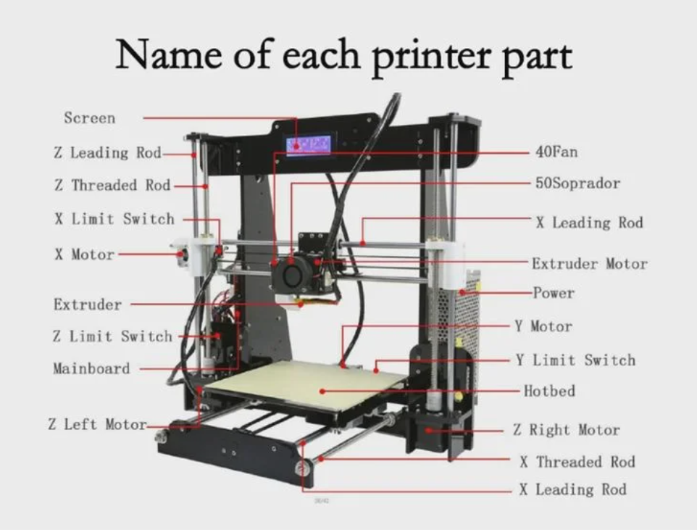

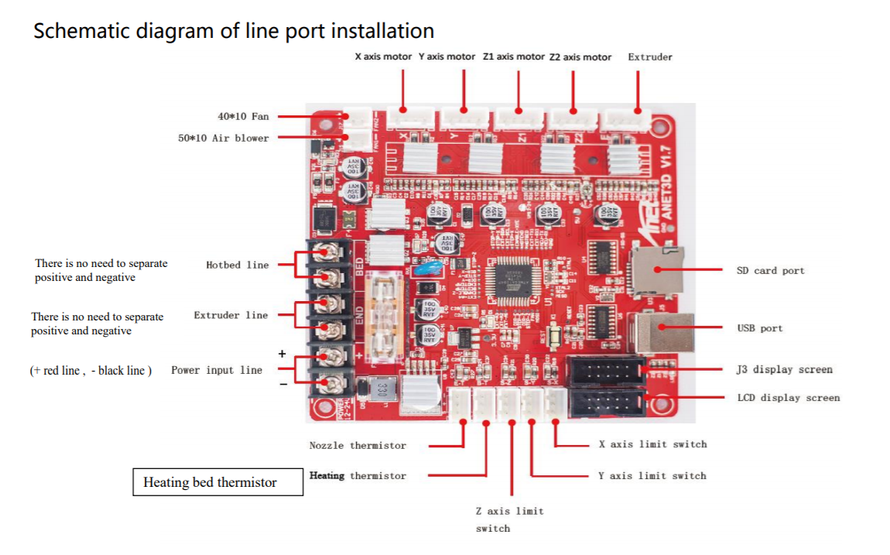
Mainboard:
Display Screen:
The display screen allows you to control the printer as well as displaying the temperature of the extruder and hot bed, the percent completion of the print in progress. The buttons to the right of the display screen allow you to scroll and select from the available options, however, these buttons can be finicky and sometimes must be pressed multiple times to work. It helps if when pressing the buttons you grip the display from the back so that you can resist the pressure of pushing the buttons on the opposite side.
Home:
Home is known as coordinates (0,0,0). You can select Home all from the printer display or Home any specific axis to set only that axis to zero. It is important to home the printer before use so that the coordinates are reset. If it is not on the home position upon powering on, it will automatically set whatever position it is at as its home. If this occurs and it is not re-homed, all coordinates previously measured will be incorrect. It is also very important to think about the commands before sending them to the printer. Is there anything in the way of the path to get to the coordinates you are sending? Do you need to move the printer up in the Z direction before moving in X and Y directions and then move down in the Z direction again? If the electrodes hit something on the way to the destination, something will likely break, whether that be the electrodes or the object in the way, so it is important to consider the path that will be taken by the printer when each set of coordinates is sent.

Stepper:
When the printer is first turned on, you will be able to move the position of the extruder (in the X direction), and the location of the bed (in the Y direction), by applying a small amount of pressure in the desired direction. Once the printer has received a command to move coordinates the motors will engage. This is also known as enabling the stepper. Once the steppers are enabled you cannot move the bed or the extruder without sending the coordinates to the printer via Gcode. To have the ability to move these by hand once again, you must click on the ‘Disable Stepper’ button on the printer’s display screen.
G-code:
The printer receives any commands to operate through a simple programming language called ‘Gcode’. These commands can be sent to the printer through a micro-SD card mounted on the left side, or through a computer connection and software such as open-source ‘Pronterface’. Below you can find a list of common Gcode commands, including Mcode, as well as defined examples of Gcode. The most common/useful commands are highlighted in yellow.
Gcode Command | Definition
G0 | Rapid Linear Motion
G1 | Linear Motion at Feed Rate
G2-G3 | Arc at Feed Rate
G4 | Dwell/Pause
G10 | Set Coordinate System Data
G17 | X-Y Plane Selection
G18 | Z-X Plane Selection
G19 | Y-Z Plane Selection
G20 | Length Unit set to Inches
G21 | Length Unit set to Millimeters
G28, G30 | Return to Home
G53 | Move in Absolute Coordinates
G80 | Cancel Modal Motion
G90 | Set Distance Mode Absolute
G93 | Set Feed Rate Mode units minutes
G94 | Set Feed Rate Mode inverse time

Mcode Command | Definition
M00 | Program stop
M02 | End of program
M03 | Spindle ON – clockwise
M04 | Spindle ON – counterclockwise
M05 | Spindle stop
M06 | Tool change
M08 | Flood colant ON
M09 | Flood colant OFF
M30 | End of program
M104 | Start extruder heating
M106 | Fan on
M107 | Fan off
M109 | Wait until extruder reaches T0
M140 | Start bed heating
M190 | Wait until bed reaches T0
M106 | Set fan speed

Other Common Commands | Definition
F | Feed rate
E | Extrude rate
S | Time length in seconds
P | Time length in milliseconds

Examples of Gcode:
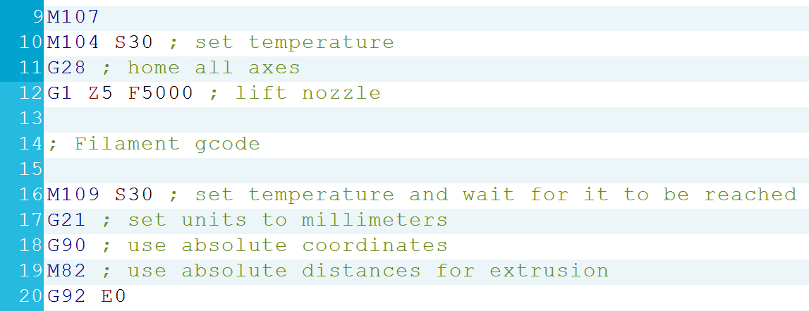

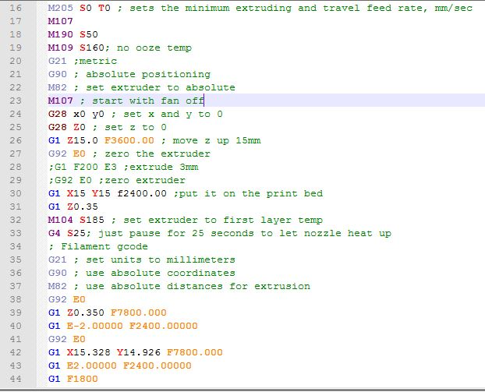

Fortunately, there are software that will write this code for you for any printing purposes. The only reason to know G-code is to write the much simpler .txt files to send coordinates to printer and control the location of the extruder or electrodes.
For more questions on G-code see: https://reprap.org/wiki/G-code, https://howtomechatronics.com/tutorials/g-code-explained-list-of-most-important-g-code-commands/

Designing Prints:
To design a custom print, you can build the design through a 3D software such as AutoCAD or FreeCAD. I would suggest AutoCAD, and you can get the student version free with a University email. When you finish designing and have all components merged to a single shape, export the design and select .stl format, click ok, select the object(s) you want to export from the CAD file so that it is highlighted, and then hit the ENTER button. This will save that object(s) under the .stl file you just exported to. You can then open the .stl in the slicing software.
Slicing Software:
A slicing software is required to take a .stl file and transform it to G-code that will then be read by the printer. There are two well-known open-source slicing software available for use: Slic3r and Ultimaker Cura. Cura is the one that I believe to be the most user friendly, so it is the one I chose to work with. Here you can change things such as printing speed, temperature, rotation of the print (best to choose a flat surface to touch the hotbed), as well as infill density and pattern, and much more. Each of the adjustable settings will affect the duration and quality of the print. If the print itself has issues, you will likely be able to find the reason by searching for the problem online, and then it can usually be fixed by adjusting settings on the slicing software.
Pronterface:
Interactive display allows for manual printer manipulation and/or direct delivery of G-code through the command window or uploading a .txt file. Connect printer to laptop with USB cable.
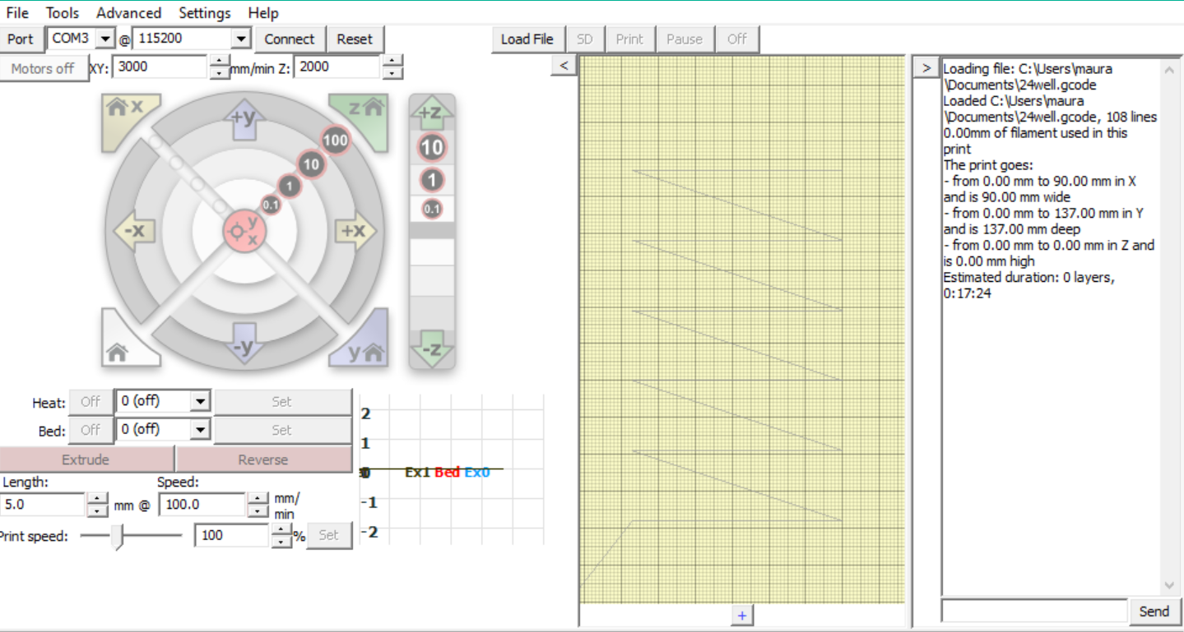
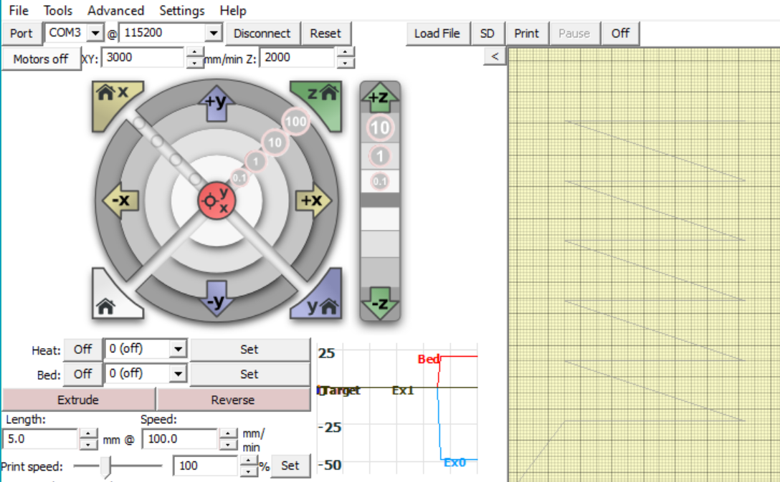
2D schematic of loaded print file
Home All, sets all axes to 0
Coordinate Home, sets Z axis to 0
Begin Print
Connect/Disconnect laptop to printer
Laptop port with connection to printer
Command line
Move Z axis up 1mm
Move X axis up 1mm
Load .txt file with Gcode
Adapted for holding electrodes
The extruder and its bracket have been removed from the printer and replaced with a support system for holding electrodes that can be easily swapped out. Each pair of electrodes should be fit to the inner compartment of the support system, this will require that a new inner compartment be printed with each set of new electrodes to be used in this set-up. A piece of foam is placed on each end of the inner compartment before inserting it into the support system. This allows for a controlled movement in the Z direction to compensate the pressure differences on the electrodes hitting the bottom of an uneven plastic plate. A glass bottom plate will not have this issue, and there is no need for the Z direction flexibility. A plate holder has been glued to the bed that will hold the plate snugly. This holder should fit any cell culture plate with dimensions 86x128mm.
Matlab codes for 6, 12, 24, 48, and 96-well plates have been generated and saved under these names. When run, the Matlab code will generate a g-code for its corresponding well plate, to deliver the electrodes to each well in the plate for a certain number of milliseconds. To adjust this value, either change the value of P in the Matlab code before running, or change each number after P in the g-code.
The g-code will go by column, starting at A1 of the plate, traveling to B1, C1 and D1 before going back up to A2 and starting on the second column. This is repeated for each column on the plate until finished, where it then returns to the home position.
The following code is for a 24-well plate, the bottom of the well is at a height of 3mm, the top of the well at 24mm. There are 19mm between the centers of each well in both the X and Y directions, with the center of A1 being at X33 Y42. At the bottom of the well the code pauses for 50 seconds to give time to apply the pulse. It also pauses for 10 seconds at the top of each column to allow the electrodes to be cleaned if necessary.
G21 ;metric values
G90 ;absolute positioning
M82; turn fan off
G28 X0 Y0 ;home x and y
G28 Z0 ;home z axis
G0 Z25 ;rise z axis
G0 X33 Y42 Z24
G0 Z3
G4 P50000
G0 Z24
G0 X52 Y42
G0 Z3
G4 P50000
G0 Z24
G0 X71 Y42
G0 Z3
G4 P50000
G0 Z24
G0 X90 Y42
G0 Z3
G4 P50000
G0 Z28
G0 X33 Y61
G4 P10000
G0 Z3
G4 P50000
G0 Z24
G0 X52 Y61
G0 Z3
G4 P50000
G0 Z24
G0 X71 Y61
G0 Z3
G4 P50000
G0 Z24
G0 X90 Y61
G0 Z3
G4 P50000
G0 Z28
G0 X33 Y80
G4 P10000
G0 Z3
G4 P50000
G0 Z24
G0 X52 Y80
G0 Z3
G4 P50000
G0 Z24
G0 X71 Y80
G0 Z3
G4 P50000
G0 Z24
G0 X90 Y80
G0 Z3
G4 P50000
G0 Z28
G0 X33 Y99
G4 P10000
G0 Z3
G4 P50000
G0 Z24
G0 X52 Y99
G0 Z3
G4 P50000
G0 Z24
G0 X71 Y99
G0 Z3
G4 P50000
G0 Z24
G0 X90 Y99
G0 Z3
G4 P50000
G0 Z28
G0 X33 Y118
G4 P10000
G0 Z3
G4 P50000
G0 Z24
G0 X52 Y118
G0 Z3
G4 P50000
G0 Z24
G0 X71 Y118
G0 Z3
G4 P50000
G0 Z24
G0 X90 Y118
G0 Z3
G4 P50000
G0 Z28
G0 X33 Y137
G4 P10000
G0 Z3
G4 P50000
G0 Z24
G0 X52 Y137
G0 Z3
G4 P50000
G0 Z24
G0 X71 Y137
G0 Z3
G4 P50000
G0 Z24
G0 X90 Y137
G0 Z3
G4 P50000
G0 Z25
G28 X0 Y0 ;home x and y

