TalkAbroad - Student Workbook
SPAN 102 – Beginner Spanish II

Old Dominion University

Overview
2 15-minute conversations
Topics: Places & Clothing, Daily Routing & Food
- Review: Pre-conversation activities
- Interact: Conversation outlines
- Reflect: Post-conversation activities

Purpose: TalkAbroad will coordinate regular conversation practice for you with native speakers during the semester. This workbook will guide you through that process with preparation activities, conversation topics, and reflection activities.

Student Quick Setup
Step-by-step instructions with screenshots are located in the section labeled Detailed Student Setup at the end of this document.

- Navigate to talkabroad.com
- Click on “Create Account” or “Login” if you already have an account
- When prompted enter section code ”XXXXXXXXXXX” (provided by professor –see the syllabus)
- Click “Add Credits” to purchase conversation credits.
- Click “Make a Reservation” on the homepage and scroll through the partners.
- Complete a test call before scheduling.
- Choose a partner and schedule a conversation using their calendar.
- Complete your conversation.

Contact our support team with any questions.

Conversation 1 – La familia (U6)

Prepare (20 min)
- Schedule your conversation
  - Remember to schedule at least 36 hours in advance.

- Review
  - Review relevant vocabulary
  - Learn at least 10 new words related to the topics.
Zapatillas deportivas  Días festivos  Escribe de  ropa  cartera | Víspera de Todos los Santos  dulce  truco  trato  fuegos artificiales
- Plan
  - Write a list of a variety of 10-12 questions you can ask your conversation partner about their family

    - Avoid questions that elicit a simple one-word (yes/no) answer.
    - Think about how you would respond to each of the questions if they were asked to you (prepare for any vocabulary that you might not know).
    - Read through the Interact and Reflect portion of the sequence to help anticipate any other questions you might need to ask of your partner.
_________________________________________________________________________¿Como ves a tu padre? Veo mucho a mi padre
_________________________________________________________________________¿Cuál es tu comida favorita que cocina tu madre?mi madrastra no puede cocinar bien
_________________________________________________________________________¿Tienes hermanos? tengo 3 hermanas
_________________________________________________________________________¿Tienes cenas familiares? Solía tener cenas familiares los domingos.
_________________________________________________________________________¿Cuántos años tienen tus abuelos?mis abuelos estan muertos
_________________________________________________________________________¿Eres el hijo mayor? Soy la mayor
_________________________________________________________________________¿Qué hace tu padre para el trabajo?mi papá trabaja en la oficina de correos
_________________________________________________________________________¿Qué hace tu madre para el trabajo? mi madrastra tiene una guardería
_________________________________________________________________________¿Qué actividades hace tu familia junta? Yo no. mi familia esta en otro estado
_________________________________________________________________________
_________________________________________________________________________
________________________________________________________________________________

- Practice
  - Practice asking and answering your questions out loud. If available, find a partner from class and practice together.
- Consider
  - What are some places that you notice you are having trouble communicating? Are there any new words or structures that you can learn before your conversation?
_________________________________________________________________________I think the only thing I will have issues with is remembering the words that they may say in response to what I ask.
_________________________________________________________________________
_________________________________________________________________________
_________________________________________________________________________
  - What are some techniques to help navigate a conversation? What sort of phrases would be helpful?
_________________________________________________________________________I think that I will try to guide the conversation with what I ask and try to ask questions that revolve around the vocabulary and things I know.
_________________________________________________________________________If I also think I will ask him to use his hands or expressions to help guide me if I do not know what he is referring to.
_________________________________________________________________________
_________________________________________________________________________

Interact (15 min)
Remember, you do not have to talk for the entire 15 minutes. It is a conversation. Aim to participate in at least 60% of the conversation.

- (3-5 minutes) Introduce yourself to your conversation partner and get to know some basic information about each other.

- (10 minutes) Share about your family. Ask your conversation partner about their family.

- Tips
  - Try to think in the language of your conversation. Your ability to think in English is much more complex right now and often, problems arise when you think of something to say in English that you are not able to say in the target language.
  - If there are words or major ideas that you don’t understand, please ask your partner to help explain/elaborate.
  - Remember, the conversation will be recorded so you don’t have to understand 100% of what your partner says during the conversation. You will have time later to look up specific words.
  - If your conversation goes a bit off topic, that is ok! The important takeaway from this is that you are building the ability and confidence to interact in the language.
  - When your partner answers a question, try to ask a related follow-up question instead of moving directly to another prepared question that might not be related.

Reflect
- Review
  - Download and listen to the audio recording of your conversation.

- Write in English
  - Overall, how did your conversation go? Explain.
_________________________________________________________________________I think overall My conversation went well. I felt that I asked most of the questions. It felt a bit stale. I think it was more that he was trying to go easy on me. However he did not really ask me much. He just answered my questions.
_________________________________________________________________________
_________________________________________________________________________
_________________________________________________________________________

  - About what percentage of your partners' speech did you understand?
_________________________________________________________________________I understood most of what he said for the most part. He spoke slowly enough for me to grasp most key words that allowed me to understand and formulate what he was saying to me.
_________________________________________________________________________

  - What are three things that you would phrase or say differently after having listened to your conversation?
_________________________________________________________________________I would have prepared more to ask him personal questions.
_________________________________________________________________________The topic was family however he really didnt have much of one.
_________________________________________________________________________I would have focused more on the introduction part and would have been more natural about responding to those questions.
_________________________________________________________________________
_________________________________________________________________________
_________________________________________________________________________

  - List three interesting things you learned about your conversation partner based on their answers to your questions.
_________________________________________________________________________I learned his wife worked in the medical field.
_________________________________________________________________________He has 3 grandparents that are alive and one that is dead.
_________________________________________________________________________He was married recently for one year.
_________________________________________________________________________
_________________________________________________________________________
_________________________________________________________________________

  - What sort of cultural inferences or comparisons can you make about your interaction with your partner? If there is insufficient evidence, what comparisons can you make between your families?
_________________________________________________________________________Seeing that he had very little kids was something I was not expecting. I thought that other cultures were more about family compared to Americans. We do not usually have big families so it was interesting to see that he did not have a big family.
_________________________________________________________________________
_________________________________________________________________________
_________________________________________________________________________
_________________________________________________________________________
_________________________________________________________________________
_________________________________________________________________________
_________________________________________________________________________
_________________________________________________________________________
_________________________________________________________________________

  - List three new words you learned from this conversation.
_________________________________________________________________________naval
_________________________________________________________________________enfermera
_________________________________________________________________________médica

  - Is there anything else about the language that you noticed?
_________________________________________________________________________I noticed that he was pronouncing very slowly so I could understand and it helped me alot to grasp what was being said.
_________________________________________________________________________
_________________________________________________________________________
_________________________________________________________________________
__________________________________________________________________________________________________________________________________________________

  - What can you do to better prepare for your next conversation?
_________________________________________________________________________I can be more persnoable nextime to try and ask more personal questions that will make the conversation go more fluid. It came off as an interview more than a conversation. I will try an be more natural next time.
_________________________________________________________________________
_________________________________________________________________________
_________________________________________________________________________
________________________________________________________________________________
________________________________________________________________________________________________________________________________________________________________________________________________________________________________________________

Conversation 2 – La buena salud y la comida (U7-U8)

Prepare (30 min)

- Schedule your conversation
  - Remember to schedule at least 36 hours in advance.

- Review
  - Review relevant vocabulary.
  - Learn at least 10 new words about this topic.
saludables  pepinillos  cangrejo de río  asqueroso  disfruto | durante  gobierno  almacen  agradable  cereales
- Plan
  - Write a list of 10-12 questions you can ask your conversation partner about how they incorporate healthy routines into their daily lives and habits and activities they consider promote good health.
- Write a list of 8-10 questions you can ask your conversation partner about their favorite and non-favorite foods and places they like to eat; a regional or unique dish of their country
- Avoid questions that elicit a simple one-word (yes/no) answer.
- Think about how you would respond to each of the questions if they were asked to you (prepare for any vocabulary that you might not know).
- Read through the Interact and Reflect portion of the sequence to help anticipate any other questions you might need to ask of your partner.
_ ¿Haces ejercicio?________________________________________________________________________ ¿Que entrenamientos haces?
_________________________________________________________________________
_____¿Preparas la comida para la semana?____________________________________________________________________ ¿Qué comidas saludables cocinas?
___¿Comes muchas frutas?
¿Cuánto duermes?______________________________________________________________________ ¿Cuáles son tus comidas favoritas para desayunar?
______¿Qué alimentos no te gusta comer?___________________________________________________________________
_________________________________________________________________________
_________________________________________________________________________
_________________________________________________________________________
_________________________________________________________________________
_________________________________________________________________________
_________________________________________________________________________
________________________________________________________________________________
_________________________________________________________________________
_________________________________________________________________________
_________________________________________________________________________
_________________________________________________________________________

- Practice
  - Practice asking your questions out loud. Can you answer your own questions?
  - If available, find a partner from class and practice asking and answering questions together.
- Consider
  - What are some places that you notice you are having trouble communicating? Are there any new words or structures that you can learn before your conversation?
___I don’t have as much of an issue as I did the first conversation trying to pronounce and understand what I am trying to convey. ______________________________________________________________________
_________________________________________________________________________
_________________________________________________________________________
_________________________________________________________________________

  - What are some techniques to help navigate a conversation? What sort of phrases would be helpful?
______I think that I will need to try and guide the conversation so I can have an idea of what the answer will be so I know how to translate in my head what is being said. ___________________________________________________________________
_________________________________________________________________________
_________________________________________________________________________
_________________________________________________________________________

Interact (15 min)
Remember, you do not have to talk for the entire 15 minutes. It is a conversation! Aim to participate in at least 60% of the conversation.

- (1-2 Minutes) Introduce yourself to your conversation partner and get to know some basic information about each other.
- (7-8 min) Ask your partner how they incorporate healthy routines into their daily lives. What are habits and activities they consider promote good health. Discuss any other areas of wellbeing you would like to discuss.
- (7-8 minutes) Talk about your favorite foods and places to eat. Ask your conversation partner about their preferences. What are some foods that you do not like to eat? Places you do not prefer to eat? Ask and share about some of the regional dishes in your country. What are some foods that are unique to your respective countries? Which foods do you have in common? What influences from other countries do you notice?

- Tips
  - Try to think in the language of your conversation. Your ability to think in English is much more complex right now and often, problems arise when you think of something to say in English that you are not able to say in the target language.
  - If there are words or major ideas that you don’t understand, please ask your partner to help explain/elaborate.
  - Remember, the conversation will be recorded so you don’t have to understand 100% of what your partner says during the conversation. You will have time later to look up specific words.
  - If your conversation goes a bit off topic, that is ok! The important takeaway from this is that you are building the ability and confidence to interact in the language.
  - When your partner answers a question, try to ask a related follow-up question instead of moving directly to another prepared question that might not be related.

Reflect

- Review
  - Download and listen to the audio recording of your conversation.

- Write in English
  - Overall, how did your conversation go? Explain
____the conversation went well. I think I enjoyed her a lot more than my first conversation. Partly because I knew what to expect, but also because she was a lot more into the conversation so it went smooth. _____________________________________________________________________
_________________________________________________________________________
_________________________________________________________________________
_________________________________________________________________________

  - About what percentage of your partners' speech did you understand?
__I would say that I understood like 70 percent of what she said. She was pretty good at speaking slowly and clearly so I could understand. _______________________________________________________________________
_________________________________________________________________________
_________________________________________________________________________
________________________________________________________________________

  - What are three things that you would phrase or say differently after having listened to your conversation?
__I would have phrased what I asked her about her foods differently. ___
I would have rephrased what I told her a the end when I had to go about my son. It was hard to formulate what was happening. ____________________________________________________________________
_I think I would have asked more about what she did in crossfit. ________________________________________________________________________
_________________________________________________________________________
_________________________________________________________________________
_________________________________________________________________________
_________________________________________________________________________
_________________________________________________________________________
  - List three interesting things you learned about your conversation partner based on their answers to your questions.
__She like to eat rice and chicken. __
She loved to do crossfit
_She also played a little soccer too. ____________________________________________________________________
_________________________________________________________________________
_________________________________________________________________________
_________________________________________________________________________
_________________________________________________________________________
___________________________________________________________________________________________________________________________________________________________________________________________________________________________

  - What sort of cultural inferences or comparisons can you make about your interaction with your partner? If there is insufficient evidence, what comparisons can you make between your families?
___We did not talk about our families in this conversation. ______________________________________________________________________
_________________________________________________________________________
_________________________________________________________________________
_________________________________________________________________________
_________________________________________________________________________
_________________________________________________________________________
_________________________________________________________________________

  - List three new words you learned from this conversation.
_________________________________________________________________________
_________________________________________________________________________
_________________________________________________________________________

  - Is there anything else about the language that you noticed?
__I noticed that it is not as hard to grasp the words when you have an enthusiastic partner. _______________________________________________________________________
_________________________________________________________________________
_________________________________________________________________________
_________________________________________________________________________

  - What can you do to better prepare for your next conversation?
___I think I did pretty well. I prepared enough to have a decent understanding conversation with her. ______________________________________________________________________
_________________________________________________________________________
_________________________________________________________________________
_________________________________________________________________________

Detailed Student Setup

Account Setup

- Navigate to talkabroad.com

- If you already have an account, click Login and then skip to step 8, Class Registration.

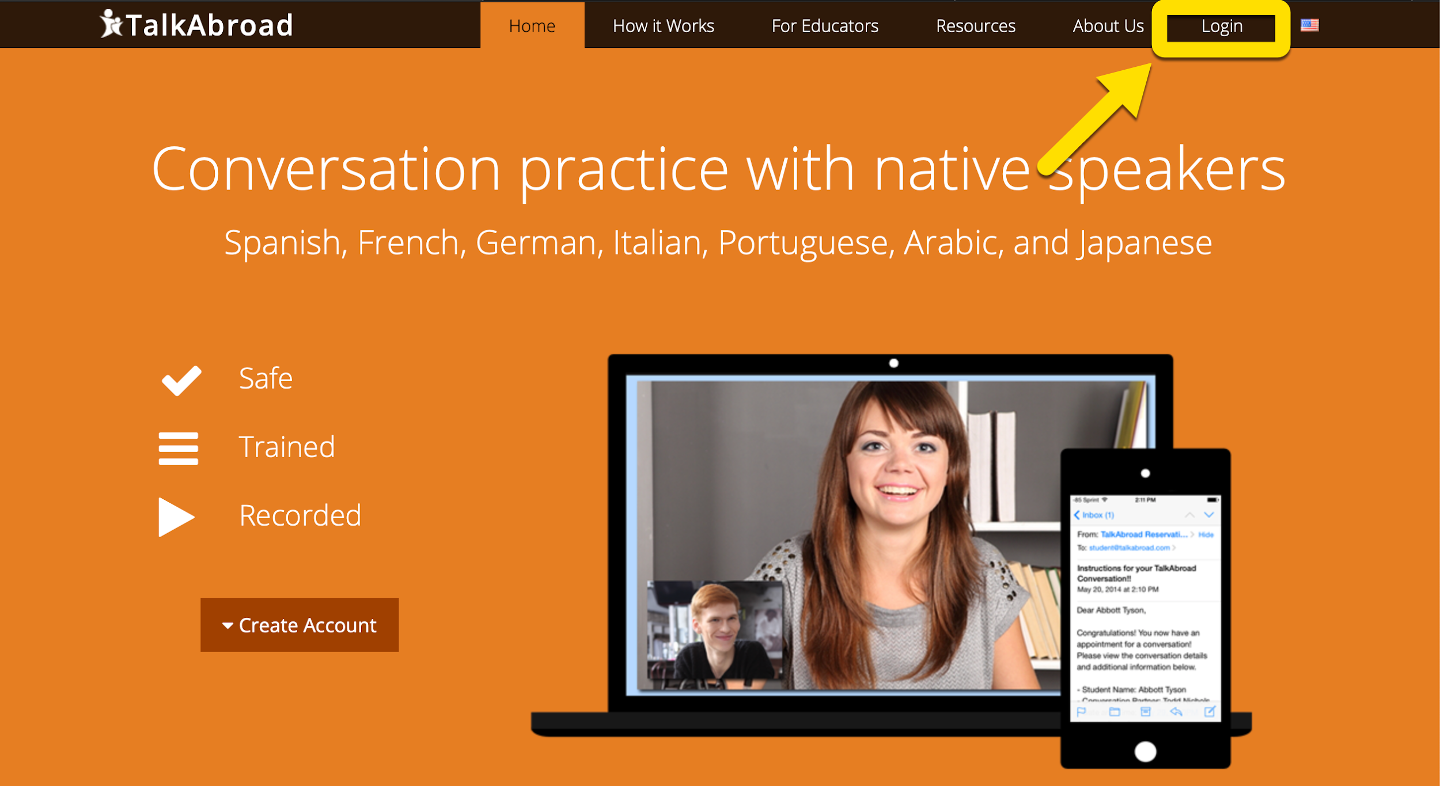

- If you do not already have an account, click Create Account.

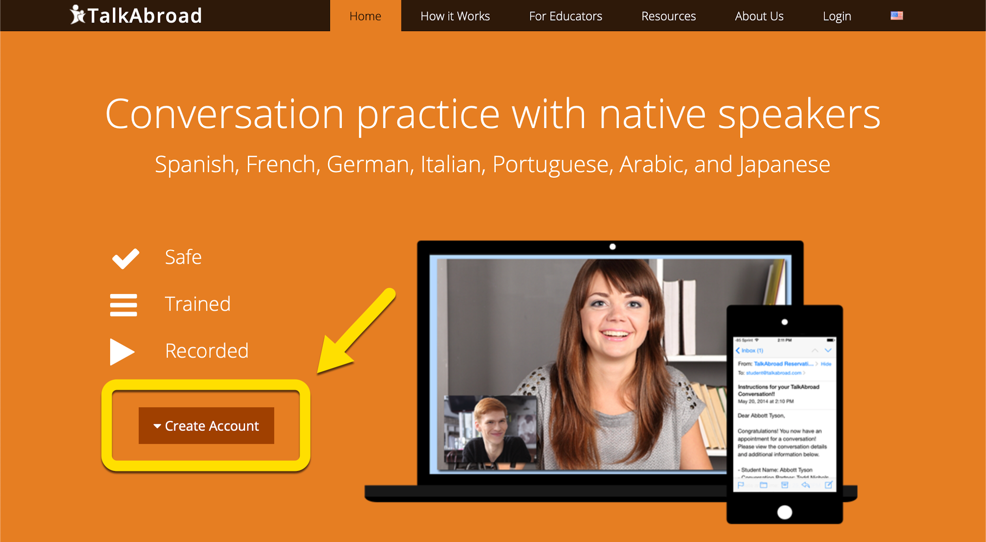

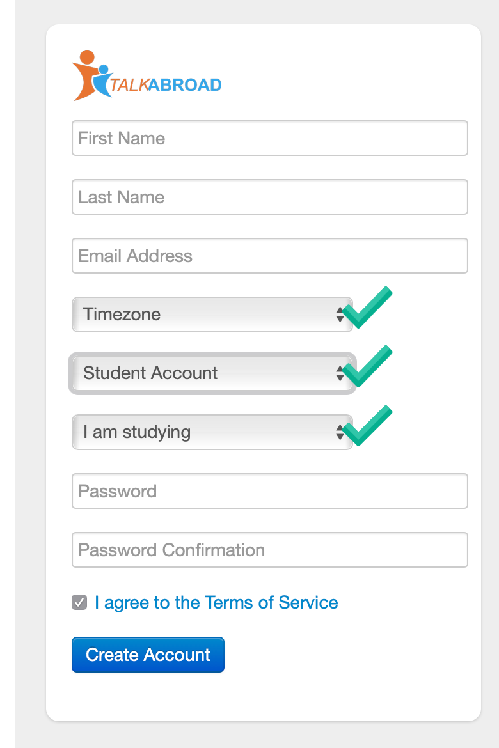

- Fill out your required information and be sure to:
select the time zone where you live, the Student Account option, and the language you are currently studying.
Don’t forget to agree to the Terms of Service.

- After clicking on Create Account you will see a confirmation page that asks you to verify your Email account to finalize the account creation.

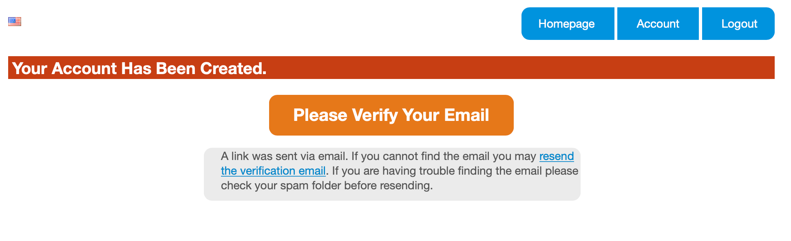
- Sign in to the email account that you provided to verify the account and follow the link provided.
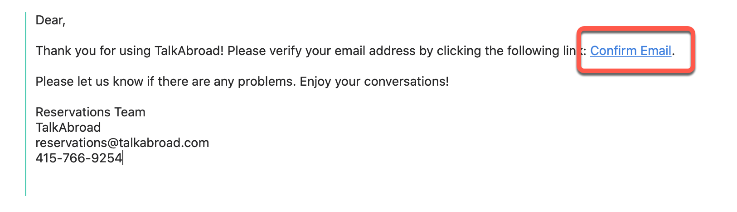
Class Registration

- After clicking on the Confirm Email link, you will be redirected to talkabroad.com and asked to enter a Section Code. When prompted, enter the section code provided by your instructor. Then click Submit.

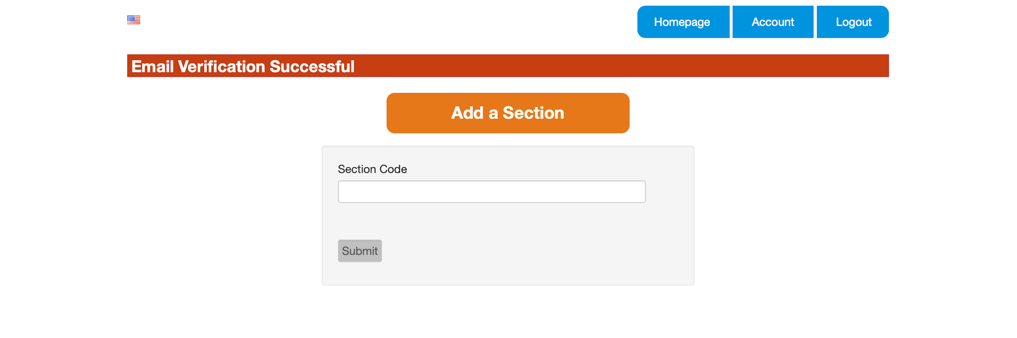
- If you already have an account you can click on the Account tab from the student homepage section and then Add New Section. When prompted, enter the section code provided by your instructor. Then click Submit.
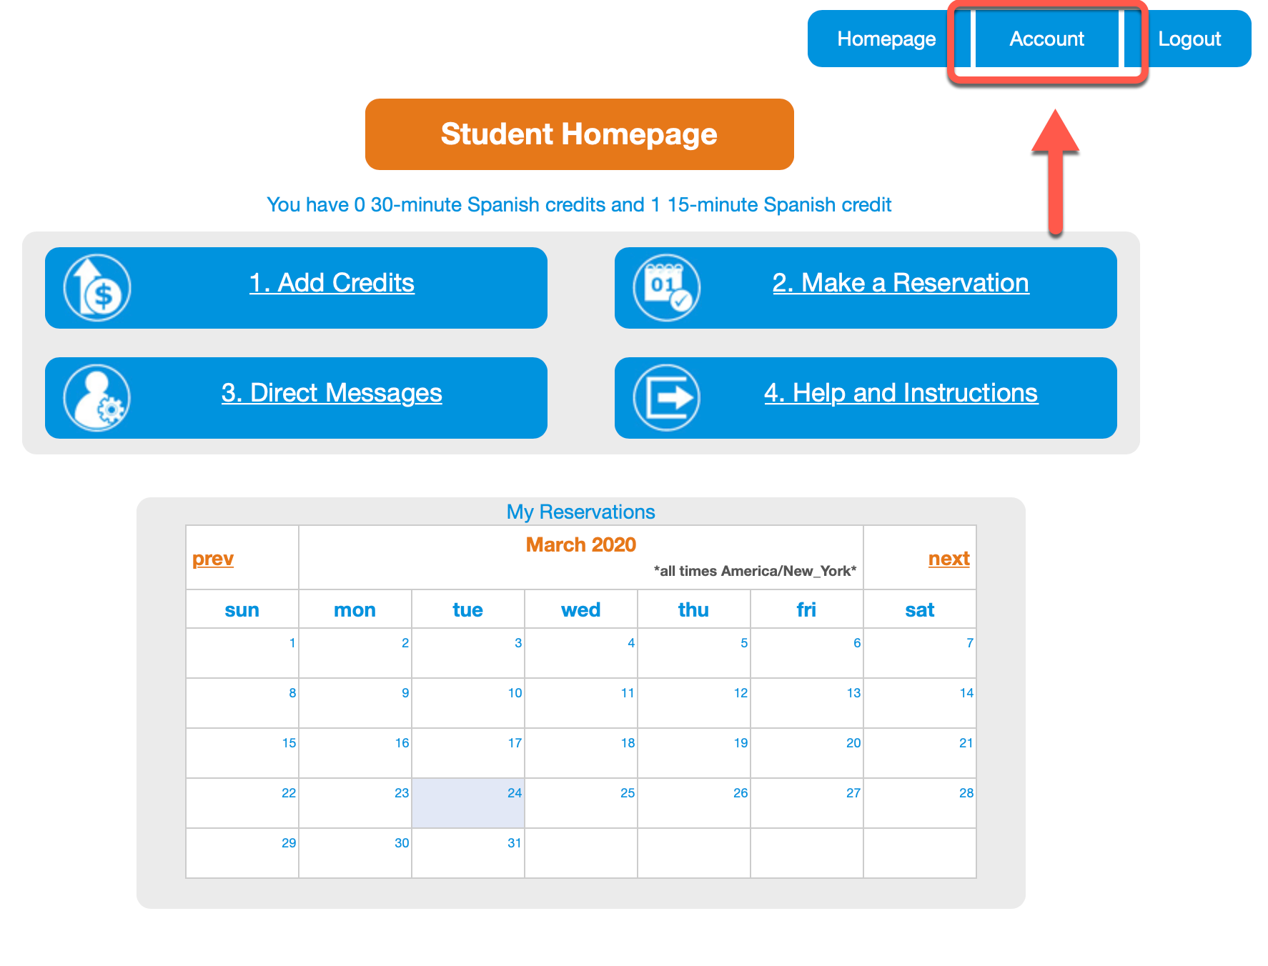

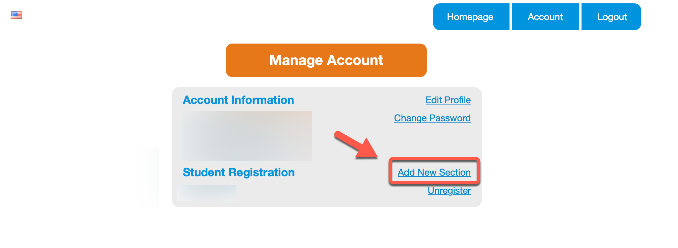

Purchase Credits

- From the Student Homepage click Add Credits.
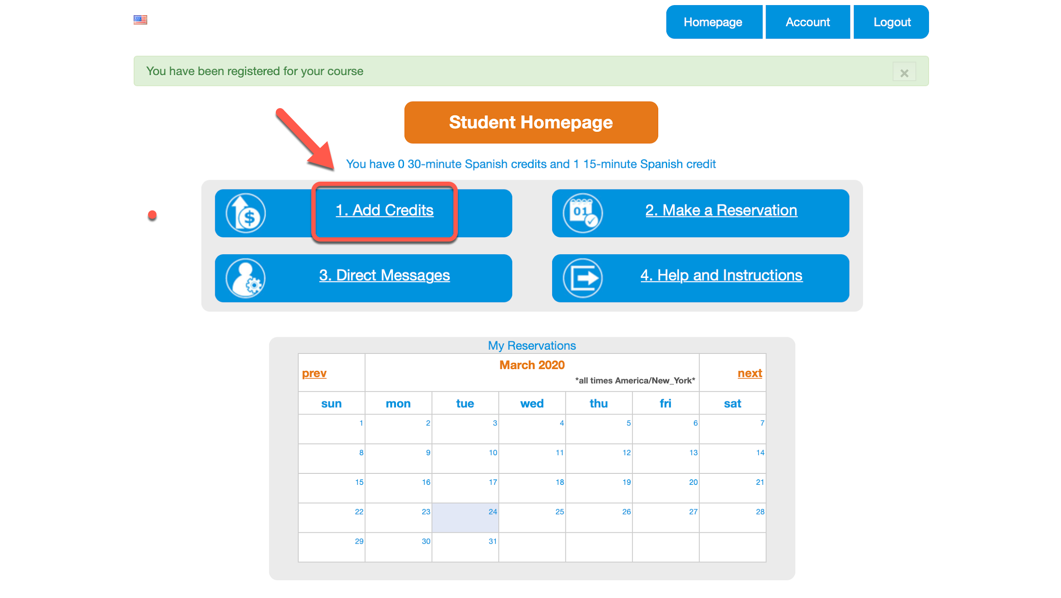
- The Purchase Credits screen will show you how many credits you already have and allow you to purchase new credits. The appropriate language will be pre-selected for you. Select the number of credits for the 15-minute conversations that you would like to purchase (the same number that your instructor has assigned to you). Enter the following in the Redeem code box: Then click Redeem. Once you see that the discount is applied, click Purchase.

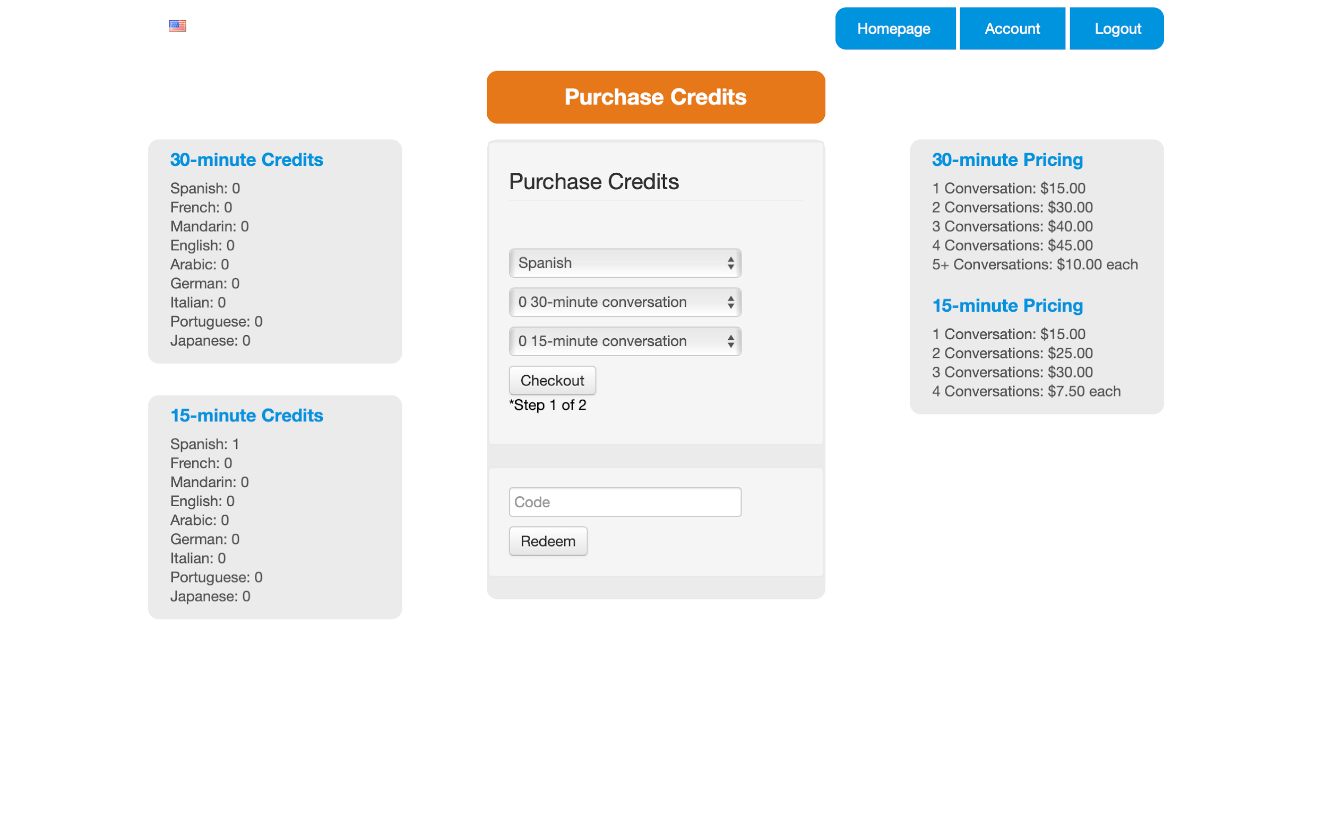
- Now fill out your billing info and credit card number in the following boxes.
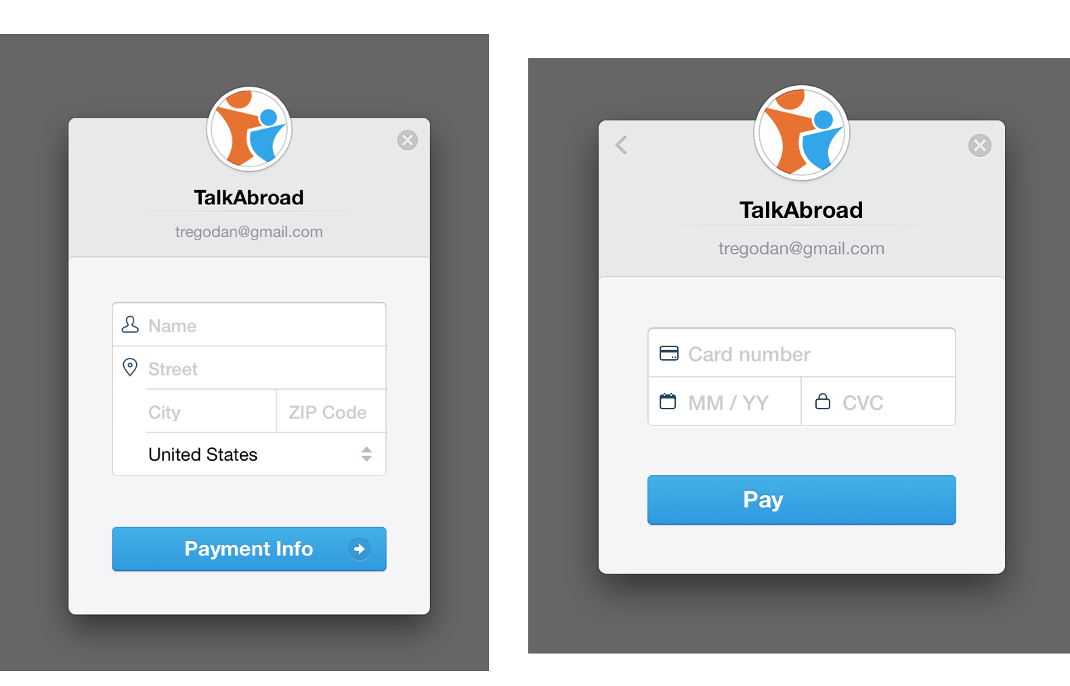

- Once successful, you will see the number of conversations available on your Homepage.

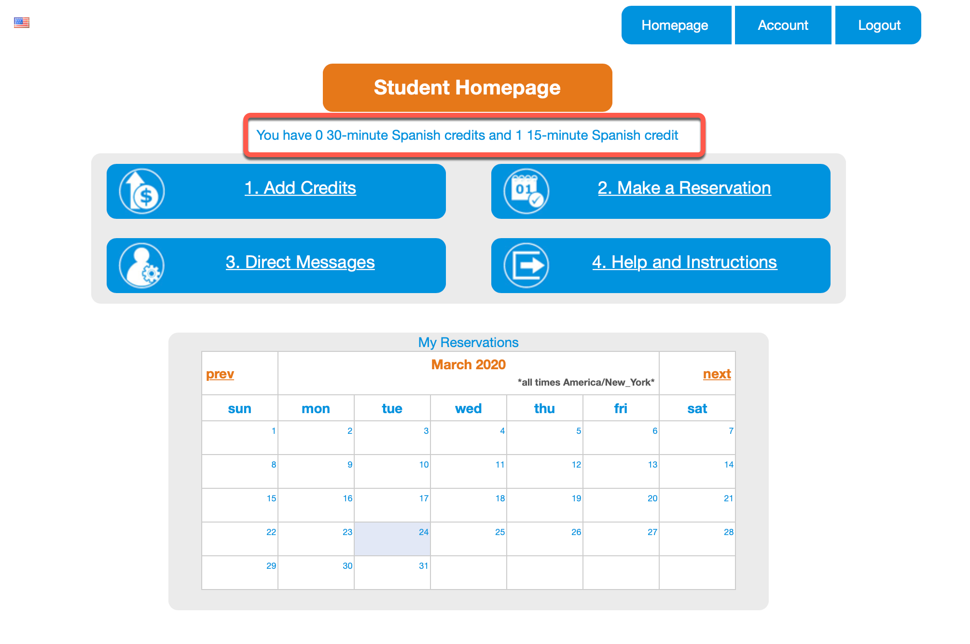

Complete a Test Call
- Before you make your first reservation, you must complete a test call.
- Click Help and Instructions on the Homepage.

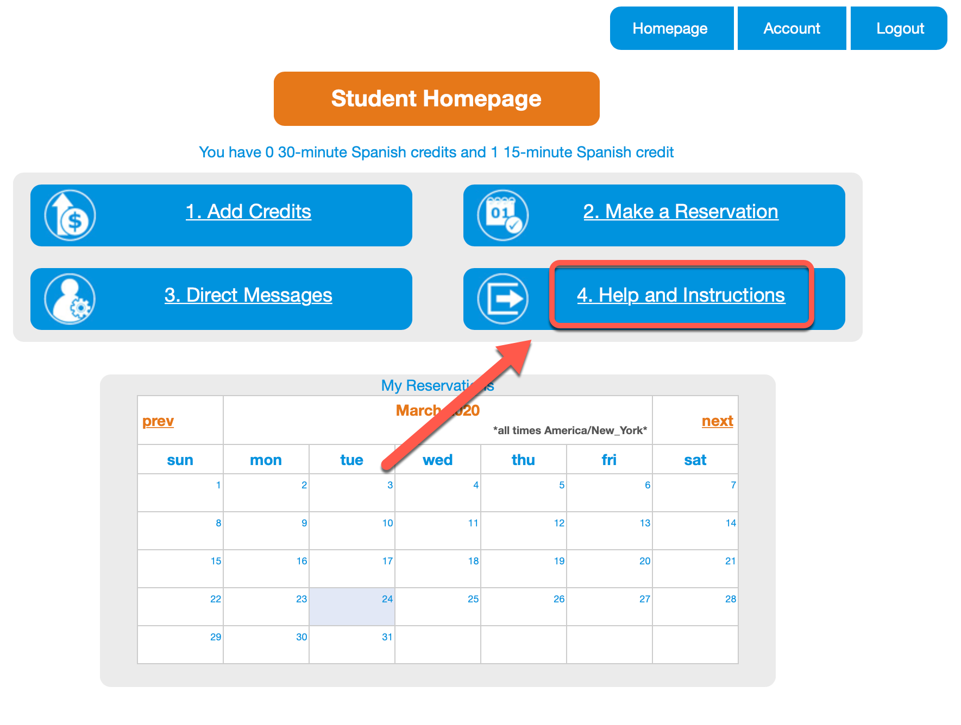
- Now click Test Call.
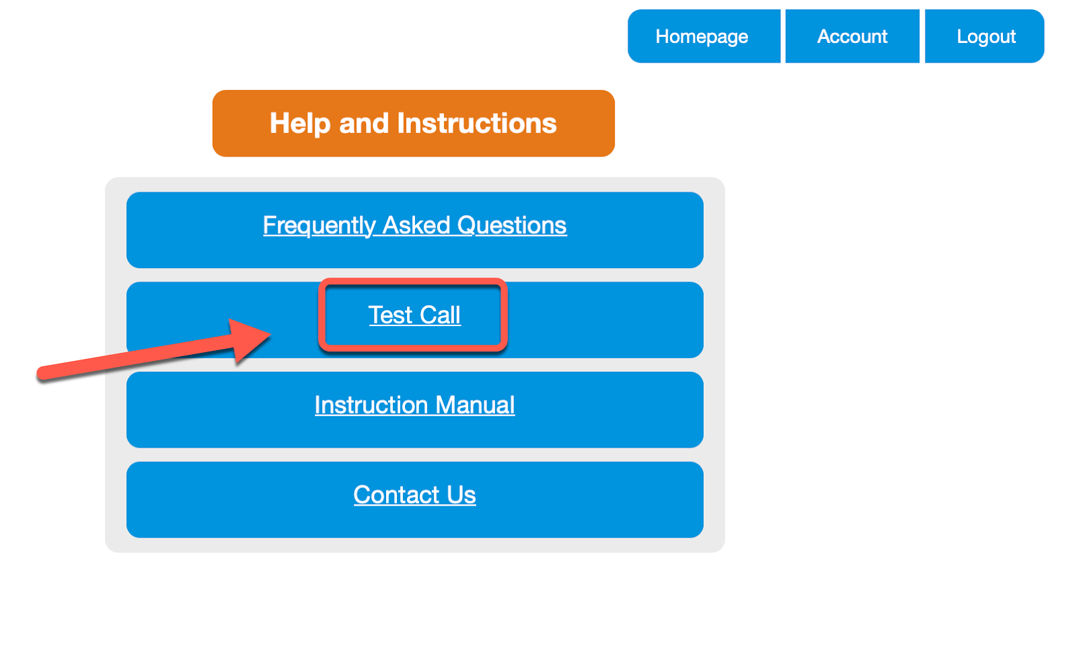

- You will see a screen with the test call instructions. The easiest way to complete a test call is to ask a friend to help by joining on the call with their device. You can also use another device you own to complete the test call.

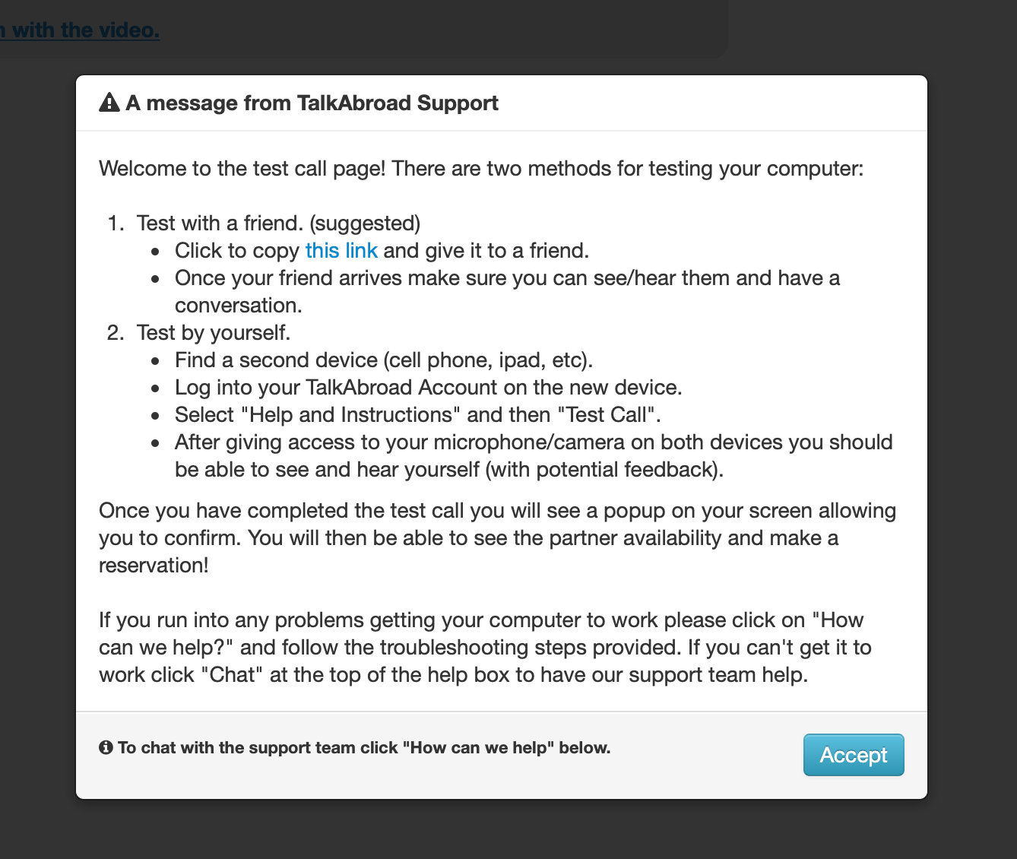

- Click Accept and then follow the instructions to allow your browser access to the camera and microphone. This will look different across devices, platforms and browsers.

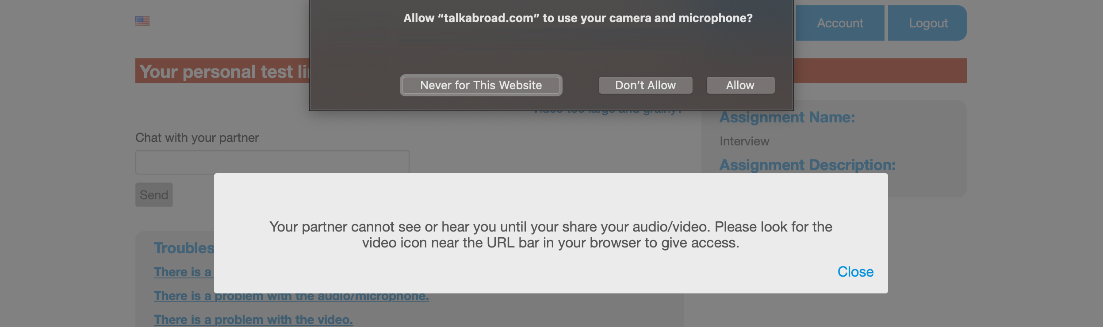

- You will now be able to complete the test call. If anything is not working, you can follow the troubleshooting tips at the bottom of the call window.

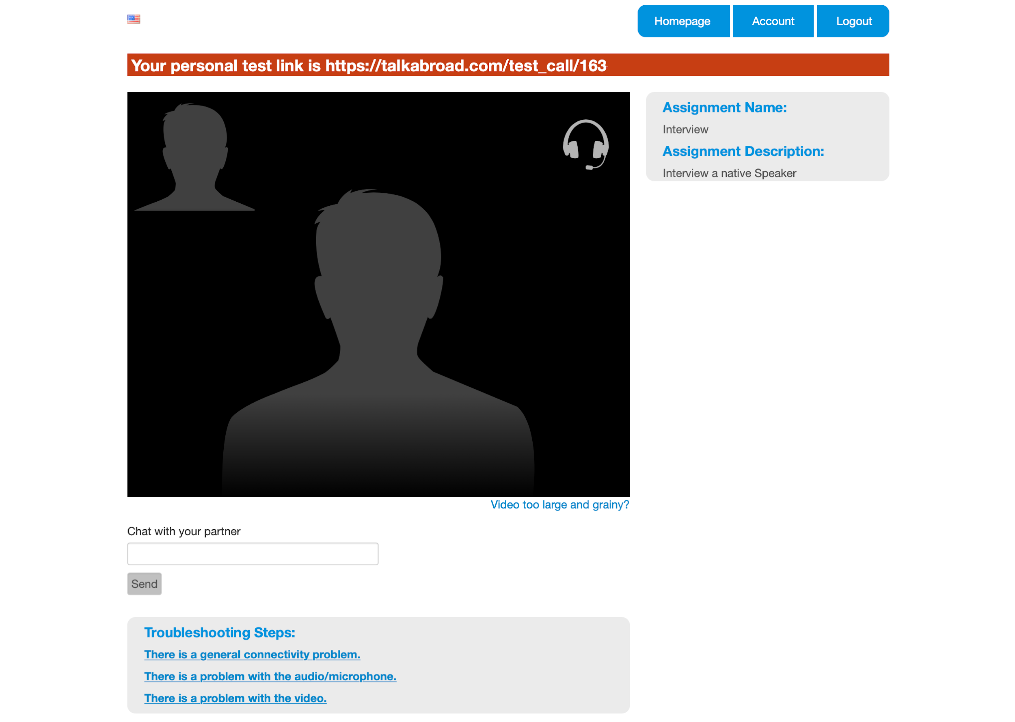

Make a Reservation
- Click Make a Reservation on the Student Homepage to begin.
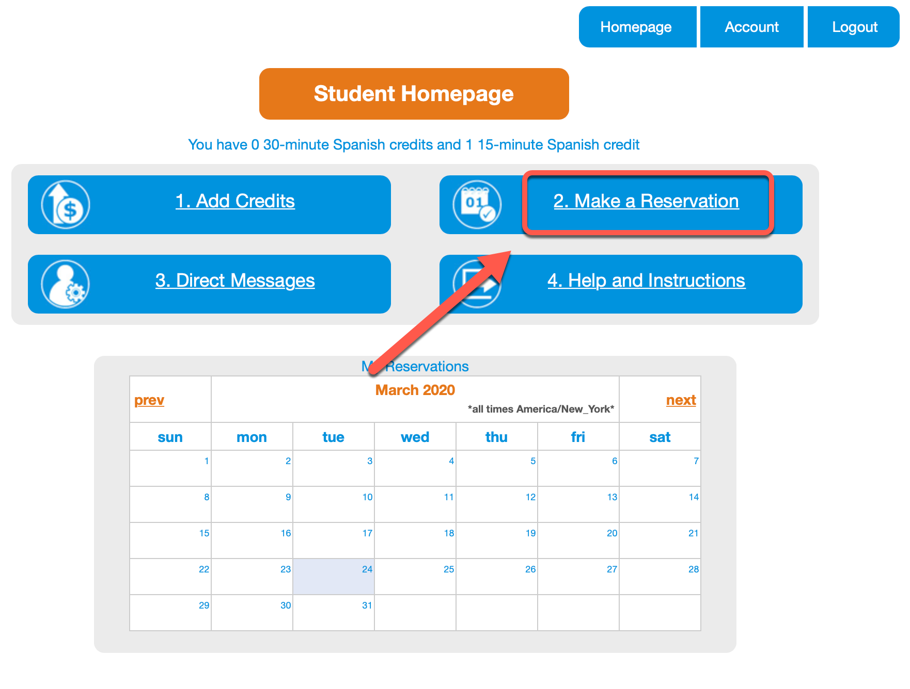
- Now you will be able to see the available partners. You can scroll down the list or choose to search by country or specific date and time. If you have had a conversation in the past, you can also select the box to only search for past partners.
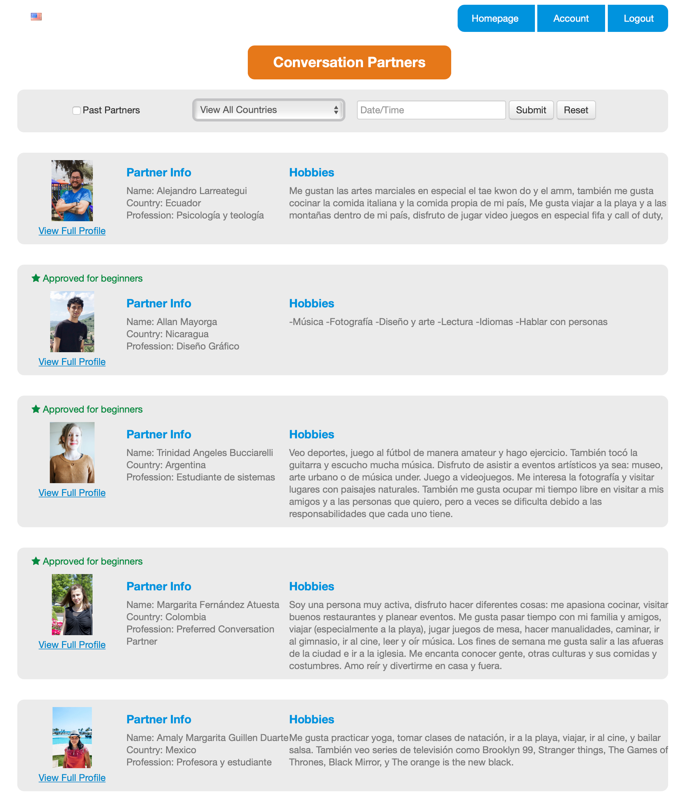

- Click View Full Profile underneath the partner’s picture to learn more about the partner and to schedule a conversation. You will notice that some partners also have a star above their picture with the text Approved for beginners. These partners are trained especially to help students that are just getting started on the language journey.

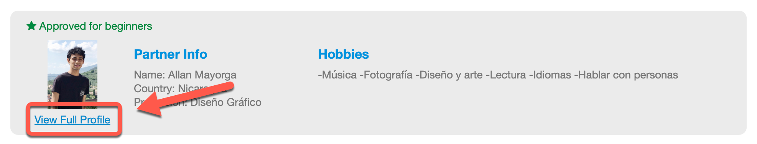

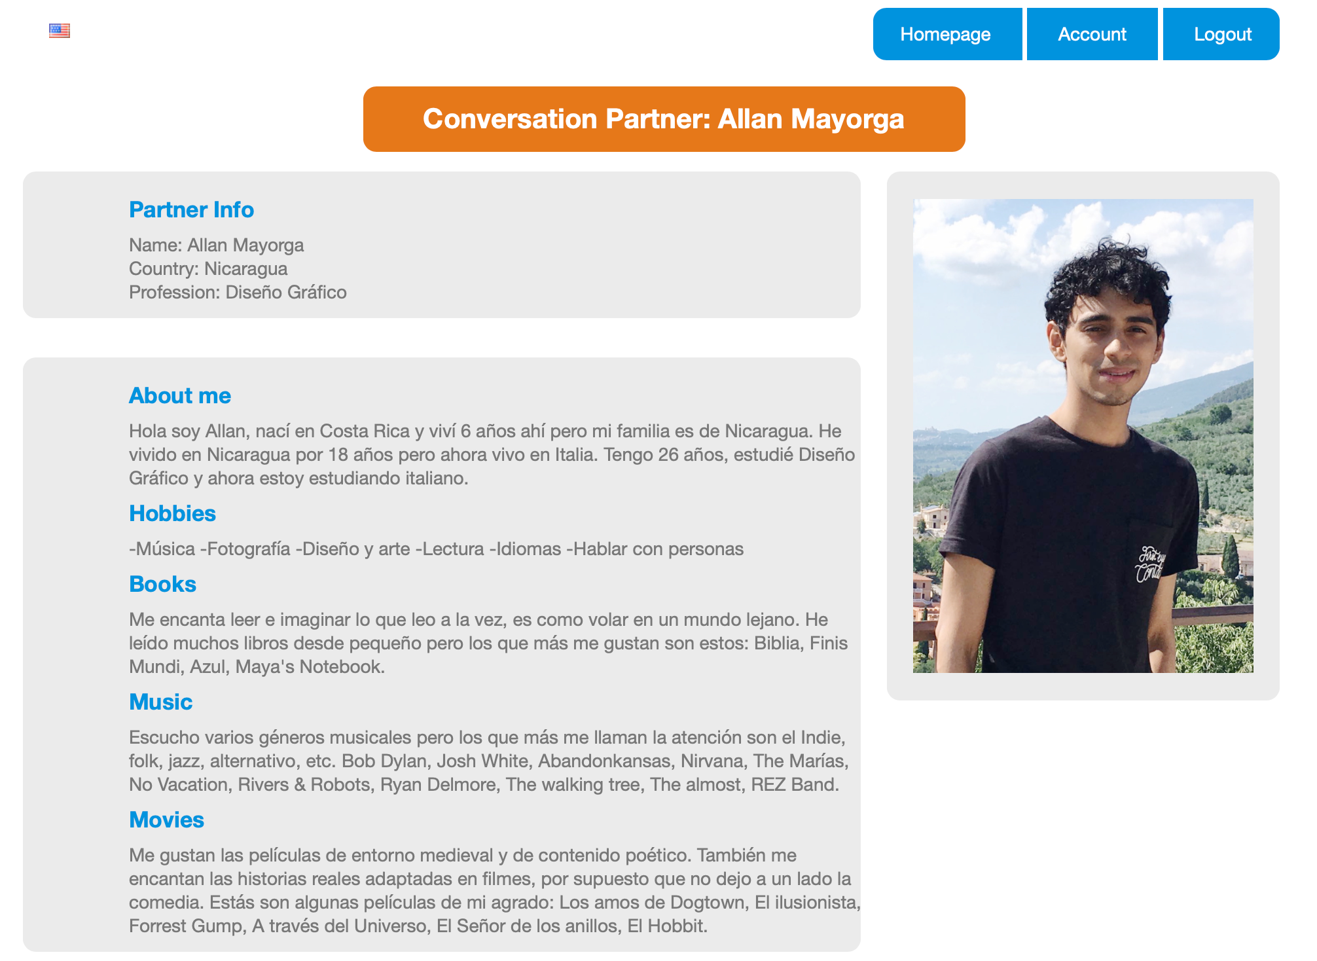

- After reading through the profile, decide if you want to schedule a conversation with this partner. To keep looking at other partners, click Back on your browser. To schedule the conversation, scroll down to the calendar. Here you will find a list of available time slots. Click on one to schedule the conversation for that time. Remember, you can only schedule a conversation 36 hours in advance.
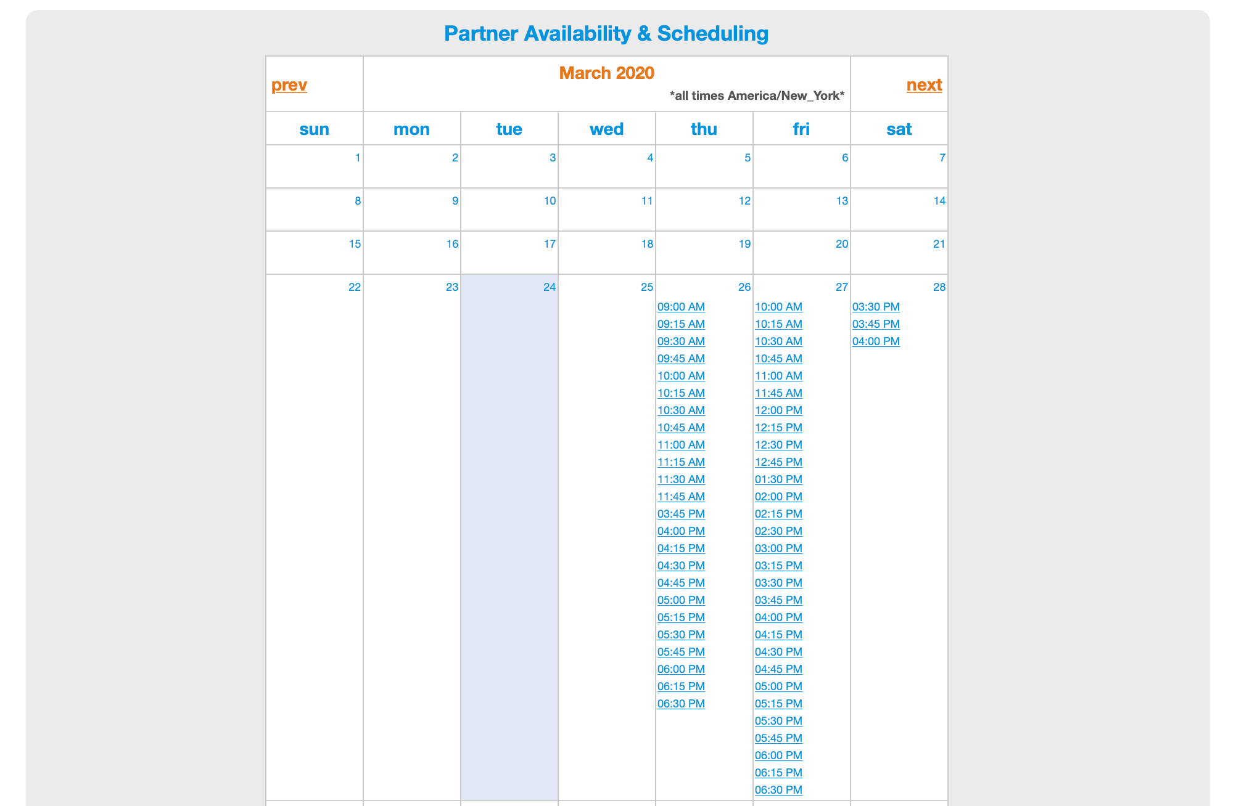
- Once you click on the time to schedule the conversation you will see a Student Reservation screen asking you to confirm your reservation and enter your phone number. It is a good idea to enter your phone number in case of technical difficulties.
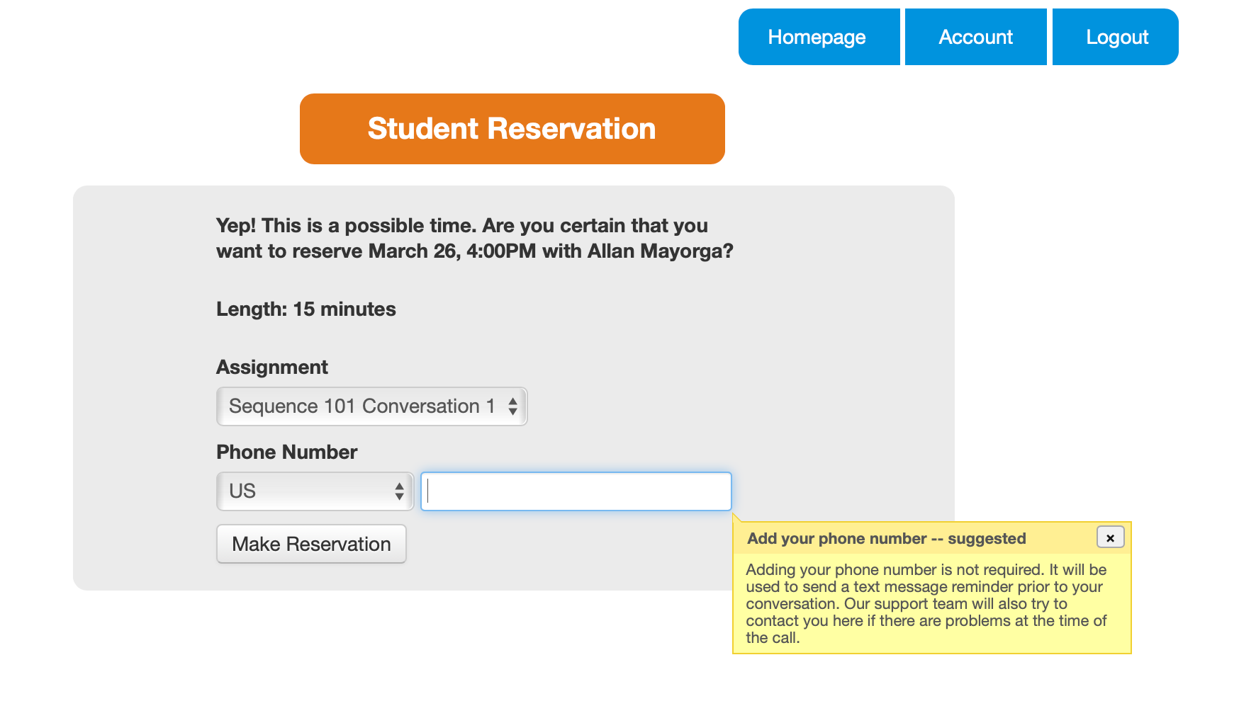

- After you make the reservation you will be asked if you want to introduce yourself to the partner before the conversation starts. This will be in the form of a text comment. This step is completely optional but highly encouraged.
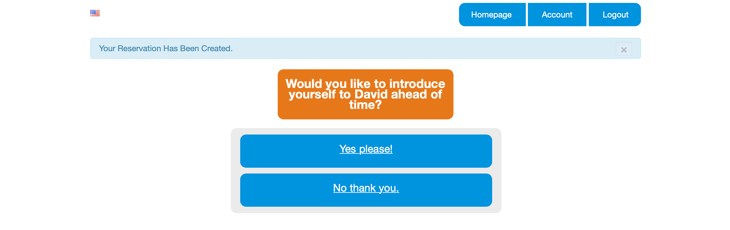

- Head back to the Homepage to see your scheduled reservation in the calendar. You will also receive and email with the conversation information.
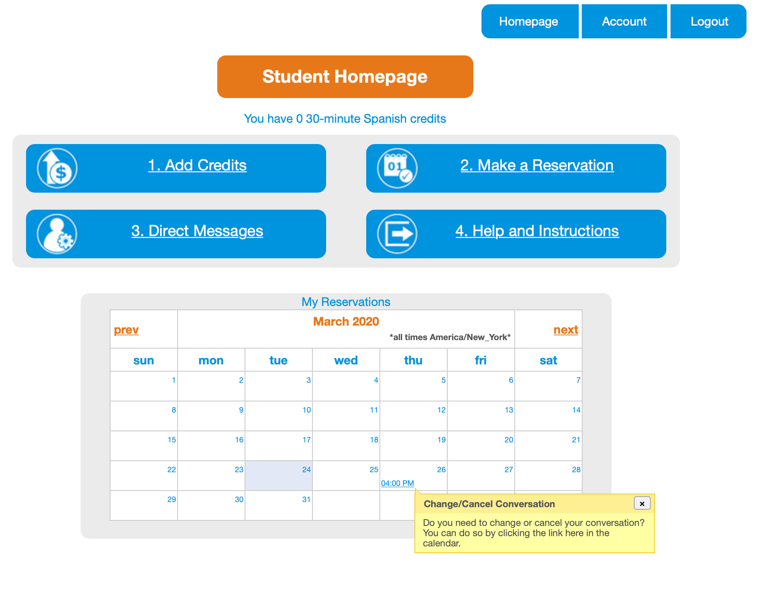

Complete Your Conversation

- Now you can view your conversation in your calendar on the Student Homepage. Click on the the conversation to view information or change the reservation. When it is time for your conversation to begin, you will be directed to the conversation when you login to talkabroad.com

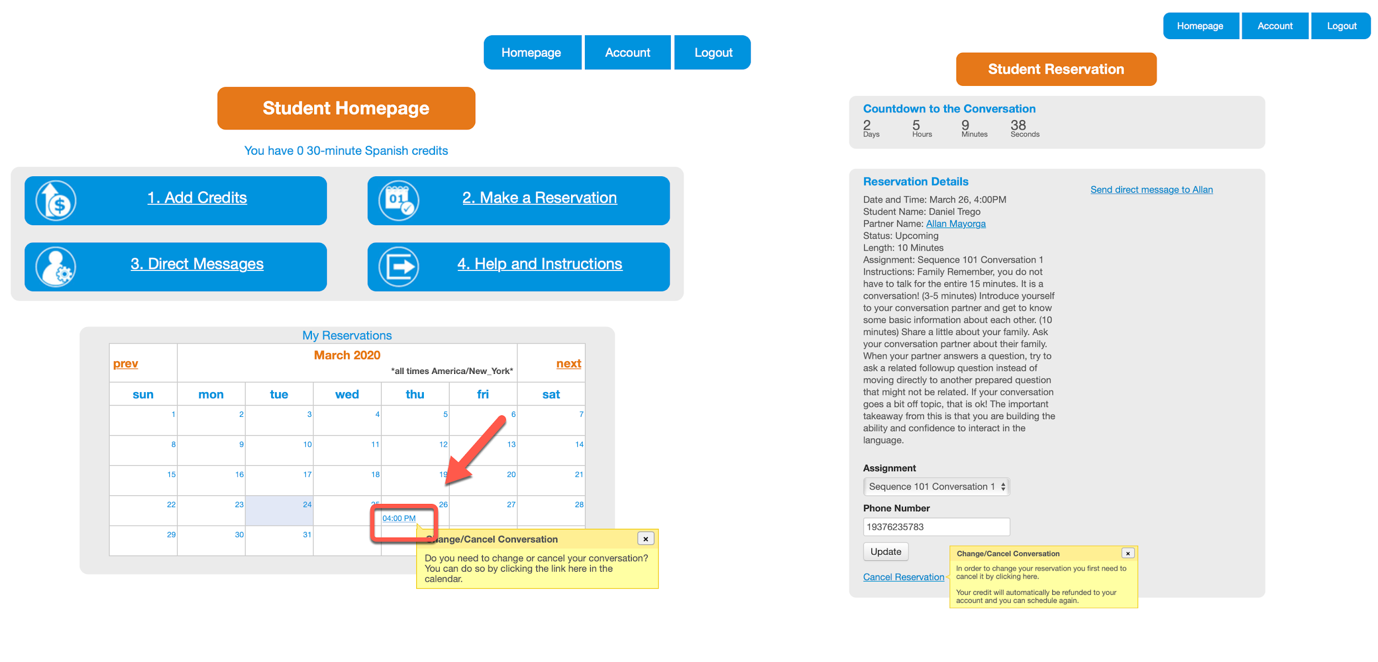

Download your conversation
- After your conversation has ended you will be prompted to rate the conversation and given the opportunity to download the audio file of your conversation. You will also receive an email with a link to the feedback form. The feedback form will also load the next time you login to talkabroad.com.

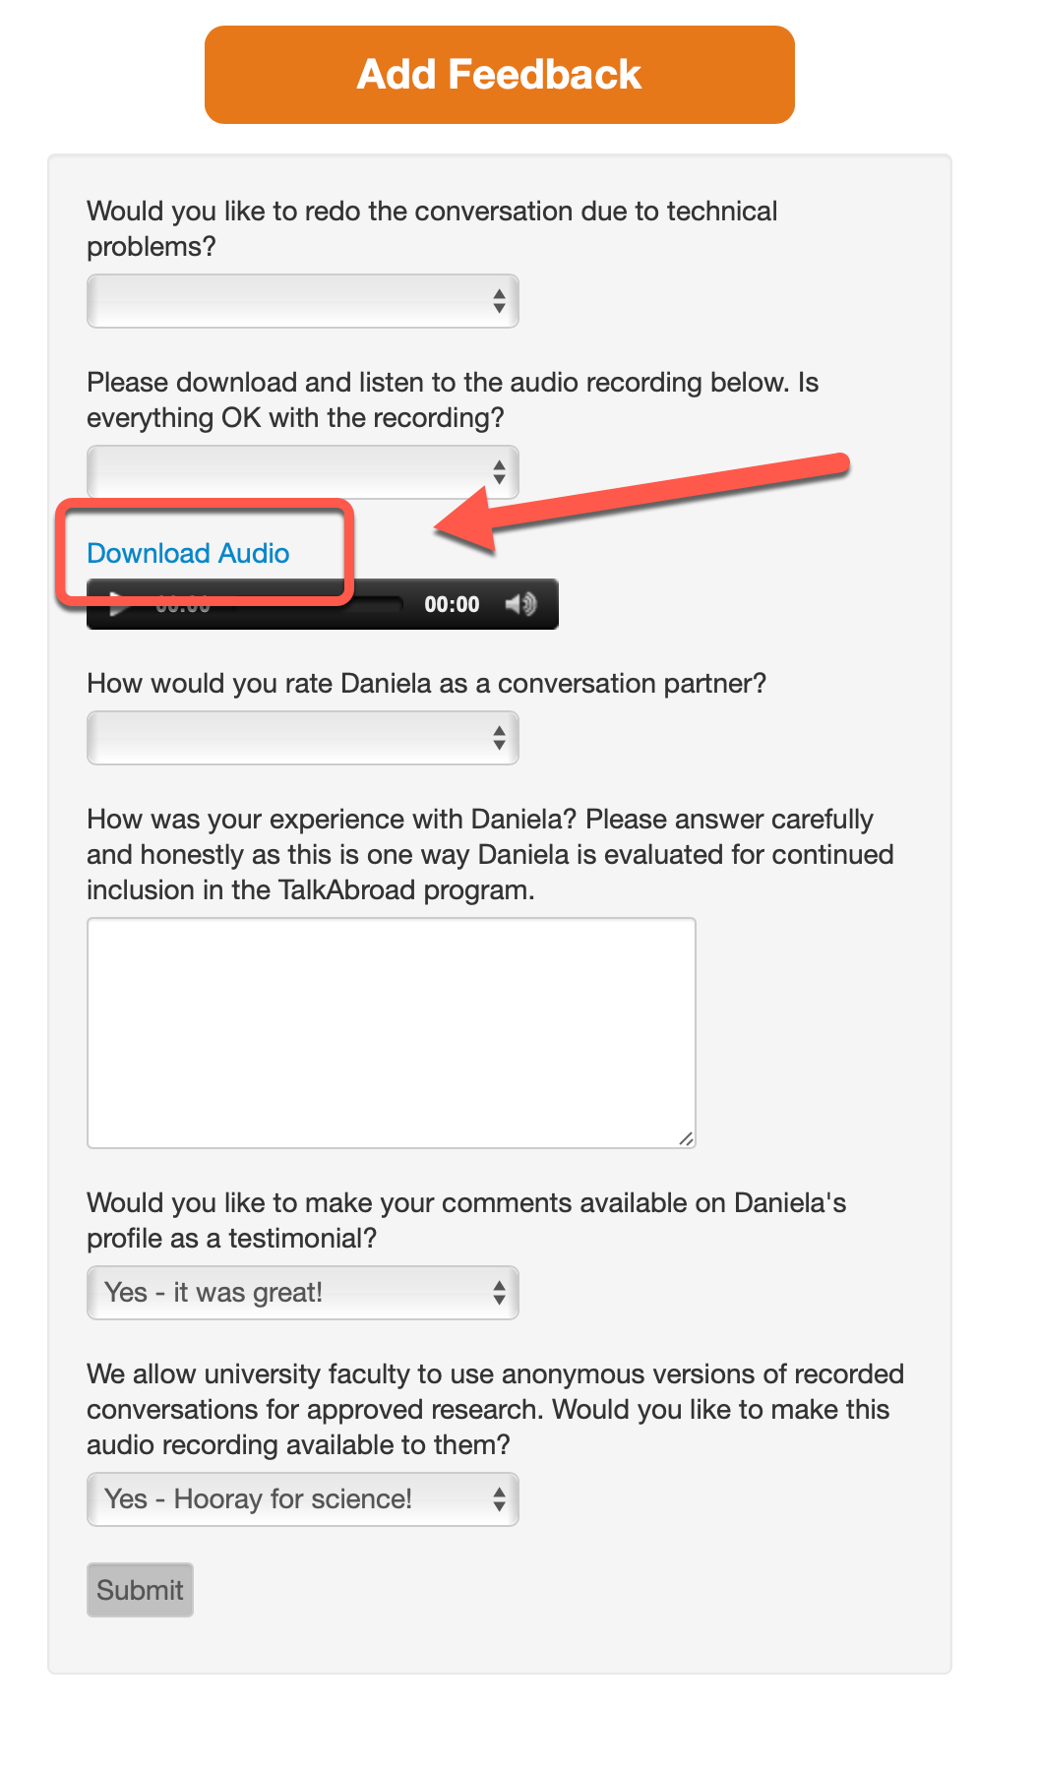

- If there were any issues due to technical problems during the conversation or with the audio file, you can report them here (on the website) and someone from TalkAbroad will be in touch.

- You can also download the audio from any previous conversation by clicking on the link to that conversation in the calendar.

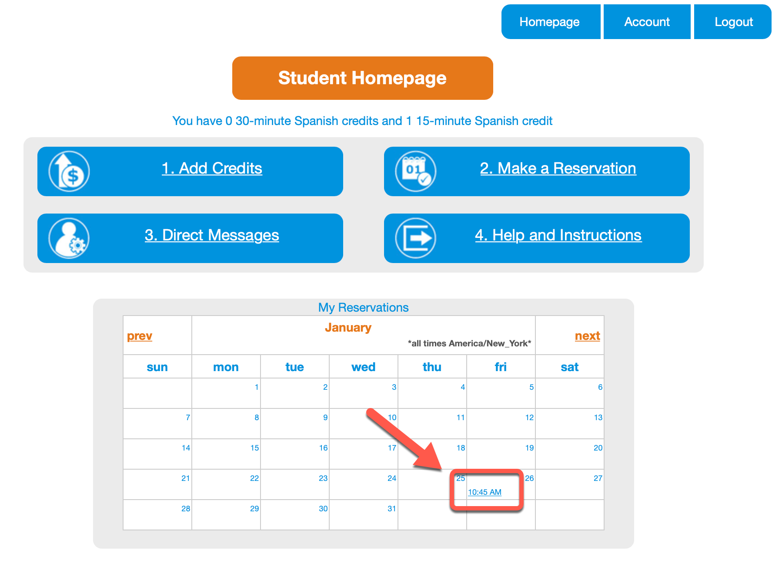

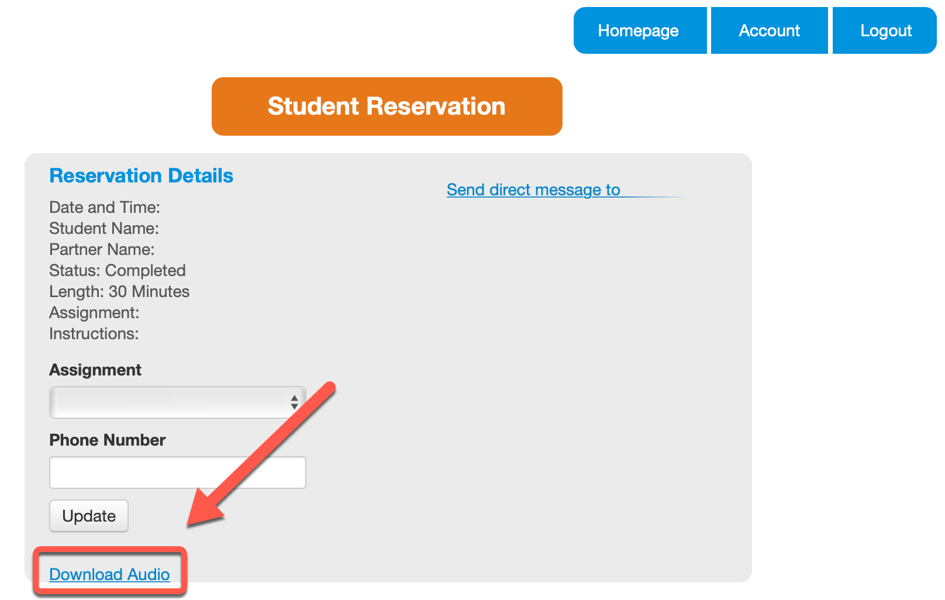

Contact
If you have any questions, please contact our support team.

