Assignment 2 - Self-construal and Self-presentation
Brianna Sheppard
Old Dominion University
Psychology 304
How well do you know yourself? Do you feel confident that you would be able to characterize different areas of your personality? This is a concept known as self-construal. In the simplest terms, it’s how we see ourselves. Now, do you find yourself acting differently depending on the time or situation? This is what social psychologists call self-presentation, and typically it is done to make yourself look better, or display positive attributes (Baron & Branscombe, 2012). An interesting way to see different ways of self-presentation is by going through a couple of pictures of you, or that you chose to post on social media. Personally, I feel that I gained a lot of insight by looking at pictures of myself; including, where I am most comfortable and how I act when I’m not.
I chose eight photos from the last 3-4 years that I felt were good examples of who I believe I am, and how I chose to present myself. I gathered them from my computer, Instagram and Facebook. One thing that stuck out from these photos was that most of them were of friends and family. I had a lot from family vacations, past jobs, and everyday life. There were also many from a summer camp that I worked at for eight summers. I worked in the kitchen, and they were some of my favorite times. And there was one other thing that stuck out: my hair. As silly as it seems, it has been a big part of my life. For many years, I hated it; and it was a big source of insecurity. But after embracing it, I learned to show it off in my pictures.
Pictures 2, 3, & 5 (photos labeled 1-8, left to right) show me with a goofy and less-serious. I find that this is how I paint myself in pictures that are just me. I am always worried about my self-image, and if I intentionally distort my face, or wear a costume, it takes away from the aspects that I do not like about myself. I have always loved to dress-up, as I am in #5 (we are all characters from Winnie the Pooh!), and I believe this again goes back to my shyness; using costumes as a way to hide the real me. They also show me embracing my hair, letting it take up most of the frame.
Pictures 4 & 6 shows me being goofy with my family. Picture #4 is of me and my little sister. She loves to be in the center of attention, and, of course, loves taking pictures of herself. I am the exact opposite. I prefer not to be in the spot-light, and I don’t like to take pictures of myself very often. Picture #6 was taken on a walk. Our parents wanted to take a picture; we did not. So, we all turned around and gave them a blank stare. I love how silly I can act around my family, but I also love how relaxed I am around them.
The remaining three pictures (1, 7, & 8) show me the most relaxed. It may be hard to distinguish, but I can tell that in those three pictures, I’m not “faking it” for the camera. Even though getting my picture taken can make me feel a little tense, in these couple of instances, I do not feel the need to present myself to the world in any particular way. I am content in who I am. In picture #8, there is no one in the picture, but I remember they were all around me. Second, this picture was also taken during one of my summers working at Bethel camp. Bethel was one of those great places where you could be totally yourself, unashamed and unabashed.
The interesting thing about self-presentation is that it is so automatic. The brain is amazing, and so much of what is going on in our head is subconscious (Baron & Branscombe, 2012). Looking back on when I took those pictures, I know I was not consciously thinking about these different aspects of my personality. I was not thinking about how comfortable I was, not what I felt insecure about, but still, all those little questions were in my head, affecting how I acted. Analyzing these pictures helped me to see that my self-construal is always changing. From one day to the next, I feel differently about myself. Now that I am more knowledgeable on how we, as humans, perceive ourselves, I will be interested to see how I continue to change what I think about myself.

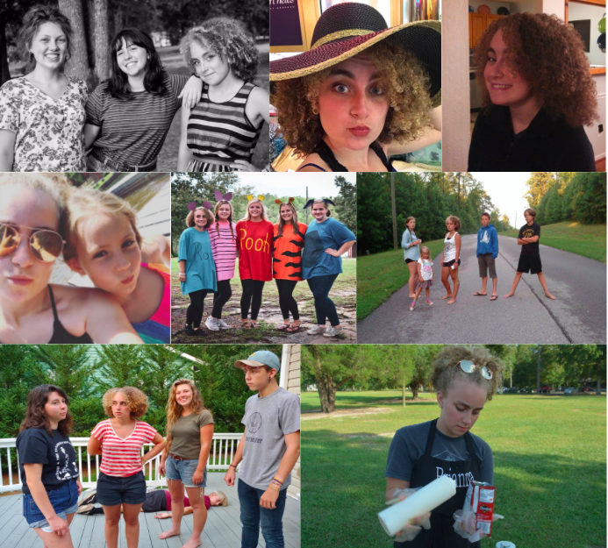
References
Baron, R.A. & Branscombe, N. R. (2012). Social Psychology. Upper Saddle, NJ: Pearson

