Assignment 4 - Love: Friendship, Rationality, and Uncertainty
Brianna Sheppard
Old Dominion University
Psychology 304

Relationships are fundamental to human nature. As such, social psychologists want to study all the aspects of relationships. An even smaller subset of these studies is on romantic love. Many different theories have been postulated about love (Baron & Branscombe, 2012), in particular, Hendrick & Hendrick (1986) studied types of love.
Researchers have proposed that there are six types of love, each corresponding to different characteristics. There is a survey that can be taken to determine how high (or low) an individual scores on each corresponding type of love, based on the ancient Greek’s explanations of love. They are Eros, Ludus, Storge, Pragma, Mania, and Agape. Eros is physical and intense; Ludus is manipulative; Storge is friendship or familial; Prama is rationality; Mania is uncertainty in the relationship; and finally, Agape, or all-sacrificing (Hendrick & Hendrick, 1986). Personally, I took this survey, and documented my own scores (appendix A). It is important to note that a low numeral score means the participant is higher for that type of love. My scores can be broken evenly into three types greater than, or equal to three; and three types below three. On Eros, Ludus, and Agape, I tested low on those characteristics of love. The other three, Storge, Mania, and Pragma, I scored higher. From their definitions, it is easier to see how a low Agape score and a high Pragma score can go hand-in-hand. My rational side prevents me from jumping all-in. And although not part of the test, my dismissive attachment style definitely plays a role in how I scored on both.
I was surprised by two of my results: Pragma and Ludus. I consider, and have been told, myself to be a highly rational person. Although I scored higher than the mean of both males and females (appendix B), I thought that I would have scored even higher. As far as my Ludus score goes, looking back, I can sometimes be manipulative in my relationships. However, after analyzing my results, this is likely to manifest from Mania, rather than Ludus. I do not treat relationships (physical or otherwise) as a game. Following that, I was rather unsurprised by my high score for Mania. Although I do not lack self-esteem in many other factors, romantic relationships are often when I express my lowest self-esteem. I feel as though I never know what my significant other is thinking; and because of this, I feel vulnerable, and try to assert more control.
One of the ways that Hendrick & Hendrick (1986) suggest to take this test, is to have a couple take the test, and plot each of their scores compared to the means of their gender. I chose to compare my means to both genders, because I was interested to see how I compared to both males and females (appendix B). In reference to the female sample, I scored rather similarly. (Note: I did not run statistical tests on the data; I simply compared the graphs by sight, and took the difference between scores.) I scored most similarly on Ludus, which was surprising. The biggest difference was in the Mania scores. I am higher on that type of love than their sample of other females. Interestingly, when compared to the male sample, again, I scored higher for Mania than the sample. My closest type with the males was Pragma, where there was a .46 difference.
This research has given me the opportunity to put some perspectives on my relationships. I have not been in many relationships; the ones that I have been in were never serious, and did not last long. I am picky when it comes to committing to someone, and this is propelled by, I believe, Storge and Pragma. First and foremost, I am looking for a steady, committed friendship before I feel ready to jump into a relationship. If I ever get to this point, then my Pragma style of love kicks in, and I try to think through every possible scenario. Unfortunately, this includes all the worse-case scenarios. And often, I don’t want to take a chance because of risk aversion, which is when negative outcomes are more heavily weighed than positive outcomes (Baron & Branscombe, 2012). And finally, if I make it past all of these mental blocks, the coup-de-grace: the Mania style of love. I feel so insecure and anxious about any and every detail or change, that I try and cut my losses by building walls. Now, this all sounds much more dramatic than it actually is, but it does honestly portray how I feel about my relationships in retrospect.

References
Baron, R.A. & Branscombe, N. R. (2012). Social Psychology. Upper Saddle, NJ: Pearson
Hendrick, C., & Hendrick, S. (1986). A theory and method of love. Journal of Personality and Social Psychology, 50(2), 392-402.

Appendix A
Author’s Scores on the Styles of Love Survey
Styles | EROS | LUDUS | STORGE | PRAGMA | MANIA | AGAPE
Scores | 3.14 | 3.71 | 1.71 | 2.57 | 1.43 | 3.00

Appendix B
Styles of Love: Gender Means Compared to Author’s
Female
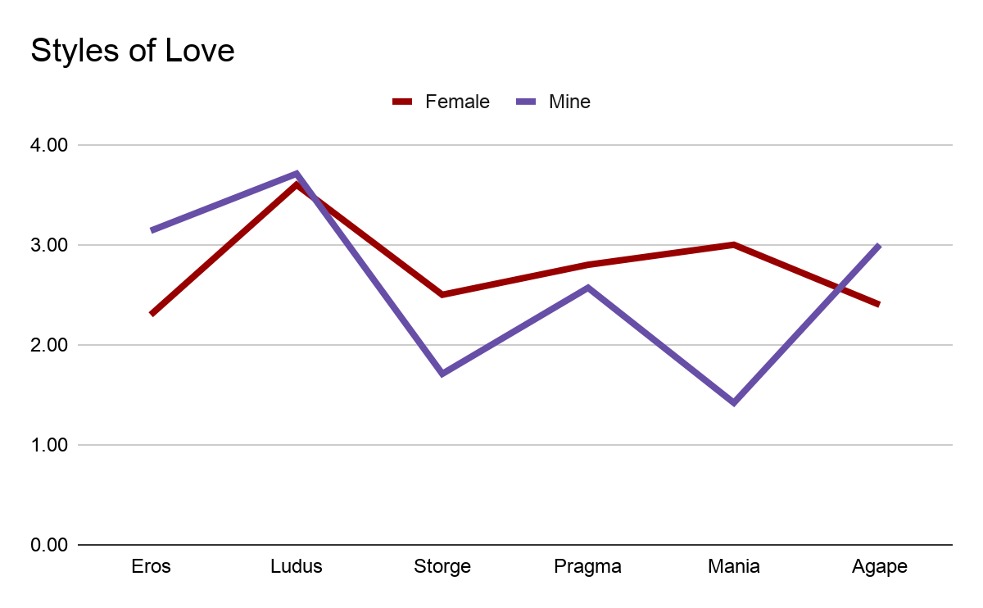
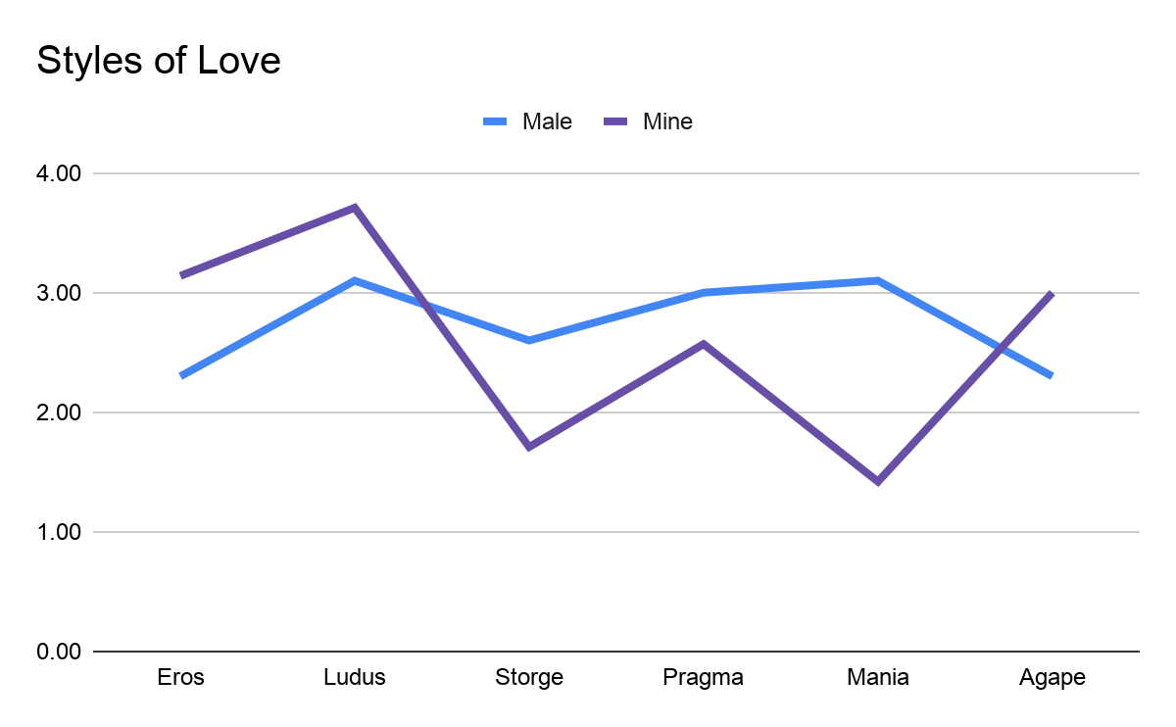
Male

