Animal Emotions: Impact on Survival
Raeghan Franklin
Old Dominion University

Abstract:

Emotions are a common phenomenon that is a result of a phase of neurobiological activity. They are important communication factors and aid in the safety of an organism. Emotions are based on the evolutionary concept of being needed to respond to dangerous stimuli. Several species depend on their emotions to ensure their survival. Emotions are what give animals their desire to live. Most animals are capable of experiencing basic emotions: fear and joy. These animals are able to experience emotions because of their brain processing centers that are comparable to that of humans. Scientists are becoming increasingly aware that more animals express complex emotions such as grief, love, and jealousy. Animals have been observed performing “mortuary rituals” and “vigils”, and remaining by deceased young for days. Certain species remain with their mating partner for life, and pets are even jealous when their owner’s affection is given elsewhere. Even non-sentient beings have adaptive behaviors that align with potentially expressing emotions. The research in this paper correlates animal emotions to their survival concerning their decision-making, reproduction, and social cohesion. The analysis of various studies conducted on animal emotions reveals that animals are capable of experiencing emotions on a higher level in the same sense as humans.

Introduction:

As a human, feelings and emotions are common phenomena that are experienced daily. The term “feeling” describes physical sensations such as pain or touch and are always conscious. Feelings are important because they play a huge role in defining life experiences; examples of feelings include being hot or cold and feeling tired. Emotions are an instinctive state of mind that is derived from certain circumstances, relationships, or moods. Examples of emotions include a reaction to a certain event and can be conscious as well as subconscious. Although the two phenomena, feelings and emotions, are related to each other, they are not the same and the terms should not be used interchangeably. Now that emotions have been made distinct from feelings, their vital importance can now be further discussed.
Emotions are important in maintaining safety by quickly responding to potential threats and in communicating with others; this concept is evolutionary in theory. The concept suggests that emotions directly correspond to thoughts and behavior. An individual’s emotional state is unique to that person and is based on temperament and personality (Cherry, 2022). Based on a more scientific approach, emotions are brought on by a phase of neurobiological activity. They derive from neurobiological development and have proven to be adaptive (Izard 2009). The research on the understanding of emotions has made remarkable progress over the last couple of years and research methods are continuously changing. Despite this, there are still many unanswered questions including one major topic: Do non-human organisms experience emotions?
One ongoing debate in the psychological biology field is whether or not non-human animals can experience emotions in the same capacity as humans. Animal emotions are not to be mistaken for feelings. Most animals have the capability of feeling, such as being hot or cold and being hungry. What is being questioned is whether or not animals are capable of certain emotions such as empathy, grief, and love. Humans depend on their emotions to survive, but it must be noted that emotions are not fundamental for survival in all organisms. Living organisms can survive without emotions, for example, plants. So if survival is capable without emotions, then why would other nonhuman organisms need to have an emotional capacity? Certain emotions, like anger, influence aggression and the desire to survive, and this is what moves animals up the food chain and increases their odds of survival (Simmons 2009). Based on what is currently known about emotions concerning non-human animals, it is likely thought that animals have limited capability to experience emotions. Following this research, it can be understood that animals experience varying emotional responses that aid in their survival.

Topic 1: Animals Expressing Emotions
Certain animals possess similar brain processing centers as humans, this would infer that these animals would be capable of experiencing basic emotions such as grief, fear, and joy. These animals include but are not limited to, dolphins, dogs, chimpanzees, cows, and squirrels (Brooks 2021). Experiencing basic emotions for a nonhuman organism is remarkable, however, evidence shows that animals’ emotional capacity far exceeds just rudimentary emotions. Real-life experiences show that certain species are capable of experiencing not only grief but empathy, happiness/anger, and love along with jealousy.
Grief is defined by deep sorrow, typically it is a response to someone’s death. The animal world can be gruesome and the circle of life relies heavily on predation. Since death is a common occurrence, it could be argued that animals are not affected when a member of the same species is met with an untimely fate. Certain species can experience grief and may be so deeply affected by death that it can result in their demise. In 2018, An orca mother kept the corpse of her dead calf with her for seventeen days before releasing it. Orcas are known to possess high levels of intelligence and empathy and this behavior was an expression of mourning. She grieved her dead calf and was not ready to let go, so she pushed the calf along behind her pod until she was ready. This behavior can also be seen in land mammals. In 2017, a mother chimpanzee was caught on camera cleaning her dead adoptive son’s teeth. It is believed that this can be compared to humans preparing loved ones before a funeral. The significance of this behavior indicates that chimpanzees understand death, and are more than capable of experiencing grief and compassion (Cormier). Elephants are famously known for visiting the remains of dead family members in ways that resemble a “vigil”. Elephants have extremely similar mourning habits to humans. These animals will bury the body of their loved ones, and travel miles to visit their remains. The empathy of elephants is also important to discuss. Elephants care greatly for each other and have been seen helping others out of mud holes, picking out tranquilizer darts from each other, and even throwing mud on each other's wounds. Giraffes are another animal capable of empathy. When a mother giraffe has lost a calf, other females surround the grieving mother and wrap their necks together as if to hug (“The Five Animals That Grieve”). These instances where animals allowed humans to get an inside look at their losses indicate that certain animals can experience grief and empathy.
Animals can express happiness in various ways. One research study shows that when a rat is tickled, it giggles and jumps for joy. The tickling of rats invoked vocalizations that were not consistent with pain (Underwood, 2016). The emotional state of animals can be determined by using the observations seen in Figure 1.
.
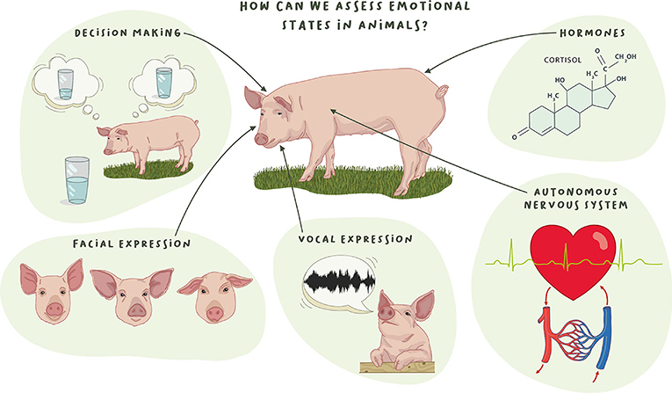
Figure 1
Unlike humans, these organisms are not able to directly tell humans what emotions they are experiencing, however, there are ways to determine what emotional state these organisms are in. This ranges from facial expressions and vocalizations to more lab-based approaches by measuring hormones and monitoring heart rates. Signals of happiness vary across species. It can look like a tail wag, and sound like a purr, giggle or snort. Aggressive behaviors are remarkably consistent among species. In order to observe these behaviors, scientists focus on biological changes like heart rate, hormone levels, and brain activity to observe this state of “anger” (Hamilton 2019). It can be argued that animals are not capable of being angry and that their aggression is based on fear. When animals are afraid, they retreat. An animal's anger is the impulse that drives an animal to go toward a threat. This also proves that animals are capable of logical thinking. When an animal is threatened it must make the decision to run or to decide if it is worth the fight (Breuning, 2017).
Arguably one of the most common emotions discussed when referring to animals is their ability to love. Love can be defined as a deep affection for someone or something. Observations indicate that nonhuman species could potentially experience this emotion to the same extent as humans. One study involving pet owners and their dogs studied hormone levels in dogs when they were interacting with their owners. The hormone measured was oxytocin, known as the “cuddle hormone”. When dogs are interacting with their humans their level of oxytocin is heightened, which in turn, leads to a stronger bond between pet and owner. Humans experience the same surge in oxytocin as seen in dogs, so chances are that one’s pet feels the same as they do (Marshall-Pescini 2019).
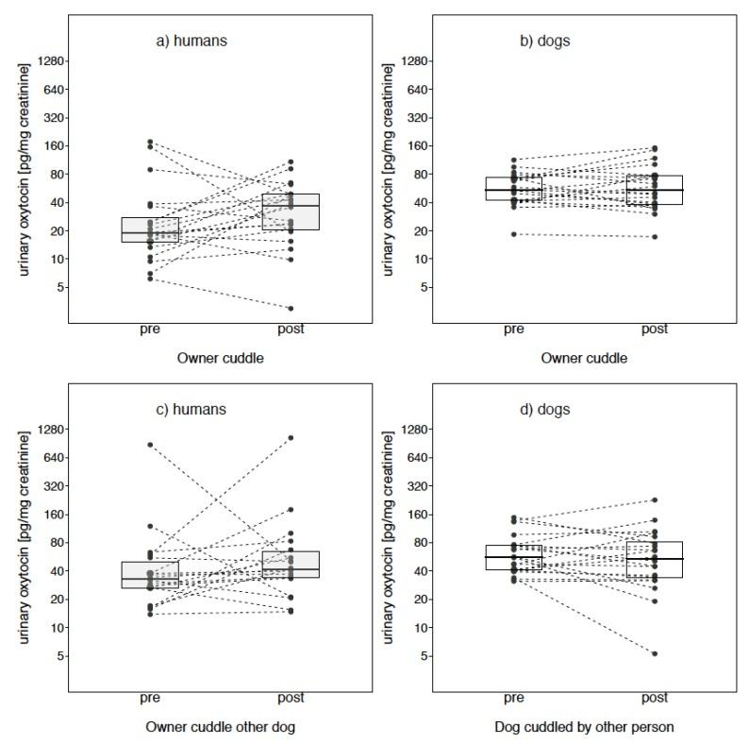
Figure 2
The data presented in Figure 2 illustrates the rise in oxytocin levels when the dogs and their owners are cuddling each other. The two bottom graphs show a decrease in hormone levels when each is put with foreign counterparts. Jealousy is also a common emotion that can be observed especially well in domesticated pets. One study conducted has shown that dogs will show signs of jealousy even when they can only imagine that their owners are interacting with a potential rival. The dogs pulled hard at their leash when their owners appeared to be petting a fake dog. When the owner was petting a fleece the dogs did not give the same reaction as when the owner appeared to be giving another dog attention (Ellis, 2021).

Topic 2: Non-Sentient Organisms
The animals mentioned in this section are considered to be non-sentient organisms. These animals plausibly lack the organs necessary to experience emotions or even feelings. After closer analysis of these species, it can be determined that there might be more to these emotionless species.
Even animals that have been thought to lack the ability to possess emotions may have a basic capacity for experiencing them in their own unique ways. Insects have been thought of as non-sentient beings, but new discoveries may change this notion. One study shows that fruit flies often fight over food and threaten each other to obtain what they want (Hamilton, 2019). This indicates that insects have more mental depth than what was originally assumed. It has also been studied that bumblebees have a positive emotional state that is akin to happiness. Bumblebees in this study were able to be trained to differentiate a blue flower, a reward-filled flower, from a plain green flower. Bees that were instructed to fly to the reward-filled flower flew more quickly than the bees directed to the plain flower. This is evidence of excitement and happiness as well as the expression of disappointment (Goldman, 2016).
One animal known for its lack of emotions and internal organs is the jellyfish. Life is sustainable for the jellyfish because its skin is so thin that oxygen is able to pass directly through it. Both jellyfish and sea anemones have a system of nerve cells called a neural net. This consists of a basic set of nerves that allows these organisms to detect touch, temperature, and salinity. Since the organisms do not have a brain they depend solely on automatic reflexes in response to stimuli. Recently, some species of jellyfish have been found to be able to detect currents using sensors on their body. What is even more remarkable is that these jellyfish can also swim against the current, which appears to be a conscious decision (Gill, 2015).

Topic 3: Animal Emotions and Survival
It was previously mentioned that humans experience emotions in order to maximize their survival. Now that it has been proven that certain species are capable of having some level of emotional intelligence, it is time to see how it correlates to their survival. The emotional state of these animals impacts many aspects of their lives. An animal’s emotions will influence its decision-making. Previous emotional experience influences what decisions an animal will make based on past experiences. One vital part of any organism’s life is its ability to reproduce. Reproduction is essential for survival because it ensures the continuity of a species. If organisms pair through love they are able to continue to reproduce and keep population numbers from diminishing completely. Emotions are also vital in maintaining social dynamics through social cohesion. Group animals rely on the other members of their group, and must be aware of the emotions and feelings of others in order to adequately care for the group, and in turn themselves.
Nonhuman animals have to make a plethora of decisions that are based on risks and rewards. As humans are changing natural systems at an unprecedented rate animals are faced with finding alternative ways of foraging for food, finding shelter, and avoiding predators. Researchers are analyzing animal decision-making in order to see how animals will respond to these environmental changes. Research also shows that animals can remember specific events and are capable of rational decision-making; these animals include elephants, chimpanzees, ravens, and lions. Some animals have even been linked to using tools and are able to solve problems. Matriarchal elephants in Kenya are able to determine the threat level of a human based on ethnicity, gender, and age. These elephants are able to recognize that Masai tribesmen kill elephants, however women and children do not pose a threat. Lions located in South Africa's Selous Game Reserve have also come up with a tactic to hunt an unlikely prey. Giraffes are not the usual prey of choice for these lions because of their difficult-to-reach necks and ability to deliver skull-cracking kicks. However, the lions have reportedly learned that giraffes in a sandy river bed can get stuck and trip, which would limit their range of locomotion. A giraffe in this circumstance would be suitable prey for an agile lion who would not typically get stuck in the river bed. A decision an animal makes has life-altering consequences (Keaver, 2017). Elephants’ sorrow and grief allow them to remember the faces of humans who have killed their loved ones, and some elephants have even taken vengeance. The fear of the lions is what motivated them to discover a new safer tactic for hunting prey. Emotions from past experiences drive animals to make smarter decisions that result in the continuation of their survival.
There are many different courtships that are species-dependent that require a varying amount of emotions from each organism involved. Certain animals like dogs, cats, goats, and rodents all have oxytocin, which is the hormone that contributes to “love” in humans. Science shows that some animals form lifelong attachments to each other. Dedication is shown to the mate by defending territory, traveling, and searching for resources together. Most penguins will mate for life. They pick one penguin out of many and choose to spend over fifteen years or more together. One exceptional observation was made by a scientist observing a penguin whose mate had disappeared. This female penguin eventually paired with another male, but periodically went back to the old nest to see if her previous mate would return. This is evidence that animals do deeply care for each other, and miss each other when they are apart. Love may be nature's way of ensuring that life goes on. If an organism feels strongly compelled to be with its mate, then it will keep producing offspring and keep the species population from depleting. What is even more astonishing is that other species like giraffes, flamingos, and vampire bats have lifelong bonds of the same sex. This indicates that species are capable of loving platonically in the way that humans love their friends and family. Similarly to what humans experience, love in the animal kingdom varies in degrees of intensity, duration, and devotion (Roller, 2017).
Most animals live in groups to guarantee their safety and increase survival rates. Group living gives protection from varying climatic conditions, allows for defense against enemies, and easier access to potential mates. When everything runs smoothly in the group organisms are able to raise each other's offspring which maximizes the amount of young that make it into adulthood. In order for social groups to be functional, all members must be aware of each other's emotional states. Social cohesion is important in order to avoid predation and effectively locate food. Herd animals such as cattle are able to express their emotions, both positive and negative, to each other through distinct vocalizations. A study that was conducted gathered three hundred and thirty-three cow vocalizations. Through these observations of cow calls, it was determined that mother cows communicate with their offspring in distinct voices. The study proves that the purpose of these calls is to maintain contact with the herd in expressing their excitement, arousal, engagement, and distress (Bates, 2020). Group living requires a balance of conflict and cooperation in order to work with clashing personalities. If a group of animals effectively communicates then the individual animal's fitness increases. In order to better maintain conformality many of these animals have a distinct animal hierarchy. This pecking order is meant to be a social order that puts members in a ranking system. These social dominance hierarchies are important in defending resources. This concept is also important in maintaining emotional boundaries. The larger, fit animals are typically in charge. This allows them to mitigate any social alterations that occur further down the hierarchy.

Conclusion
Emotions are not exclusive to humans alone. Even the most basic creatures experience some sort of emotional awareness and capacity. It is evident from multiple studies and observations that animals are competent enough to experience more complex emotions such as grief, anger, love, and jealousy. These emotional experiences are crucial to the survival of a species. Wild animals must be able to make decisions based on their past emotional experiences. They must also be able to find mates through love so that reproduction is possible and the species continues to grow. Social cohesion is also important so that members of the group are able to receive and give optimal care.
Both humans and animals experience emotions for their survival. The realization that animals are capable of feeling emotions in similar ways as humans should invoke compassion towards animal counterparts. Understanding that animals have emotions can lead to optimal care for both wildlife and domesticated animals. One should learn to recognize emotional cues like facial expressions and vocalizations, which can allow farmers and pet owners to better care for their animals. Monitoring the hormone levels of wild animals can indicate what stressors these animals are facing in areas that are heavily deforested or poached. It is extremely important that humans begin to understand their effects on the animals with whom they share the world. In conclusion, a vast majority of animals have proven to express their degree of emotional capacity in astonishing ways. With this information, it is important to be mindful of stressors that can provoke and upset non-human organisms. This research was intended to inform the general public that human decisions do in fact affect the quality of life and survival of these organisms.

References
Bates, Mary. “How Cows Express Emotions.” Psychology Today, Sussex Publishers, 2020.www.psychologytoday.com/us/blog/animal-minds/202002/how-cows-express-emotions.

Brooks, Anna. “Can We Really Ever Know If Animals Are Happy?” Popular Science, 26 Apr. 2021, www.popsci.com/is-my-pet-happy/.

Cherry, Kendra. “The 6 Major Theories of Emotion.” Verywell Mind, Verywell Mind, 7 May 2022, www.verywellmind.com/theories-of-emotion-2795717.
Cormier, Zoe. “The Truth about Animal Grief.” BBC Earth, www.bbcearth.com/news/the-truth-about-animal-grief.
“The Five Animals That Grieve.” HarperCollins Children's Books, www.harpercollins.com/blogs/harperkids/the-five-animals-that-grieve.
Gill, Victoria. “Jellyfish 'Can Sense Ocean Currents'.” BBC News, BBC, 23 Jan. 2015, www.bbc.com/news/science-environment-30936192.
Goldman, Jason G. “I'll Bee There for You: Do Insects Feel Emotions?” Scientific American, Scientific American, 30 Sept. 2016, www.scientificamerican.com/article/i-ll-bee-there-for-you-do-insects-feel-emotions/.
Izard, Carroll E. “Emotion Theory and Research: Highlights, Unanswered Questions, and Emerging Issues.” Annual Review of Psychology, U.S. National Library of Medicine, 2009, www.ncbi.nlm.nih.gov/pmc/articles/PMC2723854/.
Jeannie Kever. “Do Animals Think Rationally?” University of Houston, 1 Nov. 2017, www.uh.edu/news-events/stories/2017/november/11012017Buckner-Animal-Cognition.php.
Roller, Scott.“Let's Talk about Parks: Do Animals Fall in Love?” Gazette, 7 Feb. 2017, www.post-gazette.com/life/my-generation/2017/02/07/Let-s-talk-about-parks-Do-animals-fall-in-love/stories/201702070089#:~:text=Dogs, cats, goats and some,for food as a team.
Sun, The. “Ape Refuses to Leave Dead Son's Side.” New York Post, New York Post, 17 Mar. 2017, nypost.com/2017/03/17/ape-refuses-to-leave-dead-sons-side/.
Underwood, Emily. “Watch These Ticklish Rats Laugh and Jump for Joy.” Science, 2016. www.science.org/content/article/watch-these-ticklish-rats-laugh-and-jump-joy.
Breuning, Lorretta.“Animal Anger.” Psychology Today, Sussex Publishers, 2017 www.psychologytoday.com/us/blog/your-neurochemical-self/201705/animal-anger.
Marshall-Pescini, Sarah, et al. “The Role of Oxytocin in the Dog-Owner Relationship.” Animals : an Open Access Journal from MDPI, U.S. National Library of Medicine, 12 Oct. 2019, www.ncbi.nlm.nih.gov/pmc/articles/PMC6826447/#:~:text=A number of studies have,linked to positive emotional states
Ellis, Ralph. “Dogs Get Jealous, Too, Even for Hidden Rivals.” WebMD, WebMD, 16 Apr. 2021, pets.webmd.com/news/20210416/dogs-get-jealous-too-even-for-hidden-rivals.

