CYSE 270: Linux System for Cybersecurity
Lab 11 – Basic Network Configurations

CYSE 270: Linux System for Cybersecurity
Rhia Dimapelis
11/21/2024
You can use either Ubuntu VM or Kali Linux VM to complete the following tasks.
Task A – Explore Network Configurations (8 * 5 = 40 Points)
{{{{{{{{{Connect your VM in the NAT mode}}}}}}}}
1. Use the correct ifconfig command to display the current network configuration. Highlight your IP
address, MAC address, and the network mask.
2. Use the correct route command to display the current routing table.
3. Use the netstat command to list current TCP connections.
4. Use the ping command to determine if the ubuntu.com system is accessible via the network.
(Use the correct option to send 10 ping requests only.)
5. Use the host command to perform a DNS query on www.odu.edu
6. Use the cat command to display the contents of the file that contains the system’s hostname.
7. Use the cat command to display the contents of the file that contains the DNS servers for this
system.
8. Edit the same file you display in the previous step, set the system’s hostname to your MIDAS ID
permanently. Reboot system and repeat step 6.
Task B – A Different Network Setting (3 * 20 = 60 Points)
1. Change the VM network connection from NAT to the bridge mode (you will lose your Internet
connection if you are connected to the ODU campus Wi-Fi network, but it is okay).
2. Reboot your system, then repeat Steps 1 – 7 in Task A.
3. Highlight the differences at the end of each step and discuss what do you find.

Task A:
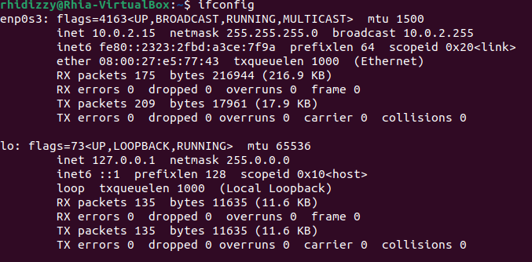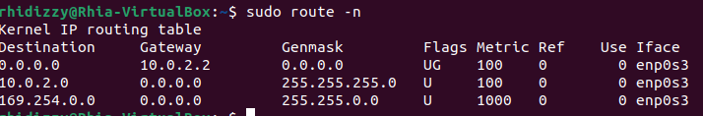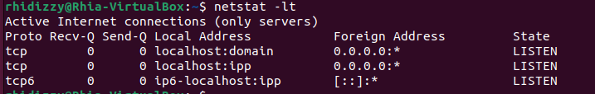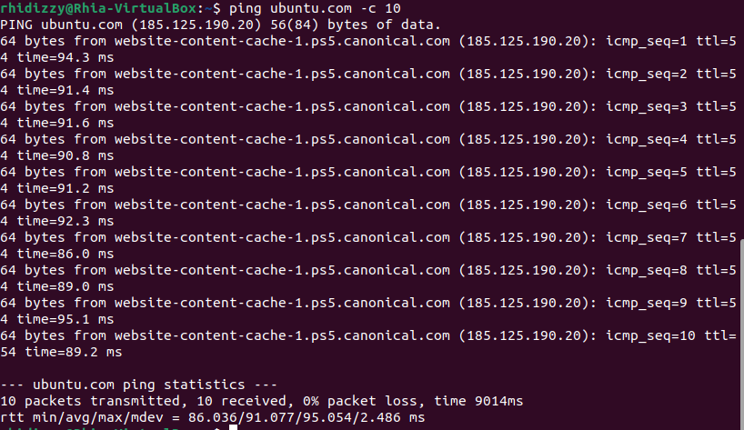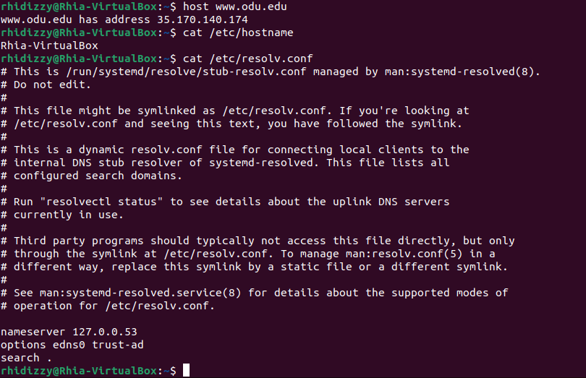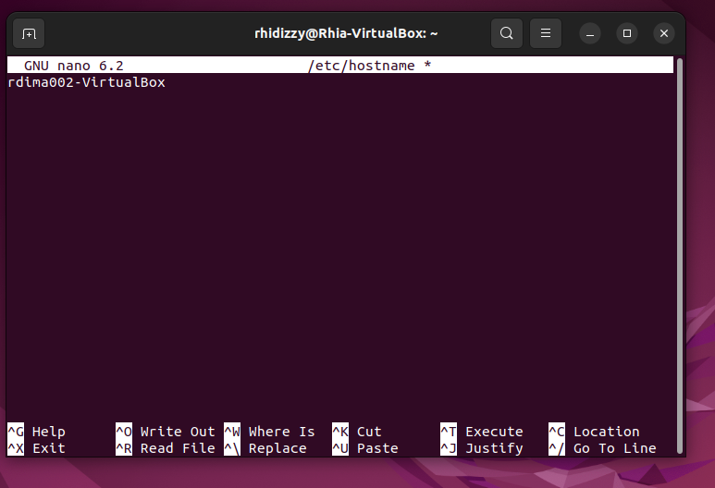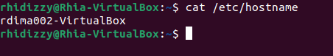

Task B: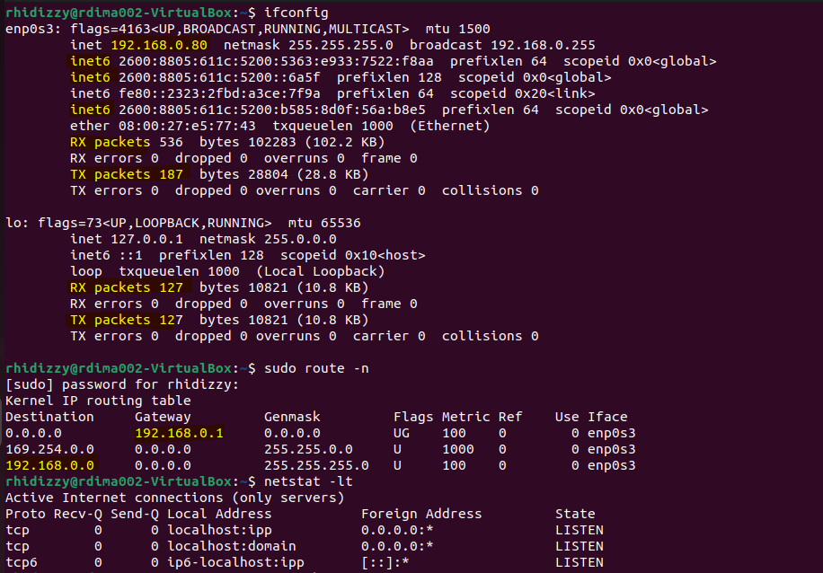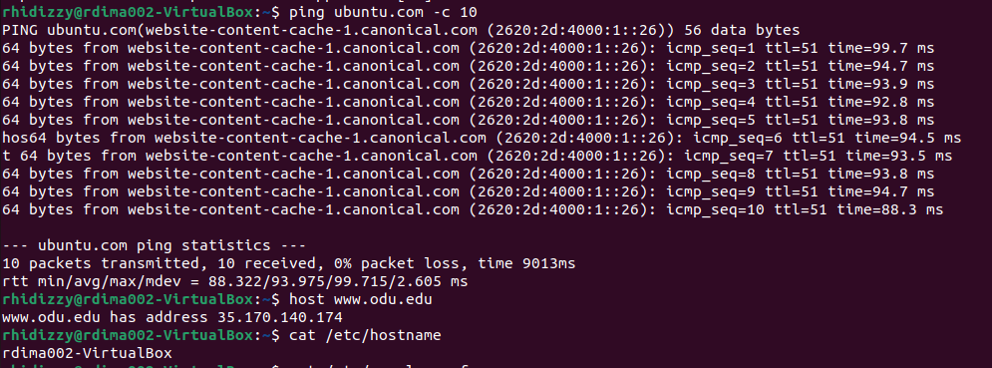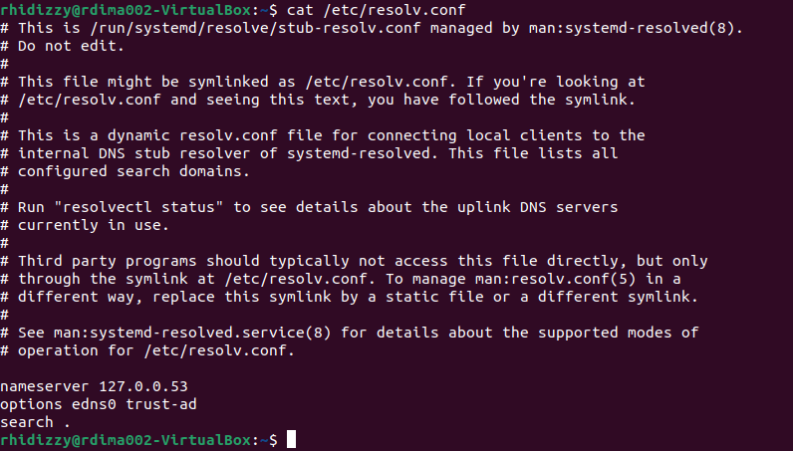

Conclusion: After changing the VM network connection from Nat to bridge adapter, the IP address changes and the routing table is also different.

