CYSE 270: Linux System for Cybersecurity
Lab 12 – Advanced Network configurations

Scenario: You, as a network admin, are going to set up your Ubuntu VM as a gateway to provide
Internet access to another client Ubuntu VM. The client VM needs to be in the same internal
network as the gateway (as shown in Figure 1). Once the connection is ready, you need to
configure the firewall to secure the network properly. The following requirements need to be
satisfied to receive full credits.
Please note that you need to customize the value in the fields marked in RED above.
Please configure the network with the following requirement: (You need to clone the existing
VM)
Task A –Network Configuration (60 points)
Please submit the screenshot for all the steps.
1. In the virtual box setting, connect two VMs in the same internal network, “internal_{UIN}”.
Replace {UIN} with your real UIN.
2. Change the hostname of the Client VM to “{MIDASname}-Client.” Replace {MIDAS name} with
your real MIDAS name. Don't forget to reboot your client VM to reflect the change in
hostname.
3. Configure the temporary IP address on the Gateway Ubuntu, as shown in Figure 1.
4. Configure the temporary IP address, routing table, and DNS server on Client VM as shown in
Figure 1.
5. Configure gateway Ubuntu to enable IP forwarding (to forward the traffic) (also NAT
configuration)
6. Test your ping connection to 8.8.8.8 and www.google.com in the client VM, respectively.
Task B –Firewall Configuration (40 points)
1. Configure the iptables on the gateway Ubuntu to block all the inbound ICMP packets from the
Client VM.
2. Configure the iptables on the gateway Ubuntu to block all the outbound ICMP packets that
originated from the gateway Ubuntu itself.
Extra credit:
Set the permanent IP address on the Client Ubuntu based on the above network topology.
Annotations
TASK A
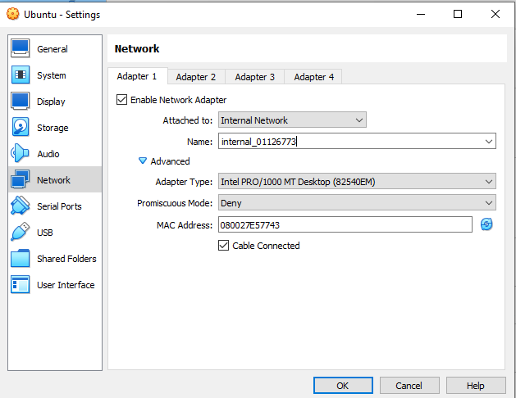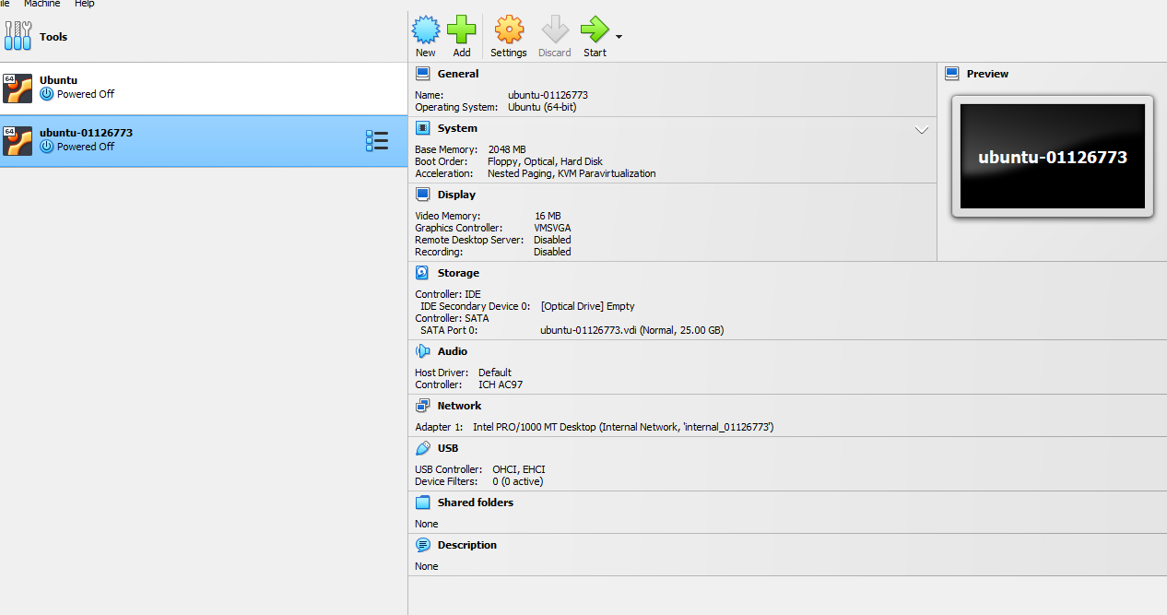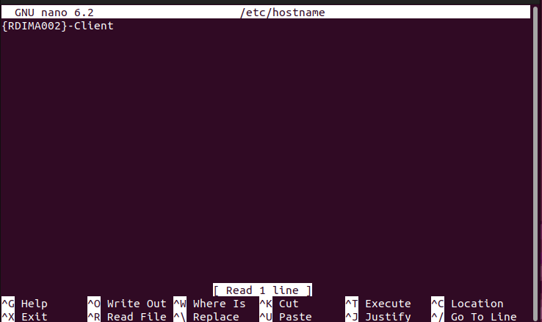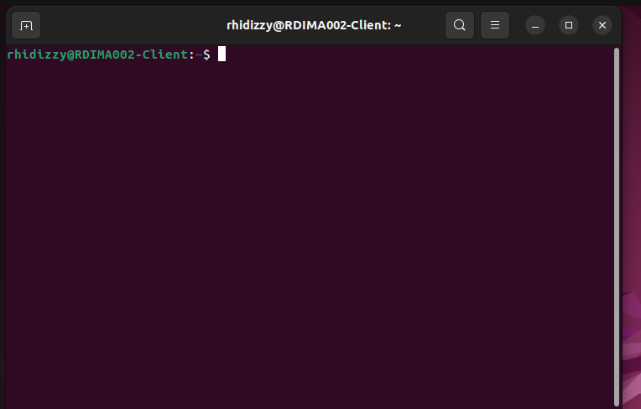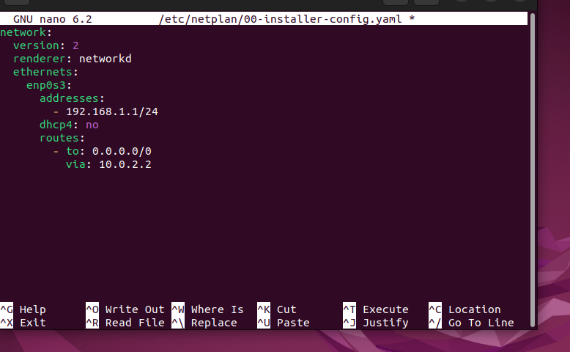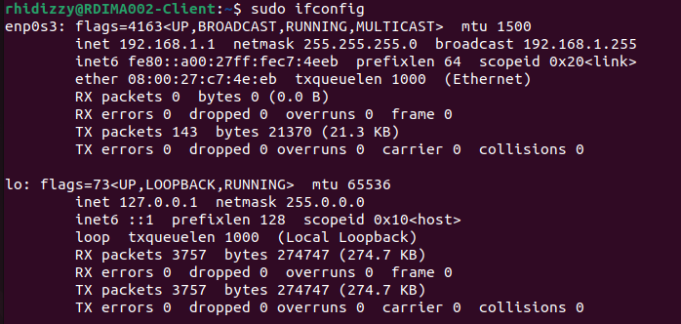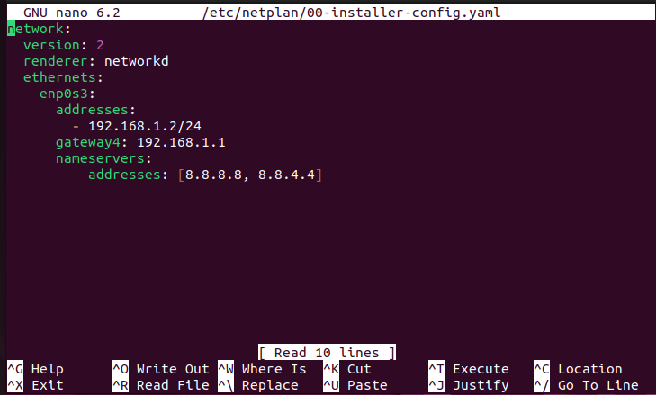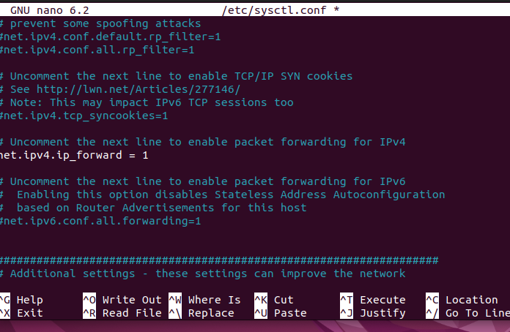
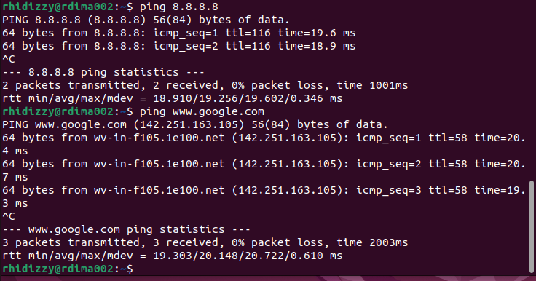

TASK B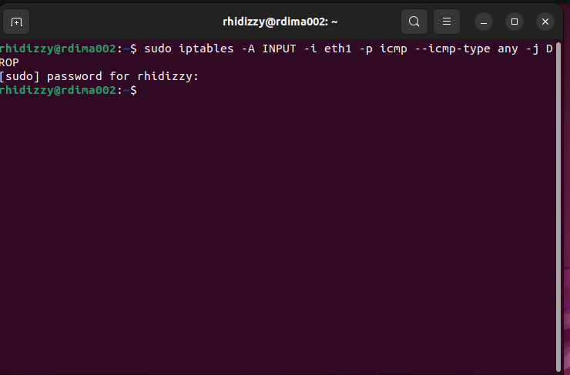
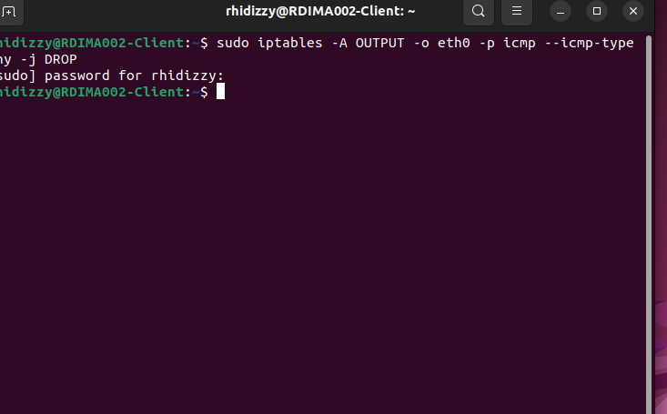
EC:
