CYSE 270: Linux System for Cybersecurity
Lab 13 – System Admin
Rhia Dimapelis

Task A: Managing System Processes (40 points)
Step 1. Open the terminal in your VM.
Step 2. List the processes that are running in the current shell.
Step 3. List all processes that are running on this system.
Step 4: Display all processes that are running by using the top command. (Keep this command
running for the next few steps.)
Step 5: While in the top command, display the help screen.
Step 6: Quit the top command.
Step 7: Execute the gnome-calculator program in the background.
Step 8: In the current shell, list all running jobs.
step-9: Use the killall command to stop (kill) all instances of the gnome-calculator program.
Step 10. In the current shell, use the ps command to list all running processes.
Task B – Package installation (60 points)
Step 1. Download the installation package (deb file) for skype in Linux and install it properly.
Note: you should not use APT GET to install Skype in this step.
Step 2. Create a backup file for the sources.list named source.list.bk in your Linux system.
Display the contents in both files, and make sure they are identical.
Step 3. Delete everything in the source.list file. Now try to download the package “joe” by
using apt get install command. What error do you see?
Step 4. Recover the sources.list from the backup file, then try to download the “joe” file again.
You should be able to install joe this time.
Step 5. Install and play the “sl” command.
Step 6. Install and play the “cowsay” command.
Step 7. Install and play the “cmatrix” command.

TASK A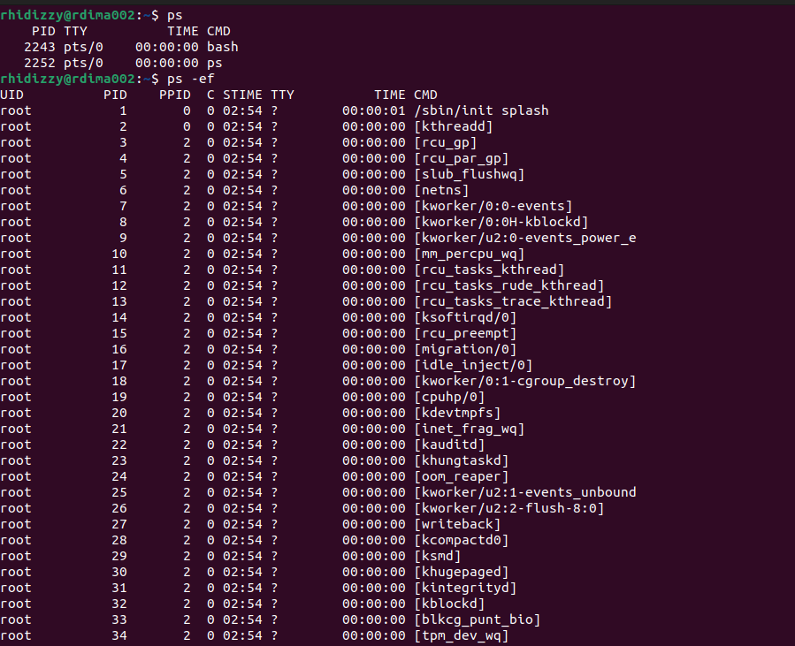
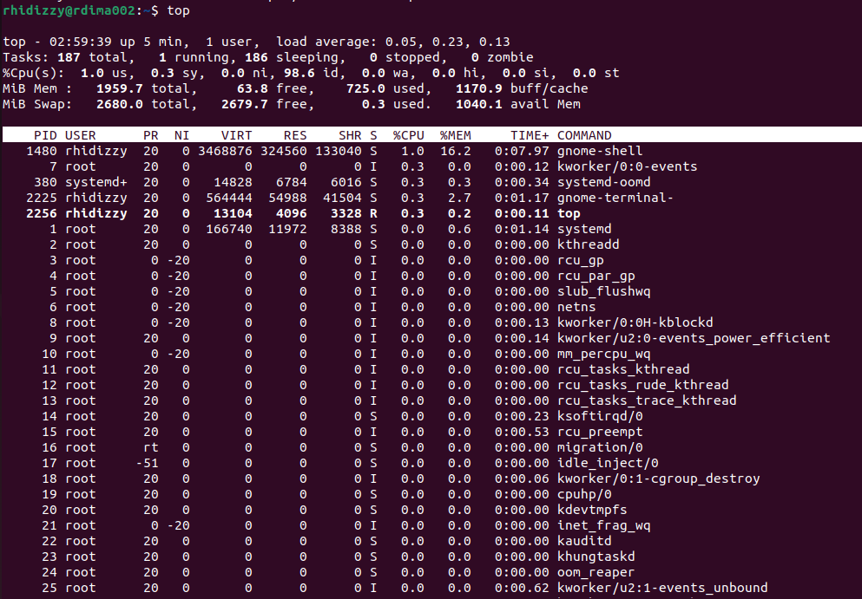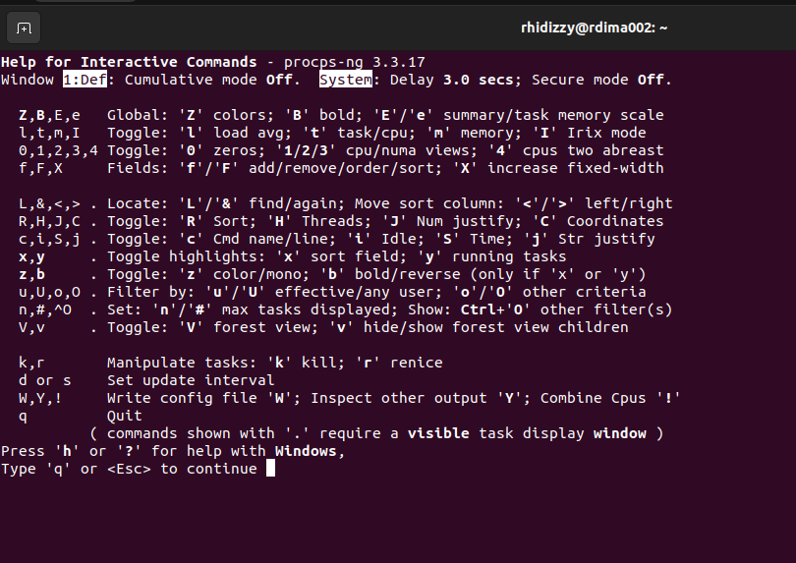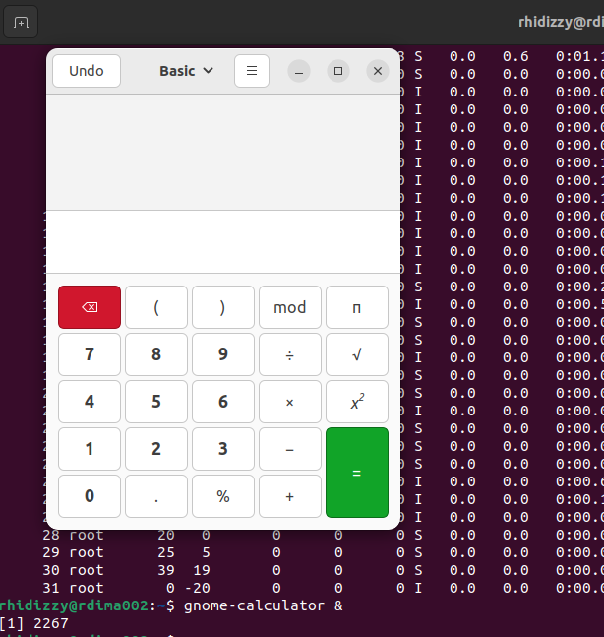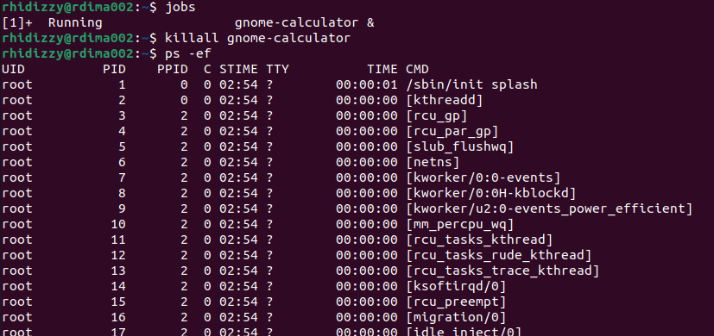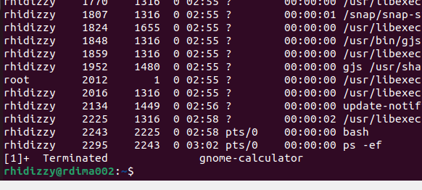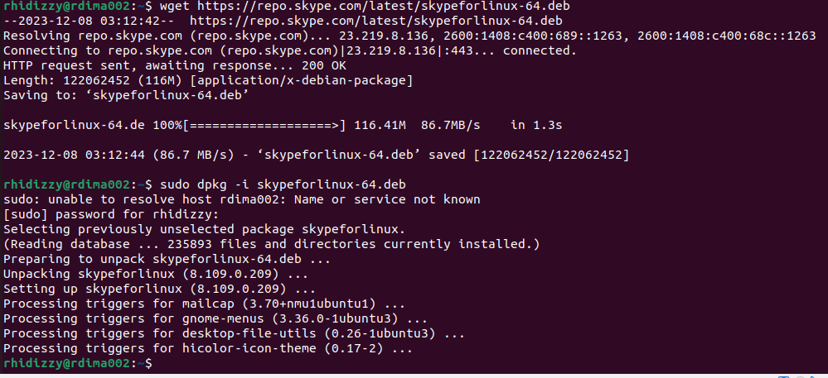
TASK B