CYSE 270: Linux System for Cybersecurity
Lab 8 – Shell Scripting
Rhia Dimapelis

Task-A: Write a shell script lab8-1.sh using vi/nano using if- elif-else condition, to
complete the following steps:
1. Prompt the user to input his/her lucky number.
2. If the input number is equal to 10, then print the message “You got the first prize.”
3. If the input number is equal to 8, then print the message – “You got the second prize.”
4. If the input number is equal to 999, then print the message – “You got the third prize.”
5. If None of the above conditions are true, then print the message – “Sorry, good Luck for
next time.”
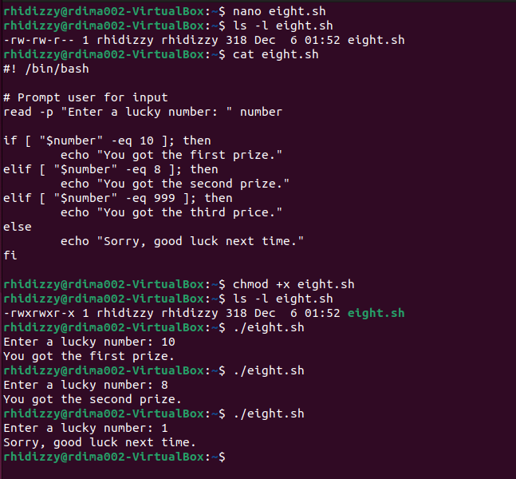

Task-B: Write a shell script lab8-2.sh using vi/nano to validate your input by using
egrep command.
1. Prompt the user to provide the input which should consists of characters and numbers
both, and check if the following requirements are satisfied:
2. Only lower-case letter [a-z] and numeric character [0-9] are allowed.
3. The length must be between 4 to 8 digits
Test your script with the following examples:
1. Your input with one upper case
2. The input having length less than 4 digits.
3. The input having length larger than 8 digits.
4. Your input in lower case and should have length between 4 to 8. 