CYSE 301: Cybersecurity Technique and Operations Assignment 4: Password Cracking (Part A)
At the end of this module, each student needs to submit a report that includes the solutions to the following tasks. Make sure you take a screenshot for every single step as proof. You need to use
Task A: Linux Password Cracking (25 points)
1. 5 points. Create two groups, one is cyse301s23, and the other is your ODU Midas ID (for example, pjiang). Then display the corresponding group IDs. 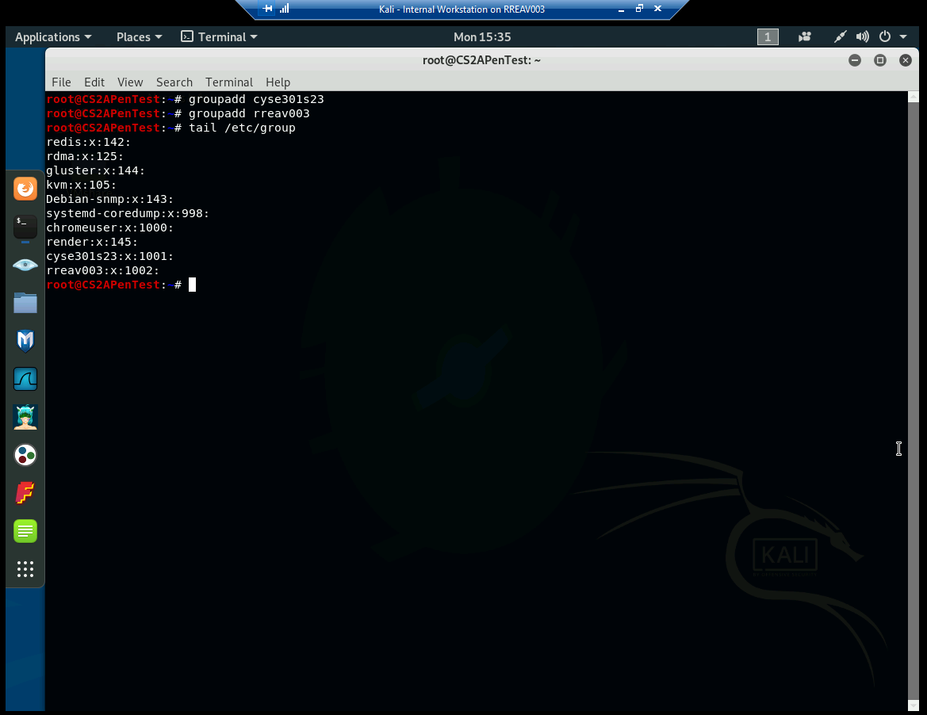
2. 5 points. Create and assign three users to each group. Display related UID and GID information of each user. 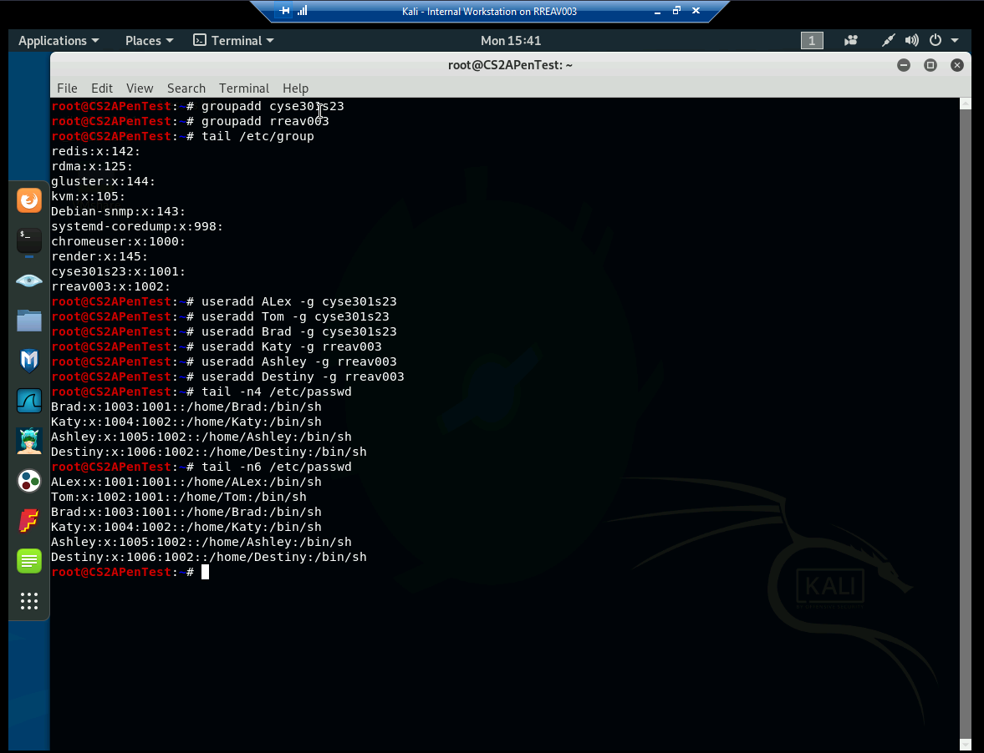
3. 5 points. Choose six new passwords, from easy to hard, and assign them to the users you created. You need to show me the password you selected in your report, and DO NOT use your real-world passwords.
Passwords:
Alex - Happy
Tom - toor
Brad - Sad
Katy - Cats
Ashley - dog
Destiny - root
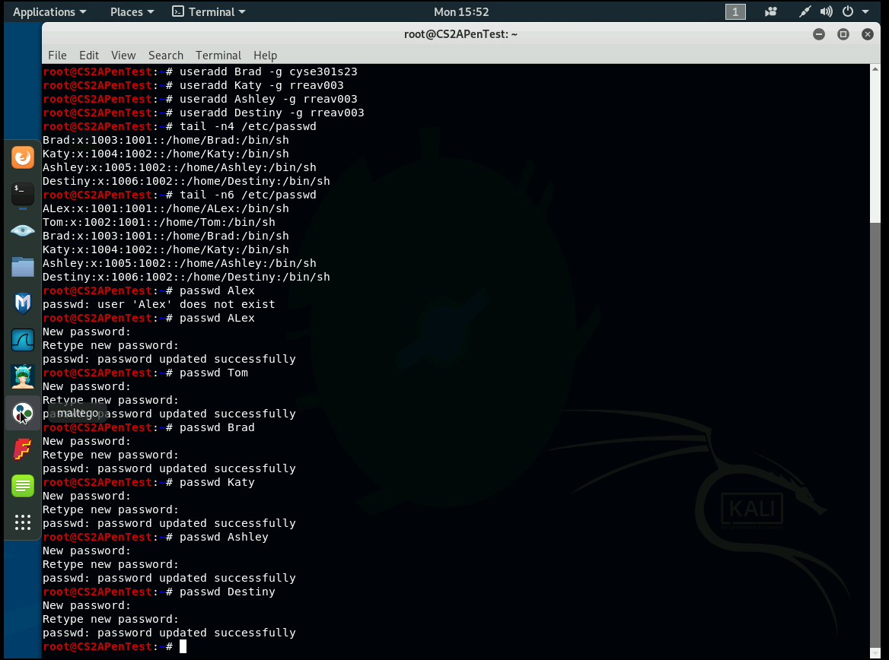
4. 5 points. Export all six users’ password hashes into a file named “YourMIDAS-HASH” (for example, pjiang-HASH). Then launch a dictionary attack to crack the passwords. You MUST crack at least one password in order to complete this assignment. 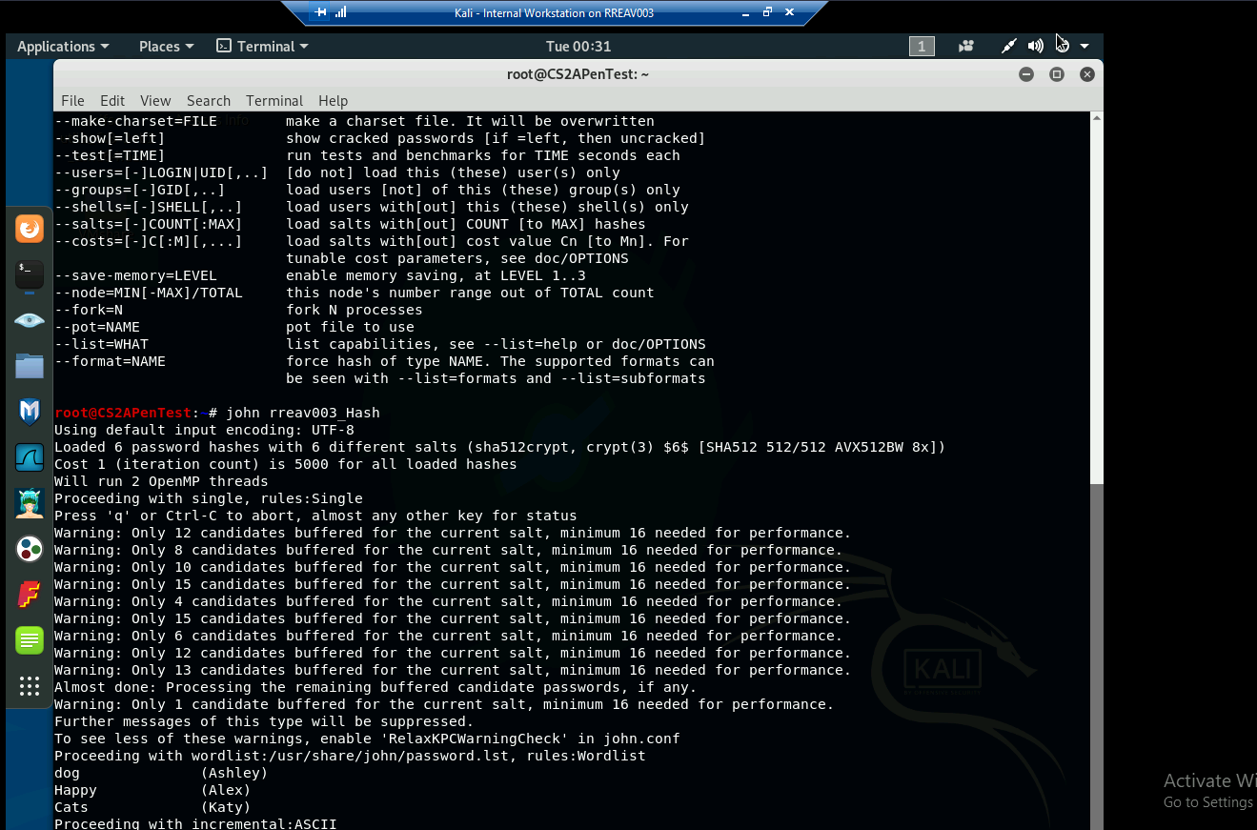
Task B: Windows Password Cracking (25 points)
Log on to Windows 7 VM and create a list of 3 users with different passwords. Then you need to establish a reverse shell connection with the admin privilege to the target Windows 7 VM.
Now, complete the following tasks:
1. 5 points. Display the password hashes by using the “hashdump” command in the meterpreter shell. Then
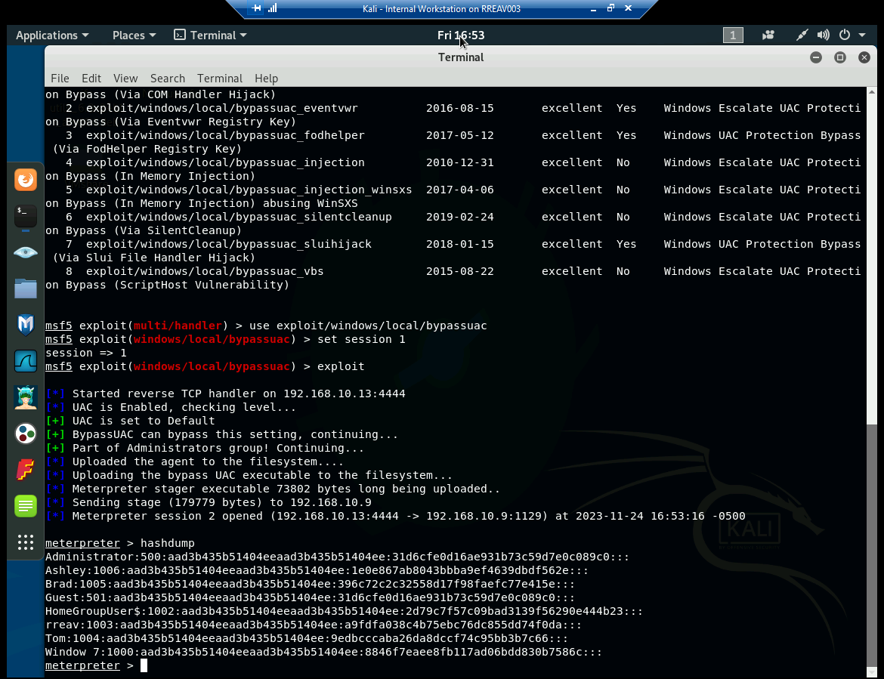
2. 10 points. Save the password hashes into a file named “your_midas.WinHASH” in Kali Linux (you need to replace the “your_midas” with your university MIDAS ID). Then run John the ripper for 10 minutes to crack the passwords (You MUST crack at least one password in order to complete this assignment.).
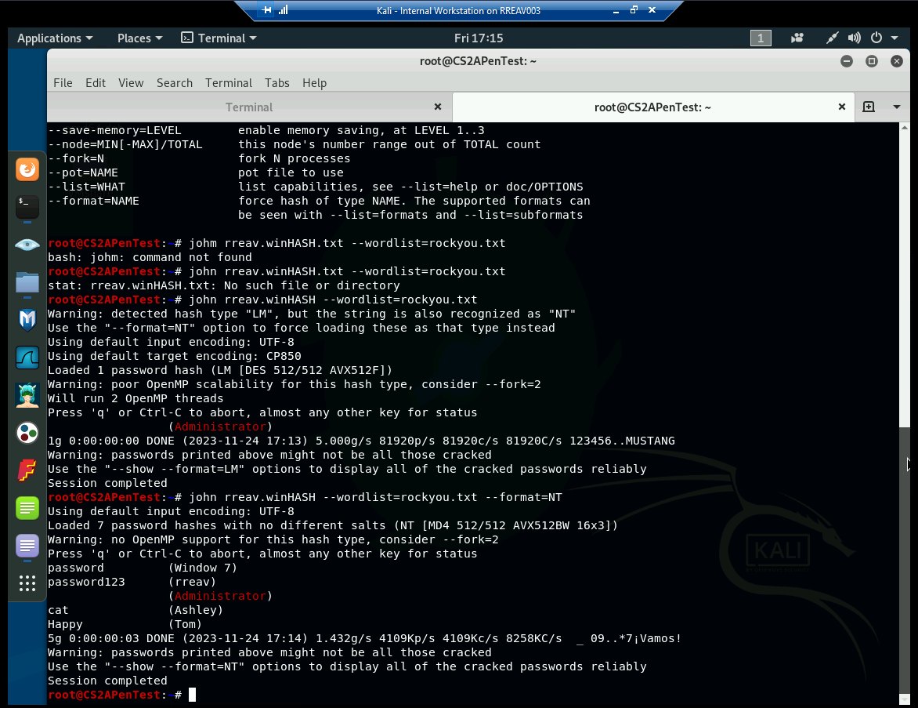
3. 10 points. Upload the password cracking tool, Cain and Abel, to the remote Windows 7 VM, and install it via a remote desktop window. Then, implement BOTH brute force and dictionary attacks to crack the passwords. (You MUST crack at least one password in order to complete this assignment.).
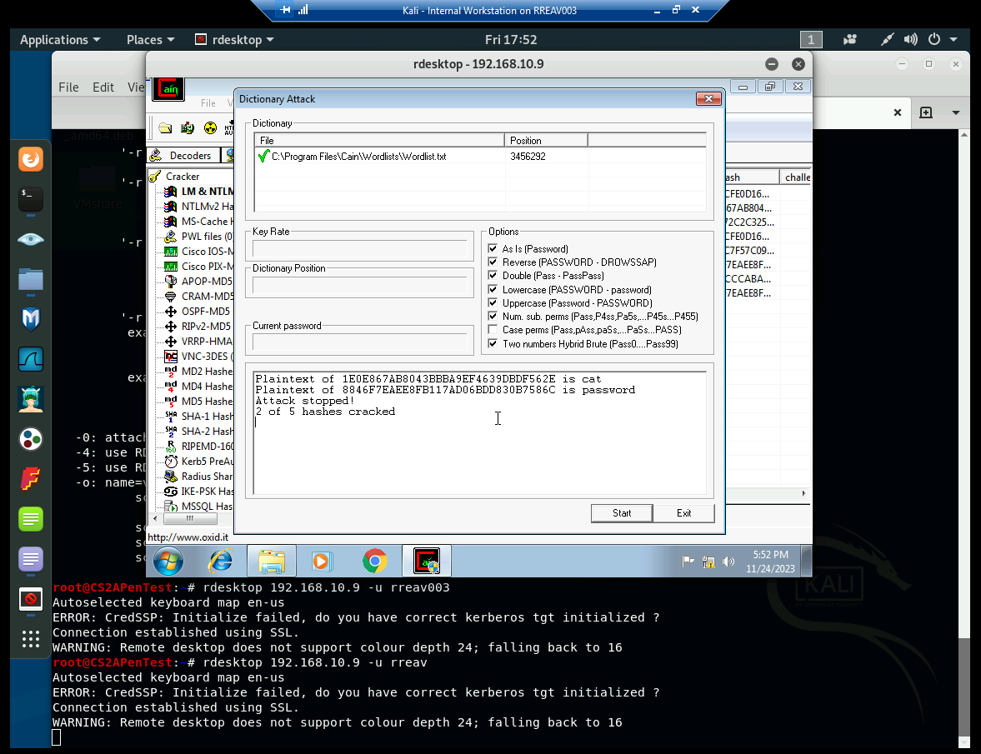
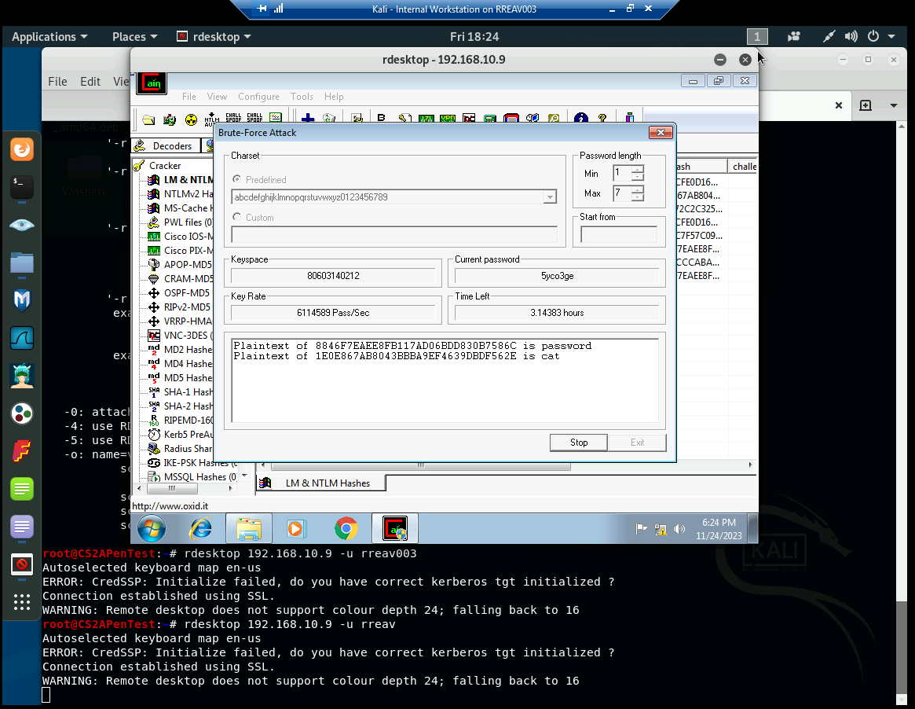
Task C: Extra credit: (10 points)
Search the proper format in John the Ripper to crack the following MD5 hashes (use the --list=formats option to list all supported formats) . Show your steps and results.
1. 5f4dcc3b5aa765d61d8327deb882cf99 - Password
2. 63a9f0ea7bb98050796b649e85481845 - Root

