CYSE 301: Cybersecurity Technique and Operations Assignment M5: Wi-Fi Password Cracking
Task A: 40 points
Follow the steps in the lab manual, and decrypt WEP and WPA/WPA2 protected traffic. Requirements:
• Decrypt the lab4wep.cap file (10 points) and perform a detailed traffic analysis (10 points)
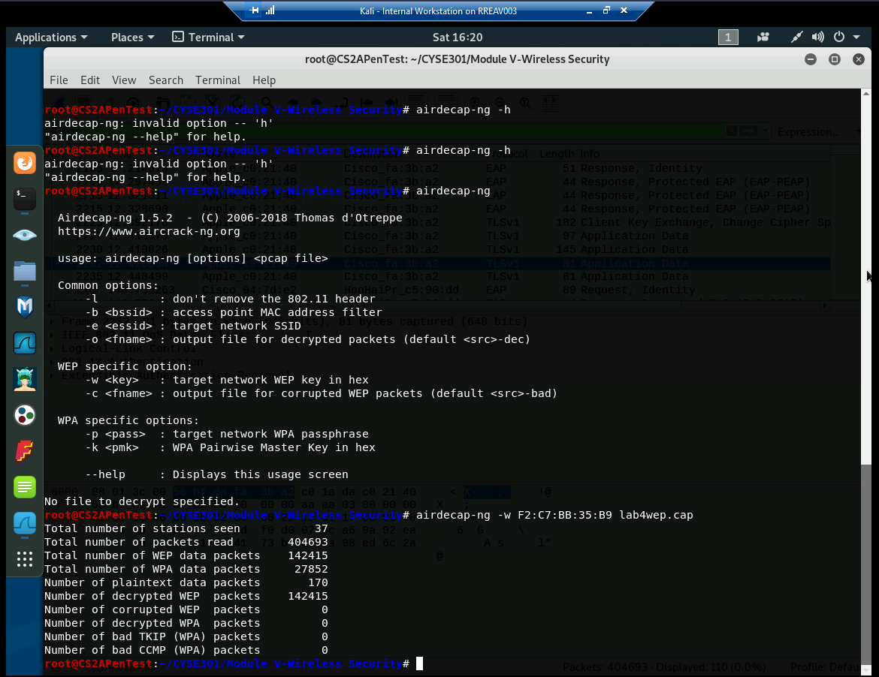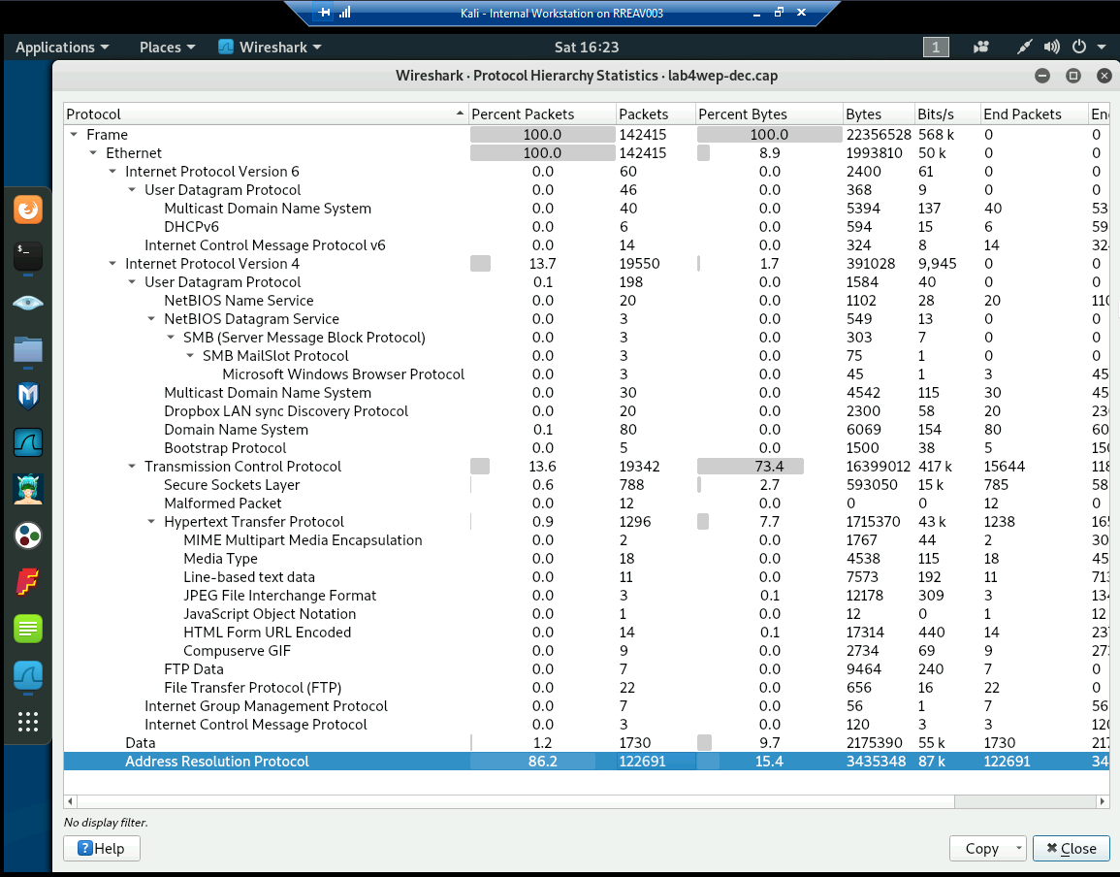
ARP traffic is normal, but if there is a high volume of ARP packets it could mean there could be some network issues, misconfigurations, or potentially malicious activity.
• Decrypt the lab4wpa2.cap file (10 points) and perform a detailed traffic analysis (10 points)
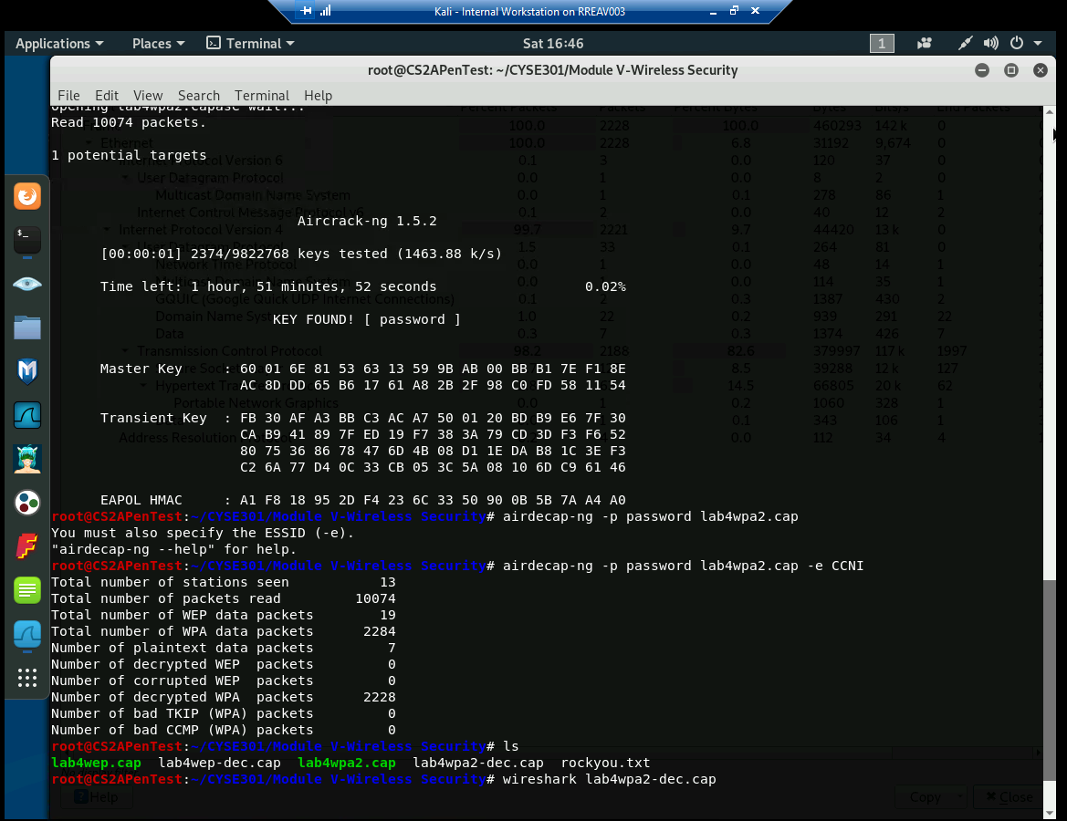
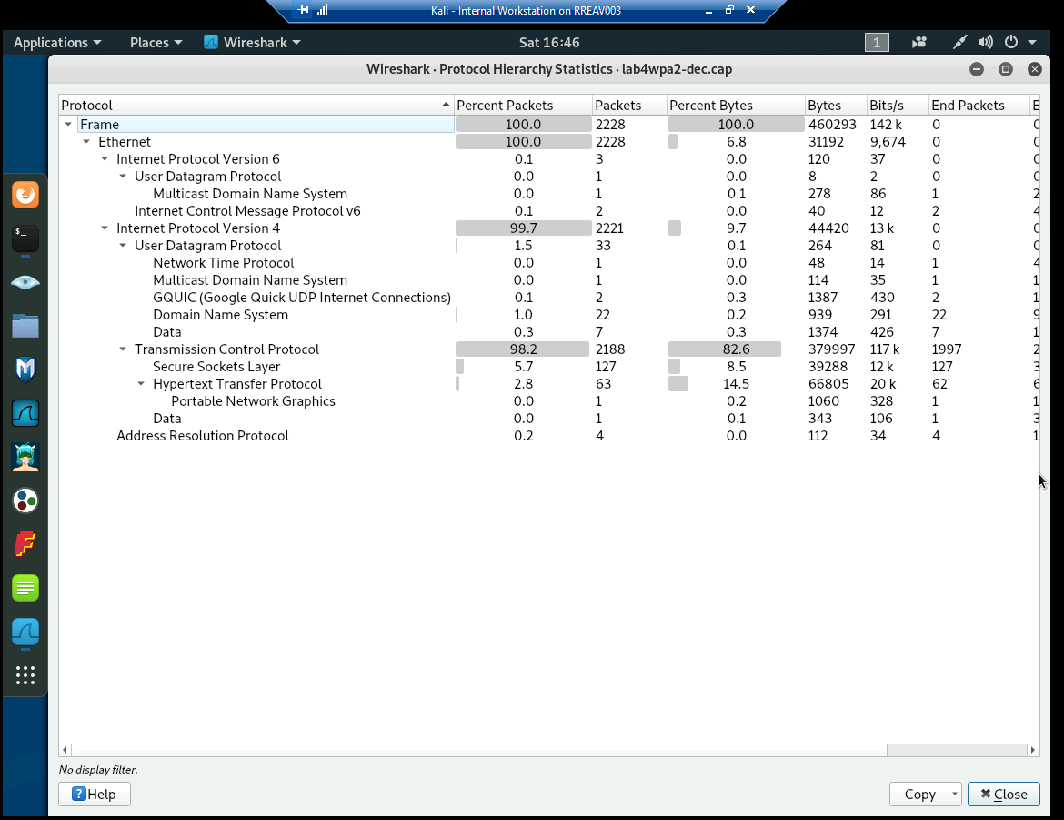
The main difference between the first one and this is that there is a significantly less amount of ARP packets.
Task B: 60 points
Each student will be assigned a new WPA2 traffic file for analysis. You need to refer to the table below and find the file assigned to you based on the LAST digit of the MD5 of your MIDAS ID. For example, the last digit of the hash for pjiang is e. Thus, I should pick up file "WPA2-P5-01.cap."
MD5 of pjiang is 5a618cdc3edffd8b4c661e7e9b70ce1e
You can find an online MD5 hash generator or the following command to get the hash of a text string, 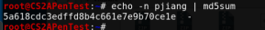
Last digit of your MD5 Filename
0~3 WPA2-P1-01.cap
4~5 WPA2-P2-01.cap
6~8 WPA2-P3-01.cap
9~B WPA2-P4-01.cap
C~F WPA2-P5-01.cap
The above files are zipped in a folder named "Lab Resources." You can locate zipped folder in the Windows 10 Host Machine under C:/VMShare. Then, unzip the following zipped file in the Kali Linux VM, find the assigned WPA file under sub-folder “Module 5”.
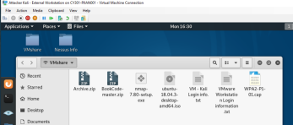
Then complete the following steps:
1. Implement a dictionary attack and find the password. - 30 points
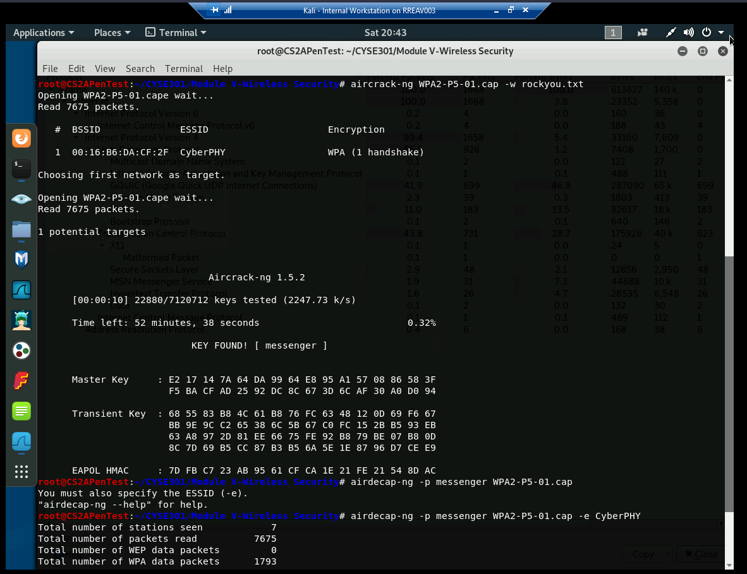
2. Decrypt the encrypted traffic and write a detailed summary to describe what you have explored from this encrypted traffic file. -30 points
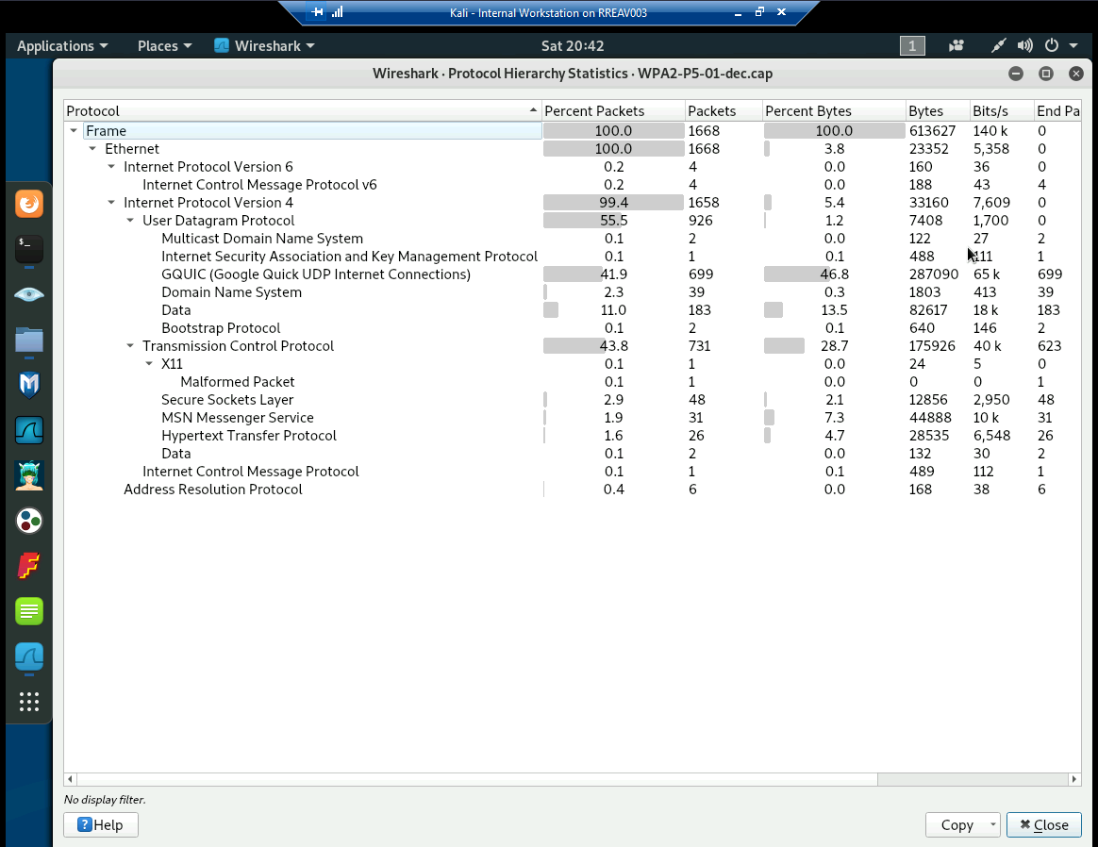
In this table the user has a lot GQUIC in the Internet protocol version 4, under User datagram protocol but otherwise everything looks normal.

