Are Cyber Attacks Serious

Introduction:
The war going on in Ukraine has been going on for a while now and took all of us by surprise. During the start of the war between Russia and Ukraine I have heard about cyber attacks that have been sent out to the US. In response to the U.S. tried to help out Ukraine. I wondered what Exactly is a cyber attack? Is it as bad as they make it out to be? What are cyber attacks and are they really that dangerous? New broadcasters make a big deal about these cyber attacks like it could be the end of America. But they also never say what is being attacked and how it's being attacked. According to the FBI, the first Cyber attack was back in 1988. (Morris Worm, 2022) Cyber attacks have evolved today to be a way to fight wars. “Cyber Attacks are attacks, via cyberspace, targeting an enterprise’s use of cyberspace for the purpose of disrupting, disabling, destroying, or maliciously controlling a computing environment/infrastructure; or destroying the integrity of the data or stealing controlled information”, says the Computer Security Resource Center. (CSRC Glossary, No date)
In this concept map it asks the basic question people would want to know about cyber attacks. Those questions would be, “what is it”, “What does it attack”, “How does it affect people”, “what is cyber security”, and “How does cyber security stop cyber attacks”.

Cyber Attacks

What is it?
What does it attack?
How do Cyber Attacks work?
What is cyber security?
How does cyber security stop cyber attacks

What Are Cyber Attacks:
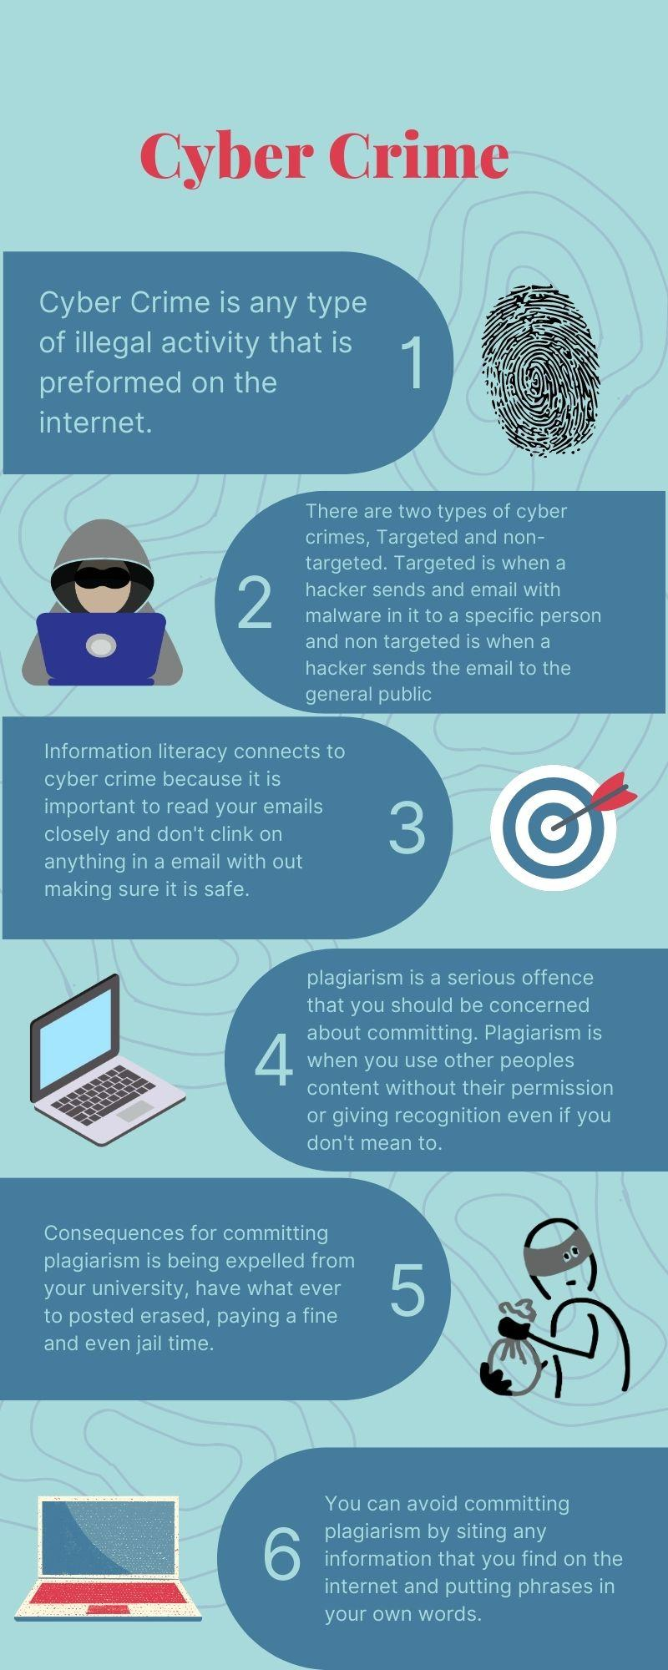
First let's look at what cyber attacks even are. According to Mary K. Pratt, a cyber attack is, “any attempt to gain unauthorized access to a computer, computing system or computer network with the intent to cause damage.” (Mary K. Pratt, 2022)) Another form of cyber attack is to gain control of a computer's system and instruct the computer to do what they so choose. One more form of cyber attack is when hackers hack into a computer to get access to classified information. This happened to the Minneapolis Police Department after a police kill a black man and the hacker sent emails to the police department and if the email was open it would download a software that was made to leak sensitive data that the police department had on their computers. According to Feng, B., Li, Q., Ji, Y., Guo, D., & Meng, X this also happened to North Korean refugees and journalists. Fake people on social media apps would send links to them that would install malware on their device which gave the hackers access to their information. ( Feng, B., Li, Q., Ji, Y., Guo, D., & Meng, X , 2019)

What do hackers look for when they do a cyber Attack:
Next we are going to look at what hackers go for during a cyber attack. Hackers will send cyber attacks to you via phone call to try to get your credit card information. According to Carnegie Endowment For International Peace, on April 11, 2022 in South Korea, hackers would call people pretending to be employees of a bank and try to ask you for your credit card information. (Carnegie Endowment For International Peace, 2022) Also hackers if they so choose can get your exact location by looking at your ip address. Those same hackers from Korea were also looking to gain access to your contacts, microphone, camera and location of the people that they called. (Carnegie Endowment For International Peace, 202) Hackers will also try to steal people's identity by getting a hold of your social security number. Carnegie Endowment For International Peace also claims that, on September 7, 2017 the biggest data breach happened to a credit reporting agency called Equifax. Equifax said that around 150 million of their customers' data had been released like their date of birth and social security numbers. ( Carnegie Endowment For International Peace, 2022) Hackers can also gain control over devices if they are able to hack through it. According to Lehto, Neittaanmäki, and Neittaanmäki Iran was able to hack one of the United States drones and fly it back to their bases so that Iran could have it. (Lehto, Neittaanmäki, & Neittaanmäki, P., 2015, pg 90)

According to Forbes this data shows the number of weekly attacks on organizations by their industry in 2021. As you can see cyber attacks towards the research and Education industry were very high in 2021.
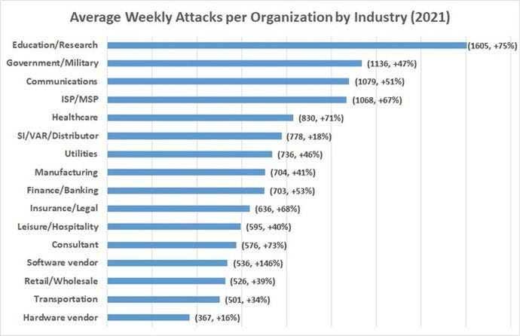
How do Cyber Attacks Work:
After looking at what cyber attacks are and what hackers are looking for when they send these attacks. Let’s look at how cyber attacks work. There are just two types of cyber attacks that hackers send, non targeted attacks and targeted attacks. Some examples of non targeted cyber attacks are phishing which according to the National Cyber Security Centre (NCSC) is when hackers send emails to a large group of people asking for sensitive data. (NCSC, 2015) Water holing which according to NCSC is when hackers make fake websites or work with real websites to use the people that visit the site. (NCSC, 2015) Some examples of targeted attacks are spear phishing which is when hackers send emails to specific people to get their information. Also subverting the supply chain which according to NCSC is when hackers attack equipment that is being sent to companies and gets into the system. (NCSC, 2015)

What is Cyber Security:
Now that we looked at what a cyber attack is and how it can affect people let's look at how we can stop it. We can stop cyber attacks through the use of cyber security. Cyber security was made to protect people's information from getting leaked. Cyber security is a coding method that detects if a hacker is trying to get into your information and stops the hacker the moment it detects it. There are people that specialize in cyber security that help protect networks on a large scale to help the city, state, or nation that they are in and can locate these hackers and put them in prison. Cyber security is like a defensive layer that prevents cyber attacks from working effectively. Some examples of cyber security are Network Security which according to Kaspersky is,”The practice of securing a computer network from intruders, whether targeted attackers or opportunistic malware.” (Kaspersky, 2022) Application security which according to Kaspersky is basically focuses on making sure devices stay threat free. (Kaspersky, 2022) Information security which according to Kaspersky, “protects the integrity and privacy of data, both in storage and in transit.” (Kaspersky, 2022) Operational security which Kaspersky states as, “the processes and decisions for handling and protecting data assets. The permissions users have when accessing a network and the procedures that determine how and where data may be stored or shared all fall under this umbrella.” (Kaspersky, 2022) Also there is disaster recovery which Kaspersky defines as, “how an organization responds to a cyber-security incident or any other event that causes the loss of operations or data. Disaster recovery policies dictate how the organization restores its operations and information to return to the same operating capacity as before the event.” (Kaspersky, 2022)

How does cyber security stop attacks:
We looked at what cyber security is but how it actually stops hackers from getting the information. When you set up a type of cyber security, it will encrypt data that comes through your computer to make sure that it's not going to be harmful to your computer or to make sure that your information is safe. All the data that comes through has to be checked by a wall of cyber security before you even know what it is. Cyber security will also stop your information from being leaked from your computer so you can rest assured that the information that you save in your computer will never leave as long as you have a form of cyber security. What also goes hand in hand with cyber security is having proper safety measures when you are using the internet or doing anything on the computer. Ways you can protect yourself from cyber attacks according to Cyber Ready is to turn off your location in the privacy setting of your computer, keep your devices up to date, use a strong password and turn on 2 factor authentication if they give you the option to, make your sure you read everything carefully before clicking on a link, and change your passwords regularly to stay safe. (Cyber Ready, 2022) Signs that something might be a virus is if you ever see something on the internet saying to do something now or right away, be careful of it. Anything that pops up on websites randomly and is glowing saying to click it or that you need to download something DO NOT CLICK IT this is the most common type of ways viruses can get into your computer.

Final Conclusion:
Cyber security is very important in today's society and no one's information would be safe without it. There are people in this world that are trying to steal your sensitive information by sending you rigged emails or rigged phone calls. These hackers are out for people's private information and money in hopes of a gain. But lucky for us there are people out trying to prevent cyber attacks. People that specialize in cyber security help locate these hackers and make sure they receive proper punishment for what they do. Cyber security helps block these hackers attacks and protect you and your private information. Without cybersecurity nothing we do on the internet or the computer would be safe. Fortunately you can help protect yourself from getting cyber attacked by being careful of what you click while on the internet. Don’t click on everything you see and if something looks sketchy it's probably best to avoid it. Also don’t give every website that asks for your personal information like your credit card information, your location, your social security number, etc. Having cyber security is just as important as protecting yourself while you are on the internet and with the help of cyber security your information can stay safe.

Citation Page

Cyber Attack - Glossary | CSRC. csrc.nist.gov/glossary/term/Cyber_Attack.
Morris Worm. (n.d.). Federal Bureau of Investigation. https://www.fbi.gov/history/famous-cases/morris-worm#:~:text=At%20around%208%3A30%20p.m.
Pratt, Mary. “Cyber Attack.” SearchSecurity, 24 Aug. 2022, www.techtarget.com/searchsecurity/definition/cyber-attack.
“Timeline of Cyber Incidents Involving Financial Institutions.” Carnegie Endowment for International Peace, carnegieendowment.org/specialprojects/protectingfinancialstability/timeline.
Lehto, Neittaanmäki, & Neittaanmäki, P. (2015). Cyber Security [e-book].
Brooks, C. (2022, October 12). Alarming cyber statistics for mid-year 2022 that you need to know. Forbes. Retrieved December 9, 2022, from https://www.forbes.com/sites/chuckbrooks/2022/06/03/alarming-cyber-statistics-for-mid-year-2022-that-you-need-to-know/?sh=32bba5ba7864
Feng, B., Li, Q., Ji, Y., Guo, D., & Meng, X. (2019). Stopping the Cyberattack in the Early Stage: Assessing the Security Risks of Social Network Users. Security and Communication Networks, 2019, 1-14.
Kaspersky. “What Is Cyber Security?” usa.kaspersky.com, 11 July 2022, usa.kaspersky.com/resource-center/definitions/what-is-cyber-security.
Cybersecurity. Cybersecurity | Ready.gov. (n.d.). Retrieved December 7, 2022, from https://www.ready.gov/cybersecurity#:~:text=Change%20privacy%20settings%20and%20do,and%20two%20methods%20of%20verification.

