Old Dominion University

CYSE 301 CYBERSECURITY TECHNIQUES AND OPERATIONS

Assignment 2 Traffic and Sniffing

Sage Hensley
01221999

TASK A-
1. Open Wireshark on External Kali and listen on interface “eth0”.
2. Open a new terminal, then ping the Ubuntu VM for 5 – 10 seconds.
3. Open a new web browser tab in Kali Linux (even if no webpage will be displayed), and keep it for
a couple of seconds.
4. Stop capturing (the red button on the tool bar).

Q1. How many packets are captured in total? How many packets are displayed?
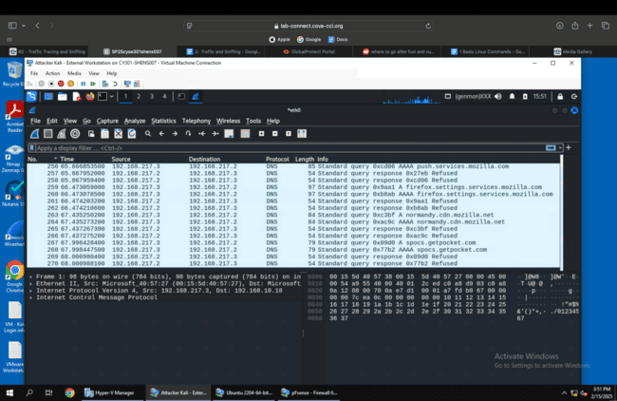

There were 270 packets captured and currently 270 being displayed

Q2. Apply “ICMP” as a display filter in Wireshark. Then repeat the previous question (Q1).
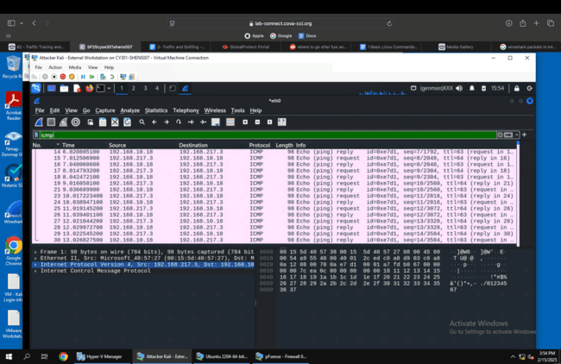

There are 30 packets displayed

Q3. Select an Echo (replay) message from the list. What are the source and destination IPs of this packet? What are the sequence number and the size of the data? What is the response time?
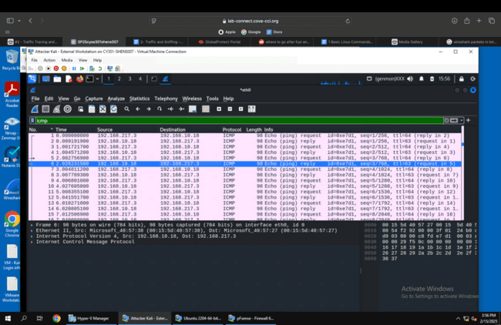

Source IP is 192.168.10.10, destination IP is 192.168.217.3
Sequence number is 3/768 and size of data is 98 bytes
The response time is 0.026

Q4. Apply “DNS” as a display filter in Wireshark. How many packets are displayed?
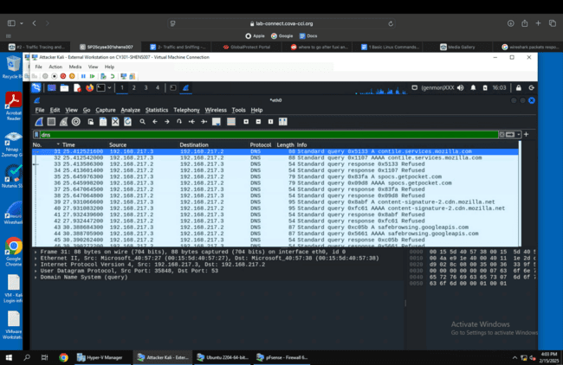

There are 239 packets displayed

Q5. Find a DNS query packet. What is the domain name this host is trying to resolve? What is the source IP and port number, destination IP and port number? Please express in the format: IP:port.
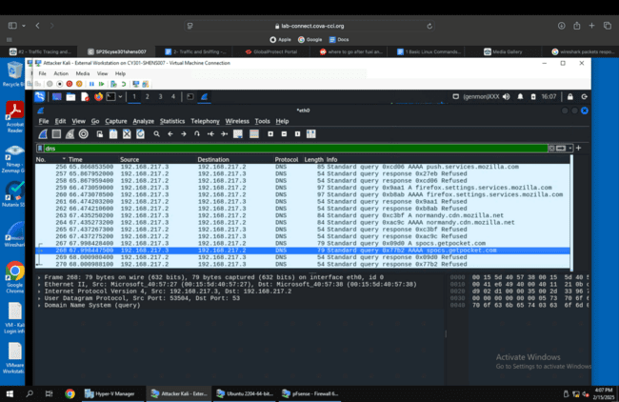

Domain name trying to be resolved is spocs.getpocket.com.
Source- 192.168.217.3: 53504
Destination- 192.168.217.2: 53

Q6. Find the corresponding DNS response to the query you selected at the previous step, and what is the source IP and port number, destination IP and port number? What is the message replied from the DNS server?
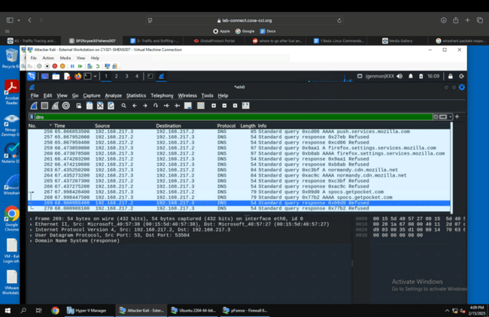

Source- 192.168.217.2: 53
Destination- 192.168.217.3: 53504
Message from DNS server- 0x09d0 Refused

TASK B

1. Sniff ICMP traffic (10 + 10 = 20 points)

Please turn on Attacker/External Kali, internal kali, pfsense, and Ubuntu
Open two terminals on External Kali VM. Use one ping Ubuntu VM, and use the other ping
Internal Kali.
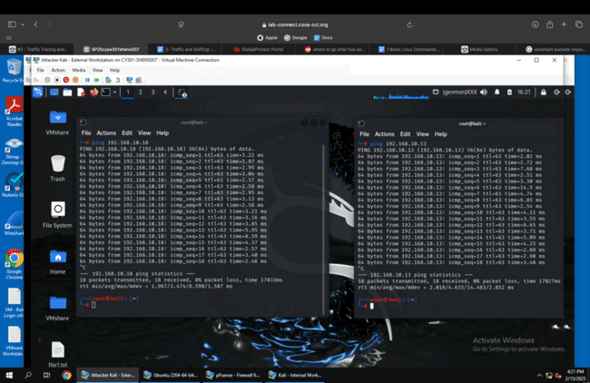

a. Apply proper display or capture filter in Wireshark on Internal Kali VM to show active
ICMP traffic.
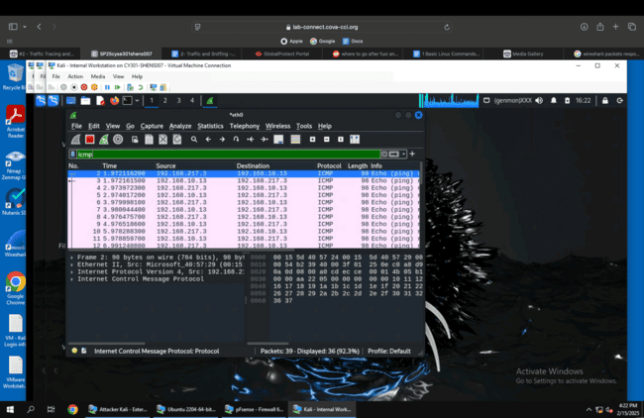

b. Apply a proper display or capture filter on the internal Kali VM that ONLY displays the
ICMP request that originated from the external Kali VM and goes to the Ubuntu 64-bit
VM.
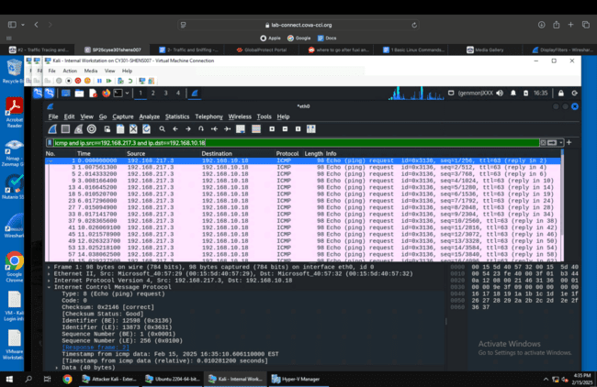

2. Sniff FTP traffic (10 + 15 + 15 = 40 pts points)

a. Ubuntu VM is also serving as an FTP server inside the LAN network. Now, you need to
use External Kali to access this FTP server by using the command: ftp [ip_addr of ubuntu
VM]. The username for the FTP server is student, and the password is password.
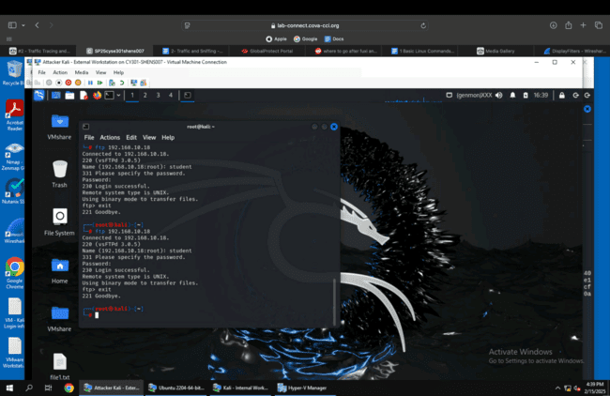

b. Unfortunately, Internal Kali, the attacker, is also sniffing into the communication.
Therefore, all of your communication is exposed to the attacker. Now, you need to find
out the password used by External Kali to access the FTP server from the intercepted
traffic on Internal Kali. You need to take a screenshot and explain how you found the password.
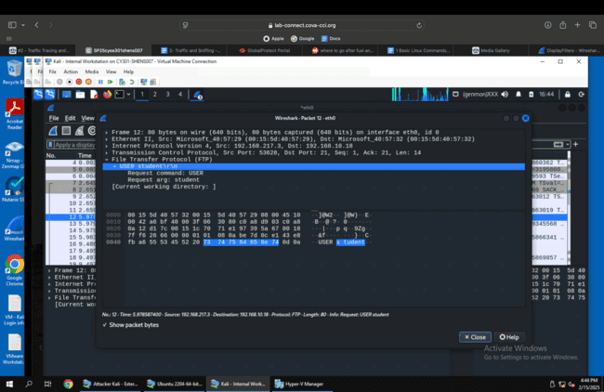

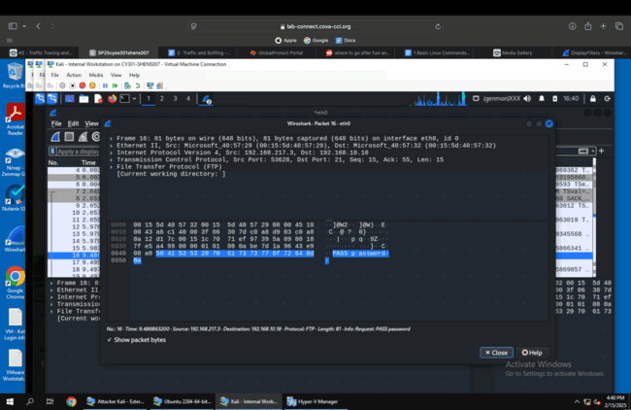

I found the password used by external Kali to access the FTP server by having wireshark running in internal Kali and finding the request password packet that was followed by the login successful packet. In the request packet it had the password in plaintext.

c. After you successfully find the username & password from the FTP traffic, repeat the
previous step (2.a), and use your MIDAS ID as the username and UIN as the password to
re-access the FTP server from External Kali. Although External Kali may not access the
FTP server, you need to intercept the packets containing these “secrets” from the
attacker VM, which is Internal Kali.
