CYSE 301: Cybersecurity Technique and Operations
Assignment 3: Sword vs. Shield
Sage Hensley

In this assignment, you will act as an attacker to identify the vulnerabilities in the LAN network and a defender to apply proper countermeasures. You need to provide a screenshot for each task below.
Task A: Sword - Network Scanning (20+ 20 = 40 points)
Power on the listed VMs and complete the following steps from the External Kali (you can use either nmap or zenmap to complete the assignment)
- External Kali
- pfSense
- Ubuntu
- Windows Server 2022
Make sure you didn’t add/delete any firewall policy before continuing.
- Use Nmap to profile the basic information about the subnet topology (including open ports information, operation systems, etc.) You need to get the service and backend software information associated with each opening port in each VM.
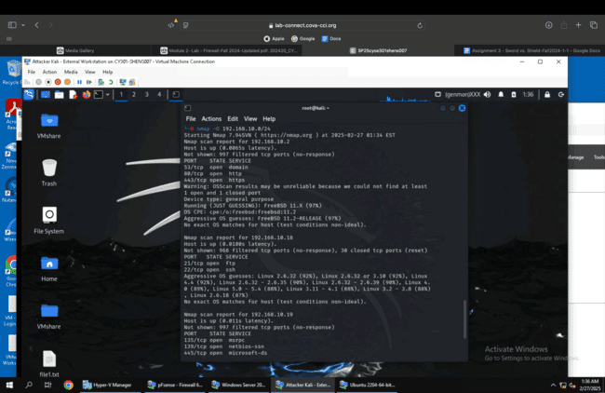

- Run Wireshark in Internal Kali VM while External Kali is scanning the network. Discuss the traffic pattern you observed. What do you find? Please write a 200-word essay to discuss your findings.
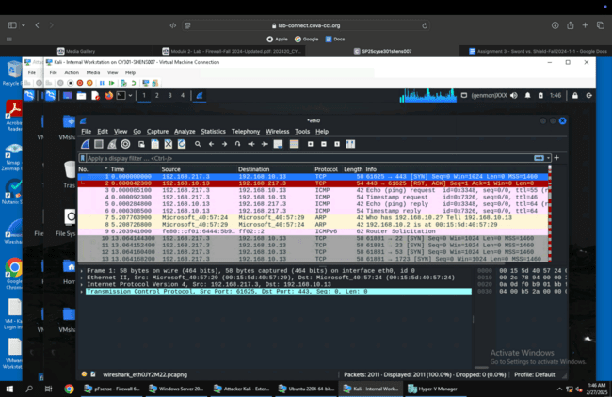
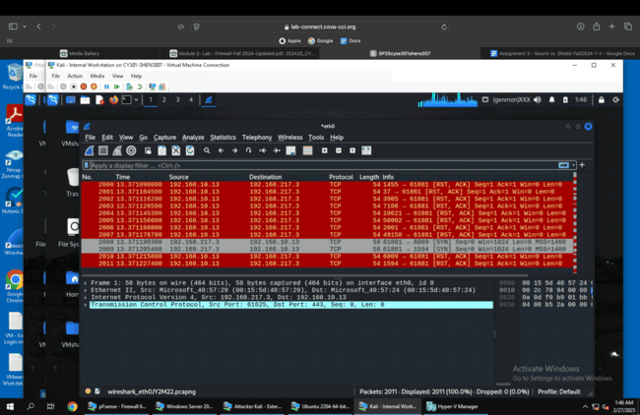

Task B: Shield – Protect your network with a firewall (10 + 10+ 20 + 20 = 60 points)
In order to receive full credits, you need to fill the table (add more rows if needed), implement the firewall rule(s), show me the screenshot of your firewall table, and verify the results.
- Configure the pfSense firewall rule to block the ICMP traffic from External Kali to Ubuntu VM.
Rule # | Interface | Action | Source IP | Destination IP | Protocol  (port # if appliable)
2 | WAN | Block | 192.168.217.3 | 192.168.10.10 | ICMP
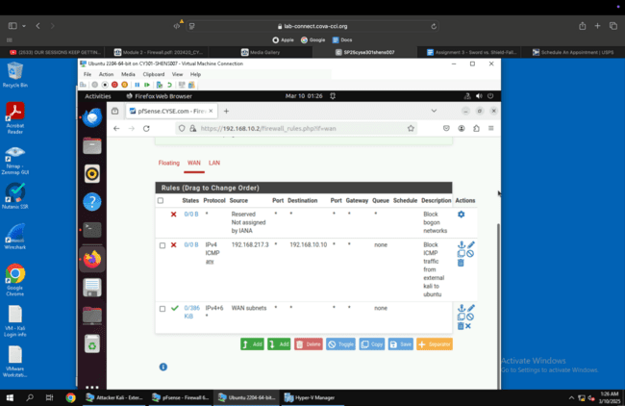
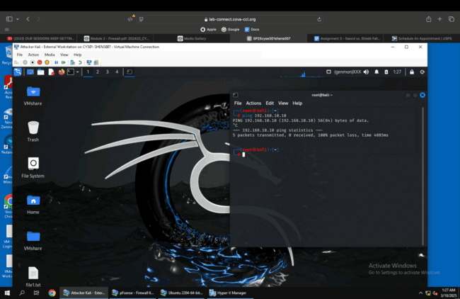

- Clear the previous firewall policies and configure the pfSense firewall to block all ICMP traffic from External Kali to the LAN side.
Rule # | Interface | Action | Source IP | Destination IP | Protocol  (port # if appliable)
2 | WAN | Block | 192.168.217.3 | All | ICMP
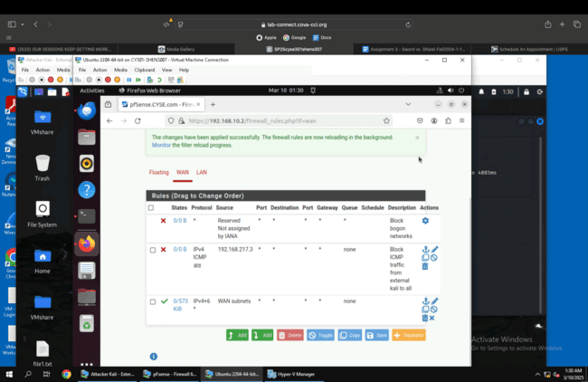
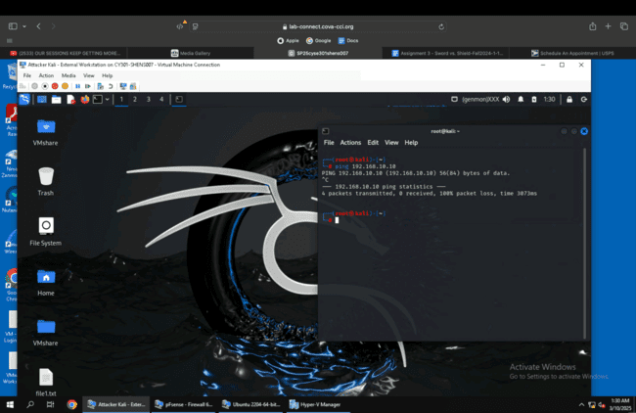

- Clear the previous firewall policies and configure the pfSense firewall to block ALL traffic from External Kali to the LAN side, except for the FTP protocol towards Ubuntu.
Rule # | Interface | Action | Source IP | Destination IP | Protocol  (port # if appliable)
3 | WAN | Block | 192.168.217.3 | All
2 | WAN | Pass | 192.168.217.3 | 192.168.10.10 | FTP (Port 21)
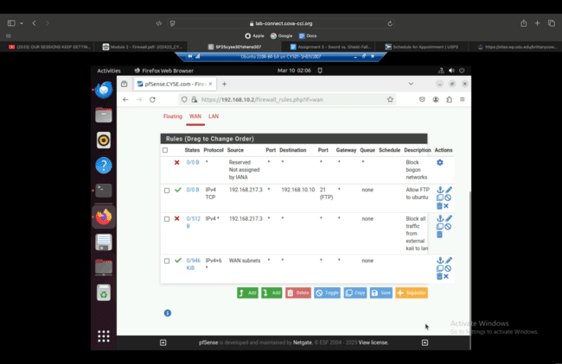

- Keep the firewall policies you created in Task B.3 and repeat Task A.1. What’s the difference?
The difference is I can no longer see any information, whereas originally I could see any information I wanted.
