1. Open the terminal in Kali Linux and install gedit using the command: sudo apt install gedit.
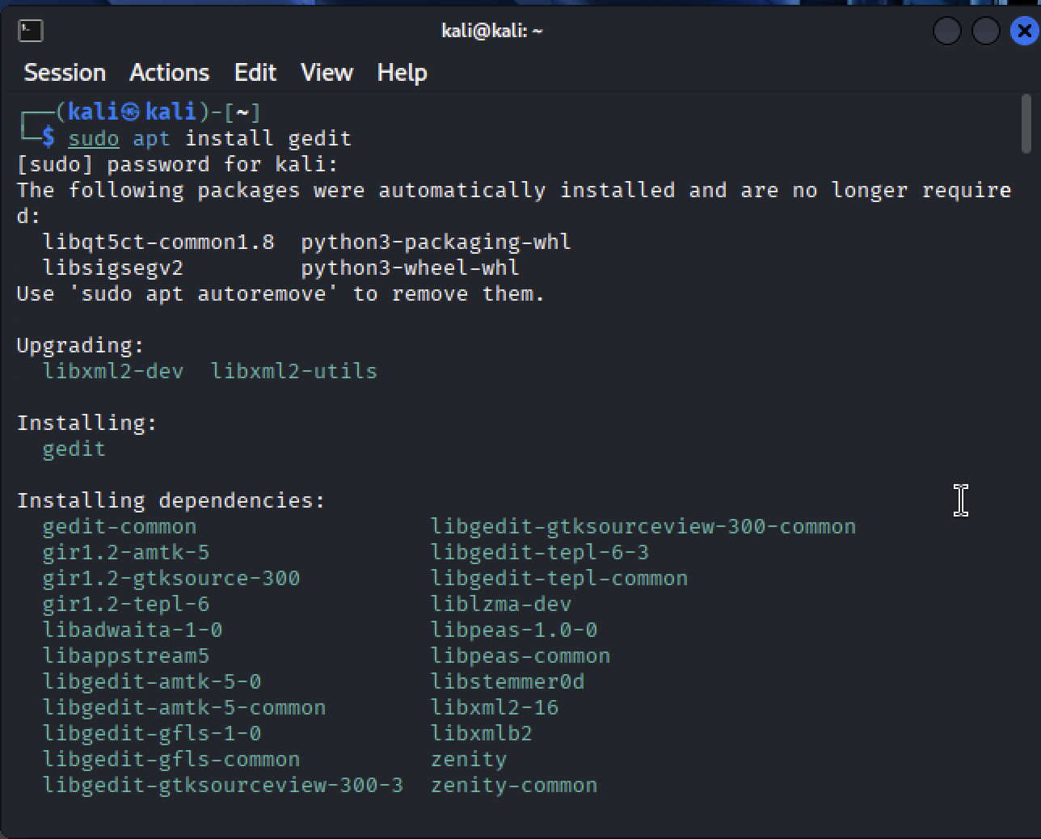

2. Create a new directory named stegDir using the mkdir command.
3. Go to the stegDir directory and create a new file named testfile.txt using the touch
Command.
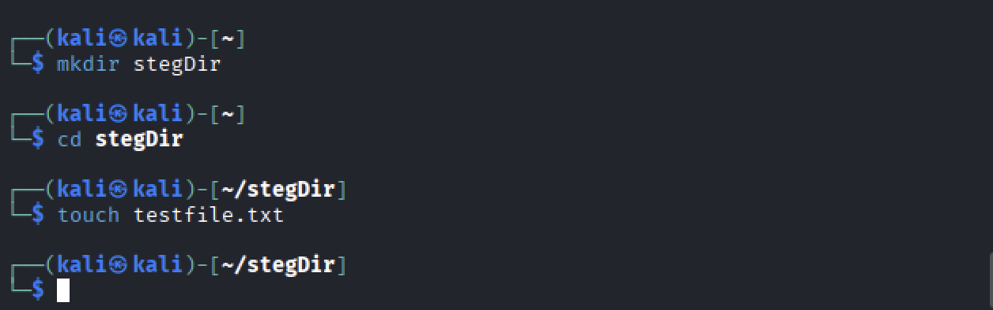

4. Open the file testfile.txt using gedit and add some secret message there as the file content.
Take a screenshot showing the secret message you added.
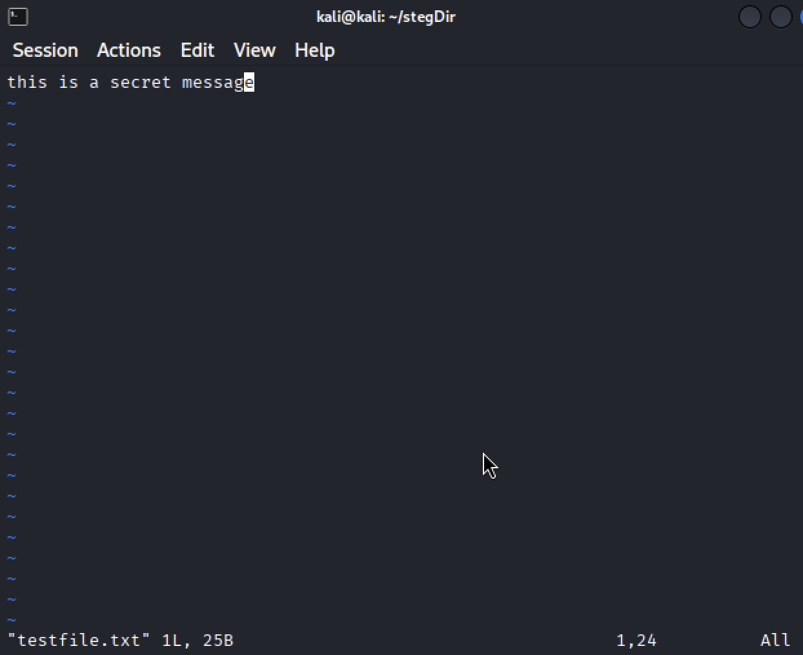

5. Open Firefox (in Kali Linux) and download a random image of a dog. Name the downloaded
file as dog.jpeg. The image will be downloaded in the Downloads folder by default.
6. Copy the image from the Downloads directory to the stegDir directory using the cp
command. The stegDir directory should have two files by now: testfile.txt and dog.jpeg.
Use ls command to show the contents of the stegDir directory and take a screenshot to attach it
in your submission.
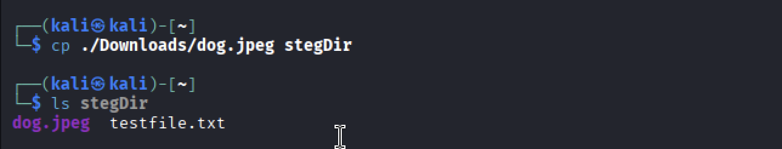

7. Execute the md5sum command to check the checksums for both testfile.txt and dog.jpeg.
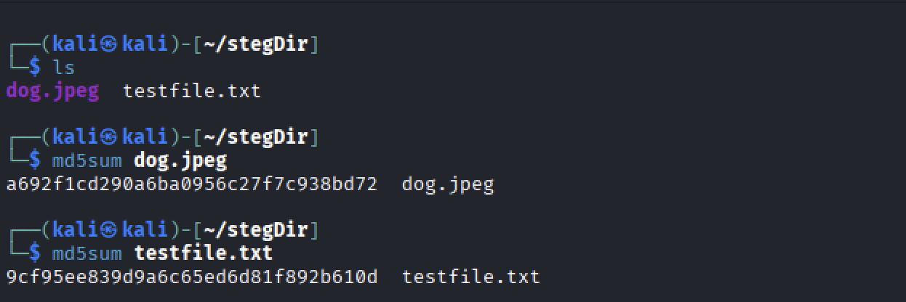

8.Use the steghide command to embed your testfile.txt (with secret message) into the image
file dog.jpeg
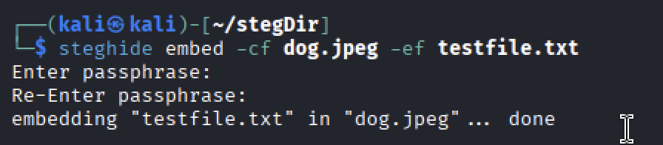

9. Execute the command md5sum for dog.jpeg to check the hash for the image file. Do you see
any difference? Take a screenshot showing the command and the output hash.
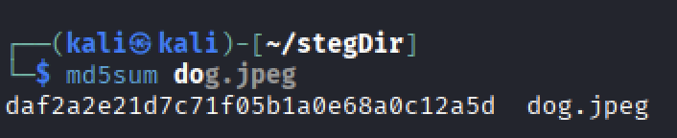
Yes there is a difference between the output hashes

10. Execute the steghide command to get some information about dog.jpeg before extracting
it, use the info command
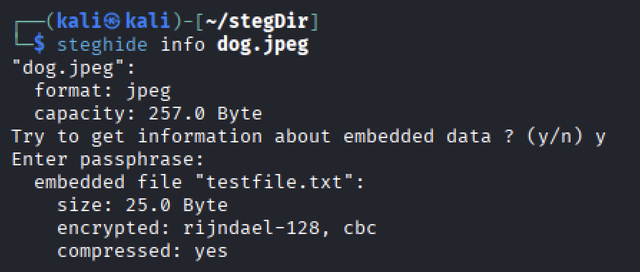

11. Now, delete the file testfile.txt using the rm command. Use the ls command to show the
contents of the stegDir directory and take a screenshot.
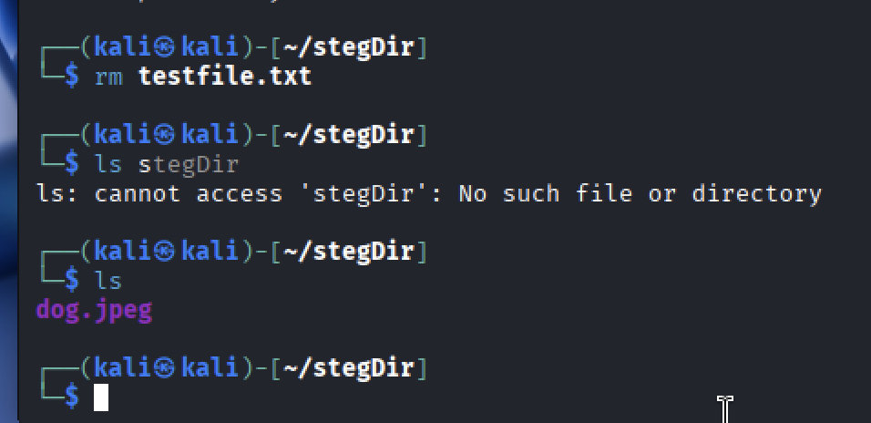

12. Extract the secret message by executing the steghide command with - - extract option
13. Execute the ls command to list the contents in the stegDir directory. You should see
testfile.txt there because it was hidden in the dog.jpeg image file and appeared after extracting
the image file in the previous step (step-12). Take a screenshot showing the contents of the
stegDir directory.
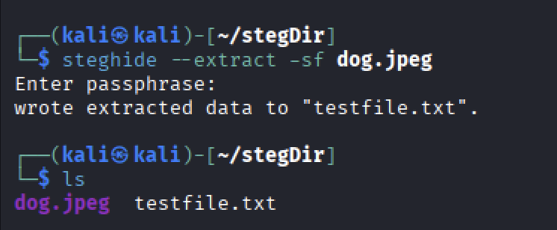

14. See the contents of the file testfile.txt using gedit. Take a screenshot showing the contents
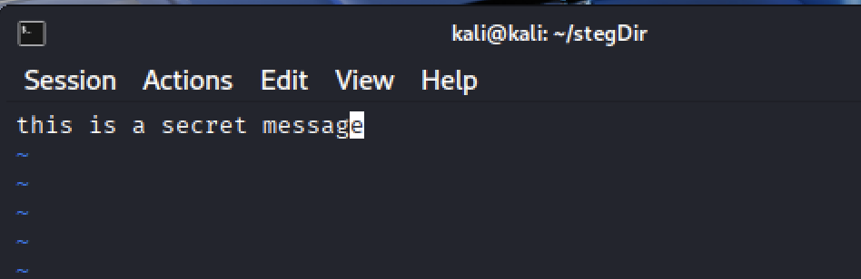

15. See the metadata of the file dog.jpeg using the exiftool command
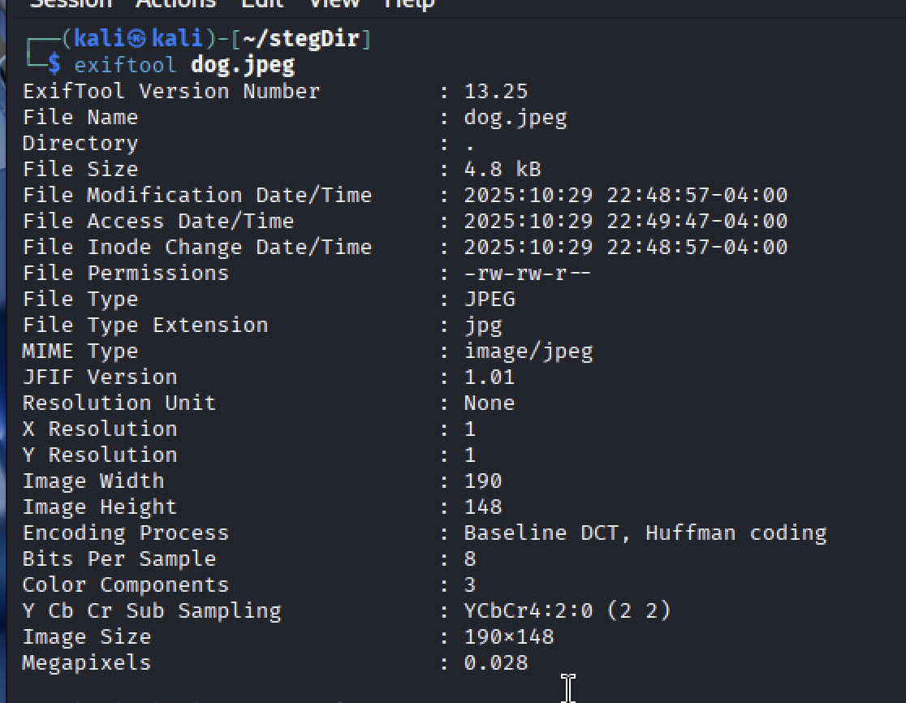

16. Change the author of the file dog.jpeg using the exiftool
17. Repeat the step-15 and take a screenshot showing the updated metadata of the file
dog.jpeg. Highlight the author’s name in the screenshot.
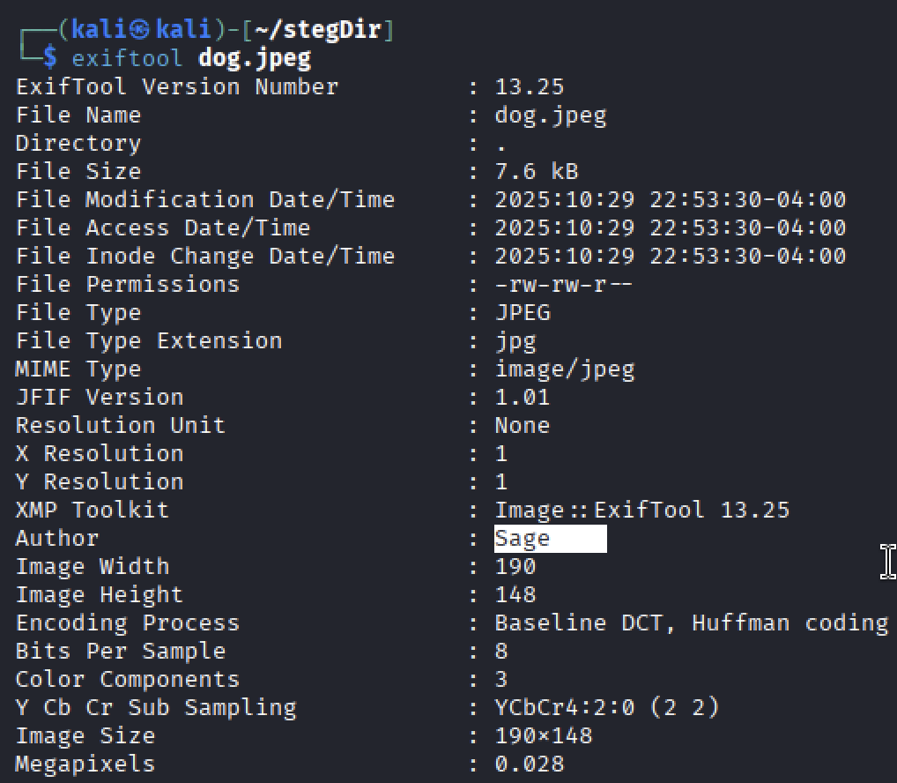

18. Execute the md5sum command for dog.jpeg. Do you see any change in the hash
value? If yes, take a screenshot of the new hash and compare it with the previous hash you
received in step-9.
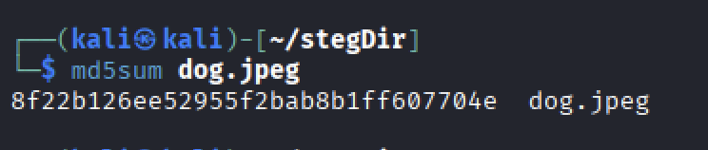
Yes this hash value is different from the previous two hash values

