Old Dominion University

CYSE 301 CYBERSECURITY TECHNIQUES AND OPERATIONS

Assignment 5 Password Cracking

Sage Hensley
01221999

Task A: Linux Password Cracking (25 points)

1. 5 points. Create two groups, one is cyse301, and the other is your ODU Midas ID (for example, svatsa). Then display the corresponding group IDs.
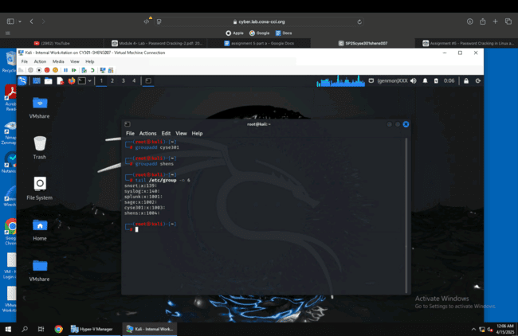

Using groupadd I added the two groups and with tail /etc/group n -6 i showed the last 6 lines of the /etc/group file. This showed their group IDs.

2. 5 points. Create and assign three users to each group. Display related UID and GID information of each user.
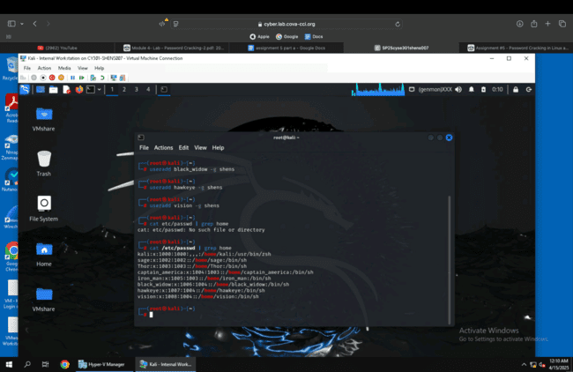

I used useradd to add three users to each group, then showed the password file of each user with a home directory to display their ID numbers.

3. 5 points. Choose Three new passwords, from easy to hard, and assign them to the users you
created. You need to show me the password you selected in your report, and DO NOT use your
real-world passwords.
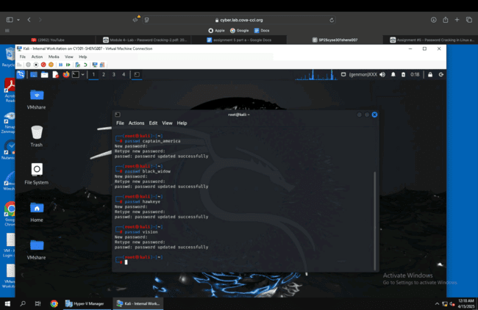

Thor- 123123
Iron_man- Banana
Captain_america- MeLLoW46!
Black_widow- dogsled
Hawkeye- PineApple1
Vision- 123123

I added passwords to each user, with 123123 being a password of both groups.

4. 5 points. Export all Three users’ password hashes into a file named “YourMIDAS-HASH” (for
example, svatsa-HASH). Then launch a dictionary attack to crack the passwords. You MUST crack at least one password in order to complete this assignment.
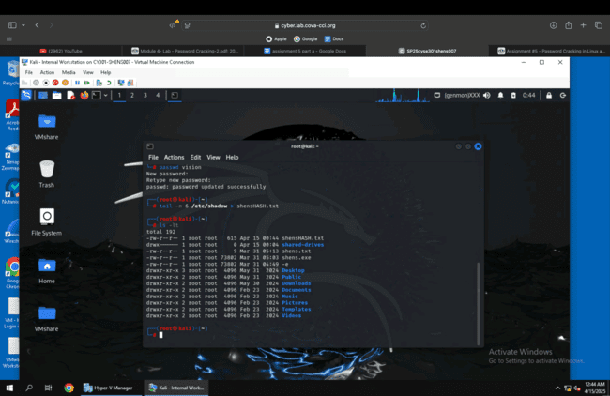
I exported the last 6 lines of the /etc/shadow file into shensHASH.txt.

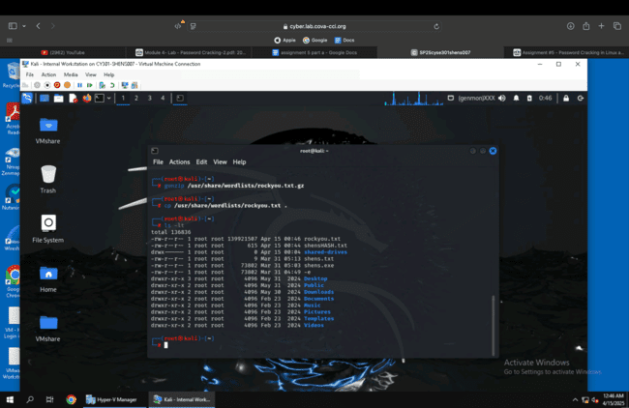
I unzipped rockyou.txt to use in the dictionary attack.
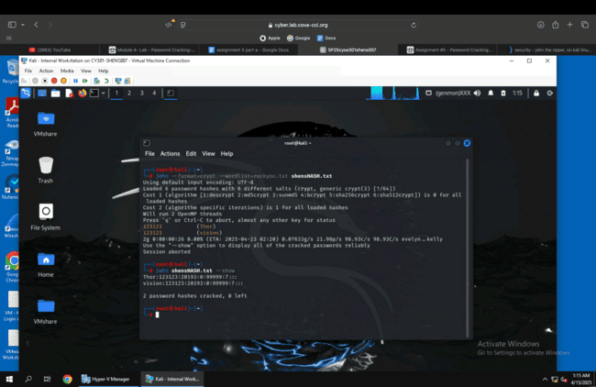
Using john and the rockyou.txt file, I launched a dictionary attack that successfully gave the passwords of one user from each group.

Task B: Windows Password Cracking (25 points)

Log on to Windows 7 VM and create a list of 3 users with different passwords (OR you may create users using net users \add command as you did in lab-4-task-c). Then you need to establish a reverse shell connection with the admin privilege to the target Windows 7 VM.

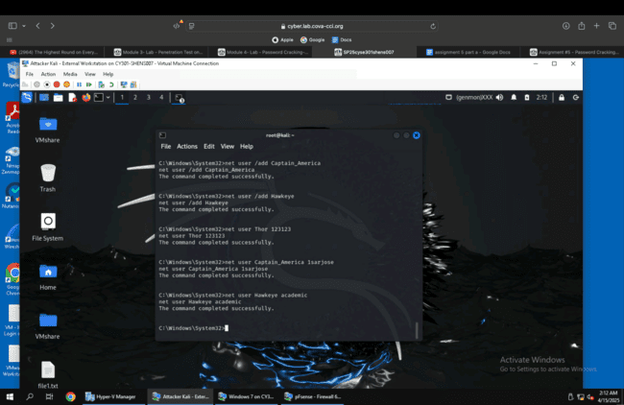

1. 5 points. Display the password hashes by using the “hashdump” command in the meterpreter Shell.
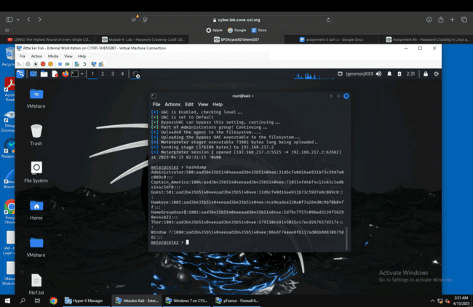

2. 10 points. Save the password hashes into a file named “your_midas.WinHASH” in Kali Linux
(you need to replace the “your_midas” with your university MIDAS ID). Then run John the ripper
for 10 minutes to crack the windows users’ passwords (You MUST crack at least one password in order to complete this assignment.).
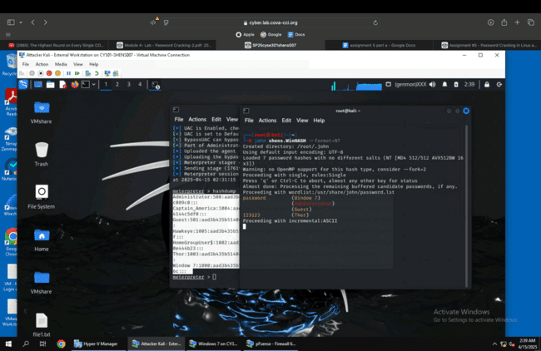

3. 10 points. Launch/open the password cracking tool, Cain and Abel in Windows 7 VM, via a
remote desktop window. Then, implement BOTH brute force and dictionary attacks to crack the
passwords for Windows7 users. (You MUST crack at least one password in order to complete
this assignment).
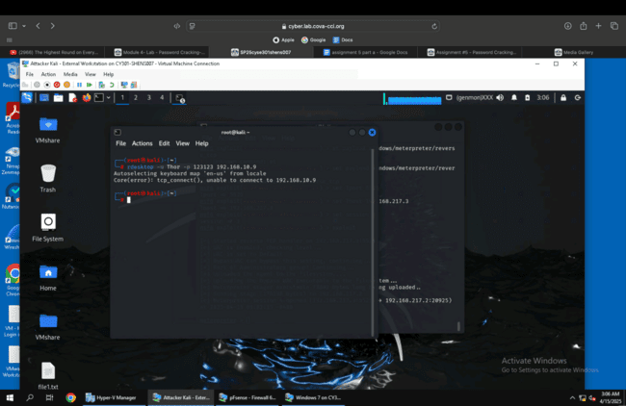

I could not get rdesktop to work for me, no matter what user I tried to do it with.

Task C: 20 points
Follow the steps in the lab manual, and practice cracking practice for WEP and WPA/WPA2 protected traffic

1. Decrypt the lab5wep-demo. cap file (5 points) and perform a detailed traffic analysis (5 points)
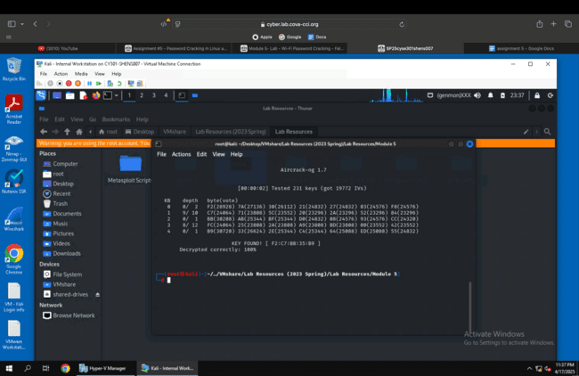
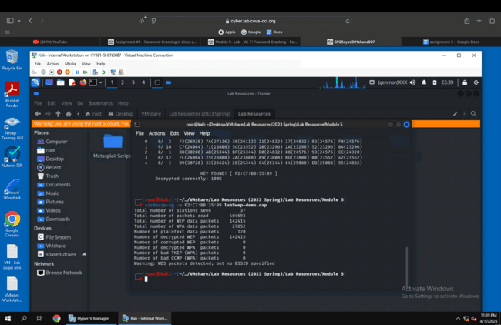
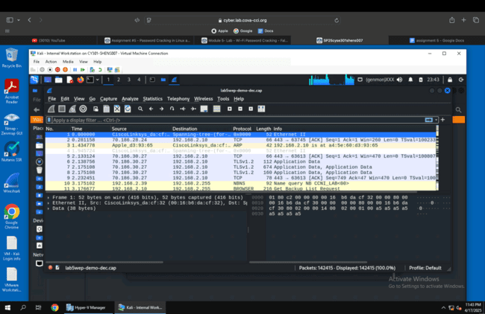

2. Decrypt the lab5wpa2-demo. cap file (5 points) and perform a detailed traffic analysis (5 points)
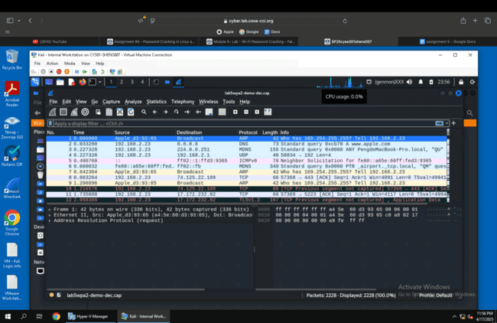

Task D: 30 points
Each student will be assigned a new WPA2 traffic file for analysis. You need to refer to the table below and find the file assigned to you based on the LAST digit of the MD5 of your MIDAS ID. For example, the last digit of the hash for svatsa is 8. Thus, I should pick up the file "WPA2-P3-01.cap.

MD5 of shens is 52b5fd76bf394ffa86bbd159f9385905

File is WPA2-P2-01.cap

1. Implement a dictionary attack and decrypt the traffic using the correct file based on your last
character of md5 hash for your midas name. - 20 points
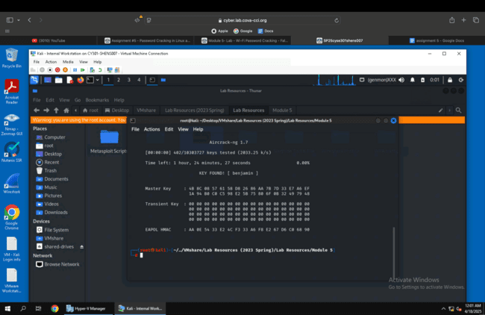
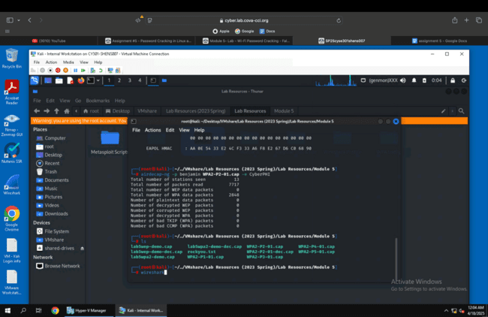

2. Decrypt the encrypted traffic and write a detailed summary to describe what you have explored from this encrypted traffic file (using wireshark). -10 points
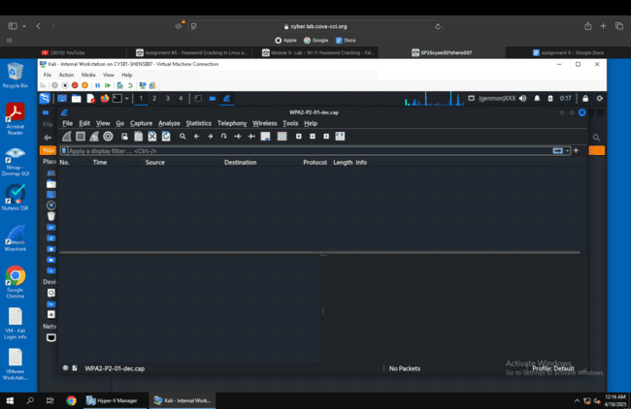

When I used wireshark to examine the packets of WPA2-P2-01-dec.cap there were no packets.

