Ch13: 22, 23, 25, 34(only 2 of this prob), 17, 19, 55, 65, and Design Problem 3.
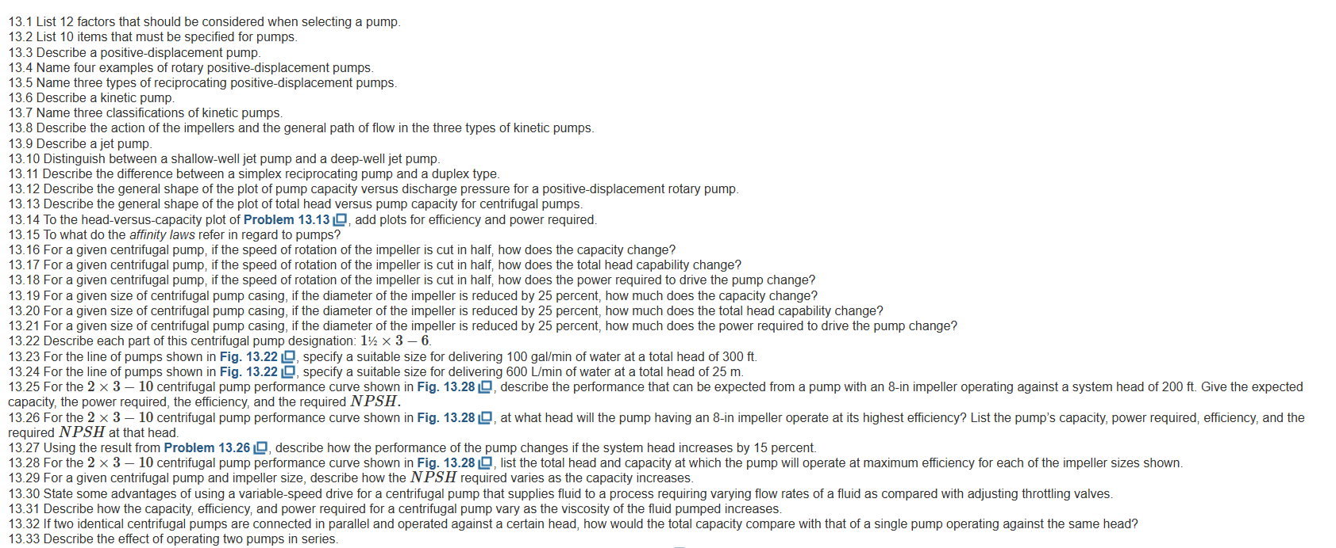
.

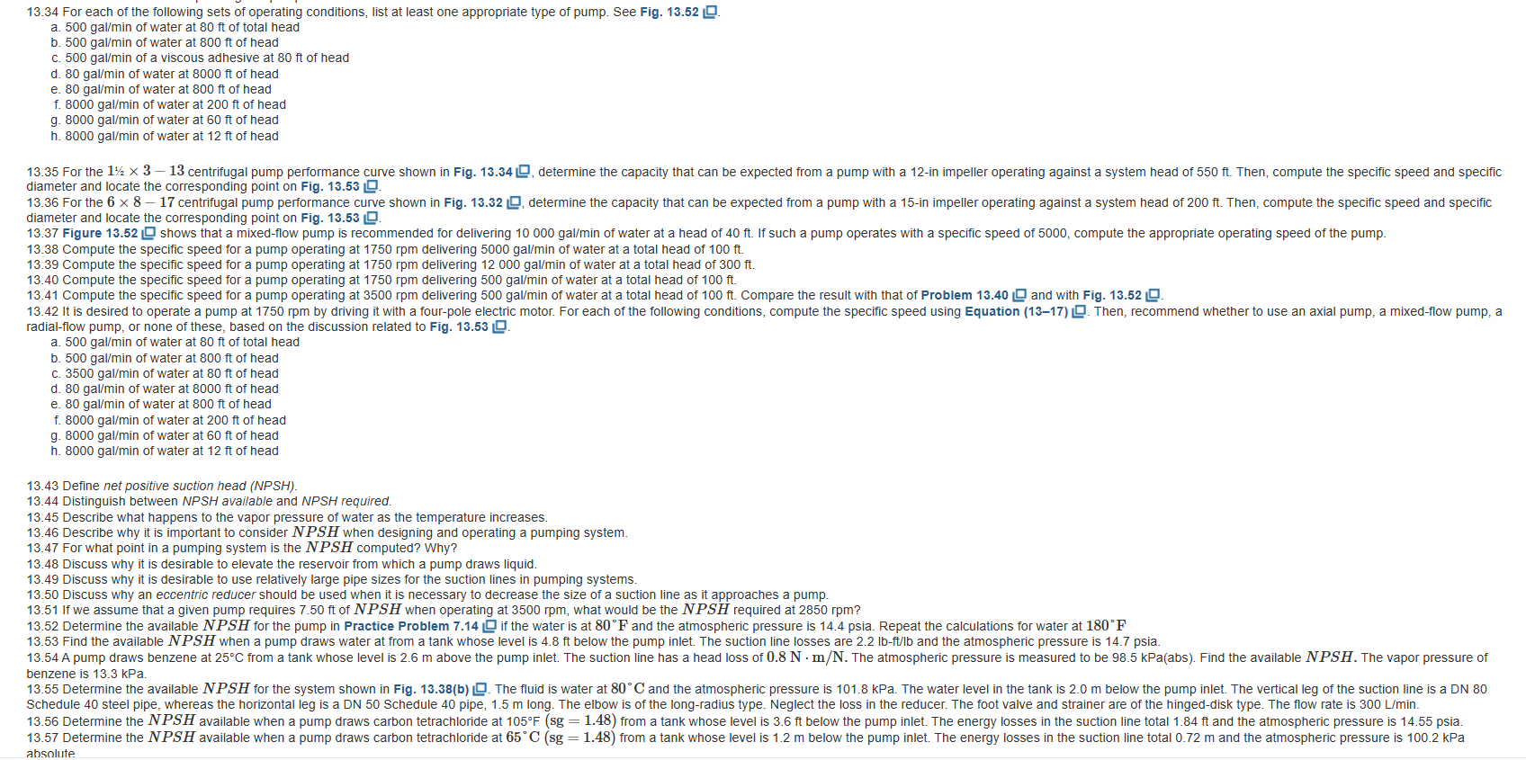
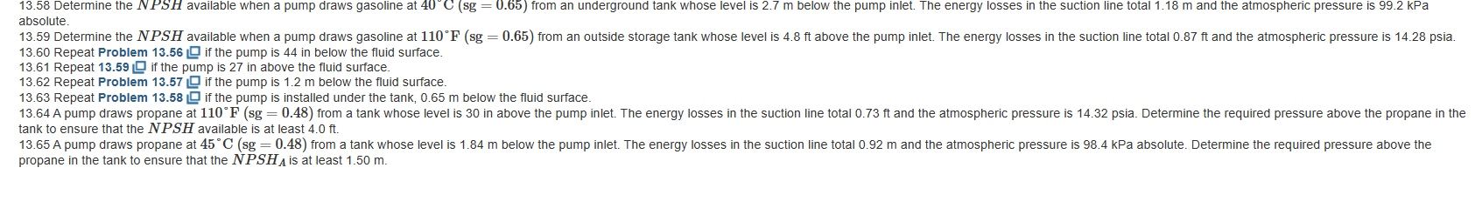

WORDs

