CYSE 270: Linux System for Cybersecurity
Assignment: Lab 3 – VI Editor Goal
- Practice using the vi editor.

Notes:
- Remember the “modes” in the vi editor.
- You may use the “Escape” key to return to command mode if you get confused and need to start over.

Submission Instructions
- Take screenshots for each step you perform and write down the correct command corresponding to each step number. Submit this in a PDF file.
Task: vi Practice on Kali Linux (20 * 5 = 100 points)
Open the terminal in your VM, then complete the following tasks. Please take the screenshots of all the necessary commands that you execute for each step and submit the screenshots with their step number in a pdf file.
NOTE: You may write the correct vi editor commands, if screenshot is not applicable. Please see the note added to some steps below.
- Copy the file /usr/share/doc/zstd/copyright to your home directory. Screenshot
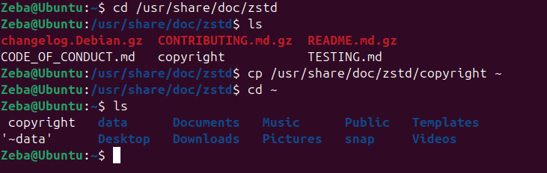
- Perform a long list in your home directory using the correct command. Screenshot
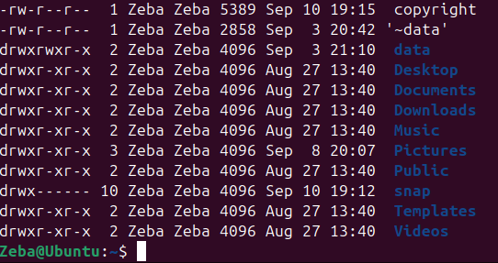
- Open the file copyright in a vi-editor using vi command. Screenshot
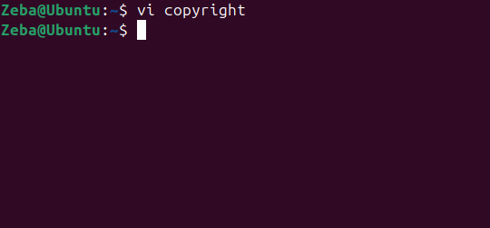
- Move to line 15, then insert your MIDAS ID in the same line with the following format:
****XXXX****(replace XXXX with your own MIDAS name). Screenshot + Write Command.
:15
2w
i 01296900
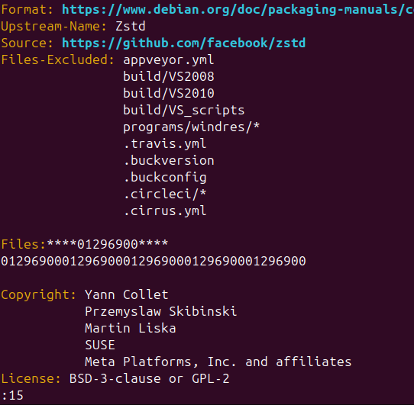

Return to the command mode. Write Command
esc
- Open a new line below the current line using correct command (please refer to slides with the list of commands used in vi editor). Screenshot + Write Command.
o
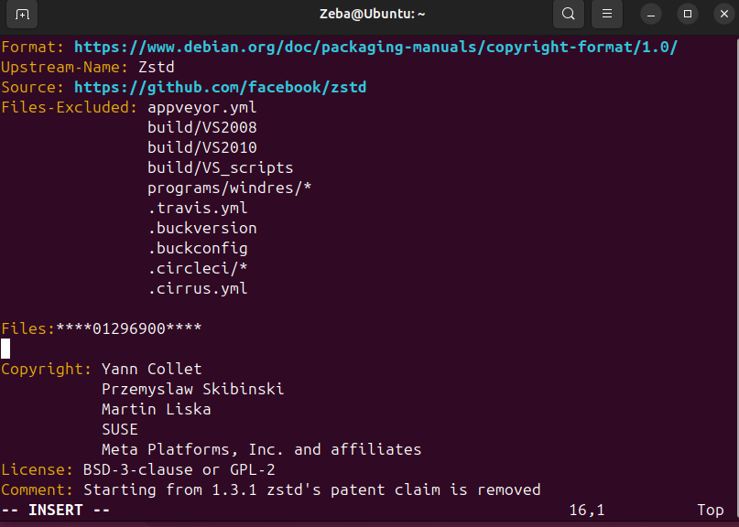

- Return to the command mode. Write Command
esc
- Use command to Insert “****XXXX ****” five times. Screenshot + Write Command
5i “01296900” esc
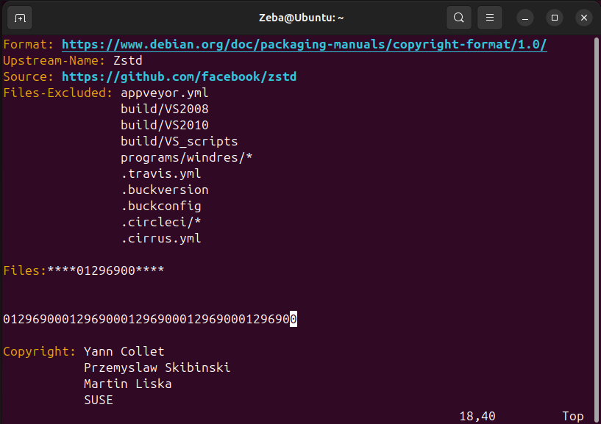
- Use command to return the top of the file. Screenshot + Write Command
1G
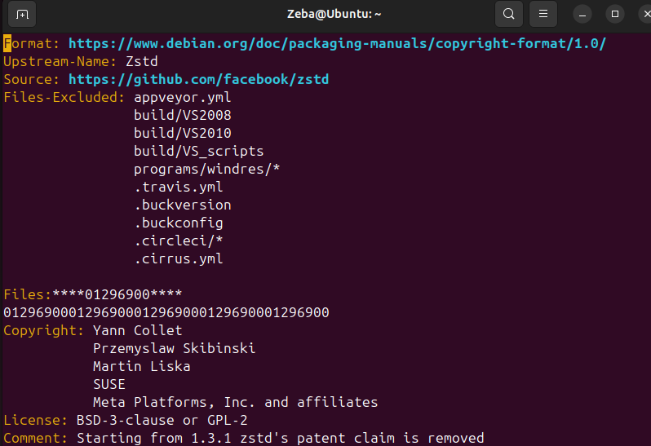
- Move forward three sentences. Screenshot + Write Command
3)
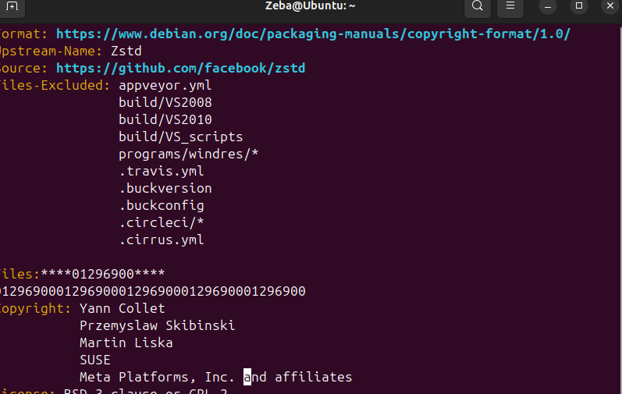
- Move forward four words. Screenshot + Write Command
4w
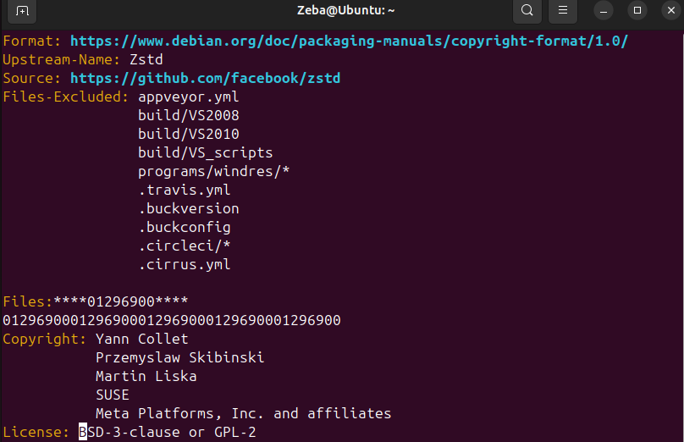
- Search for the word example or any word existing in the document that you are using for lab-3. Screenshot + Write Command
/example
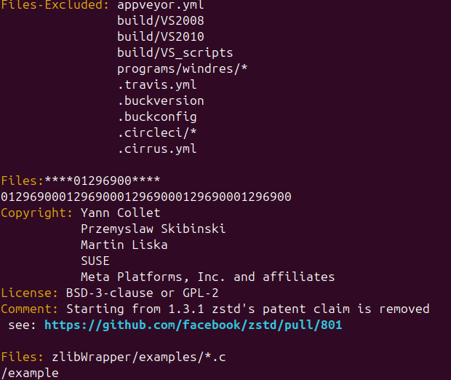

- Continue to the next occurrence of the search term example. Screenshot + Write Command
/example
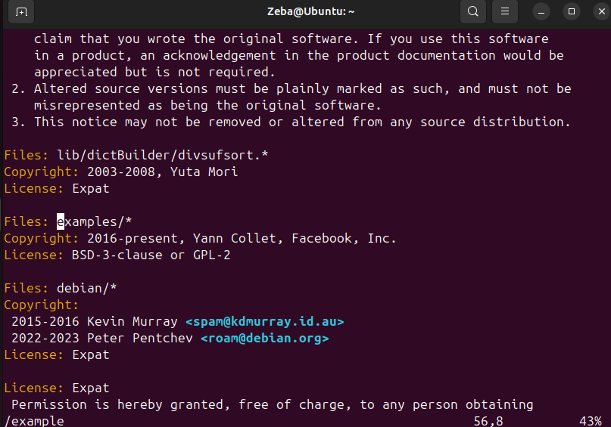
- Delete the current word, example. Screenshot + Write Command
Cw
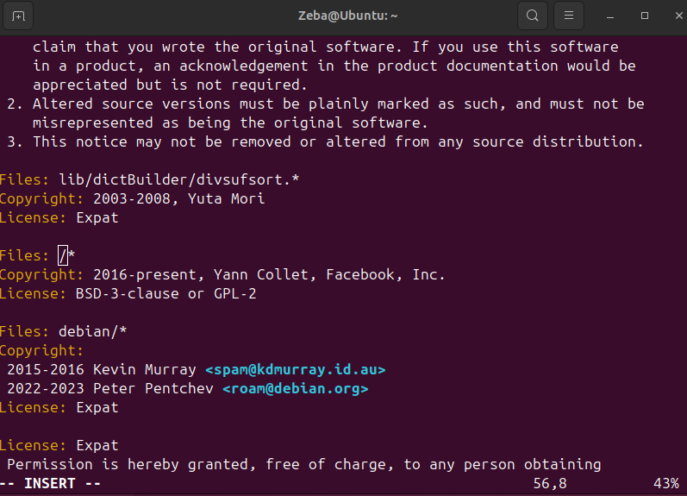

- Delete the current line. Screenshot + Write Command
cc
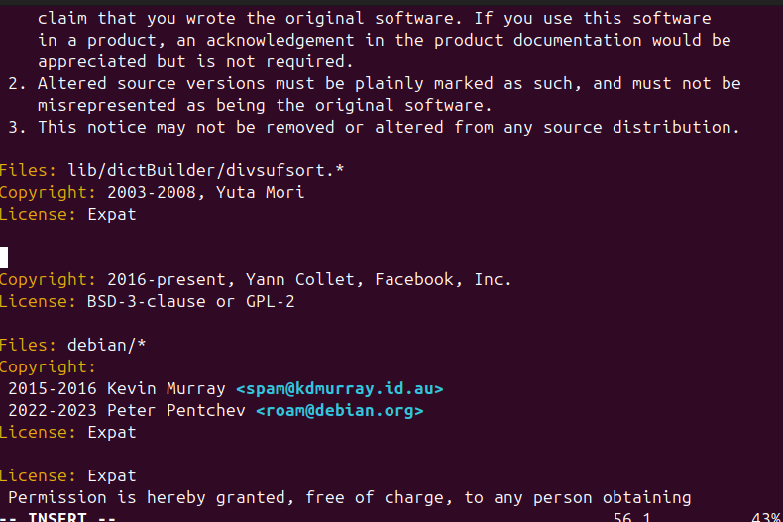
- Use command to jump to the end of the file. Screenshot + Write Command
]]
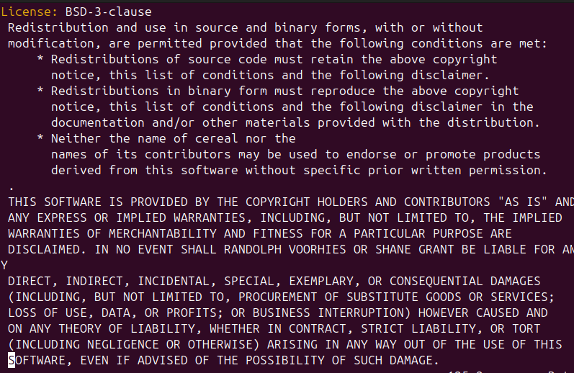
- Copy line 16 and paste the text at the end of the document. Screenshot + Write
Command
:16, yy, ]], P
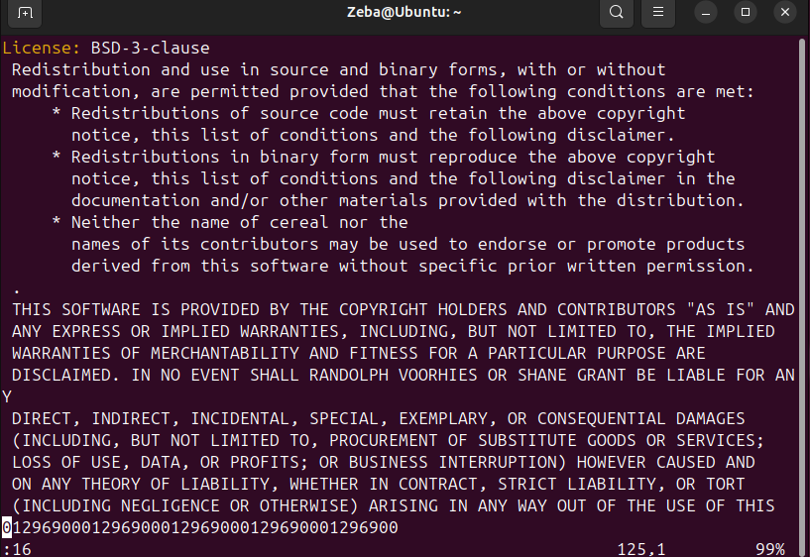
- Replace all occurrences of http with HTTP throughout the document. Screenshot + Write Command
:%s/http/HTTP/g
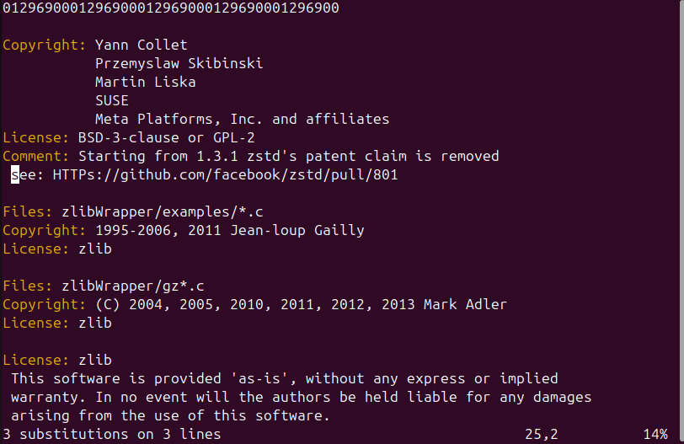

- Save and quit the document. Screenshot + Write Command
:wq
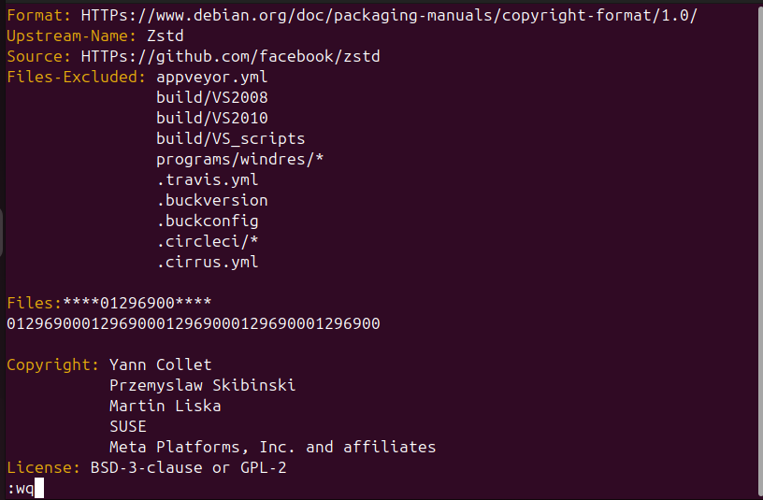
- Rename the file copyright to copyright_cyse270. Screenshot + Write Command Please note: mv copyright copyright_cyse270
Make sure you highlight and annotate important information.
