Scott Worm
11/12/25
CYSE 270: Linux System for Cybersecurity
Assignment-9
Task A - Backup your system (Using crontab) [100 points]
Scenario: Performing system backup can be time-consuming, and the process is often overlooked. For this scenario:
- (10 Points) Create a new user Alice (with home directory).
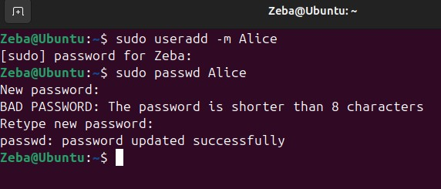
- (50 Points) Write a shell script that backups Alice’s home directory by creating a tar file (tape archive), using the following steps:
  - Do the following:
    - Take 2 inputs with their values- your MIDAS name and current date (for example, midas=Mohammed).
    - Create a variable named as filename that should be assigned the value as MIDAS-date (example output after executing the script would be like, Mohammed-2024.11.04-22.08.01.tar.gz).
    - Using tar command, create a tape archive for Alice’s home directory (/home/Alice) and the filename created above (in step-2-ii). (Please learn about tar command in Linux for its usage)
  - Move the tape archive file/tar file (created in step 2-iii) to /var/backups/ directory using correct command in linux.
  - To optimize the disk usage, pick a compression algorithm (bz2, gzip, or xv) to compress the tar file you created in /var/backups/ in the previous step-2b.
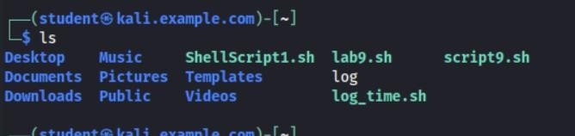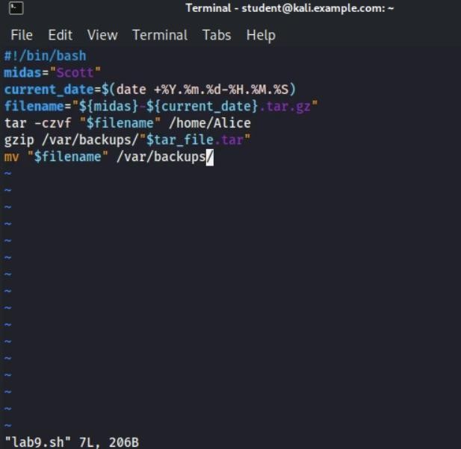

- (30 Points) Create a crontab file to keep the scheduled task running for 3 minutes, then check the contents in the /var/backups directory. Your output should be look similar to the following:

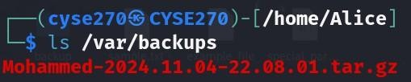

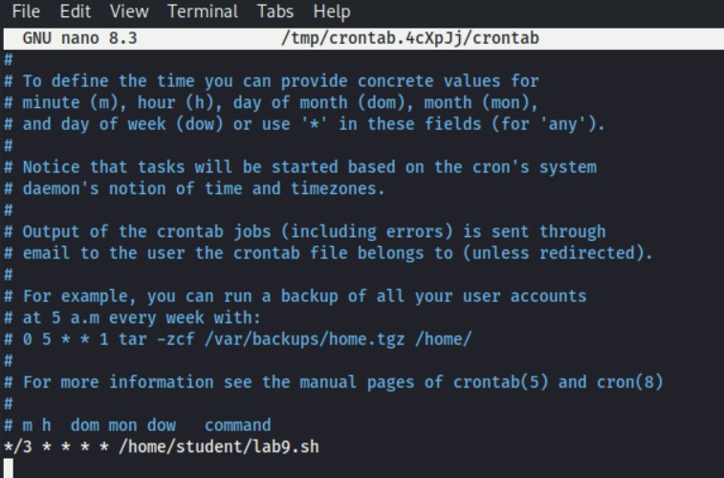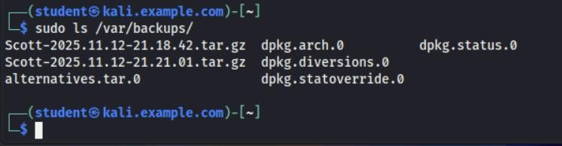

- (10 Points) Cancel the crontab jobs.
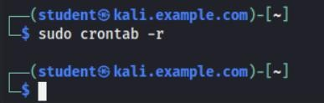

TASK B: SYSTEM CLEANUP (EXTRA CREDIT) [20 Points]
Scenario: In the above scenario, your system disk will be filled up eventually without cleaning up the old backups. Therefore, in this optional task, create a script that checks the number of backups you created in Task A. If the number of the backup file is more than a pre-defined threshold, the script will delete the old archives to maintain the backups under a reasonable size.
This script should do the following:
- Count the number of backups created in Task A and determine if this number is larger than 3.

- Nothing should happen if the number of backups is less than the threshold, 3.

- If more backup archives are detected, calculate the number of backups to delete. Then delete the old archives.

Note: As the script needs to write contents in the “/var/backups” folder, which is owned by root, you should consider the permission issue properly. (Using sudo to create crontab file)

Reference: How to Format Date for Display or Use In a Shell Script:
https://www.cyberciti.biz/faq/linux-unix-formatting-dates-for-display/ Reference:
How to append date timestamp to filename:
https://crunchify.com/shell-script-append-timestamp-to-file-name/

