CYSE 270: Linux System for Cybersecurity
Assignment 2 Total: 100 Points Instructions:
- Execute the correct commands for all the steps listed below.
- Take screenshots after completing each step.
- Submit your screenshots in a single Word or PDF file.
- Clearly label each screenshot with the corresponding step number.
Steps:
- Open a terminal window. /
- Display your current working directory. /
Pwd (Prints the current directory)
- Using an absolute pathname, switch to the /etc directory. /
cd /etc (Change directory to /etc)
- Using a relative pathname, move to the /etc/skel directory. /
Cd skel (Change to the directory within /etc that has skel)
- Using a relative pathname, move up one directory. /
cd .. (Move up a directory)
- List the files in the current directory. /
ls (Lists all files in the current directory)
- Perform a “long display” listing of the files in the current directory. /
- List all the files in the current directory that begin with the letter s. /
- Run the command that will determine the type of contents in the /etc/group file. /
- Display only the last five lines of the /etc/group file. /
- Execute the command to return to your home directory. /
- Make a directory named data in the current directory. /
- Copy the /etc/passwd file into the data directory. /
- Copy the /etc/ppp directory into the current directory (and ignore any “Permission denied” error messages). /
- Rename the ppp directory that is located in the current directory to peers. /
- Execute the command (ls) to verify the change in the name of the directory. /
- Create a new empty file named test in the data directory. /
- Delete the data/passwd file. /
- Delete the peers directory. /
- Re-execute the ls command.
1-5
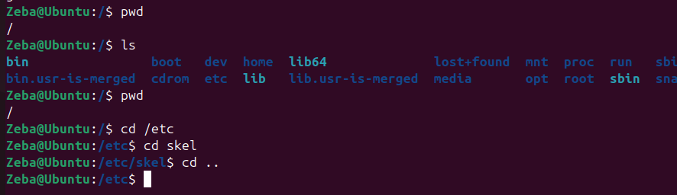
6
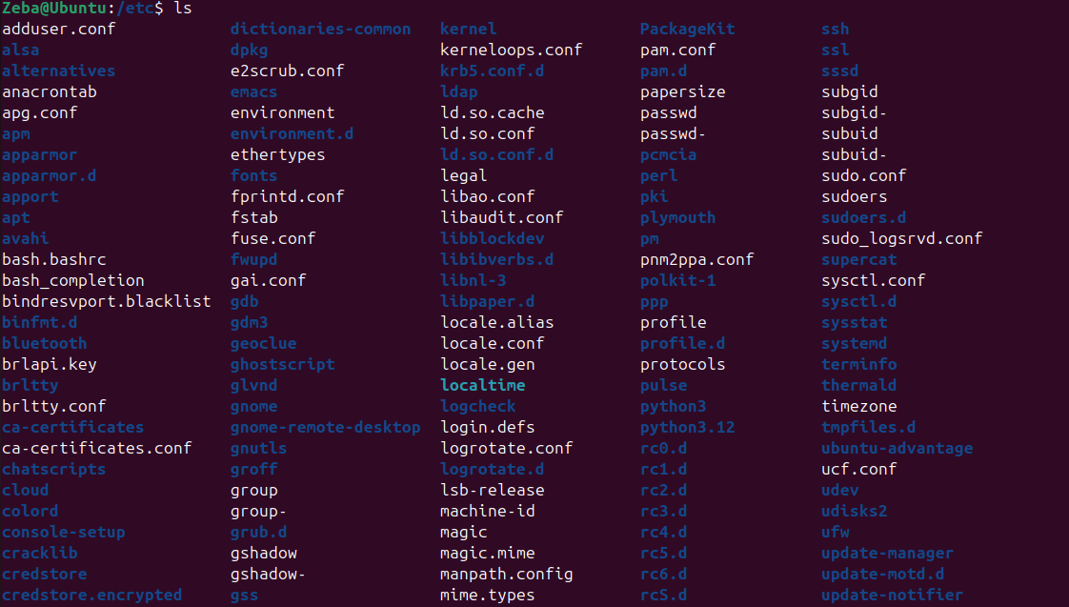
7
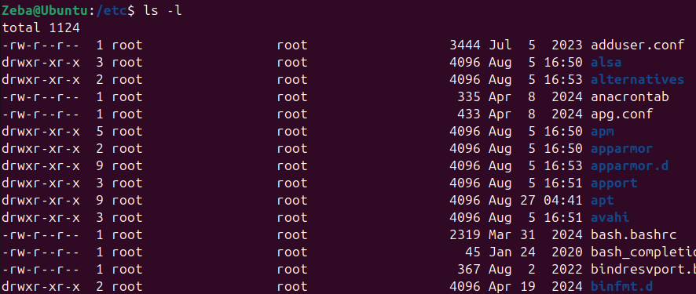
8-10
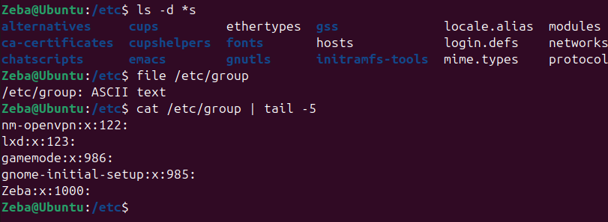
11-13
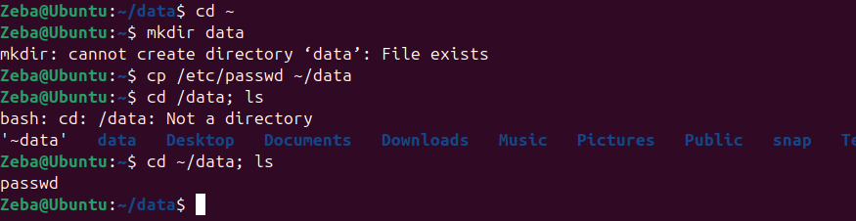
14-20
