Scott Worm
10/2/25

CYSE 270: Linux System for Cybersecurity

CYSE 270: Linux System for Cybersecurity
The goal of this lab is to test the strength of different passwords.

Task A – Password Cracking
- Create 6 users in your Linux Terminal, then set the password for each user that meets the following complexity requirement respectively. You should list the passwords created for each user. [6 * 5 = 30 points].
  - For user1, the password should be a simple dictionary word (all lowercase)
Password used: apple
  - For user2, the password should consist of 4 digits.
Password used: 1234
  - For user3, the password should consist of a simple dictionary word of any length characters (all lowercase) + digits.
Password used: order3518
  - For user4, the password should consist of a simple dictionary word characters (all lowercase) + digits + symbols.
Password used: cookies0142!*#^&
  - For user5, the password should consist of a simple dictionary word (all lowercase) + digits.
Password used: starbase3001
  - For user6, the password should consist of a simple dictionary word (with a combination of lower and upper case) + digits + symbols.
Password used: FiTNeSs321@>!%&
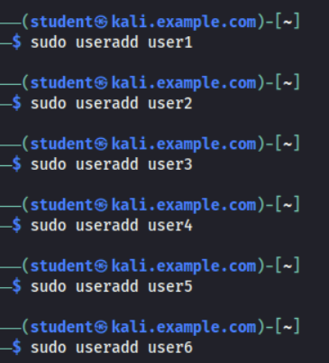
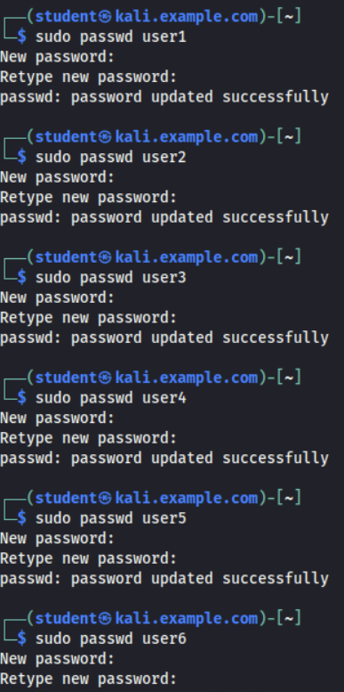
Remember, do not use the passwords for your real-world accounts.
- Export above users’ hashes into a file named xxx.hash (replace xxx with your MIDAS name) and use John the Ripper tool to crack their passwords in wordlist mode (use rockyou.txt). [ 40 points]
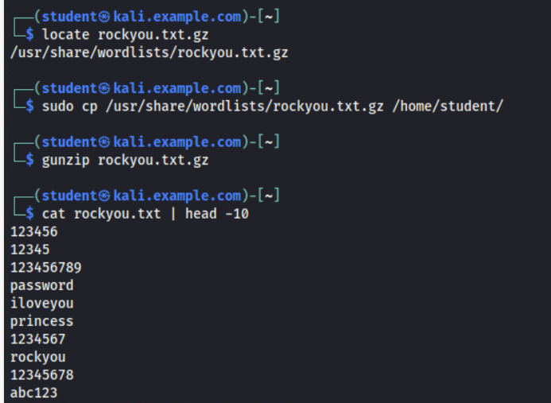
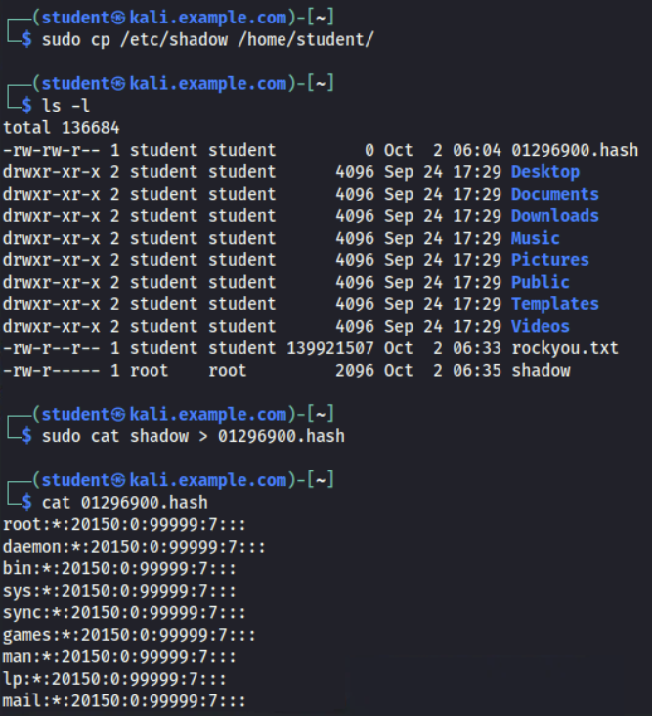
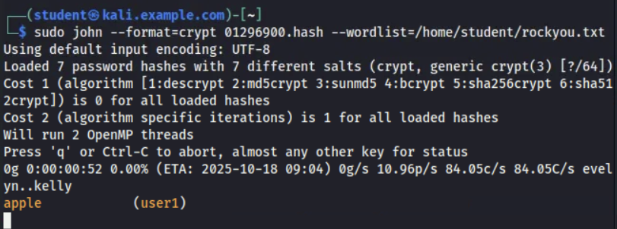
- Keep your john the ripper cracking for 10 minutes. How many passwords have been successfully cracked? [30 points]
Only three
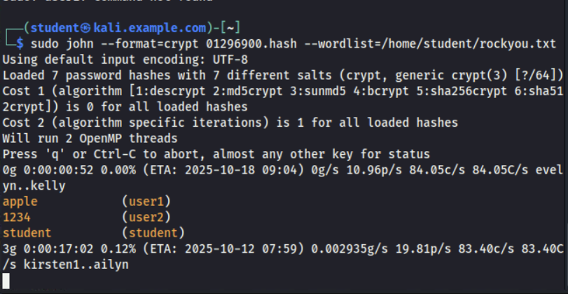

CYSE 270: Linux System for Cybersecurity

Extra credit (10 points):
1. Find and use the proper format in John the ripper to crack the following MD5 hash.
Show your steps and results.
- 5f4dcc3b5aa765d61d8327deb882cf99
- 63a9f0ea7bb98050796b649e85481845
5f4dcc3b5aa765d61d8327deb882cf99
63a9f0ea7bb98050796b649e85481845
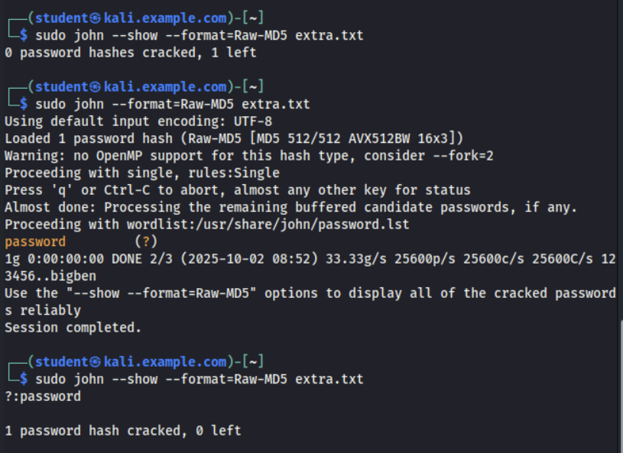
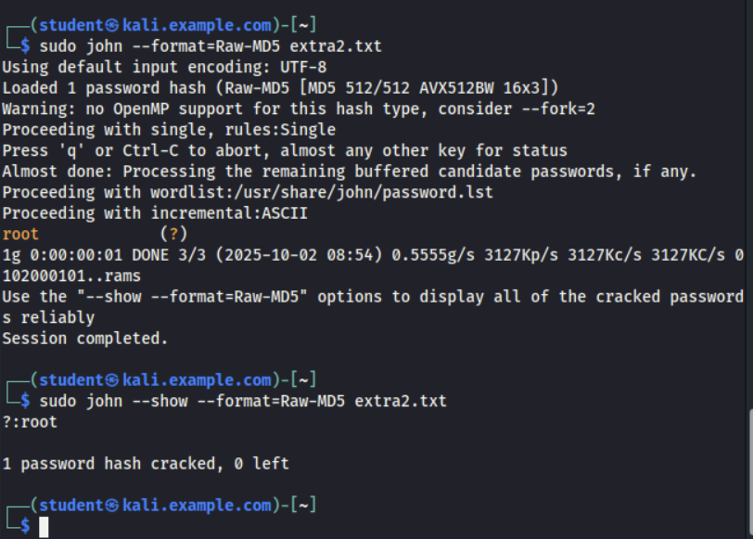
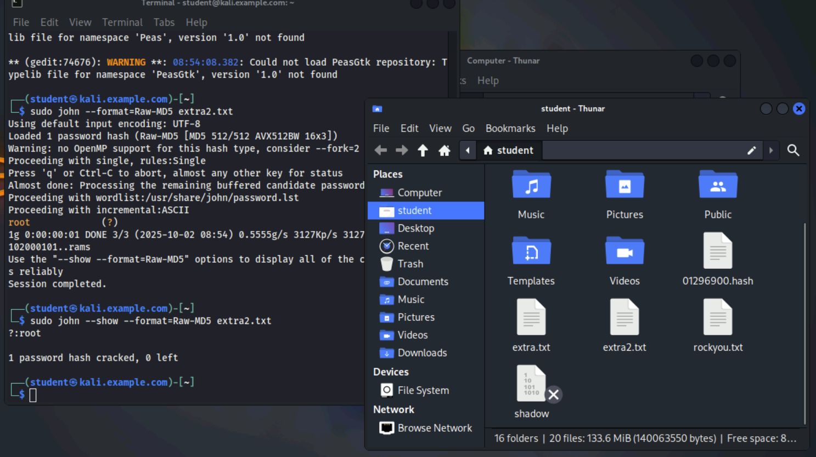
Methods to create files and add the MD5 hash in the text:
“touch extra.txt” “gedit extra.txt”
“touch extra2.txt” “gedit extra2.txt”

