Scott Worm
11/29/30
CYSE 270: Linux System for Cybersecurity
Lab 11 – Basic Network Configurations

CYSE 270: Linux System for Cybersecurity
You can use either Ubuntu VM or Kali Linux VM to complete the following tasks.
Task A – Explore Network Configurations (8 * 5 = 40 Points)
{{{{{{{{{Connect your VM in the NAT mode}}}}}}}}
- Use the correct ifconfig command to display the current network configuration. Highlight your IP address, MAC address, and the network mask.
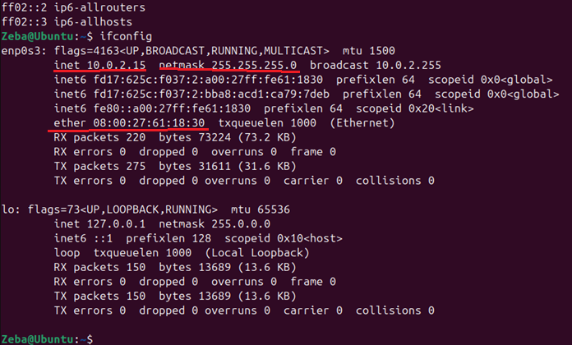
- Use the correct route command to display the current routing table.
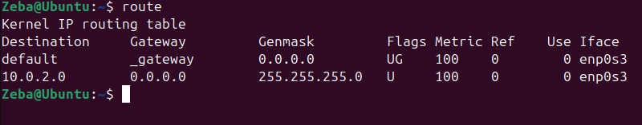
- Use the netstat command to list current TCP connections.
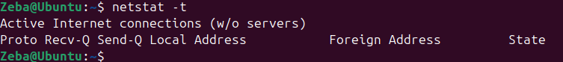
- Use the ping command to determine if the ubuntu.com system is accessible via the network.

(Use the correct option to send 10 ping requests only.)
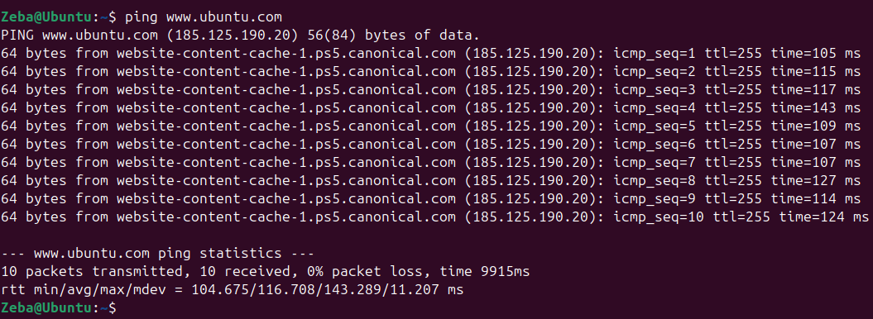
- Use the host command to perform a DNS query on www.odu.edu
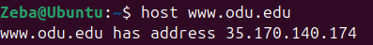
- Use the cat command to display the contents of the file that contains the system’s hostname.
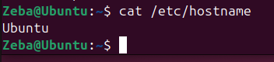
7. Use the cat command to display the contents of the file that contains the DNS servers for this system.
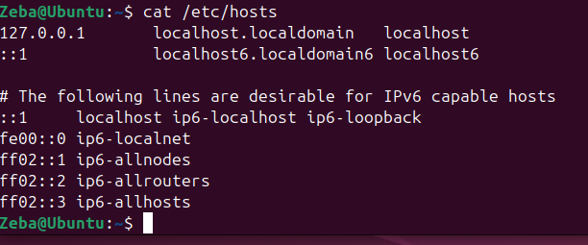
8. Edit the same file you display in the previous step, set the system’s hostname to your MIDAS ID permanently. Reboot system and repeat step 6.
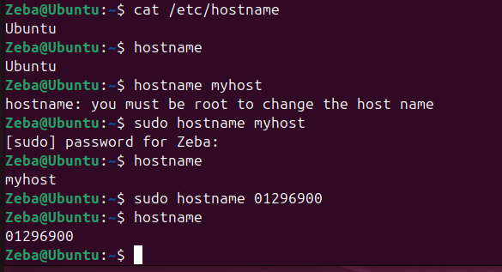
After the reboot
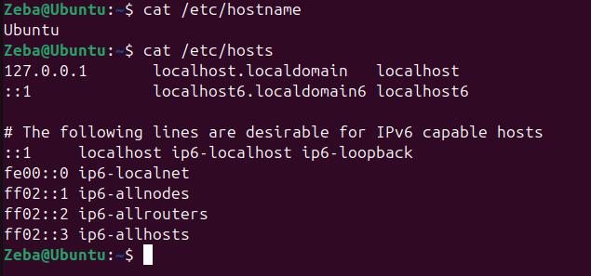
Task B – A Different Network Setting (3 * 20 = 60 Points)
- Change the VM network connection from NAT to the bridge mode (you will lose your Internet connection if you are connected to the ODU campus Wi-Fi network, but it is okay).
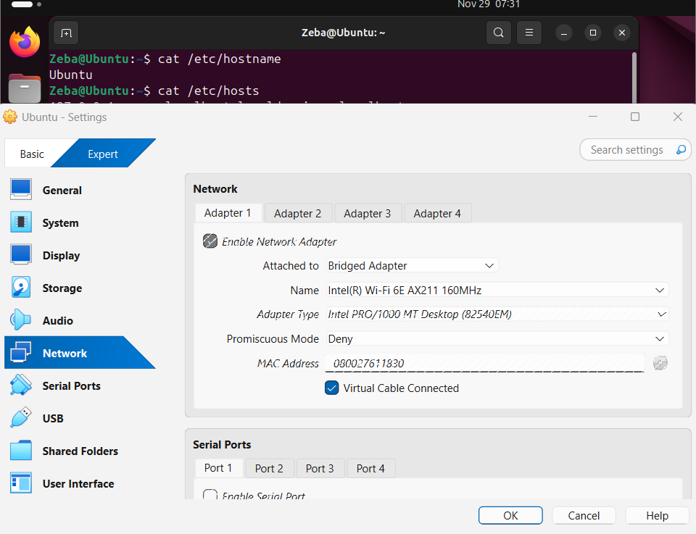

- Reboot your system, then repeat Steps 1 – 7 in Task A.

- Highlight the differences at the end of each step and discuss what you find.
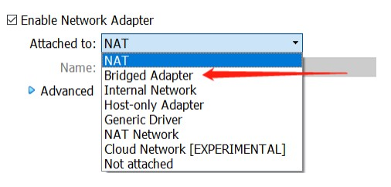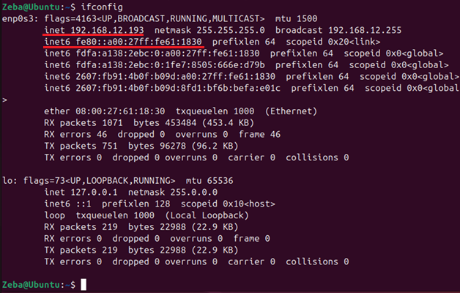
The IP address was changed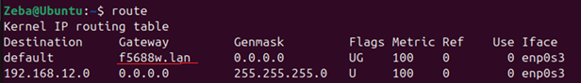
The gateway was changed
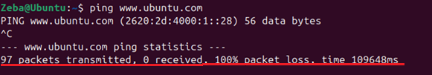
Ubuntu couldn’t be pinged

