Scott Worm
10/31/25
CYSE 270: Linux System for Cybersecurity
Lab 8 – Shell Scripting
(Total 100 Points)
Please refer to the slides for week 8 - Shell scripting and write shell scripts to complete the following tasks. Submit the screenshot for the script and its output, both.
NOTE: Please replace the name of the script with the name you used for the script. In the sample screenshot, I have used those names to create my script.
Step-1: Use vi or nano editor to write your script (Ex, vi YourScriptName.sh) for the following tasks.
Step-2: After saving the script, save and exit out of the editor and make the script executable by adding execute permission ( chmod +x YourScriptName.sh) Step-3: Run your script using ./YourScriptName.sh

Task A (Correct script (25 points) + result/output after executing the script (25 points)- Conditional Statement
Write a shell script using nano or vi editor (eg, vi scriptname.sh) like below, that performs the following task:
- Add the Shebang (#!/bin/bash) as the first line in your script. /
- Read a number using read function /
- Using if statement, check if the input number is greater than 10, then print the message “Input number is greater than 10”. /
- If the number is not greater than 10, then print the message, “Input number is not greater than 10”. /
(Your script should result into the output similar to this sample screenshot after executing as shown below)

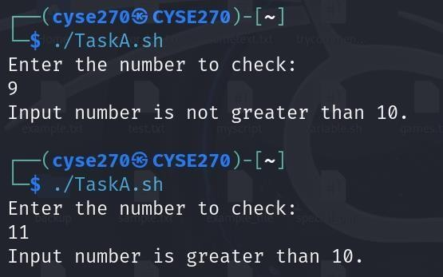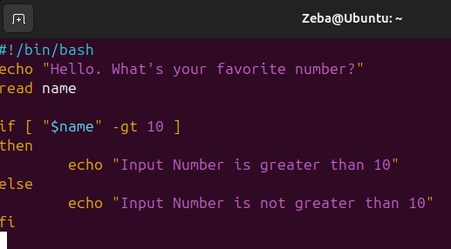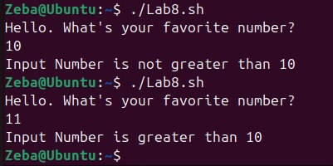

Task B (Correct script (25 points) + result/output after executing the script (25 points) - Shell Script to Create a new file
Write a shell script using nano or vi editor (eg, nano scriptname.sh) like below, that performs the following task:
- Add the Shebang (#!/bin/bash) as the first line in your script. /
- Reads the name of the file to check for a filename that exists. /
- Check whether the given input is a directory or regular file. /
- If the input is a directory and exists, then display the message “Directory exists”. /
- If the input is a regular file, then display the message “It is a regular file, and the file exists” and display the contents of the file. /
- If the given input name in step-1 doesn’t exist, then create the new file with the given name in step-1. /
(Photos in step 7)

(Extra credit: 10 points) Add your name to the file (using redirection operator ‘>’) and display the contents for the newly created file.
- Save and exit the editor and remember to make the script executable using the command chmod +x scriptname.sh)
(Your script should result into the output similar to this sample screenshot after executing as shown below)

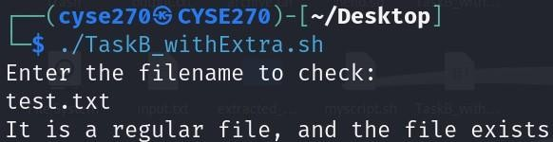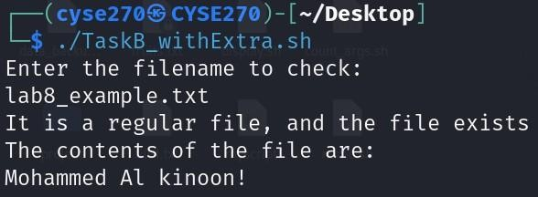
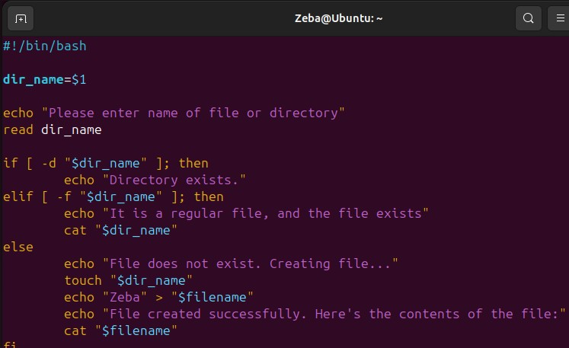
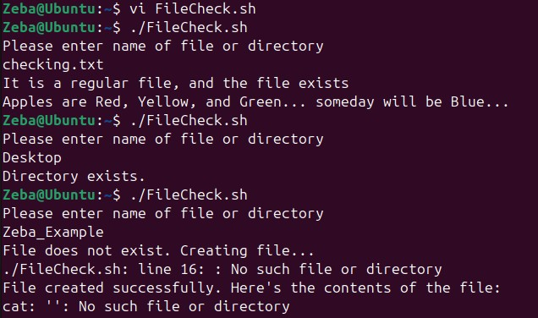

Extra Credit (15 points)- Check Directory
Write a script like below that
- Reads Two variables- your name and the name of the directory as input.
- Your script should check for the validity of the given directory name, if the entered filename is a directory, then display its contents
- If the directory doesn’t exist, then print an error message “Sorry, the entered directory name is not a valid directory name.”
- You need to execute your script and test the following directories to test with your script
  - /etc/systemd
  - /home
  - A directory that does not exist
Display the contents for the directories you have entered
(See the screenshot below where the script has been executed 3 times to check for the Three different directory names as the test input)
