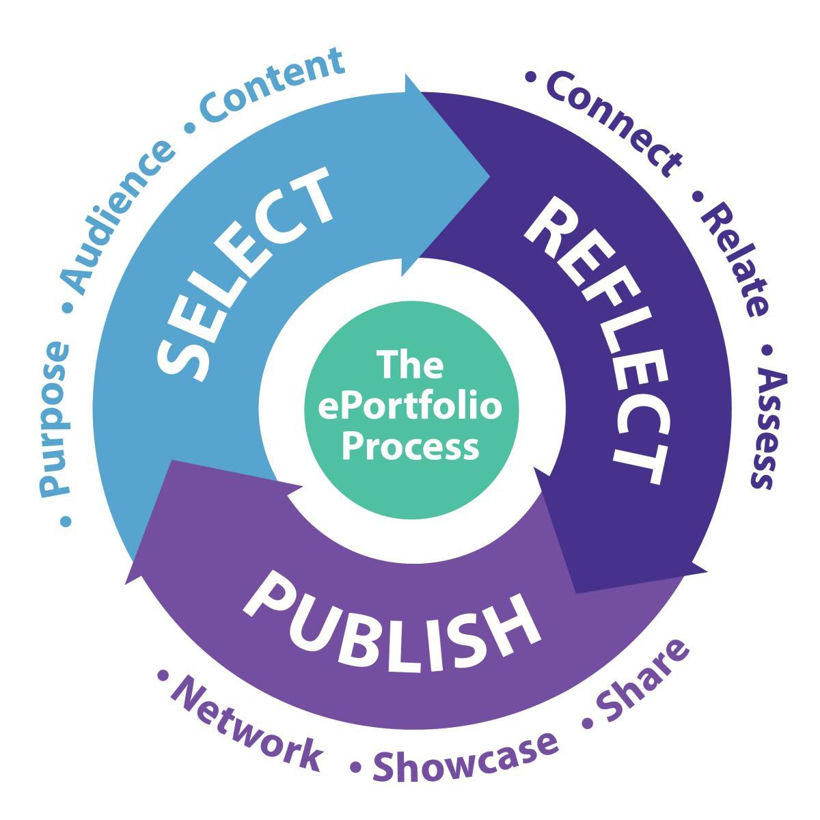
ARTIFACT SELF-EVALUATION FORM
e-Portfolio Artifacts are digital evidence of progress, experiences, achievements, and goals over time. Artifacts are examples of your work. (Image: SFSU)

Name: Tavia
Date: 1/24/2022
Leçon:1

Artifact Title:

Type: Choose one (*Be sure to embed all information and give credit )
___ Photo/Image | ___ Recording | ___ Assignment
___ Forum (corrected) | ___ TalkAbroad | ___ Cultural Understanding
___ Notes | ___ Vidéo | ___ News/Events
_x__ Journal | ___ Rédaction | ___ Other:

My Reflective Process (answer prompts 1-5 below in English to help you process your French learning this week):
- Why did I select this particular artifact? What is the significance for me?
I chose to write about my real world experience with using french within my career. It is very significant for me because it really put into perspective how useful being able to communicate in french will be in my teaching career.

- What did I learn from this artifact?
I learned that it is very possible to have french speaking students in my classes and that it is important to work hard in this class to help my potentially french speaking students.

- How does the artifact reflect my strengths and interests? What have I done well? Name 1-3 items related to this artifact that you are proud of this week.

This artifact reflects my interest with teaching and my true passion for kids and wanting to make sure my classroom in very inclusive and everyone feels welcomed and like they belong.

- What was my biggest challenge when completing this artifact? Would I have done anything differently?

One challenge was that I realized learning the words is one thing but it is very important that I practice with accents because that can make or break someone understanding me when communicating in french.

- What can I improve on moving forward in my French learning process?

My accent.

*Embed artifact information below and be sure to give proper credit:

Over winter break I substituted in many classes. I was in one class for a few days straight and there were 2 students who were native french speakers. I saw an opportunity to try and communicate with them with some basic conversations and I thought it would help them feel like someone else was like them. The issue that arose was they had french accents that I haven't really learned much of myself so they had some trouble understanding what I was trying to say.

