Photo 5
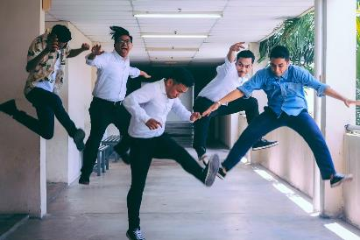
“All we do is win win win no matter what!”
This describes a workplace where all employees are on the same page about what needs to be done in regard to maintaining a safe and secure workplace. As from the module, reducing human error by developing human-centered and socio-organizational initiatives such as education on the importance of cybersecurity and making sure that a zero-trust policy is established and implemented will overall boost the morale of the team, in the fact that they know that they are all on the same page when it comes to security procedures and principles.
Photo 8
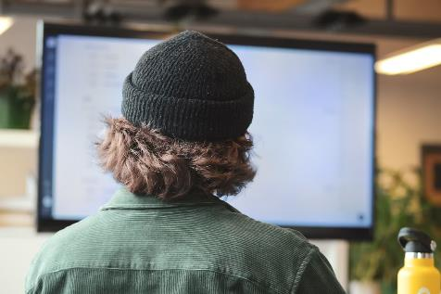
“I always feel like, somebody’s watching meee, and I got no privacy”
This image displays the importance of keeping your private information confidential, especially when typing in passwords or reviewing confidential information.
Photo 9
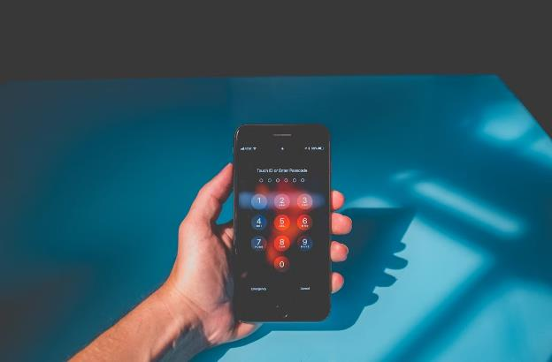
“Aye...watch it buddy”

I think that this photo is very similar to the last meme as it stresses the importance of keeping certain personal devices secure through various methods, in this case by using multi-factor authentication. I am a huge supporter of multi-factor authentication, especially with biometrics, something that will make it even more difficult for people with malicious intent to gain unauthorized access to personal information. A recent update for the iPhone has even allowed an individual to have the option to establish face scans to gain access to applications, something that will be incredibly beneficial for millions of users.

