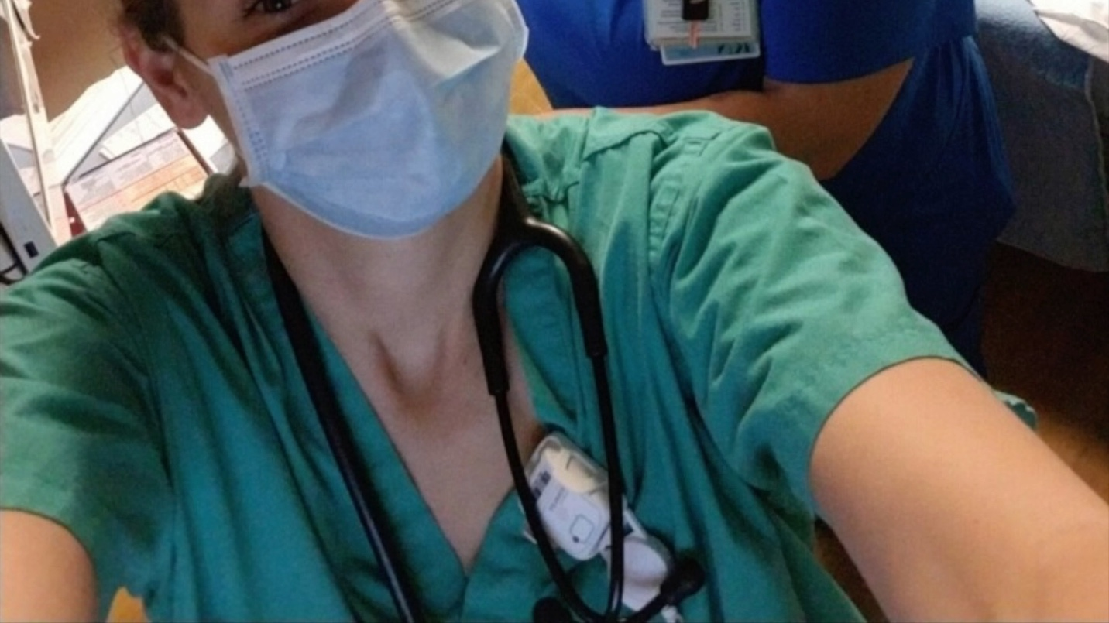Electrocution Jumpstarted My Career: RN Felicia Ward

Double Click Picture to Play Video^^

Transcript:

T'Ericka McNeal: Good morning. So, first, we're going to start with your name, your position, and education level.

Sgt. Ward (RN): My name is Felicia Ward. My position is a registered nurse, or would you like me to talk about the military?

T'Ericka McNeal: Either one.

Sgt. Ward (RN): OK, so I'm also a registered nurse, but I currently switched to full time military as a medic and my education level. I am working on my RN-MSN and I've already finished my BSN.

T'Ericka McNeal: So, what inspired you to join your career field?

Sgt. Ward (RN): So, I kind of fell into nursing. I always thought I would want to be like a doctor or something, because when I was first in the military as a young airman, I went home on leave one day and I actually came across two people, cause I'm from Florida, who were electrocuted from lightning in the water. And I performed CPR on them. They came back to life and I was like, that's really fascinating and cool. And ever since then, I've been kind of fascinated with medical. When I got off active duty, I knew I wanted to be a doctor. So, I went to yourself. I started the whole medical program. I did my premed. I took my MCAT. I found out I was pregnant with my daughter and I realized I wanted to be a mother, not a doctor. So, what am I going to do with all this education? So, then I decided to go into nursing, and it was the best career path I could have ever chose. I lined up perfectly. It has everything I want in medical and the nurturing side. So, I kind of fell into my dream job.

T'Ericka McNeal: And what was your I guess we just answered your path and journey to your current job, we answered that. OK, so what are some basic roles and responsibilities in your everyday job life?

Sgt. Ward (RN): OK, so as a nurse, my basic roles and responsibilities is advocating for my patient and making sure they get adequate care and that their needs are met. So not only are they here, let's say for cellulitis, and I'm treating them with proper medication and lab work and staying on top of their vitals and everything like that. I'm also advocating for whatever may be going on with them. Maybe they don't like a certain internal medicine doctor, maybe they don't like their plan of care. Maybe something wasn't explained to them further. So, I am also like a teacher and a nurturer by helping advocate for them to find somebody else or explaining further why whatever procedures needed that they're getting.

T'Ericka McNeal: All right. Thank you. And what is the most rewarding or your favorite aspect of your job?

Sgt. Ward (RN): I love personal connection. I really enjoy getting to know each person and making that connection. I think that's why nursing is my favorite, because you come across so many different people and you get to learn their story. It's not just here. I'm here to give you your meds today or I'm taking your vitals as I always am, like, what did you do for a living or how many kids do you have? I like I really like that personal aspect that I touch. And I think that shows in my practice. But that's why I really like what I do, because I get to meet so many people in.

T'Ericka McNeal: What is the most surprising aspect of your job or something you came across like while you were working and like you know something exciting,

Sgt. Ward (RN): Something exciting? I didn't realize how many lives; how many little things could turn into such big events. Like, for example, if you're not paying attention when you're passing your medication, you know, your person supposed to go to surgery in a day or two and you're giving Eliquis and now you don't fess up and say something you gave them because they could bleed more little things like that. But also something that's most challenging, too, is I didn't realize how, even though with health care, our job is to care for the patient and treat the patient, it's still a business and you have higher management getting on you about business aspects when you're worried about your patient care. So that could be challenging as well.

T'Ericka McNeal: Thank you. And lastly, what advice would you give to someone getting into the health field?

Sgt. Ward (RN): I think it's really important when you go into the health care career field that you know why you're going and it's not for the paycheck, but it's for actual patient care, because it's really easy to tell when a nurse is there because they want to be there or if they're there to get a check. And I don't think that this is the job you should be doing if you're there for the money. I think there's other jobs that you could do that are just as lucrative. But I think caring for a patient should be really why you want to be there. And it's something to consider because it's not an easy job. But if you love what you do. It's not hard to do.

T'Ericka McNeal: All right, thank you.

Sgt. Ward (RN): You're welcome.