T' ERICKA D. MCNEAL

# A I R F O R C E M E D I C – C U R R E N T N U R S I N G S T U D E N T

MAIN OBJECTIVE

I am a prospective nursing student, serving in the US Air Force Reserves as a medical technician, who hopes to obtain a job within the nursing field to help widen, practice, and maintain skills.

# ACCOMPLISHMENTS

* Consistent Honor Student
* National Honor Society-Bryan Old Chapter (2018-present)

-Basic Life Support, American Red Cross (2019)

- NREMT (2019)

-House of Delegates Award (2017-present)

-WISE Certified (2016-present)

# CONTACT DETAILS

Cell: (757) 675-8788

Email: [terickam01@gmail.com](mailto:terickam01@gmail.com)

851 Norview Ave Apt 202, Norfolk, VA 23513 United States

# WORK EXPERIENCE

## Air Force Medic- 4N051

### Fort Sam Houston- Langley AFB | 2019 - Present

* I work in the hospital when I am on orders. At the hospital I take care of patients give meds, monitor their care, put in and change IV's, I basically do whatever is needed of me within my scope of practice. I have experience in almost all of the units of the hospital.

## Elementary School Tutor

### South Western Elementary SOL Prep Tutor | 2015 - 2019

* When I tutored at Southwestern Elementary, I helped the 5th graders study and prepare for their SOL’s
* Taught basic math to students
* Made math sheets for teachers and students
* Created fun activities and new ways of learning

# ACADEMIC HISTORY

## Maury High School

### Class of 2016 - 2020 | Honor Student

* Scholar, National Honors Societyy
* Treasurer, FCCLA (Family Career Community Leaders of America)
* Member, FBLA (Future Business Leaders of America)
* Member, Pink Club
* Member, Cheer Team

-Member, DECA (Distributive Education Clubs of America)

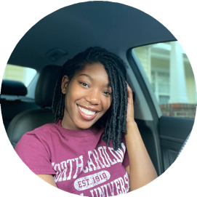

## United States Air Force

### Class of 2019-2020 | Honor Student

* + Scholar, Aerospace Medical Service Apprentice (phase I, phase II) 240 Hours
  + Scholar, CCAF 4 Hours
  + Scholar, NREMT 10 Hours

-Conducted by 59th Training Group Fort Sam Houston,

# MAIN INTERESTS

-I love to help others

-Nursing

* + Art

-Mathematics