**Fall Semester Pre-Assessment (50 Points)**

**Due Date: Week 2**

**Assignment Submission:** Download this document and save it as a Word Document. Save it as your Last Name_First Name. Send it to me as an attachment along with your [Professional Email Signature](https://docs.google.com/document/d/1RTO2ImKLiqyGbxPOMSp6SzI-Fp0v8HWWYUmuuPwPIKM/edit?usp=sharing).

Please answer the following questions in complete sentences completely.

1. Major/Career
   1. What is your intended major and why did you choose this major?
      1. Nursing is my intended major. I chose nursing because In the military I am a medical technician and I like it, so I want to further my career and get my degree and license.
   2. What skills or abilities do you possess that make this major/career a good choice for you?
      1. I have the ability to communicate and nurture my patients.
   3. What experience, if any, do you have that relates to your chosen major/career?
      1. I am a medical technician in the Air Force.
   4. In what type of setting would you prefer to work?
      1. I prefer to work in the pediatric clinic because I like working with the kids and also because it's not too busy.
   5. What are your career goals (in 5 years/in 10 years)?
      1. In five to tens years I see myself working in my own pediatric clinic with my doctor of nursing practice degree.
   6. Complete the MyMajors quiz: <https://odu.mymajors.com/quiz/>. Provide a screenshot
      1. 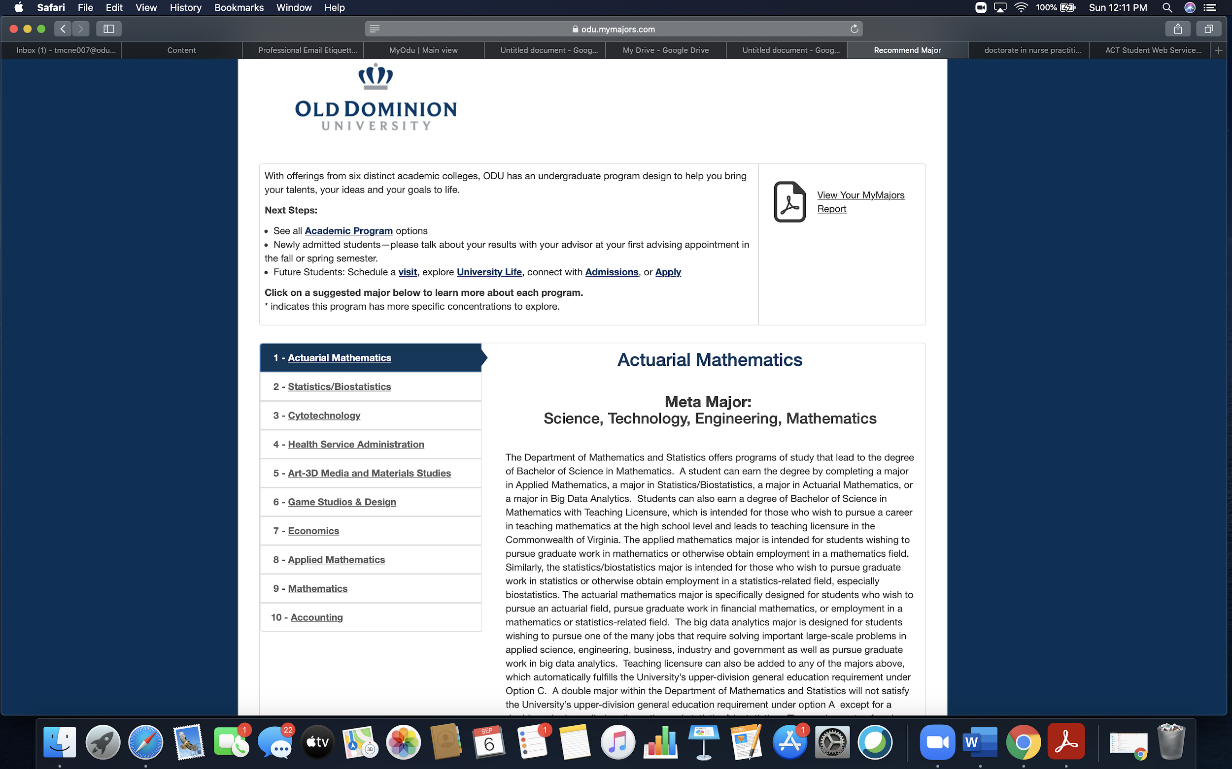
   7. of your results. Of the majors on your top 10 list, which 3 would you like to learn more about?
      1. I am not really interested in any of the majors but if I had to choose I’d pick health service administration, game studios design, and accounting.
2. Transition to college
   1. What do you expect to be the biggest difference between high school and college?
      1. I believe the biggest difference between the two is the structure of things as in the amount of work and the time you have to complete the tasks.
   2. What do you expect to be your biggest challenge this semester?
      1. I expect my biggest challenge to be maintaining a 4.0 GPA
   3. *If you live on campus:* What do you expect to be your biggest challenge with moving away to college?
      1. I do not live on campus.
   4. OR *If you commute to class:* What do you expect to be your biggest challenge with commuting to campus?
      1. The only challenge I feel I might run into is traffic.
   5. Do you have a job/ or plan to get a job? If so, where? How many hours will you be working per week?
      1. I do not currently have a job, but if i were to get a job I’d try to only work maybe 10-20 hours a week.
3. Study habits
   1. Is there a difference between “studying” and “homework”?  Explain your answer.
      1. Homework is something that is assigned to test your knowledge on materials you learned. Studying is going over what you learned testing yourself making sure you understand the material.
   2. How much time do you plan to spend studying for each class every week?
      * 1. I plan to spend at least 8 hours studying.
      1. For which class do you expect to spend the most time studying?
         1. I plan to spend the most time studying chemistry and history.
      2. For which class (other than HLTH 101) are you expecting to spend the least amount of time studying?
         1. I plan to spend the least time studying for my chemistry lab class.
   3. Where do you plan to study?
      * 1. I plan to study in my room at home.
      1. What potential distractions can you anticipate?
         1. I can see my family or tv being a potential distraction.
      2. How do you plan to avoid these distractions?
         1. I will avoid these distractions by letting my family know not to bother me and I won't turn my tv on.
   4. What time of day is your best time to study and why?
      1. The morning and night are the best times for me to study.
   5. This Fall, you are in online courses, some of which do not meet at a specific time, how do you plan to manage all of your assignments?
      1. I plan on completing my assignments the day or next day they’re assigned.
   6. Think about all of your commitments i.e. job, family, social life (from a distance and wear your mask! #ReignResponsibly). How do you plan on balancing your various commitments?
      1. I will completes assignments and tasks in their order of importance
4. Learning style
   1. What specific study techniques do you think work best for you?
      1. I think flash cards work best for me.
   2. Do you use different study techniques for different classes? Provide examples.
      1. For most subjects flashcards work but for chemistry I like to complete practice problems.
5. Connecting to campus
   1. Name one academic resource at ODU you can use to help you earn “As” this semester.
      1. I will go to the writing center and use the chemistry tutors.
   2. Name one non-academic resource at ODU and how it can help you this semester.
      1. The writing center will help me write good quality essays.
   3. Name one resource you think you will use this semester.
      1. One resource I will use is the University Bookstore.
   4. Name one resource at ODU you would like to learn more about, and why.
      1. I would like to learn more about the library, and all of the resources they have to offer.
   5. In high school, what clubs, organizations, or activities did you participate in, if any?
      1. Pink Club, FCCLA, FBLA, and DECA.
   6. Is there a club or organization you plan to join this semester and what do you expect to gain from this experience? If not, why not?
      1. I am not sure of all of the clubs the university has to offer, but I am looking to join a sorority.

**Rubric**

|  |  |  |  |  |
| --- | --- | --- | --- | --- |
| **Criteria** | **Excellent**  **(75-70.5 points)** | **Sufficient**  **(70.49-63 points)** | **Minimal**  **(62.99-55.5 points)** | **Unacceptable**  **(55.49-0 points)** |
| **Depth of Reflection** | Response demonstrates an in-depth reflection about the semester so far. Viewpoints and interpretations are insightful. Clear, detailed examples are provided, as applicable. | Response demonstrates a general reflection about the semester so far. Viewpoints and interpretations are supported. Appropriate examples are provided, as applicable. | Response demonstrates a minimal reflection about the semester so far. Viewpoints and interpretations are unsupported or supported with flawed arguments. Examples, when applicable, are not provided or are irrelevant to the assignment. | Response demonstrates a lack of reflection about the semester so far. Viewpoints and interpretations are missing, inappropriate, and/or unsupported. Examples, when applicable, are not provided. |
| **Required Components** | Response includes all components and meets or exceeds all requirements indicated in the instructions. Each question is addressed thoroughly. MyMajors Screenshot is provided. | Response includes all components and meets all requirements indicated in the instructions. Each question is addressed. My Majors Screenshot is provided. | Response is missing some components and/or does not fully meet the requirements indicated in the instructions. Some are not addressed. MyMajors Screenshot is provided. | Response excludes essential components and/or does not address the requirements indicated in the instructions. Many parts of the assignment are addressed minimally, inadequately, and/or not at all. No MyMajors Screenshot. |
| **Structure** | Writing is clear, concise, and well organized with excellent sentence/paragraph construction. Thoughts are expressed in a coherent and logical manner. There are no spelling, grammar, or syntax errors per page of writing. | Writing is mostly clear, concise, and well organized with good sentence/paragraph construction. Thoughts are expressed in a coherent and logical manner. There are no more than three spelling, grammar, or syntax errors per page of writing. | Writing is unclear and/or disorganized. Thoughts are not expressed in a logical manner. There are no more than five spelling, grammar, or syntax errors per page of writing. | Writing is unclear and disorganized. Thoughts ramble and make little sense. There are numerous spelling, grammar, or syntax errors throughout the response. |