Verneshia Heidelberg
BIOL 405W
Final Draft Paper
Periodontal Disease: The Hidden Pathway to Infection Transmission

- Abstract
Periodontal disease is often dismissed and seen as a simple dental issue, but growing evidence suggests it plays a significant role in systemic health. The disease, caused by bacterial infections in the gums and supporting structures of the teeth, has dangerous implications that extend far beyond the oral cavity. Through bacterial migration and entry into the bloodstream, periodontal pathogens contribute to a multitude of systemic infections and diseases. Some of these include cardiovascular conditions, respiratory illnesses, diabetes, and pregnancy complications. This paper will explore the pathogenesis of periodontal disease, its microbial components, mechanisms of systemic transmission, physiological responses, and vulnerable populations. It will also discuss current research and future directions in prevention, management, and treatment.

- Introduction (Personal Perspective)
How often is dental care neglected? For whatever the reasons: finances, time, fear
or low on the priority list, most tend to avoid not only the Dentist, but at-home dental
care as well. Dental care plays a huge role in infectious diseases. The implications of
poor dental hygiene extend well beyond oral health. Research shows a link between
periodontal disease and the transmission of systemic infectious diseases. This is
extended to cardiovascular disease, respiratory infections, and even diabetes. This
happens because the bacteria enters your bloodstream and from there travels
throughout your entire body. This triggers immune responses, and it is ultimately how
the spread of infections occurs. The body has physiological responses that snowball into bigger issues. We will discuss the findings, and how to move forward in treatment and the future of the research in this disease. Good dental hygiene is not a luxury practice or a back-burner chore. It is necessary and often times critical for our overall health. Poor oral hygiene creates a fertile environment for pathogenic bacteria, which thrives in the warm crevices between the teeth and gums. Once periodontal disease sets in, it opens a dangerous gateway for bacteria to enter the bloodstream. From there, the affect it has on organs far from the mouth is dangerous. This paper will investigate the underlying mechanisms of how periodontal disease becomes that gateway for systemic infection, and we will offer insight into how we can better address and prevent these hidden health threats.

- Main Body:
- Pathogenesis
Periodontal disease develops due to the colonization of pathogenic bacteria in the subgingival environment. The primary initiating factor is a build up of dental plaque [1]. Dental plaque is a biofilm that is made up of bacteria, various food particles, and saliva. If this plaque is not removed, it will harden into tartar. This then irritates the gums and promotes inflammation. Over time, if consistently occuring, this can lead to gingivitis. Gingivitis eventually and inevitably progresses into periodontitis. What escalates this progression is the interaction between microbial communities and host responses. There are certain bacteria, such as Porphyromonas gingivalis, Tannerella forsythia, and Treponema denticola, that are highly harmful and have the ability of evading immune responses [1,2].

- Role of bacterial pathogens
Periodontal pathogens actively manipulate the host’s immune response to establish chronic infections. P. gingivalis, for example, is known for destabilizing the complement system and disrupting neutrophil responses[1]. These bacteria release what are called proteolytic enzymes and toxins that degrade the tissue and modulate immune signaling [1,2]. They survive within biofilms, protected from both immune attacks and antibiotics. This all contributes to persistent infection.

- Plaque and biofilms formation
Dental plaque is the initial stage of biofilm development. Biofilm is very complex, and it has what called a three dimensional organization [11]. It forms when biofilm-producing bacteria in an aqueous environment, in this cause the mouth, adhere to solid surfaces. It then goes on to produce a network of extracellular polymeric substances (EPS), adopting a “multicellular lifestyle” [11]. Within hours of brushing, something called pellicle proteins attract early colonizers [3,11]. These bacteria then multiply and produce extracellular polymers that facilitate adherence and recruitment of anaerobic, gram-negative bacteria [2,3,11]. Biofilms are dense communities where bacteria communicate via quorum sensing [11]. Quorum sensing is a process in which it helps induce microbial biofilm formation [11]. It has enhances virulence. It does this by regulating the metabolic activity of plankton cells [11]. They then coordinate activities that enhance survival. These structures are resistant to antimicrobials, and that is how they also contribute to persistent infection [3].

- Contributions to Systemic Infections
The oral cavity is a central hub for microbial exchange. In periodontal disease, ulcerations in the gingival epithelium provide a direct route for bacteria to escape the oral environment [4]. Lymphatic spread occurs, which is when bacteria can travel to regional lymph nodes, where immune responses may be weak. You also have aspiration. This generally occurs in the elderly or those with swallowing issues. It increases the livelihood of bacteria being aspirated into the lungs [4,5]. Transmission through the bloodstream also occurs during daily activities like brushing your teeth, chewing, and even flossing. This leads to bacteria entering circulation and contributing to things like cardiovascular disease, infective endocarditis, insulin resistance, and even pregnancy complications [4,5,6].

- Spread from oral cavity to body systems
- Bacterial migration is how some bacteria move from the mouth, which harbors a lot of bad bacteria, to the body’s various sytems. With poor oral hygiene, bacteria then enters the surrounding tissues by way of lymphatic channels and mucosal surfaces [4,5]. In some vulnerable population, like the elderly, bacteria from the oral cavity can then migrate to the lungs through aspiration [5]. This leads to things like pneumonia.
- Transmission through the bloodstream
- When a person has periodontal disease their gums tend to be inflamed. When doing everyday activities, like brushing, chewing, or even flossing, it can cause damaged areas and allow bacteria to enter the bloodstream by way of these injuries [4].
- Physiology of the Body’s Response to Periodontal Disease
When bacteria builds up in the gums, the body reacts by way of inflammation. This is its natural defense against infection. This happens first as an acute inflammatory response, where immune cells like white blood cells rush to the gums to try to fight off the harmful bacteria [4]. This quick reaction is meant to stop the infection early and repair any minor damage. However, if poor oral hygiene is continued, this inflammation doesn’t go away. Instead, it evolves to become chronic. When it is chronic, the body stays in a constant state of defense, which will eventually start to damage healthy gum tissue and the bones that supports the teeth [4].
This long-term inflammation is not only the cause of gum recession and tooth loss, but it can also affect the entire body. Chemicals released during this immune response, like cytokines, which are messenger proteins, can enter the bloodstream and travel to other organs [5]. Research, including studies by Fiorillo and colleagues (2018), shows that these inflammatory signals may interfere with how the body heals and can contribute to diseases like heart problems, diabetes, and even issues during pregnancy [4,7]. At the same time, the immune system then becomes more active, trying to keep the infection in check. The body produces specialized cells to attack the bacteria, but in gum disease, this response often becomes out of balance. Certain bacteria, like Porphyromonas gingivalis, can trick the immune system by disabling some defenses while fueling others [4,5,7]. This leads to them surviving and continue damaging healthy tissue. As explained by Hajishengallis (2014), this “immune hijacking” leads to even more inflammation and tissue breakdown, making it harder for the body to heal and more likely for bacteria to spread into the bloodstream [2].
This immune imbalance doesn’t just stay in the mouth. According to Panagakos and Scannapieco (2011), the ongoing stress on the immune system may cause low-grade inflammation throughout the body, which has been linked to serious health problems [3]. So, what starts as a simple gum problem can ripple outward, eventually affecting a person’s overall health.
In short, periodontal disease is not just about sore gums or bad breath. It’s a condition that activates the body’s defenses in a way that can spiral out of control if not continuously cared for. When left untreated, it can harm not only your mouth but also your organs. That’s why regular dental care and managing inflammation early are key to protecting both your smile and your long-term health.

- Vulnerable Populations
Certain populations are more vulnerable to the effects of periodontal disease. Pregnant women are particularly at risk. During pregnancy, hormonal changes make the gums more sensitive to plaque and bacteria [7]. This increases the risk of developing gum disease or escalating gum disease that has already occurred. But beyond swollen or bleeding gums, periodontal disease in pregnant women has been linked to serious complications like preterm birth, low birth weight, and pre-eclampsia [7]. Pre-eclampsia is an extremely dangerous condition marked by high blood pressure and damage to other organs that happens very fast. Kranz et al. (2022) reviewed studies showing that inflammation caused by gum disease can trigger immune responses that affect the placenta and fetal development as well [7]. Bacteria from infected gums can enter the bloodstream and reach the uterus, where it may then stimulate early labor or stunt the baby’s growth. Even though the exact biological pathways are still being explored, the association is strong enough that maintaining good oral health as well as taking supplements that support bone strength is now considered an important part of prenatal care.
Periodontal disease doesn’t just affect pregnancy outcomes. It’s also a contributing factor in heart disease, particularly in people who already have preexisting cardiovascular issues. When harmful bacteria from the mouth enter the bloodstream, it can then travel to the arteries and contribute to plaque buildup. This condition is known as atherosclerosis [9]. Song et al. (2024) analyzed a wide range of research and found a clear pattern linking gum disease to an increased risk of heart attacks and strokes [9]. Other researchers found similar patterns. Schenkein, found links between periodontitis and atherosclerosis that showed that upon inflammation, the mechanisms initiated by bacteria associated with periodontal lesions influence the initiation or propagation of the atherosclerotic lesion [12]. These lesions, initiated by inflammatory stimuli including systemic and locally, then produced inflammatory cytokines and chemotactic agents that trigger changes in the endothelium [12]. This then causes an upregulation of adhesion molecules [12]. These changes promote interactions with leukocytes, such as monocytes. The leukocytes then migrate into the innermost layer of the artery. Lipid streaks that have low-density lipoproteins (LDL) within macrophages and dendritic cells in the that innermost layer can then initiate and propagate this inflammatory response [12]. Upregulation of the endothelium also leads to the release of chemotactic cytokines that attract monocytes or other cells that can transport bacteria into the lesion [12]. CD4+T cells are components of this lesion, comprised of predominantly Th1 cells which amplify the inflammatory process by producing INF-γ [12]. This all leads to initiation and propagation of early atherosclerotic lesions. Theoretically this is enhanced in periodontitis patients if periodontal microorganisms contributed to endothelial dysfunction, modification of LDL, attraction and maturation of monocytes [12]. It enhances uptake of lipids or the attraction and promotion of Th1 T cell subsets [12]. The inflammation caused by periodontal disease has the ability to worsen existing cardiovascular conditions, making it especially important for people with heart disease to manage their oral health carefully.
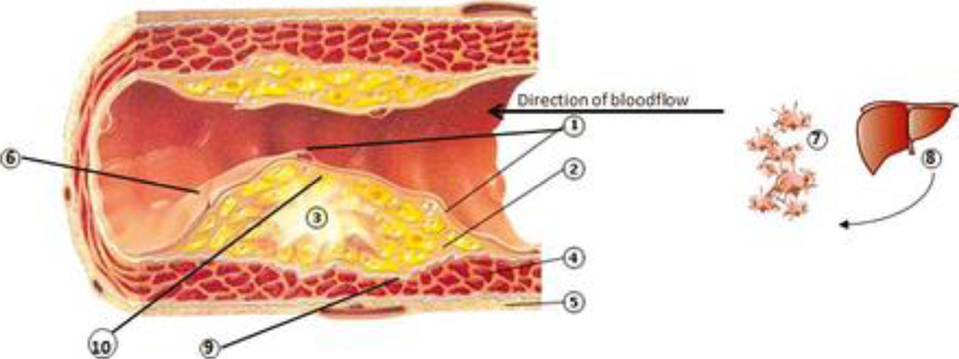
Figure 1: Inflammatory mechanisms linking periodontal diseases to cardiovascular diseases. Process as described from [12]: 1. Dysfunctional endothelial lining: partial loss of integrity. ↑ adhesion molecules (ICAM-1, VCAM-1, E-selectin, P-selectin) and chemoattractants (e.g. IL-8, thrombin), increased platelet and leukocyte adhesion; diapedesis of monocytes, dendritic cells (both possibly with ingested bacteria) and T cells into the underlying inflammatory lesion. Activated platelets may form mini-thrombi. 2. Inflammatory lesion which may be in part initiated and/or propagated by bacteria originating from the periodontitis lesion, and also propagated by pro-inflammatory mediators (IL-1, IL-6, CRP, TNFα) and chemotactic factors (e.g. monocyte chemotactic protein-1) spilled over from the periodontal lesion, produced both in the liver and systemically. 3. Atheroma maturation. Lipid streaks and calcifications, comprised of modified low-density lipoproteins phagocytosed within macrophages/foam cells, resulting in ↑ pro-inflammatory cytokines (IL-6, IL-1, TNFa), ↑ chemoattractants (IL-8), ↑ matrix metalloproteinases (MMPs); the upregulated inflammatory lesion induces dysfunctional endothelial lining. CD4+ Th cells (↑IL-12,IL-18, IFN-γ) are also within the atheroma. 4. Smooth muscle cells (SMCs) and fibroblast with progressive fibrosis and loss of demarcation between inflammatory lesion and SMCs; development of a compensatory blood supply and increased outer muscle layer. 2 + 3 + 4 form the initimal layer of the artery. 5. Outer muscle layer. 6. Disintegrated endothelial lining (i.e. plaque rupture, exposition of underlying atherosclerotic plaque) generates thrombin from prothrombin, which in turn enzymatically generates fibrin from fibrinogen, →clotting cascade resulting in thrombosis, consequently to stroke or myocardial infarction. This process may be mediated by repeated bacteremias and pro-inflammatory state and activated inflammatory cells, such as from chronic periodontitis. 7. Activated platelets by bacteria in circulation from periodontal lesions, forming aggregates, the initiation of micro thrombus formation (out of scale with the whole picture). 8. ↑production of clotting factors in the liver due to inflammatory signals (IL-6), →pro-thrombotic state. Also increased production of acute phase reactants, including CRP, which will increase the pro-inflammatory state (out of scale with the whole picture). 9. Decreased collagen production and activation of MMPs resulting in reduction of SMC content and increased degradation of collagen that borders the fibrous cap, weakening the strength of the vessel, leading to fissuring of the atheroma. 10. In a progressed stage, the atheroma comprises of a large necrotic core which is exposed to the vasculature within the lesion, leading to contact with platelets, initiation of coagulation and ultimately, plaque rupture in so-called vulnerable lesions.

Another high-risk group includes people with diabetes, where the relationship with periodontal disease is two-way [8]. Poor blood sugar control can make it harder for the body to fight infections, including those in the gums. At the same time, gum disease can worsen insulin resistance, making diabetes more difficult to manage. This creates a vicious cycle that can lead to even more severe complications if not addressed.
Immunocompromised individuals and the elderly are also at greater risk for complications from periodontal disease. For these groups, the immune system may be too weak to contain infections effectively, which allows oral bacteria to spread and cause systemic issues such as pneumonia or bloodstream infections [8]. As people age, they may also experience dry mouth, take medications for other bodily functions that in-turn affect oral health, or struggle with proper brushing and flossing due to aging or arthritis. This all makes them more susceptible to gum disease [8]. As Cho et al. (2021) noted, new advances in epigenetics are helping us understand how periodontal disease affects gene expression and immune response in these vulnerable populations. This deeper understanding could lead to more personalized prevention strategies in the future. For now, the evidence is clear: maintaining oral health is not just about teeth. It’s essential for protecting the whole body, especially in those who are already medically vulnerable.
- Preventative Measures
Prevention includes daily oral hygiene, regular dental visits, public health education, antimicrobial therapies, and periodontal screening for patients with systemic diseases.
- Research/Future Direction
Recent research in periodontal disease is moving beyond traditional diagnostics and treatment to focus on the complex interactions between host tissues and microbes. A major advancement highlighted by Makkar and Sriram (2025) is the use of organotypic models and organ-on-chip systems, which simulates the structure and function of human gum tissue in a laboratory setting [10]. OoC systems work by emulating barrier tissues such as skin-on-chip, lung-on-chip, and gut-on-chip. They mimic various micro-physiological interactions between host barrier tissues, microbes, materials, and environmental factors [10]. These advanced models allow researchers to closely observe how specific bacteria, like Porphyromonas gingivalis, interact with human cells in real time under controlled conditions [10]. This represents a significant leap from only animal studies or standard petri dish experiments, which offers more accurate insights into the cellular and molecular processes involved in periodontal disease. One of the most exciting aspects of this research is the ability to replicate immune responses, inflammatory signaling, and tissue degradation in a way that mirrors human biology. These platforms can also be used to test new therapies like anti-inflammatory drugs, probiotics, or gene-targeting agents. Looking ahead, these technologies could lead to personalized medicine approaches, where treatments are tailored to a patient’s unique genetic and microbial profile [10]. As our understanding of periodontal disease becomes greater, the focus is shifting from just treating symptoms to preventing disease progression at its root cause. The future of periodontal research is interdisciplinary, meshing together biology, engineering, and precision medicine to develop more effective and individualized strategies for oral and systemic health.
- Conclusion
Periodontal disease is a systemic threat. Its ability to facilitate the transmission of infection is the reason why oral health needs to be taken seriously. As research reveals the intricate mouth-body connections, it becomes clear that dental hygiene is critical to preventing a wide range of systemic diseases. It’s not just about preventing bad breath or having whiter teeth. It’s not a luxury. It is proving to be a necessity to prevent avoidable disruptions to our already complicated bodily functions.

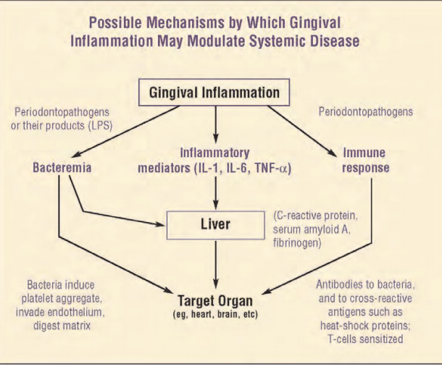
Figure 2. showcases a theoretical pathway mechanism for how inflammation modulates the systemic disease.

- References
- Wang, P.-L. (2010a). Roles of oral bacteria in cardiovascular diseases — from molecular mechanisms to clinical cases: Treatment of periodontal disease regarded as biofilm infection: Systemic Administration of Azithromycin. Journal of Pharmacological Sciences 113, 126–133.
- Hajishengallis, G. (2014). Periodontitis: From microbial immune subversion to systemic inflammation. Nature Reviews Immunology 15, 30–44.
- Panagakos, F., and Scannapieco, F. (2011). Periodontal inflammation: From gingivitis to systemic disease? Gingival Diseases - Their Aetiology, Prevention and Treatment.
- Fiorillo, L., Cervino, G., Herford, A.S., Lauritano, F., D’Amico, C., Lo Giudice, R., Laino, L., Troiano, G., Crimi, S., and Cicciù, M. (2018). Interferon crevicular fluid profile and correlation with periodontal disease and wound healing: A systemic review of recent data. International Journal of Molecular Sciences 19, 1908.
- Fentoğlu, Ö., Köroğlu, B.K., Hiçyılmaz, H., Sert, T., Özdem, M., Sütçü, R., Tamer, M.N., Orhan, H., Ay, Z.Y., Öztürk Tonguç, M., et al. (2010). Pro-inflammatory cytokine levels in association between periodontal disease and hyperlipidaemia. Journal of Clinical Periodontology 38, 8–16.
- Breivik, T.J., Gjermo, P., Gundersen, Y., Opstad, P.K., Murison, R., Hugoson, A., von Hörsten, S., and Fristad, I. (2024). Microbiota‐immune‐brain interactions: A new vision in the understanding of periodontal health and disease. Periodontology 2000 96, 20–41.
- Kranz, A., Feierabend, N., Sliwka, D., Wiesegart, A., Abele, H., and Graf, J. (2022). Assessment of the association of periodontal diseases in pregnant women and the efficacy of periodontal treatment in the context of premature births and pregnancy complications – a narrative review. Geburtshilfe Und Frauenheilkunde 82, 831–841.
- Cho, Y.-D., Kim, W.-J., Ryoo, H.-M., Kim, H.-G., Kim, K.-H., Ku, Y., and Seol, Y.-J. (2021b). Current advances of epigenetics in periodontology from Encode Project: A Review and Future Perspectives. Clinical Epigenetics 13.
- Song, W., Bo, X., Dou, H., Fan, Q., and Wang, H. (2024). Association between periodontal disease and coronary heart disease: A Bibliometric analysis. Heliyon 10.
- Makkar, H., and Sriram, G. (2025). Advances in modeling periodontal host–microbe interactions: Insights from organotypic and organ-on-chip systems. Lab on a Chip 25, 1342–1371.
- Preda, V. G., & Săndulescu, O. (2019). Communication is the key: biofilms, quorum sensing, formation and prevention. Discoveries (Craiova, Romania), 7(3), e100.
- Schenkein, H. A., & Loos, B. G. (2013). Inflammatory mechanisms linking periodontal diseases to cardiovascular diseases. Journal of clinical periodontology, 40 Suppl 14(0 14), S51–S69. https://doi.org/10.1111/jcpe.12060

