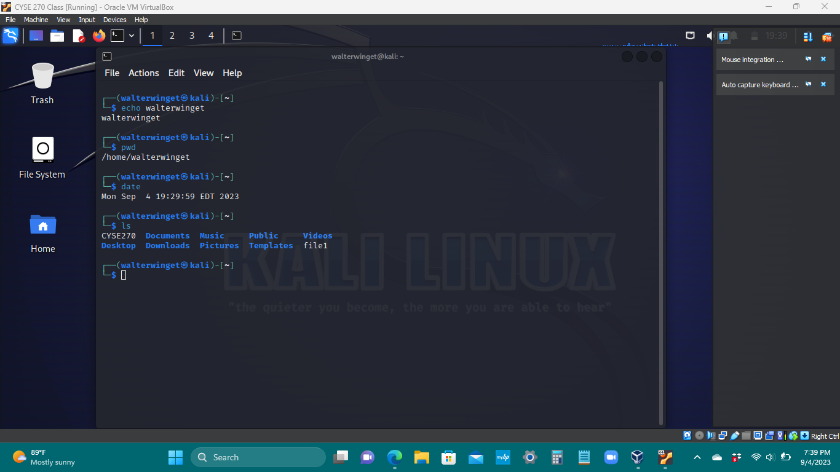

The echo command tells you your name
The pwd command displays the working directory
The date command displays the current time and date at its employment
The ls command displays all of the current directories and files

