Ian Waweru

Google SERPs

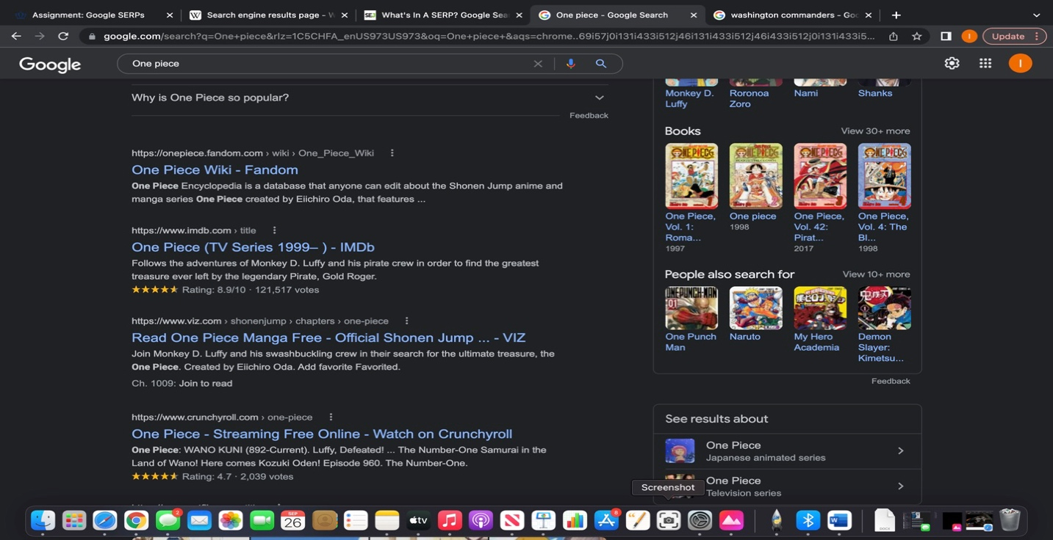

1. Top stories: query has related news stories
2. Knowledge Panel: In the following search for one piece google displayed a knowledge panel with a summary of what one piece the show is.
3. People also ask: it displays five of the top questions asked about
4. Reviews: Display star ratings and review counts within organic search results.

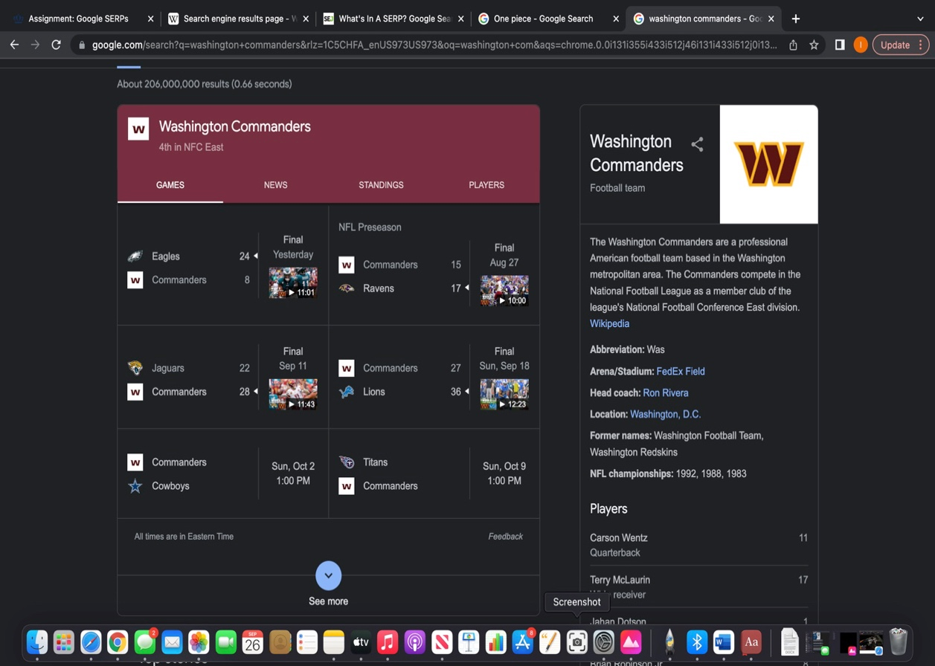

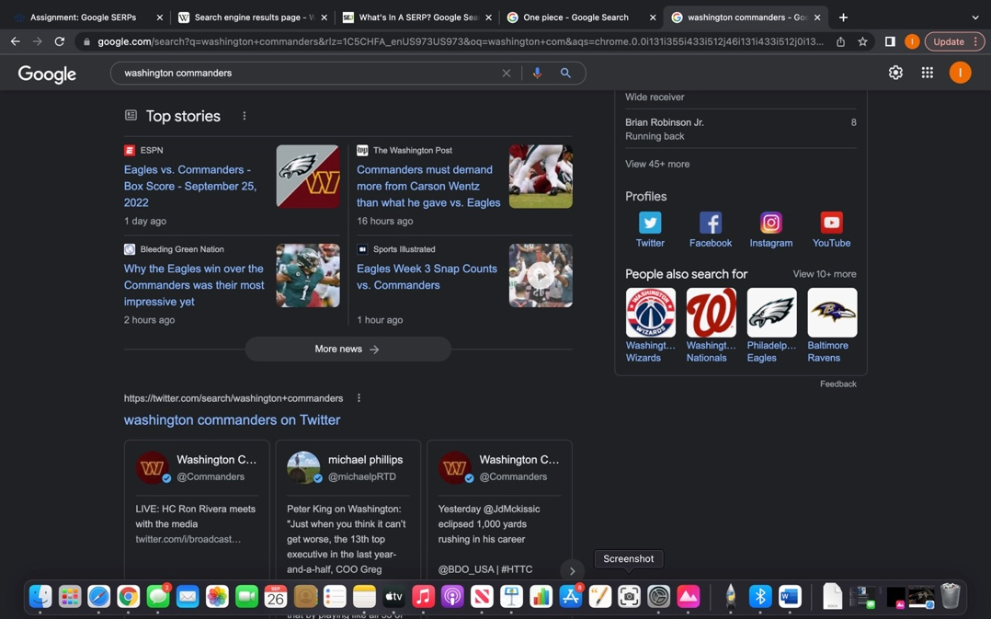

1. Knowledge Panel: In the following search for Washington commanders google displayed a knowledge panel with a summary of who the commanders are.
2. Videos: Google displays a video section of the games played and what games are up next
3. Top stories: query has related news stories
4. Tweets: SERPs will feature tweets relevant to the search