**CYSE 270: Linux System for Cybersecurity**

Assignment: Lab 3 – VI Editor

By: Ian Waweru

1. **Goal**
   1. Practicing using vi editor
   2. Notes:
      1. Remember the “modes” in the vi editor
      2. You may use the “Escape” key when you get confused and start over
2. **Exercises:**
   1. Create a file using vi editor
   2. Navigate, copy, paste, and edit in the vi editor
3. Take the screenshot for each step and submit it in a word or pdf file. NOTE: You may submit multiple commands that fit into a single screenshot.

# Task: vi Practice on Ubuntu / Kali Linux (20 * 5 = 100 points)

**Open the terminal in your VM**, then complete the following tasks. Please take the screenshots of all the necessary commands that you execute for each step and submit the screenshots with their step number in a word or pdf file.

NOTE: You may write the correct vi editor commands, if screenshot is not applicable. Please see the note added to some steps below.

1. Copy file /usr/share/doc/zstd/copyright to your home directory. [NOTE: You can use any text file that is large if you cannot find this file on yours. For example: If you are not able to locate copyright file in your VM, you may copy **/etc/passwd** file to your home directory to work for lab-3.
2. Perform a long list in your current directory using the correct command.

1. Open the file copyright (or any file that is large enough with multiple lines of text) in a vi-editor using **vi** command.
2. Move to line 15, then insert your MIDAS ID in the same line with the following format:

****XXXX****(**replace XXXX with your own MIDAS name**).

1. Return to the command mode (using ESC key).
2. Open a new line below the current line using correct command (please refer to slides with the list of commands used in vi editor)
3. Return to the command mode.
4. Use command to Insert “****XXXX ****” **five** times.

The image above will answer questions 3-8. I used the command “ vi copyright” to enter into the copyright file. My Midas is 01151080 located at line 15. Then after using a couple of commands, I was able to go below my Midas and insert question 8 five times.

1. Use command to return the **top** of the file. [Please write the correct command for this step]
2. **Move forward** **three sentences**. [Please write the correct command for this step with step number]
3. Move forward **four words**. [Pease write the correct command for this step]
4. Search for the word example or any word existing in the document that you are using for lab-3. [Please take the screenshot for this step to submit]

I was able to find the first example by typing the command /examples

1. Continue to the next occurrence of the search term example. [Please take the screenshot for this step to submit]

This is the next example I was able to find and I used the command “n: to find it

1. Delete the current word, example. [Please take the screenshot for this step to submit]

I then deleted the second example in this line

1. Delete the current line. [Pease write the correct command for this step]

I then deleted the entire row

1. Use command to jump to the end of the file.
2. Copy line 16 and paste the text at the end of the document. [Pease write the correct command for this step]
3. Replace all occurrences of http with HTTP throughout the document. [Please take the screenshot for this step to submit]

1. **Rename** the file **copyright** to **copyright_cyse270** [Please take the screenshot for this step and submit]

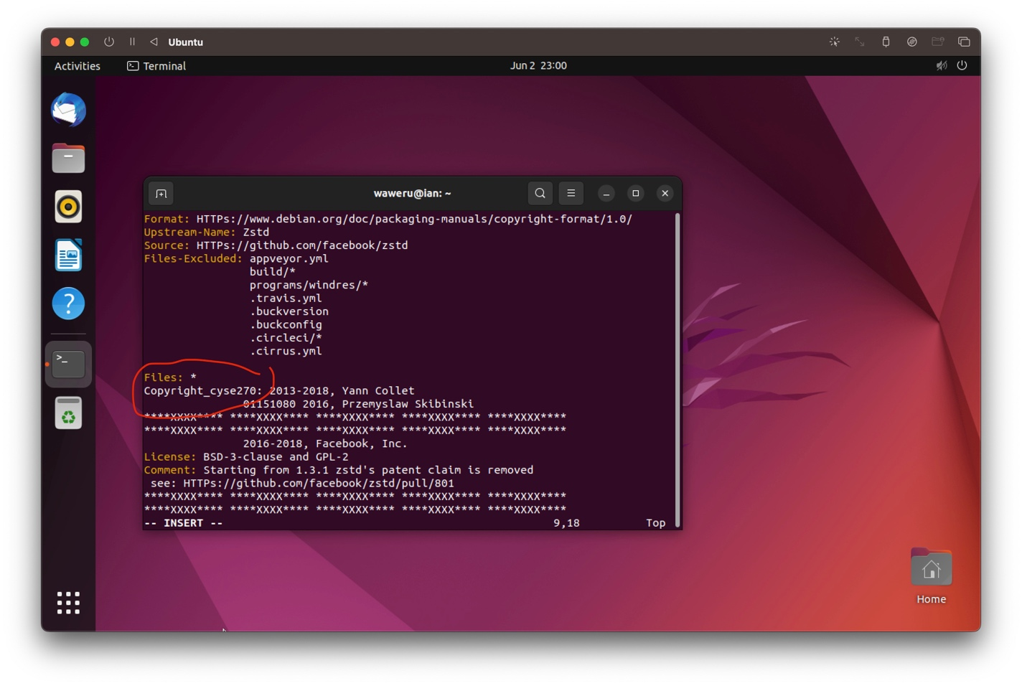

1. Save and quit the document. Then **submit all the screenshots** of previous steps along with the command name on canvas, in word or pdf file.

Please note:

You can use one screenshot to cover multiple steps. Make sure you highlight and annotate important information.